Note-taking app usage

1. Creating a new Note

* When user clicks on the ‘Create Note’ button it will open a form on the right.
* Enter the title and description for the note and pick a background color for it
* When you click submit it will create a new table row containing title and description, and a background color equal to the one selected in form
* When the form is open, the ’Create Note’ button will be disabled until
* Title and Description are mandatory fields so they cannot be empty

1. Delete a Note

* Click on the ‘X’ button to delete a particular note from the table
* If the table has only one row and you delete that row then the table is hidden

1. Edit a Note

* When user clicks on the ‘Edit’ button it will open a form on the right with the

title and description that were in that row

* When the button is clicked the row is removed from the table and saved again when you are done editing and click submit
* Latest modified note gets appended at the end of the table
* Title and Description are mandatory fields so they cannot be empty while editing

1. Save/Refresh notes

* Once you have added notes to the table, the page will show a Save/Refresh button. This button will show the current notes in the table in form of sticky notes which has the background color that was picked for the note
* If you edit/delete the notes in table then you need to click on Save/Refresh again in order to reflect your changes
* When the number of notes in the table are 0 the Save/Refresh button and the sticky notes will be hidden

**Demo:**

Click ‘Create Note’:

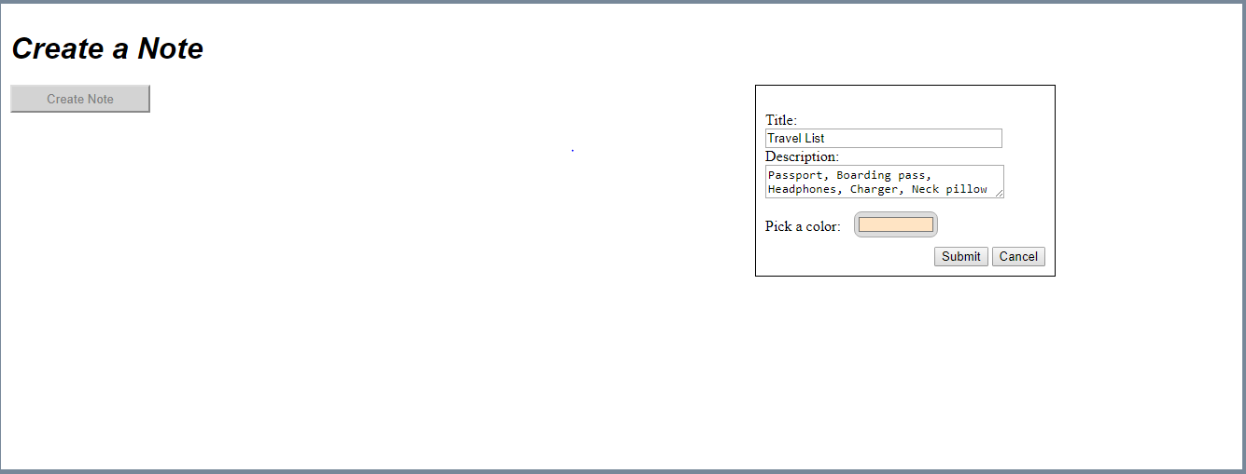

Click ‘Submit’: 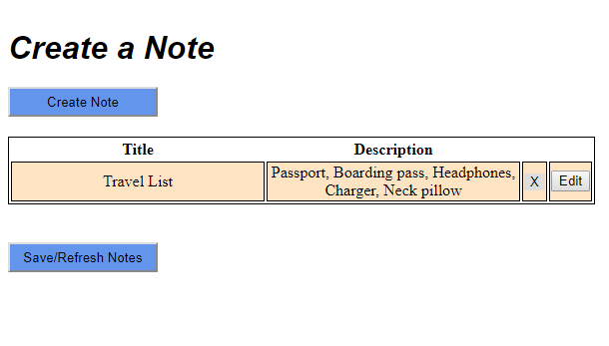

Create a second note:

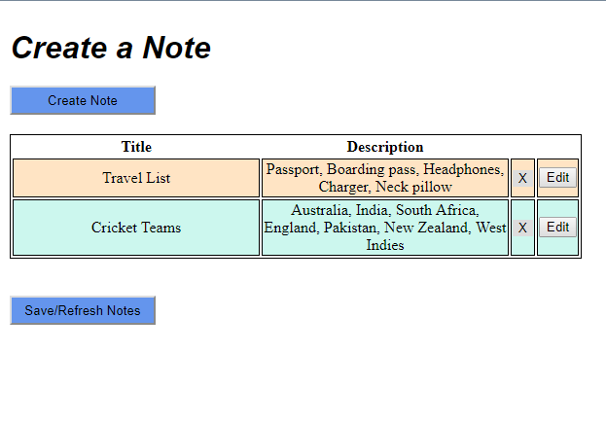

Click on ‘Edit’ for Cricket teams note:

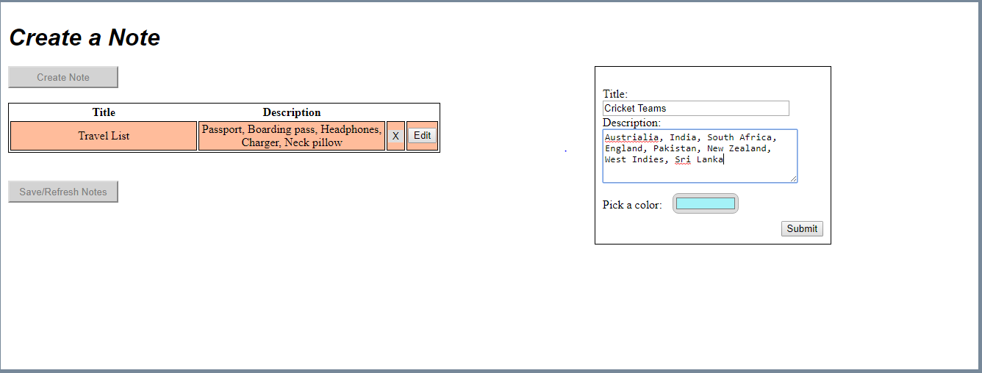

Click ‘Submit’:

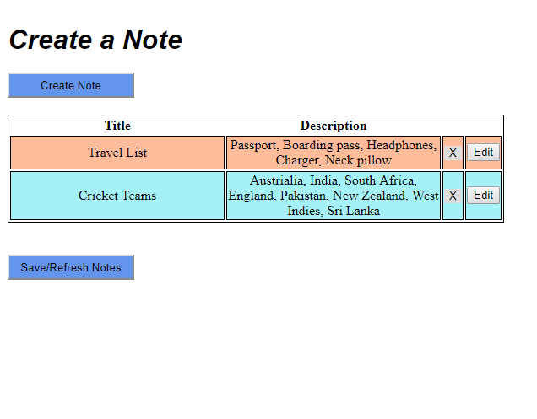

Click on ‘X’ for Cricket teams note:



Click Save/Refresh Notes:

