**Chapter 1: Introduction**

**1.1 Problem Statement: PS ID – SIH1702**

**Overview:** **Bail Reckoner aims to simplify the process of determining bail eligibility and preparing the necessary legal documents for bail application. Using AI models, the platform provides personalized drafts and predictions for various stakeholders in the legal system.**

* Bail Reckoner is a digital platform designed to make the process of applying for bail easier and more efficient. It helps users—such as lawyers, legal aid providers, and even individuals representing themselves—understand if someone is eligible for bail.
* Traditionally, determining bail eligibility and preparing the required documents can be complex, time-consuming, and dependent on legal expertise. Bail Reckoner uses artificial intelligence to analyze each case and offer tailored predictions on bail outcomes.
* The platform goes a step further by automatically generating personalized legal drafts needed for bail applications. This saves time and ensures that the documents are accurate and appropriately formatted.
* It considers various factors like the nature of the offense, past criminal record, and case specifics to provide relevant insights. By offering this support, Bail Reckoner helps improve access to justice, especially for those who might not have immediate access to legal counsel. It ultimately empowers stakeholders across the legal system to make informed, data-driven decisions.
* **Why we choice this Problem Statement**
* We choose the **Bail Reckoner** as our problem statement because the current bail determination process can be **complex, time-consuming, and prone to inconsistencies.**
* In many cases, defendants face unfair bail amounts due to subjective assessments or lack of proper consideration of factors such as their financial situation, past criminal record, and the nature of the offense.
* This solution promotes judicial efficiency, ensures justice is accessible to all, and reduces human errors or biases in the bail-setting process.
  1. **Project Objectives**

The primary objectives of the **Bail Reckoner** project are as follows:

* **The objective is to develop an innovative digital solution, termed the "Bail Reckoner," designed to assist undertrial prisoners, legal aid providers, and judicial authorities in streamlining the bail process.**

1. **Simplify Bail Processes**: To streamline and simplify the complex legal procedures involved in bail applications, making them more accessible to legal practitioners and the general public.
2. **AI-Powered Eligibility Assessment**: To leverage artificial intelligence models for accurately assessing bail eligibility based on case-specific factors such as charges, criminal history, and court precedents.
3. **Generate Personalized Legal Drafts**: To provide automated, customized bail application drafts that meet legal standards and reduce manual drafting efforts.
4. **Improve Access to Justice**: To support underrepresented or self-represented individuals by offering easy-to-use tools for navigating the bail process effectively.
5. **Enhance Decision-Making**: To assist lawyers, judges, and legal aid workers with data-driven predictions and recommendations to make fair and informed decisions.
6. **Reduce Delays and Workload**: To decrease the administrative burden on courts and legal professionals by automating repetitive tasks and documentation.
7. **Ensure Legal Accuracy and Compliance**: To ensure that the documents and suggestions provided align with current legal frameworks and regional judicial practices.
8. **Offer Stakeholder-Specific Solutions**: To tailor the platform's outputs and features to the distinct needs of various legal system stakeholders, including defense attorneys, judges, and legal aid workers.
9. **Promote Transparency and Consistency**: To provide a standardized and unbiased approach to evaluating bail applications, thus promoting consistency in legal outcomes.
10. **Continual Learning and Adaptation**: To enable the AI system to improve over time by learning from new legal data, feedback, and evolving legal norms.
    1. **Applications**

The **Bail Reckoner** platform has a wide range of practical applications within the legal system, particularly in areas where efficiency, accuracy, and accessibility are crucial. Some key applications include:

1. **For Lawyers and Legal Practitioners**
   * Quickly assess a client’s bail eligibility.
   * Generate accurate and customized bail application drafts.
   * Save time on legal research and documentation.
2. **For Judges and Magistrates**
   * Use AI-backed insights to make informed bail decisions.
   * Access a standardized, unbiased view of the case and risk factors.
3. **For Legal Aid Organizations and NGOs**
   * Help underprivileged individuals navigate the bail process.
   * Reduce dependency on overburdened legal aid systems through automation.
4. **For Law Students and Trainees**
   * Serve as a learning tool to understand real-life bail scenarios.
   * Practice drafting legal documents using case simulations.
5. **For Self-Represented Litigants**
   * Guide individuals who cannot afford legal representation through the bail application process.
   * Provide easy-to-understand, step-by-step support.
6. **For Court Administration**
   * Automate document intake and processing.
   * Reduce the backlog of bail applications and hearings.
7. **For Policymakers and Legal Researchers**
   * Analyze trends and outcomes in bail decisions using aggregated data.
   * Support legal reform and policy development with data insights.
8. **Integration with Case Management Systems**
   * Seamlessly integrate with digital court and legal record systems for faster case processing.



**Chapter 2: Literature Survey**

**2.1 Background**

* The bail process is a critical component of the criminal justice system, particularly for undertrial prisoners who await trial while in custody. However, this process often faces challenges such as delays, lack of transparency, and inconsistent application of legal provisions. These issues can lead to prolonged detention of individuals who may otherwise be eligible for bail, disproportionately affecting vulnerable and marginalized populations.
* **Bail Reckoner** is a digital solution designed to address these challenges by streamlining and enhancing the bail process for undertrial prisoners, legal aid providers, and judicial authorities. Leveraging AI-driven risk assessment models and integrated legal frameworks, the Bail Reckoner facilitates informed, consistent, and timely bail decisions. By providing data-backed insights and aligning with statutory guidelines, it aims to reduce unnecessary pretrial detention, support legal aid efforts, and improve overall efficiency within the justice system.
* This initiative represents a significant step toward a more equitable and technologically empowered legal process, ensuring that the right to bail is accessible, fair, and efficiently administered.

**2.2 Existing Systems (Study of Research Papers)**

|  |  |  |  |  |
| --- | --- | --- | --- | --- |
| **S. No.** | **Title / Concept** | **Author(s) / Source** | **Key Contributions** | **Relevance to Bail Reckoner** |
| 1 | **Responsibility Gap in AI** | Matthias (2004) | Introduced the concept that AI’s autonomy creates a gap in moral/legal responsibility | Highlights a foundational issue the Bail Reckoner must address when using AI decision-making |
| 2 | **COMPAS Algorithm** | Angwin et al. (ProPublica, 2016) | Exposed racial bias and fairness issues in AI-assisted bail decisions | Basis for using transparent, fair, and explainable AI in bail tools |
| 3 | **Pluralistic Theories of Responsibility** | Shoemaker (2011), Van de Poel (2011) | Differentiated moral responsibility into categories like task, obligation, blame, etc. | Supports the Bail Reckoner’s need to address multiple responsibility dimensions |
| 4 | **Explainable AI (XAI)** | DARPA XAI Program, Floridi et al. | Promotes the use of interpretable AI models in high-stakes areas like law | Underlines the need for interpretable algorithms in the Bail Reckoner |
| 5 | **Public Perception Studies on AI Responsibility** | Lima, Grgić-Hlača, Cha (2021) | Empirical study showing how people assign responsibility to AI vs humans in bail settings | Informs how users might trust or question AI in the Bail Reckoner system |
| 6 | **Path Model of Blame** | Malle et al. | Suggests blame is based on causality and intentions | Guides how the system should present AI actions and outcomes to avoid undue blame |
| 7 | **Techno-Responsibility Gap Debate** | Danaher, Bryson, Beck | Discusses ethical and legal implications of assigning blame to AI | Reinforces the need for human oversight and accountability layers in the tool |

**Chapter 3: Methodology**

**3.1 Hardware and Software Requirment**

* **Hardware Requirment**

|  |  |
| --- | --- |
| **Component** | **Specification** |
| Processor | Intel i3 or AMD equivalent |
| RAM | 8 GB |
| Storage | 256 GB SSD |

### ****Processor: Intel i3 or AMD equivalent :-****

* A CPU that handles all major tasks and runs the system efficiently.  
  Intel i3 or similar AMD processors are good for basic to moderate workloads.

### ****RAM: 8 GB :-****

* RAM (Random Access Memory) helps your computer run multiple applications 8 GB is enough for general development, browsing, and multitasking.

### ****Storage: 256 GB SSD :-****

* An SSD (Solid State Drive) provides fast data access and boot times.  
  256 GB gives sufficient space for OS, tools, and essential project files.
* **Software Requirment**

|  |  |
| --- | --- |
| **Category** | **Specification** |
| Operating System | Windows 11 |
| Frontend Technologies | Next.js (React + TypeScript), Tailwind CSS |
| Backend Language | Python(Flask) |
| Dataset | undertrial_prisoner.csv , legal_aid_provider.csv , judicial_authority.csv |
| IDE | VSCode |

### ****Operating System: Windows 11****

* A modern operating system by Microsoft with a user-friendly interface.Used for running software and managing hardware resources.

### ****Frontend Technologies: Next.js (React + TypeScript), Tailwind CSS****

* **Next.js** is a React framework for building fast web apps with server-siderendering.**Tailwind CSS** provides utility classes for rapid UI design.

### ****Backend Language: Python (Flask)****

* **Python** is a versatile and easy-to-read programming language.  
  **Flask** is a lightweight web framework for building backend services and APIs.

### ****Dataset:undertrial_prisoner.csv,legal_aid_provider.csv, judicial_authority.csv****

* These CSV files contain structured data used for analysis or applicationfeatures. They likely include legal or judicial information such as prisoner details or legal aid providers.
* **Visual Studio Code** is a lightweight, powerful code editor by Microsoft.It supports extensions, debugging, and multiple programming languages.

**3.2 System Design (Block Diagram)**

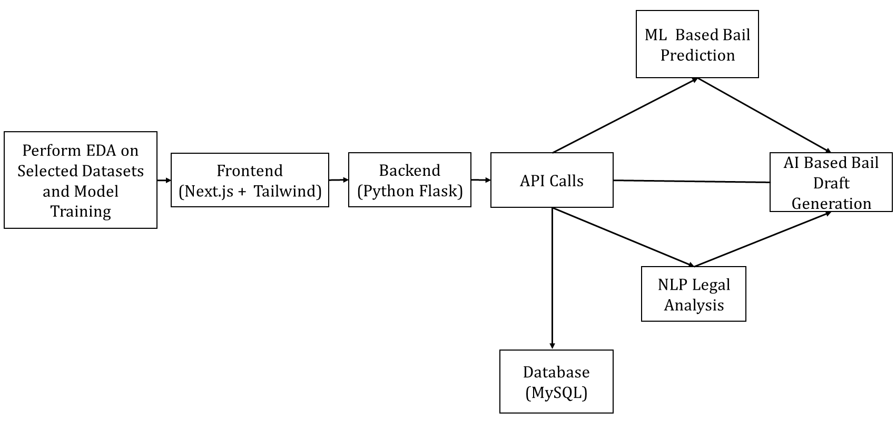

1. **Perform EDA on Selected Datasets and Model Training**  
   → Analyze datasets and train machine learning models for predictions.
2. **Frontend (Next.js + Tailwind)**  
   → User-facing interface built with React and styled using Tailwind CSS.
3. **Backend (Python Flask)**  
   → Handles business logic, API endpoints, and communication with ML/NLP modules.
4. **API Calls**  
   → Facilitates data exchange between frontend, backend, ML models, and database.
5. **ML Based Bail Prediction**  
   → Predicts bail eligibility using trained machine learning algorithms.
6. **AI Based Bail Draft Generation**  
   → Automatically creates a draft of a bail application using AI.
7. **NLP Legal Analysis**  
   → Analyzes legal documents using Natural Language Processing techniques.
8. **Database (MySQL)**  
   → Stores structured data like user inputs, predictions, and bail drafts.

**3.3 Algorithm**

1. **Algorithm Workflow: Decision Tree**

To build a decision tree workflow for bail prediction, we need to:

1. **Define the target variable** :- Is bail granted (Yes/No)? If not available, we can define a threshold based on bail bond amount.
2. **Preprocess the data** :- Apply Preprocessing techniques on the datasets.
3. **Train a decision tree model** :- Fit a model using relevant features.
4. **Evaluate & interpret the tree** :- Visualize how decisions are made.
5. **Bail Eligibility Criteria for Prisoner:**
6. If Imprisonment Served ≤ 4.5 years → Bail Granted (YES) .
7. If Imprisonment Served > 4.5 years:
   * If Surety Bond > ₹29,894 → Bail Granted (YES)
   * If Surety Bond ≤ ₹29,894 → Bail Denied (NO)

**C..Final Bail Prediction Criteria for Judeg :**

1. **Award Bail – Grant Bail if:**
   * risk_score ≤ 2
   * offense_category is in [Petty Crimes, Non-Violent Offenses]
   * penalty_severity ≤ 100
2. **Deny Bail – Deny Bail if:**
   * risk_score > 5
   * offense_category is in [Violent Crimes, Terrorism, Organized Crime]
   * penalty_severity > 300

**3.4 Exploratory Data Analysis and Dataset Visualization**

* In this part, we focused on understanding and analyzing the dataset before moving on to model training. This process involved EDA (Exploratory Data Analysis) and visualization using Power BI to extract key insights.
* Dataset used : a(2).csv
* **Exploratory Data Analysis**
* Understand the distribution of **undertrial prisoner** data (age, gender, case type).
* Analyze **legal aid provider** availability across regions.
* Check for missing or inconsistent data in all datasets.
* Identify correlations (e.g., between case type and bail status).
* Prepare data for **ML models** and **NLP processing**.
* **Dataset Visualization in Power BI :**
* Bar Charts & Column Charts – For categorical data distribution
* Line Charts – To show trends over time
* Pie Charts & Donut Charts – For percentage-based analysis
* Geo Maps – For location-based insights
* Heatmaps & Scatter Plots – To explore correlations

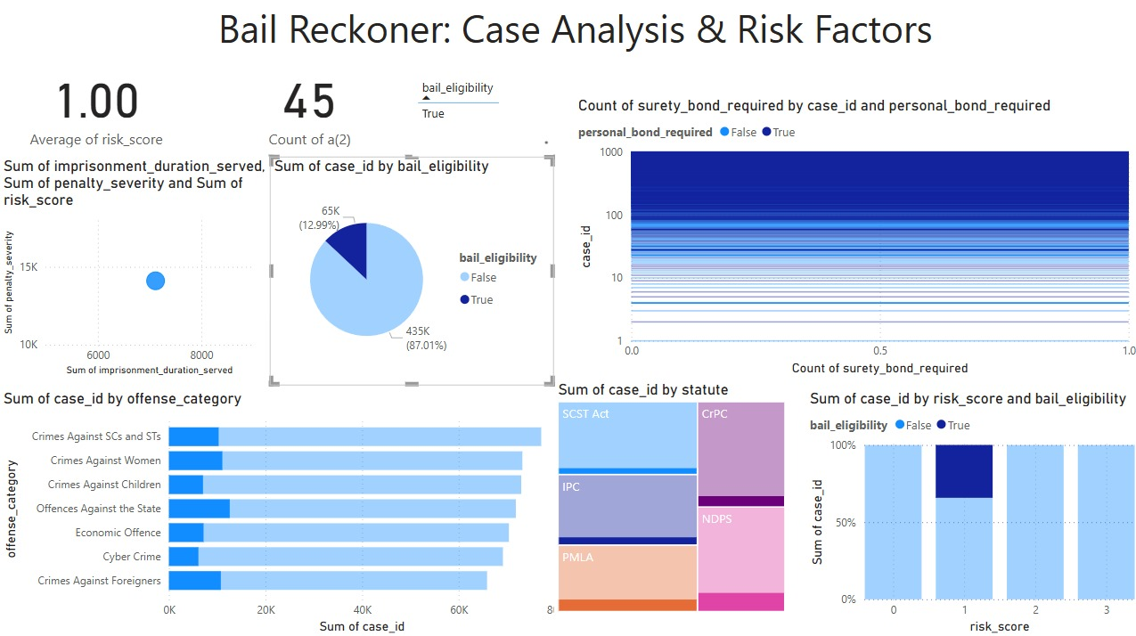

**Fig 1**:This Power BI dashboard titled "Bail Reckoner: Case Analysis & Risk Factors" presents insights into bail eligibility, risk scores, and case distributions across different legal factors.

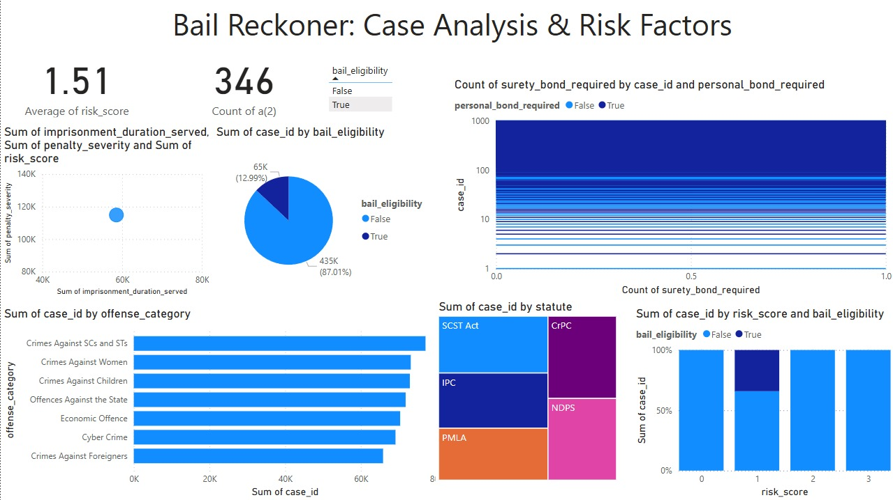

**Fig 2** : This dashboard helps in assessing bail decisions based on risk, offense type, and legal framework