**Step** **1**: Launch Three Instances in AWS

Create a pem key

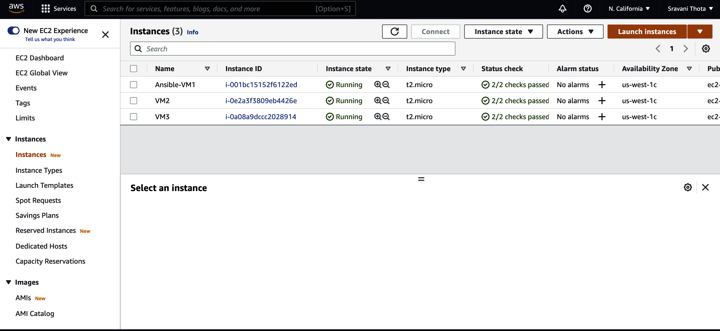

**Step 2:** Connect to virtual machines using ssh as follows:

Local host commands:

*ssh-keygen*

VM1 Commands:

Copy the ssh key to VM2 :

*cat ~/.ssh/id_rsa.pub | ssh -I ~/.ssh/ansible-key.pem 54.219.103.238 “cat >> ~/.ssh/authorized_keys”*

Connect to VM2 :

*ssh -i "ansible-key.pem" 54.219.103.238*

Copy the ssh key to VM3 :

*cat ~/.ssh/id_rsa.pub | ssh -I ~/.ssh/ansible-key.pem 52.53.229.102 “cat >> ~/.ssh/authorized_keys”*

Connect to VM3:

*ssh -i "ansible-key.pem" 52.53.229.102*

S**tep 3:** Executed Ansible playbook on VM1 to deploy apache2 server to VM2 and VM3

*ansible-playbook ansible-webserver.yml*

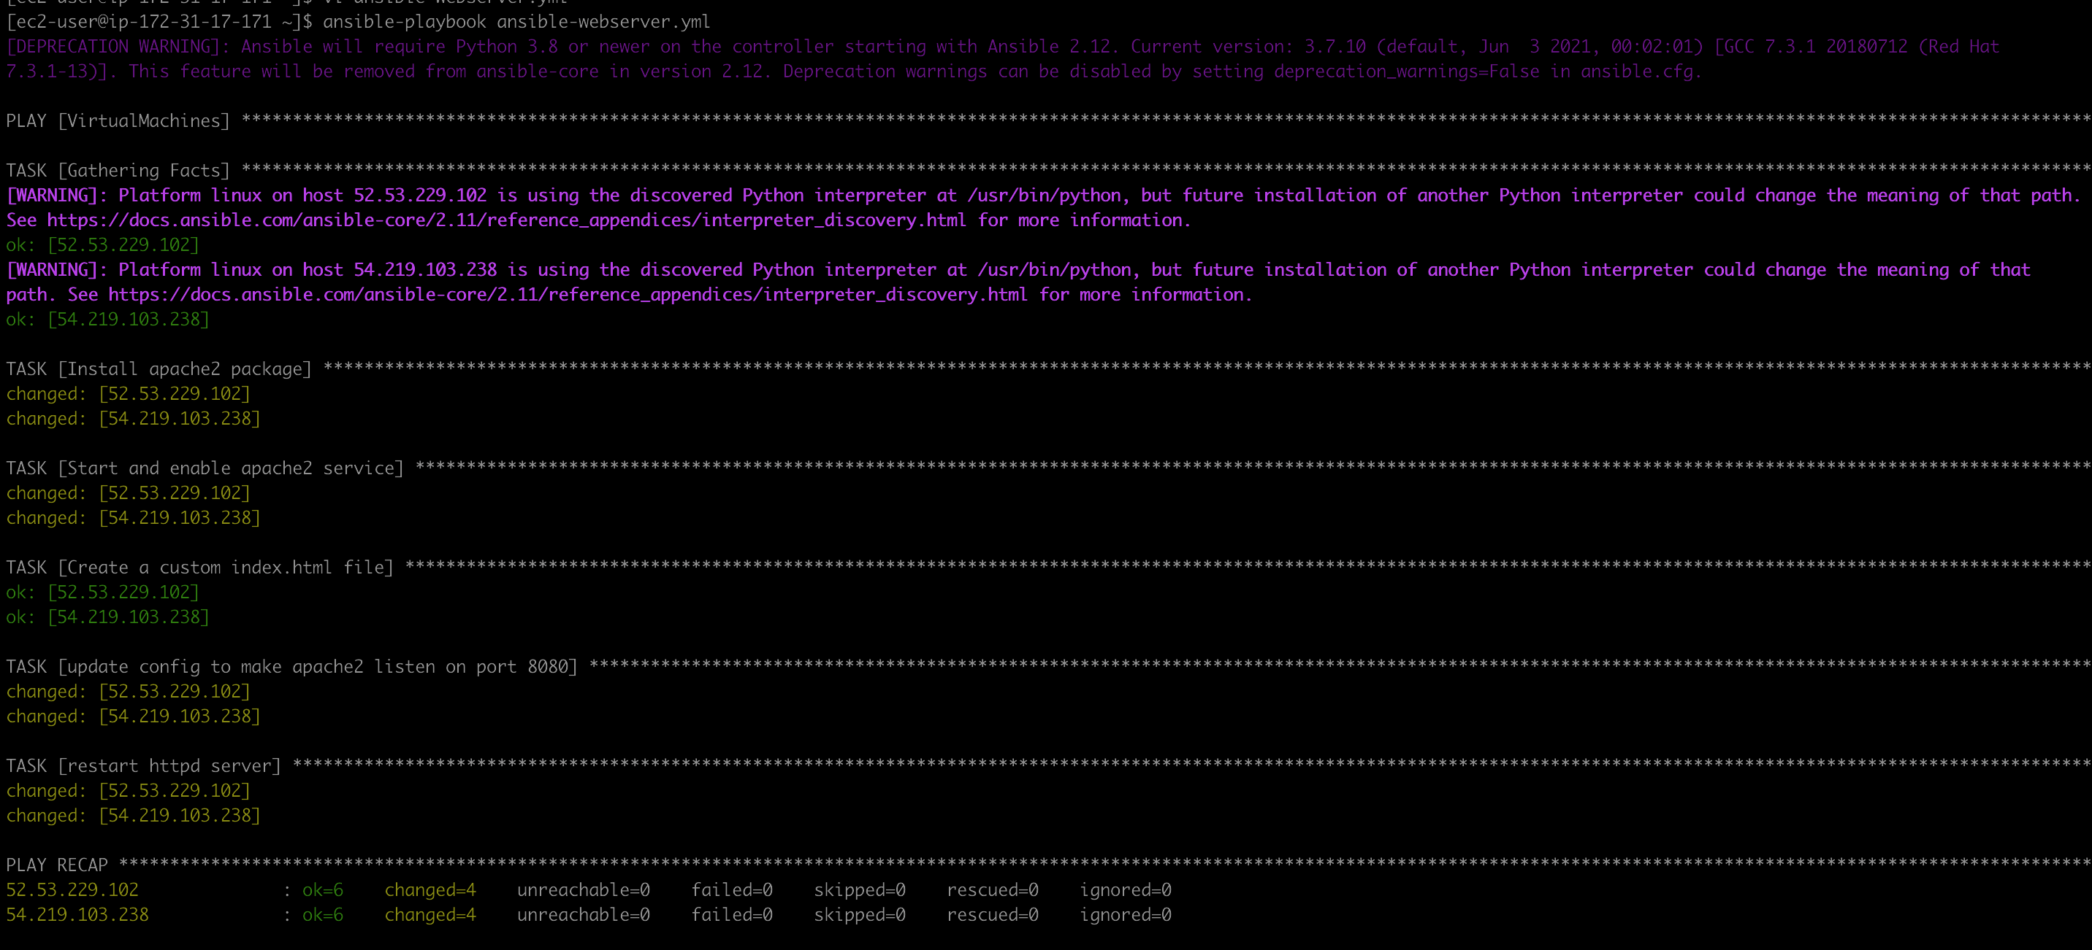

**Step 4**: Verify the Message on the configured port

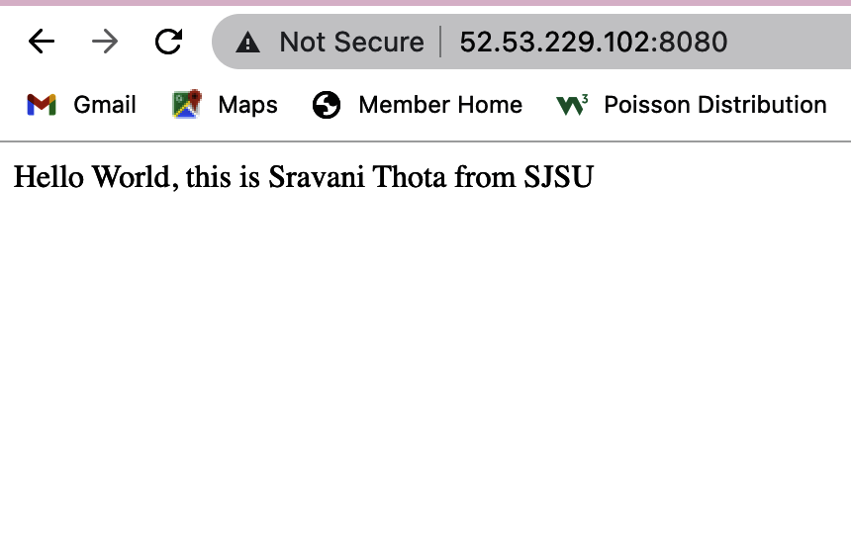

**Step 5**: Execute same ansible playbook to undeploy webserver

