**Cleaned Data**

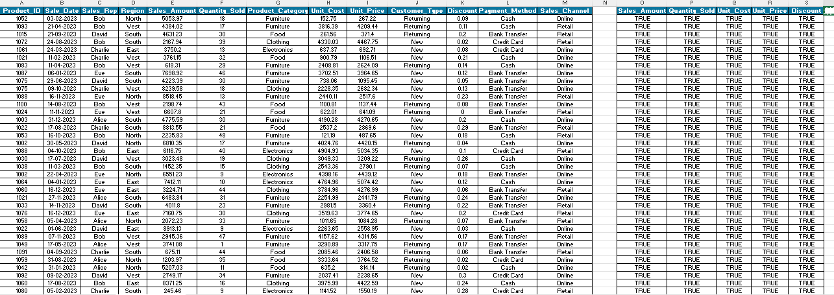

**Formulas**

**Pivot Analysis**

**LOOKUPS**

**Charts**

