**3. Create 2 models in the app for storing data of books and authors -- authors[first_name, last_name, email, books_count, average_rating] -- books[name, price, average_rating, count, author(foreign key)]**

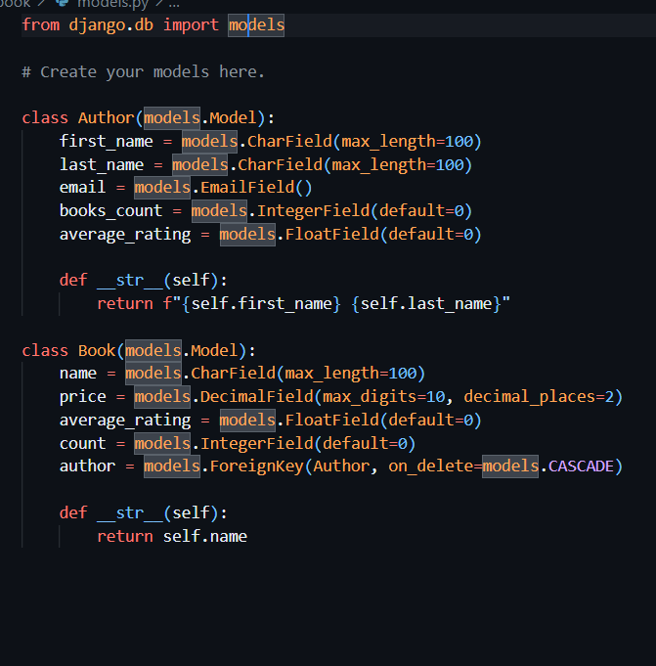

**4. Install django-extensions package and use shell_plus to run queries -- create 5 authors -- create 10 book**

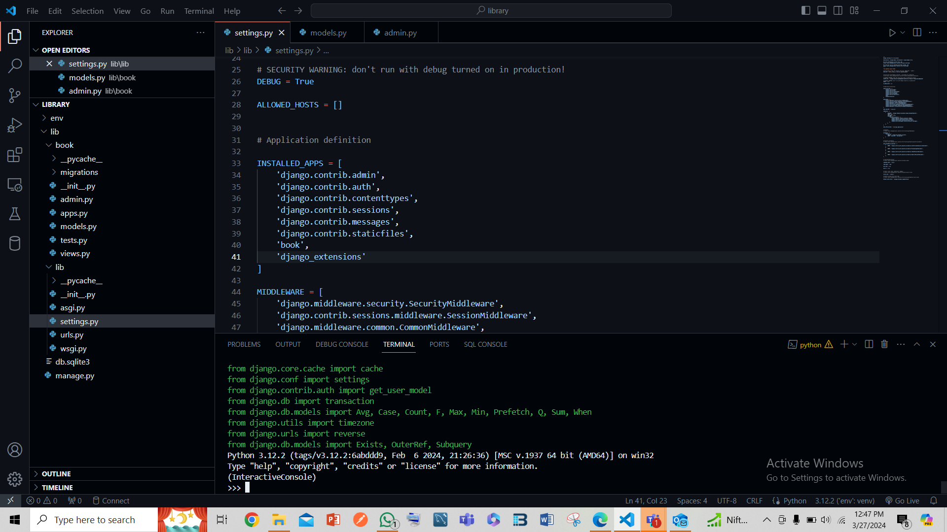

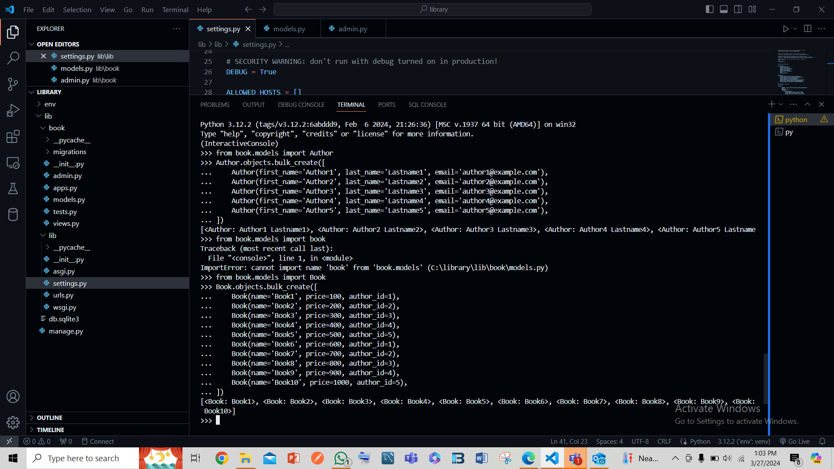

**-- filter and show some authors using first_name field**

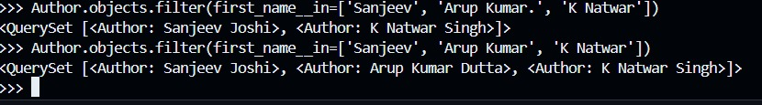

**-- filter and show some authors that does not have a last_name**

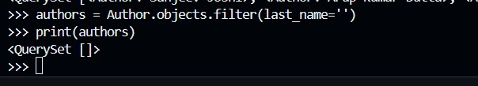

**-- filter and show some authors that have books count greater than 10**

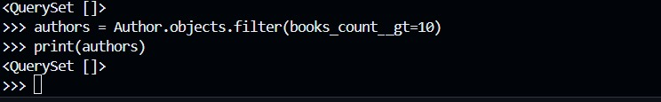

**-- filter and show some authors that have an average rating less than or equal to 3**

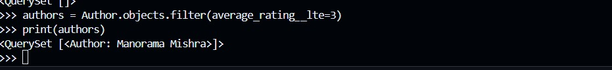

**-- filter and show some books that have price less than or equal to 500**



**-- filter and show some books that have price greater than or equal to 700**

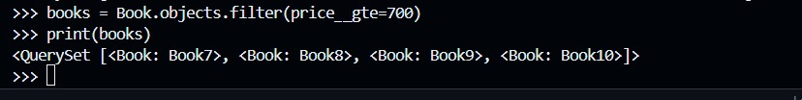

**-- filter and show some books that has an average rating greater than 3**



**-- filter and show some books that has count greater than 100**

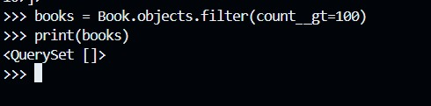

**-- filter some books that has price greater than 500 and show the names of all one by one along with its** **price and author's first name**

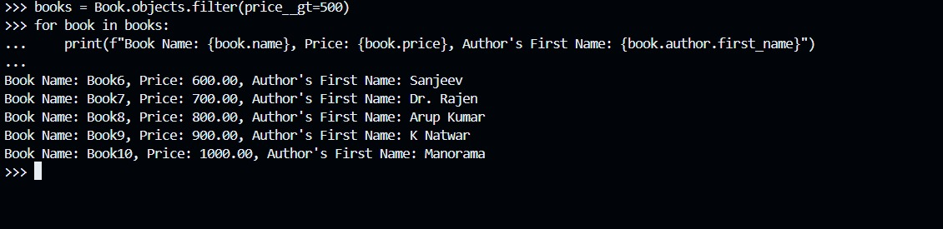

**-- fetch the first book and show its name**

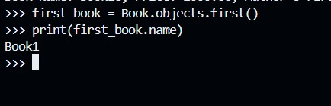

**-- fetch the last book and show its authors full name**

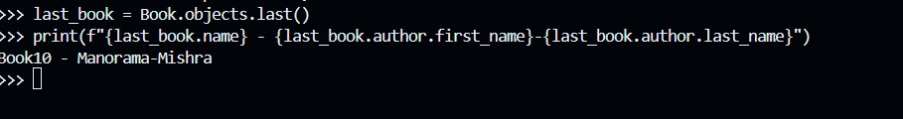

**-- fetch a book using its id, show its name and author's full name**

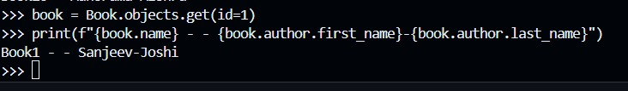

**-- show the total count of books and authors**

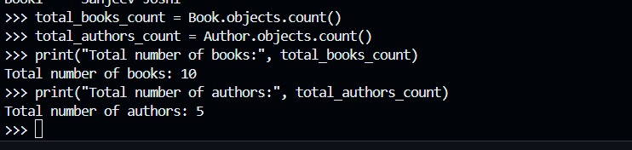

**-- fetch a book by its id and update the author and save**

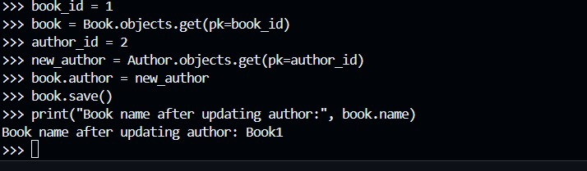

**-- show the total count of authors**

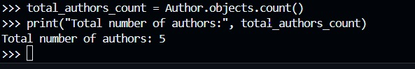

**-- show the count of authors that has an average rating greater than or equal to 3**

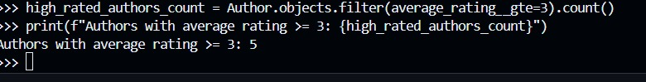

**-- check whether an author exists in the table using email field**

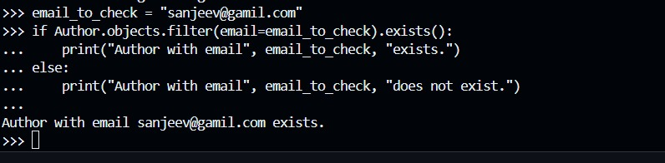

**-- check whether a book exists in the table with its name**

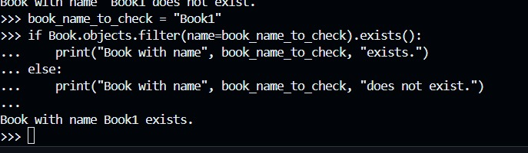

**-- show all the books in the order of its name**

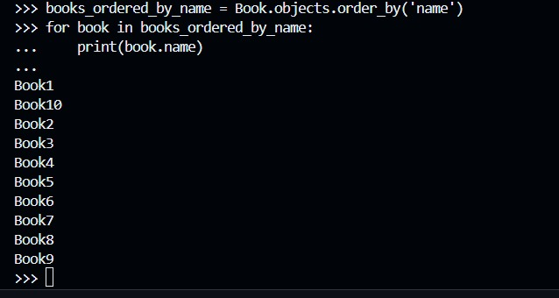

**-- delete 2 books from the table after fetching it with name**

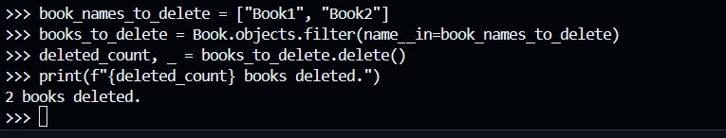

**-- update the books count value after fetching a book using its name**

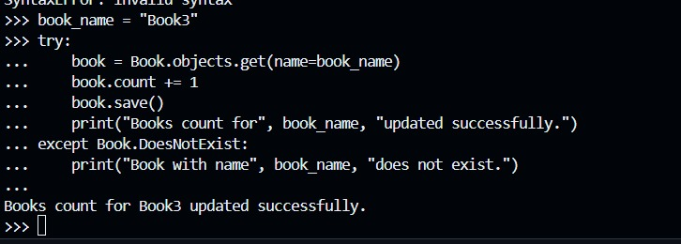

**-- filter and show the name of books that has books count less than or equal to 20**

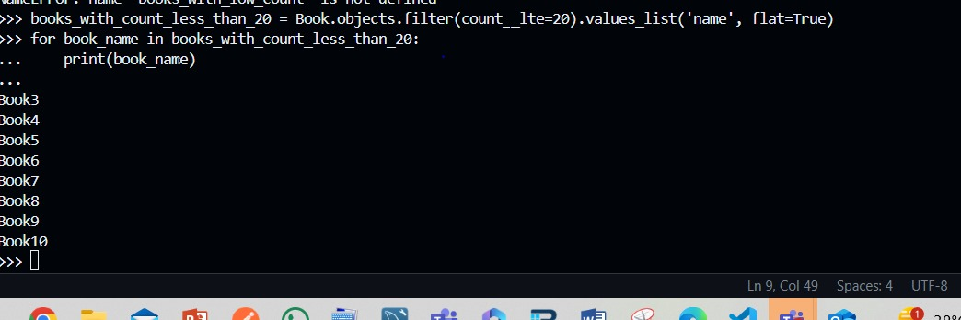

**-- show all the authors that has first name starting wth "a"**

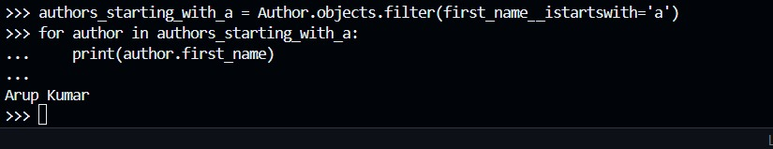

**-- show all the authors that contains "d" in the first name**

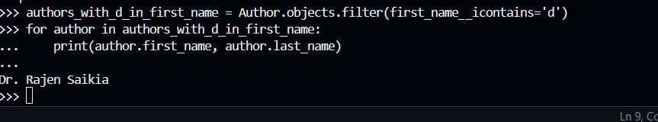

**-- delete the books that has book count 0**

