**. Using the shell plus and the django project you created before, run these queries to:**

**-- fetch all the objects from the book table and use annotate to add book_name to show name of the book. Show only book_name and price in list of dictionaries**

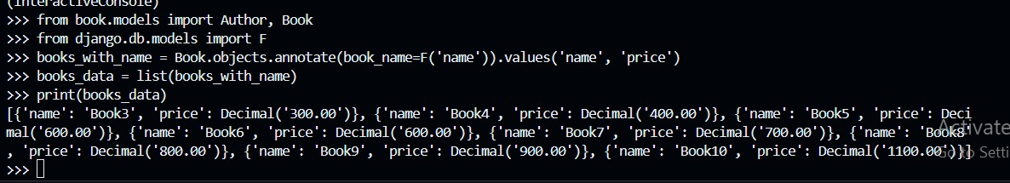

**-- fetch all the authors and use annotate to set full name and show the list of full name of the authors**

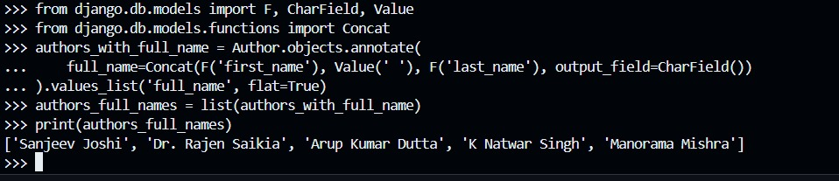

**-- show the count of authors that has an average rating greater than or equal to 4 using aggregate**

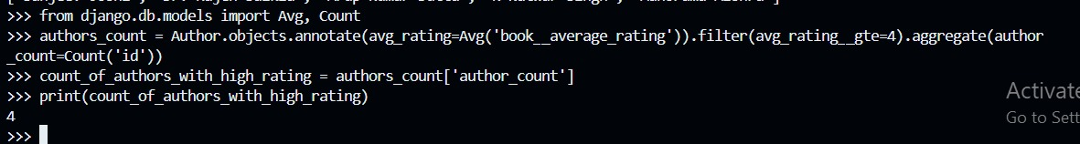

**-- fetch all the books and add a field to store discount using annotate, the book with an averate rating less than or equal to 3 should have a discount of 20% and all others should have 0% discount. Add another variable to store the actual price of that book after discount by using annotate. Show the books name, discount, actual price in a list of dictionaries**

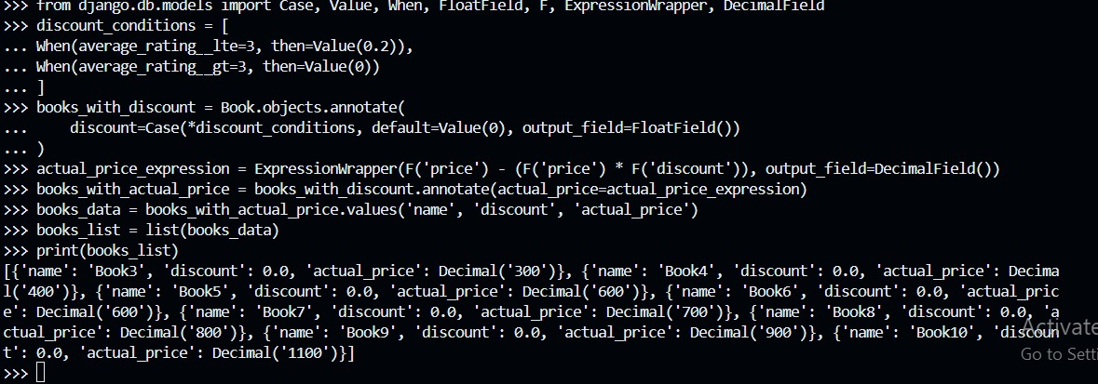

**-- fetch all the authors and their books count that has average rating greater than or equal to 3 using subquery and annotate. Show the first name of author and books count as a list of dictionaries**

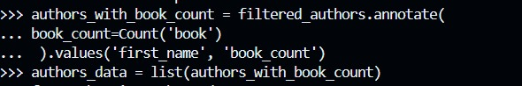

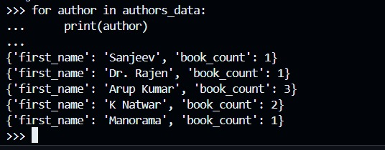

**-- fetch all the books which are from one of the authors, filter using first name**

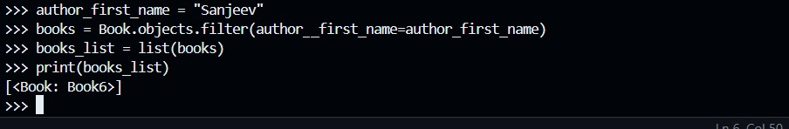

**-- fetch all the authors along with their books**

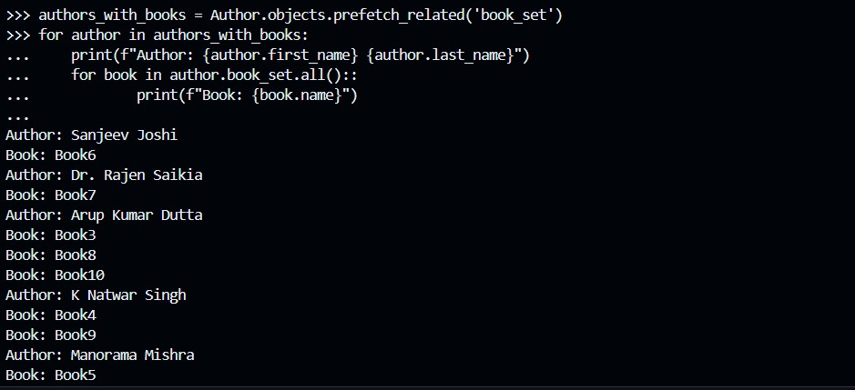

**-- fetch all the authors and use subquery to fetch count of the books, show the full name and count of the books in a list of dictionary format**

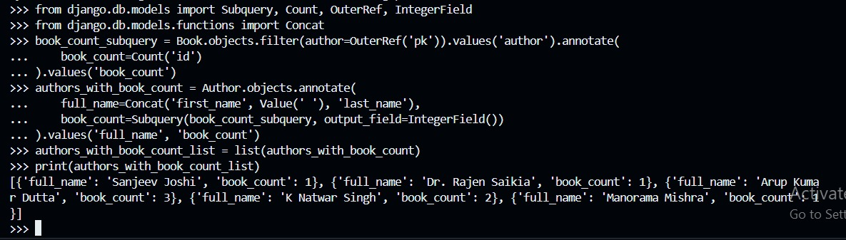

**-- fetch an object from books table and update its count and save it**

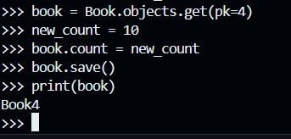

**-- fetch an object from authors table with select for update and atomic transaction to update the average rating and save it**

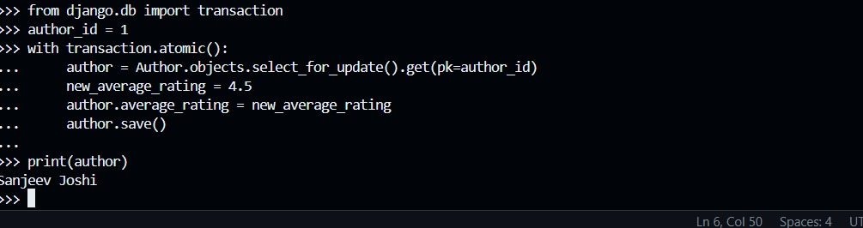

**-- fetch all the objects from book table and show the name, average rating, full name of author of the books in a list of dictionary format**

