1. **Create an API for updating records,using PUT and PATCH.**

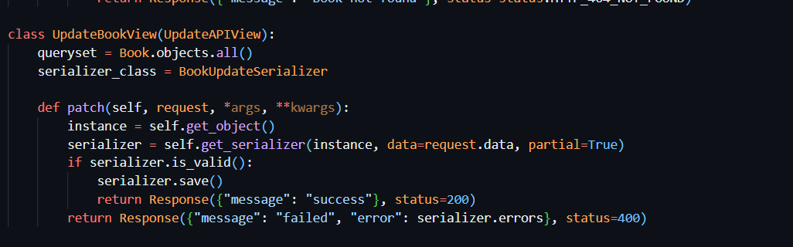

**PUT:**

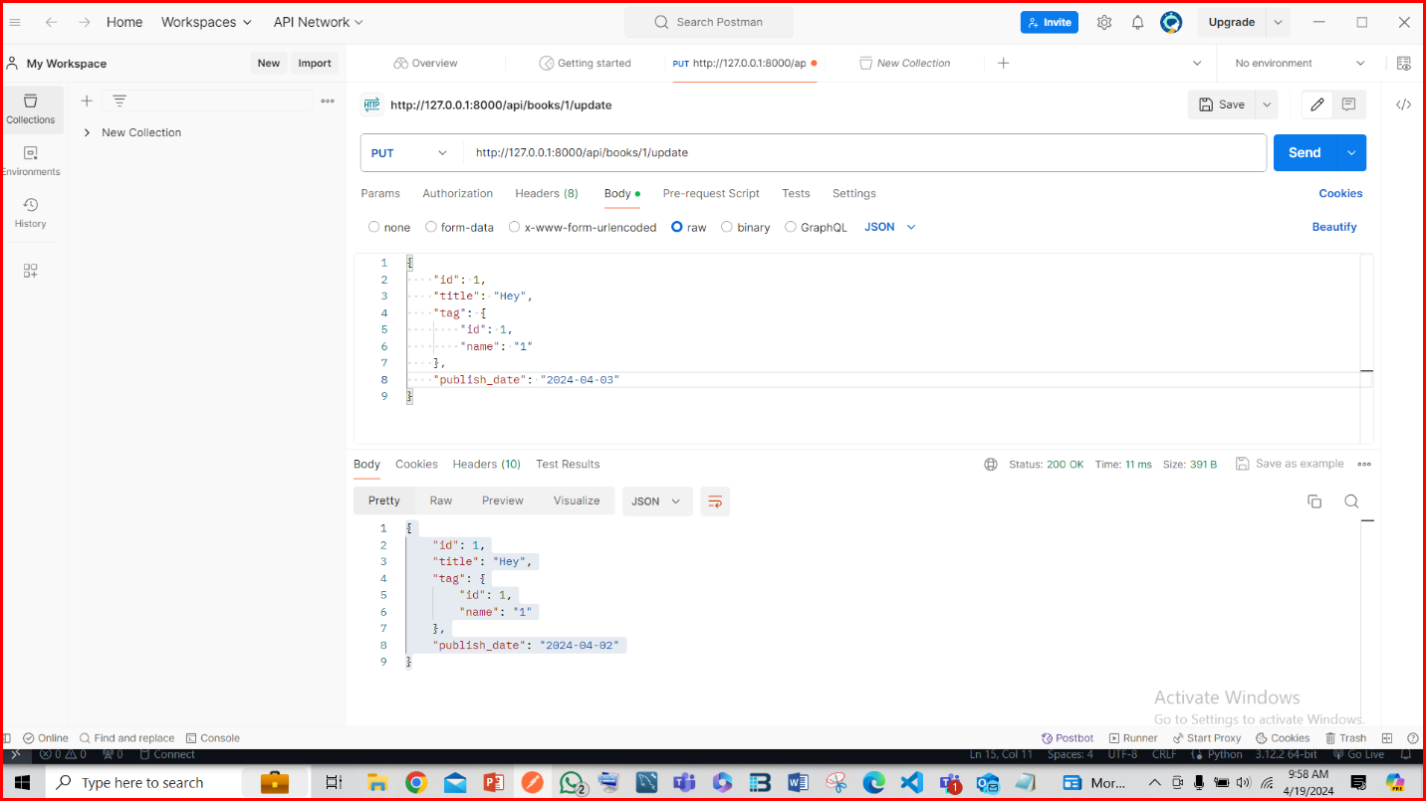

**PATCH:**

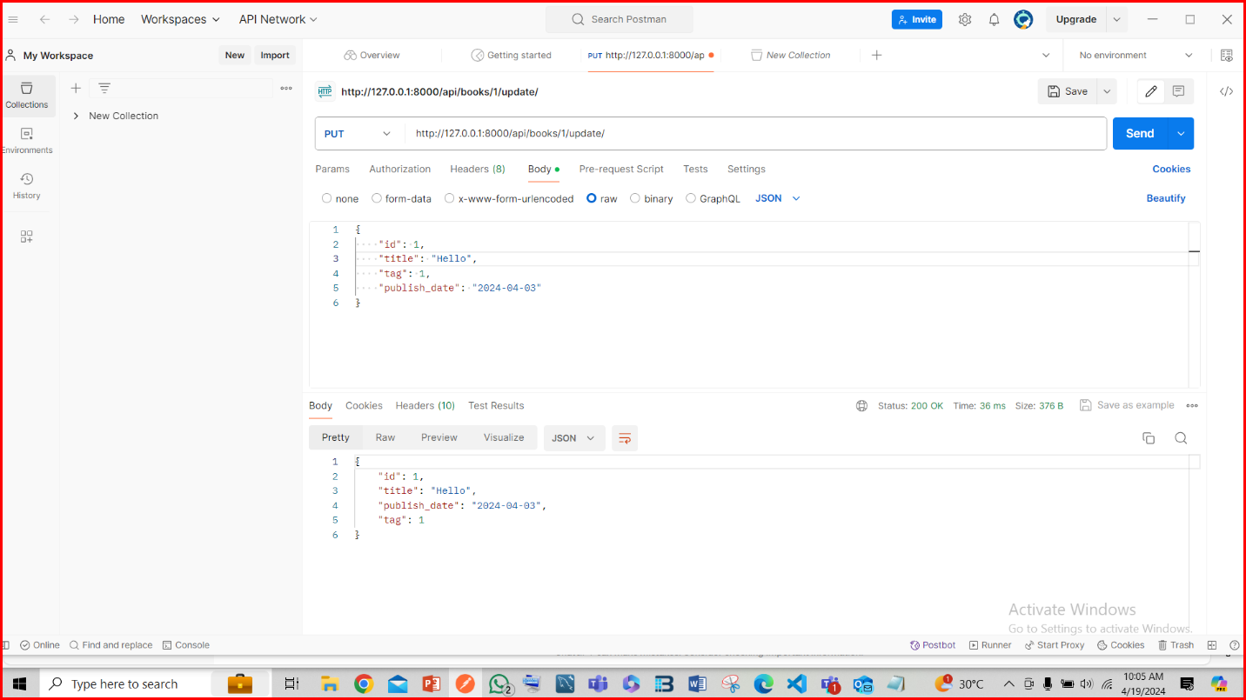

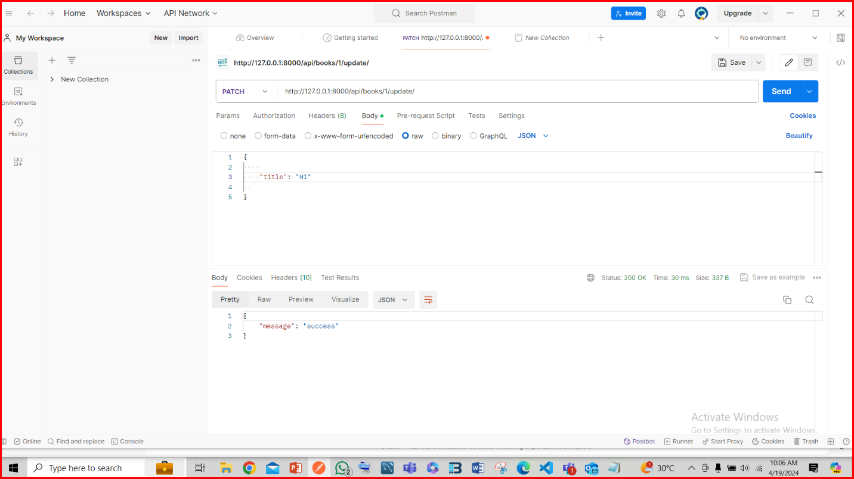

1. **Create an API for deleting records with custom error messages.**

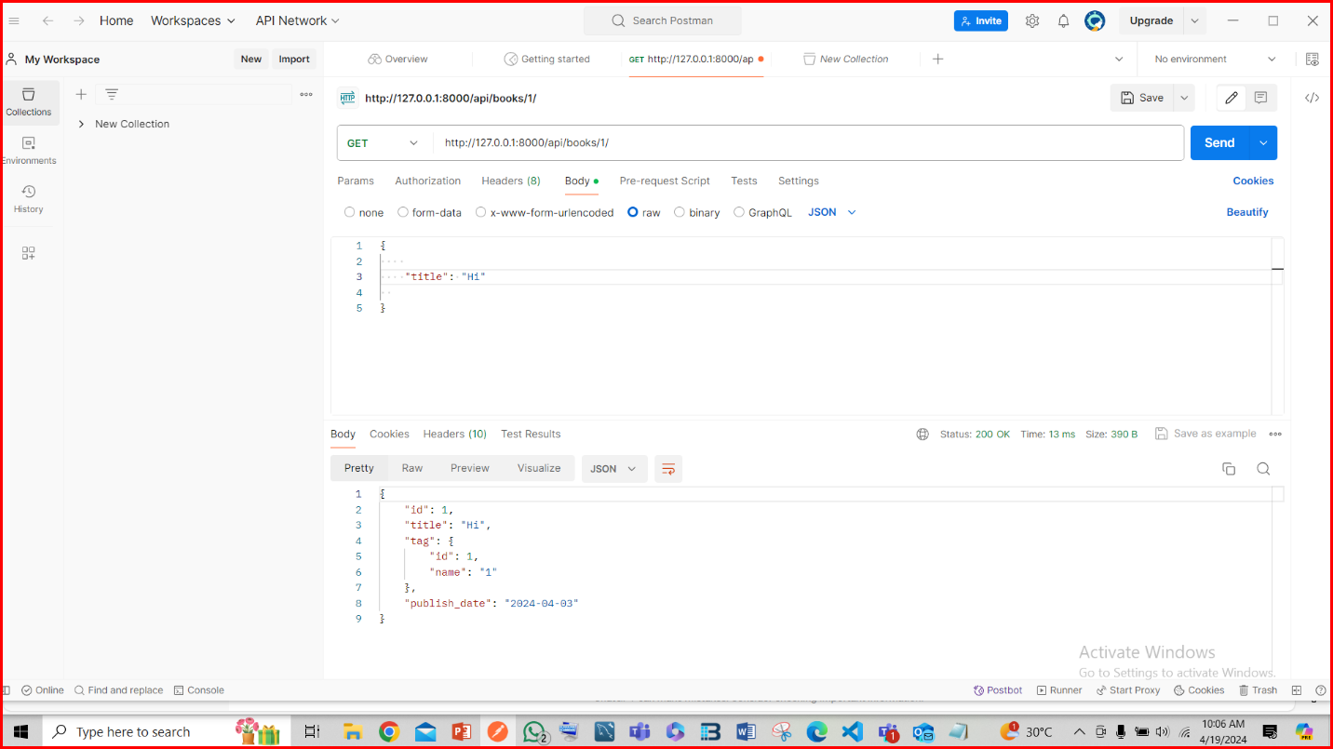

**AFTER DELETE:**

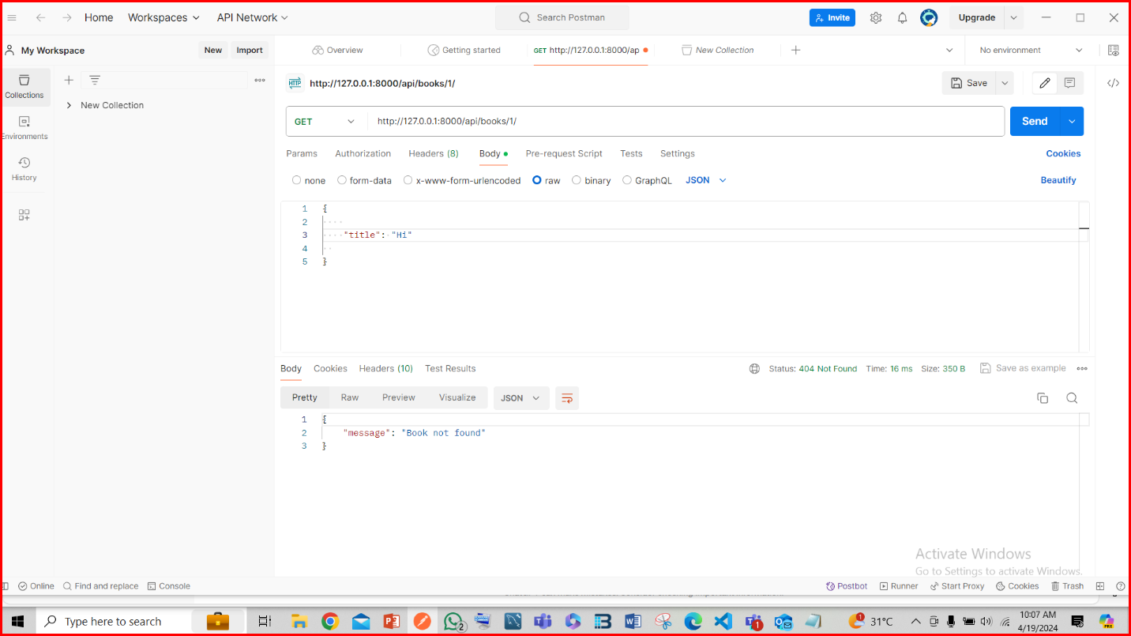

**3. Create an API for bulk deletion.**

**BULK DELETE:**

