1. **Create a virtual environment and install django in it - attach a screen shot**

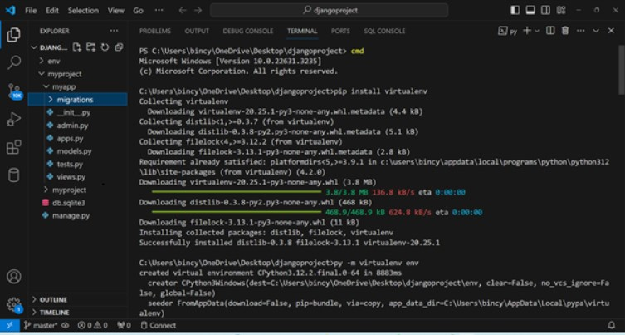

1. **Create a django project and app , explain the files of the project and app folders**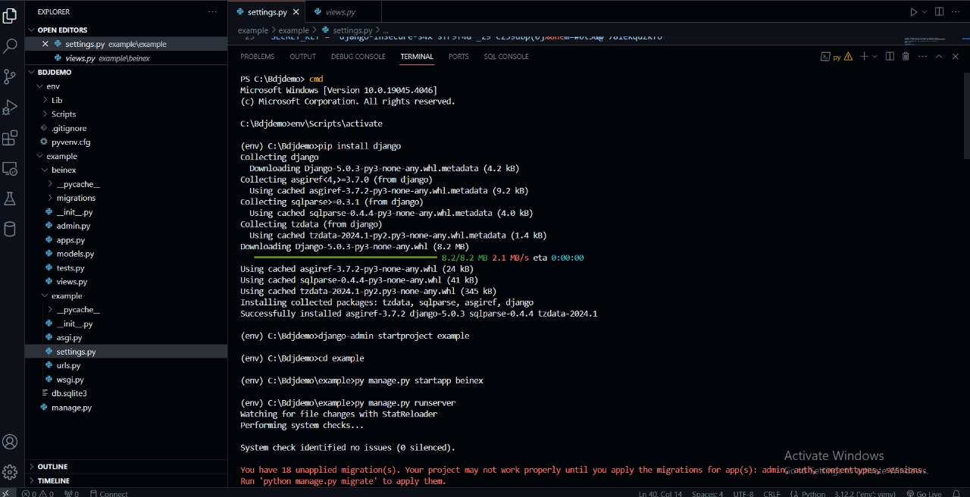

**myproject/:** This is the main directory of our Django project. Inside this directory, we can find the following files and directories:

* **manage.py:** This is a command-line utility that allows you to interact with our Django project. We can use it for various tasks like running development server, creating migrations, etc.
* **myproject/:** This is the inner directory with the same name as our project. It contains the settings and configurations for our Django project.

**__init__.py:** This file tells Python that this directory should be considered a Python package

* **settings.py:** This file contains all the settings for our Django project, such as database configuration, static files, middleware, etc.
* **urls.py:** This file contains the URL patterns for our project.
* **wsgi.py:** This is the entry-point for WSGI-compatible web servers to serve our Django application.
* **asgi.py:** Entry-point for ASGI-compatible servers to serve the project asynchronously.

**myapp/:** This is the directory of our Django app.

* **__init__.py:** This file tells Python that this directory should be considered a Python package.
* **admin.py:** This file is where we register our models to make them accessible via Django's admin interface.
* **apps.py:** This file contains configuration for the app.
* **models.py:** This is where you define our database models using Django's ORM (Object-Relational Mapper).
* **tests.py:** This file is for writing unit tests for our app.
* **views.py:** This is where you define the views (or controllers) for our app.

1. **Added new app to settings**

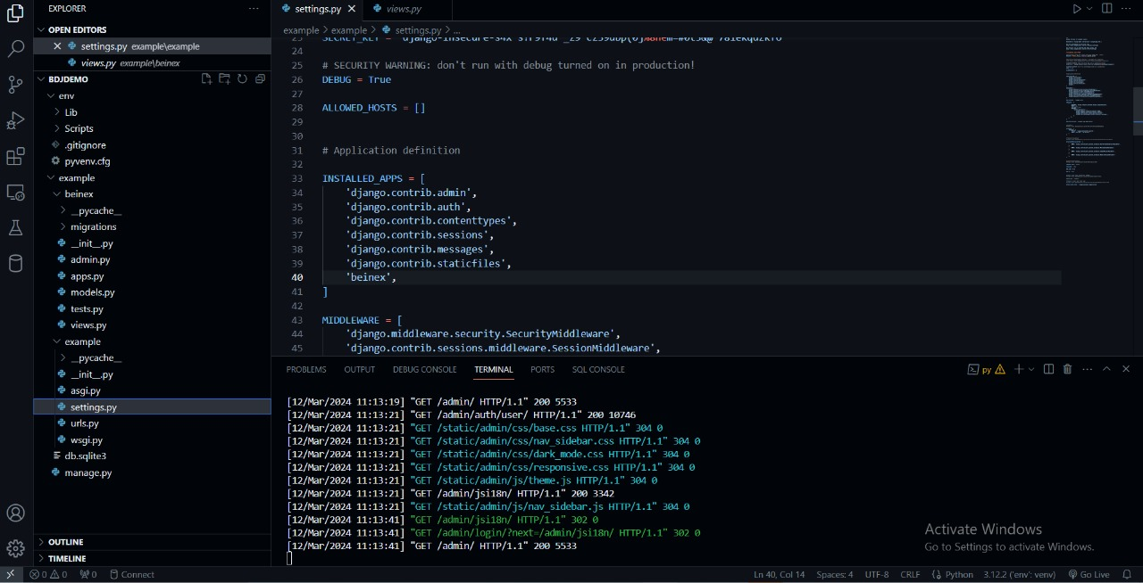

1. **Run the django project - attach screen shots of the django admin panel and SITE**

