1. **What are the key features of the Django Template language? And how do they contribute to its advantage in web development**

Key features of the Django Template language:

* **Simple Syntax**: Easy-to-read syntax using template tags {% %} and variables {{ }}.

* **Template Inheritance**: Allows for creating base templates with common elements and extending or overriding sections in child templates.

* **Template Filters**: Built-in filters for manipulating and formatting data directly within templates.

* **Template Tags**: Provides tags for logic, iteration, inclusion of other templates, and control flow within templates.

* **Template Context**: Access to a context containing variables and data passed from views to templates.

* **Security**: Automatic HTML escaping by default to prevent cross-site scripting attacks.

* **Integration with Django ORM**: Seamless integration with Django's Object-Relational Mapping system for displaying database objects in templates.

* **Extensibility**: Ability to create custom template tags, filters, and loaders to extend functionality as needed.

**2) Create a Django view using both function-based and class-based approaches. Utilize different Django Template Language (DTL) tags within these views.(attach screenshots of SITE)**

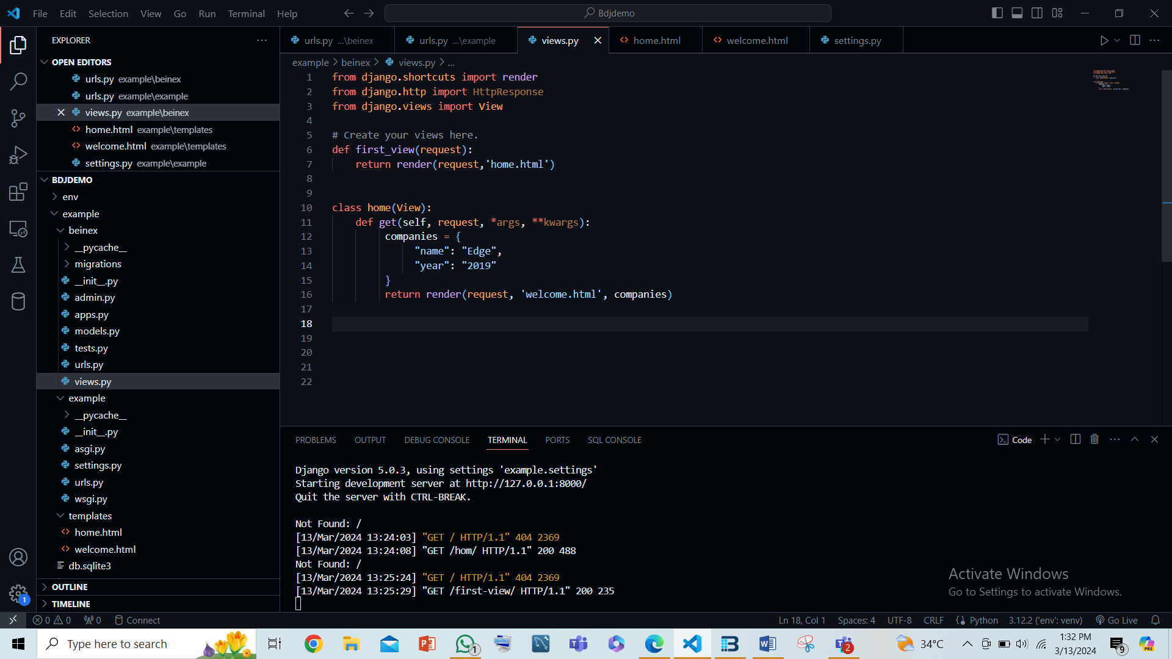

* 1. **Using function**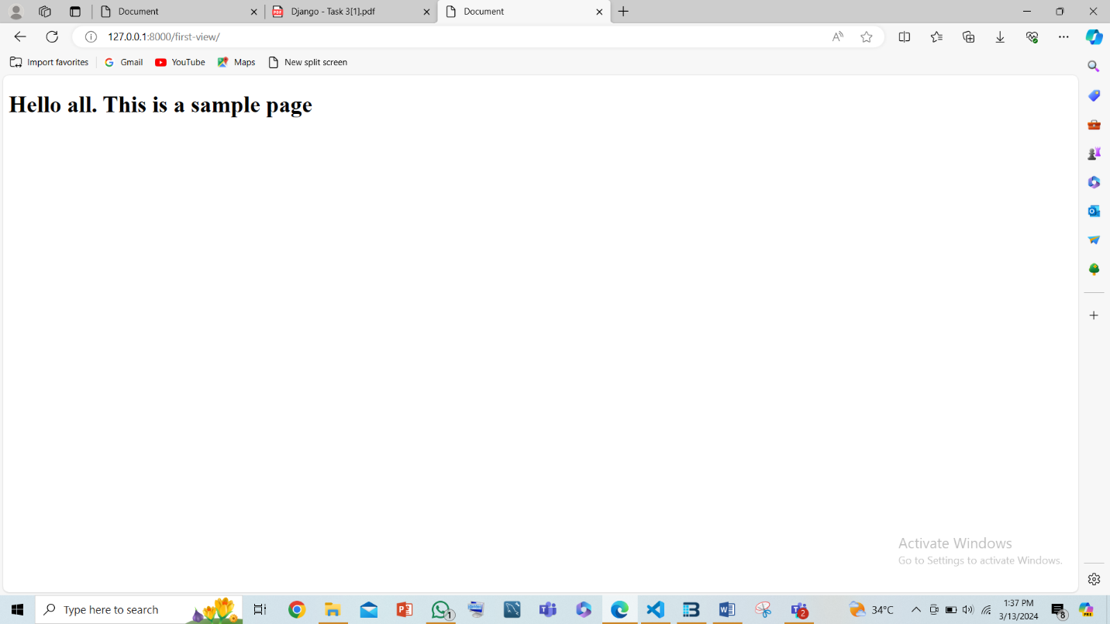
  2. **Using Class**

