

**Case Study No: 02**

## **TITLE:** Transformation of an Object in Computer Graphics: Mathematical Matrix Theory

## **SOFTWARE REQUIREMENTS:**

|  |  |  |
| --- | --- | --- |
| **Sr.No** | **Name of Software and Hardware** | **Latest Version** |
| 1 | Operating System | Windows 10 |
| 2 | CPU, RAM | 2500 MHz, 8 GB |

1. **Introduction to Transformations**

In computer graphics, transformations play a foundational role in controlling the position, size, orientation, and appearance of digital objects. Whether in 2D user interfaces or immersive 3D virtual worlds, transformations make it possible to animate characters, zoom into scenes, rotate cameras, and more. These operations are fundamental to enabling interactivity and realism in modern digital experiences.

1. **Types of 2D/3D Transformations**

Transformations are categorized as follows:

* **Translation:** Shifts an object from one location to another by adding displacement values along the X, Y (and Z in 3D) axes.
* **Scaling:** Alters an object’s size by stretching or shrinking it along one or more axes.
* **Rotation:** Turns an object around a fixed point or axis.
* **Reflection:** Creates a mirror image of the object across a defined line or plane.
* **Shearing:** Skews the shape of an object by displacing coordinates in one axis based on the other. Each of these transformations can be applied individually or in combination to achieve complex effects.

1. **Matrix Representation**

Transformations are mathematically represented using **matrices** in homogeneous coordinates. This approach allows us to consolidate translation, scaling, rotation, and other transformations into a single matrix operation.

For 2D transformations, a 3x3 matrix is used:

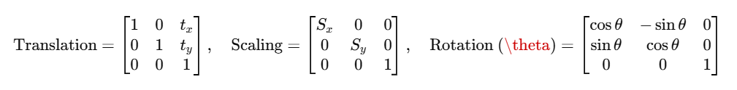

For 3D, similar transformations are extended using 4x4 matrices.

1. **Composite Transformations**

In real applications, multiple transformations are often combined. This is done by multiplying their matrices in a specific order (known as matrix composition). The **order is crucial**, as different sequences produce different results.

Example:

Composite transformations enable complex manipulations like rotating a scaled object about a shifted origin. Most rendering pipelines rely on this composite matrix to position objects in world or view space.

1. **Real-life Implementation**

In practice, transformation matrices are used extensively in:

* **OpenGL/WebGL:** Low-level APIs use matrix stacks to handle object, view, and projection transformations.
* **Game Engines (Unity, Unreal):** Provide built-in transformation systems for manipulating objects in 3D space with translation, rotation, and scale functions.
* **Web-based 3D tools (Three.js):** JavaScript libraries that implement transformation hierarchies for scene objects.

These systems leverage matrix math to allow users to create, animate, and render objects in real-time environments.

1. **Case Study Example: Scene Transformation in Unity**

In Unity, a 3D character may be animated using transformation matrices. When a player moves forward, a translation is applied. When turning, a rotation matrix is used. During an upgrade, the character might scale up. All these transformations are applied in sequence:

This final matrix is applied to the object’s mesh to update its position and orientation within the 3D scene. Unity internally handles these transformations using matrix multipliers in its rendering pipeline.

1. **Challenges and Optimization**

While transformation matrices are powerful, they come with challenges:

* **Floating-point errors** can accumulate over repeated operations.
* **Matrix stack management** is critical in APIs like OpenGL to maintain correct scene hierarchy.
* **Performance:** Applying many transformations per frame can be computationally intensive, so using precomputed composite matrices improves rendering efficiency.

Optimization strategies include:

* Using **hardware-accelerated transformations** via GPU shaders.
* Minimizing state changes by **batching draw calls**.
* Utilizing **scene graphs** to manage hierarchical transformations efficiently.

1. **Conclusion**

Transformations are the backbone of modern computer graphics. They allow for the creation of rich, interactive, and realistic scenes by controlling how objects appear and behave in space. With matrix theory at its core, transformation systems are integral to animation, modeling, simulation, and virtual experiences. A deep understanding of these concepts is essential for anyone working in graphics, gaming, or simulation-based fields