SQL_Assingment-12

Q.1--> Write a query that selects all customers whose ratings are equal to or greater than ANY of Serres’.

Ans -->
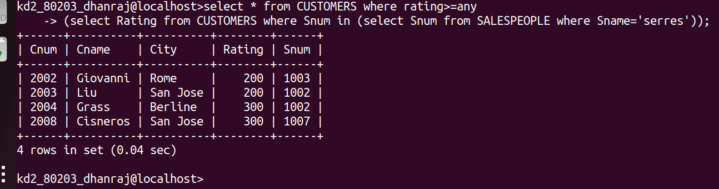

Q.2 -->Write a query using ANY or ALL that will find all salespeople who have no customers located in their city.

Ans -->
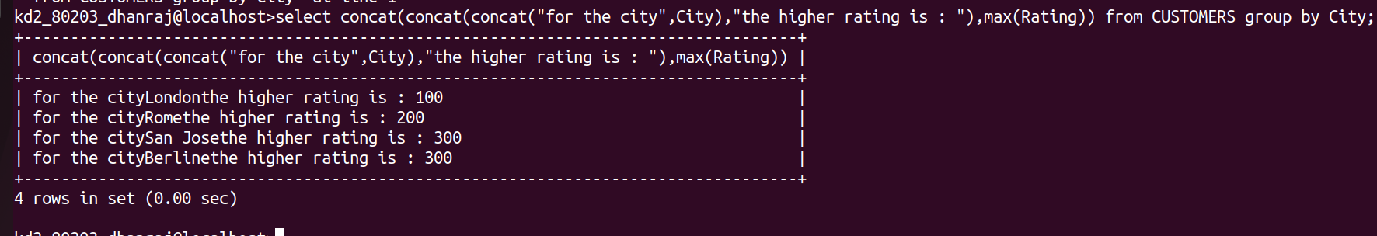

Q.3 --> Write a query that selects all orders for amounts greater than any for the customers in London.

Ans-->
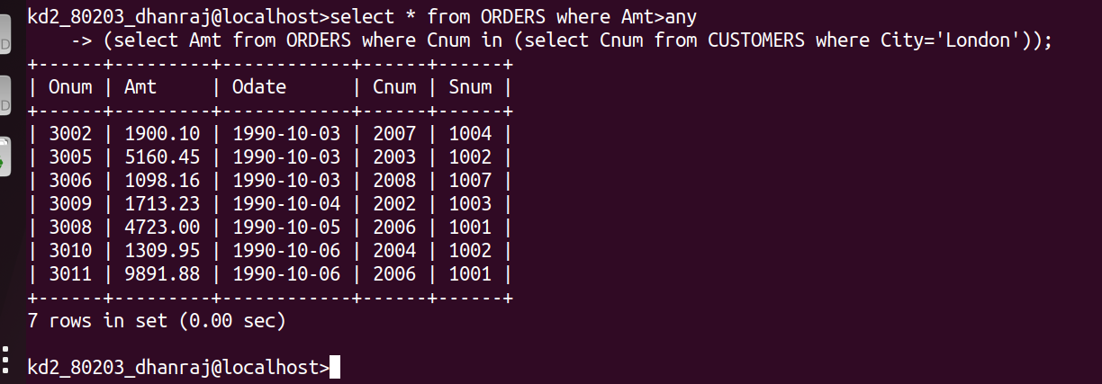

Q.4 --> Write the above query using MIN or MAX

Ans -->
