SQL_Assingment-6

Q.1--> Write two diff queries that would produce all
orders taken on october 3rd or 4th 1990 ?

Ans -->
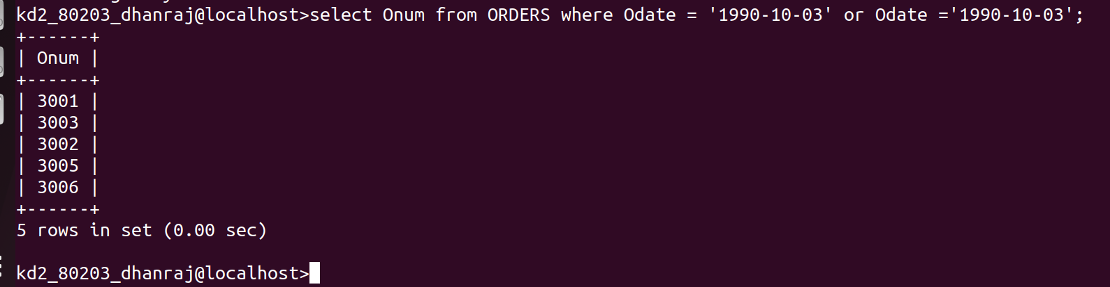
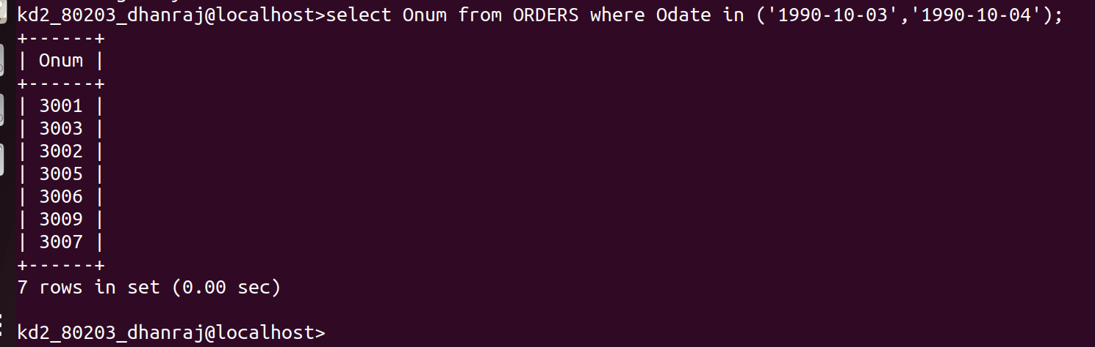

Q.2 --> Write a query that selects all of the customers serviced
by peel or motika. ?

Ans -->
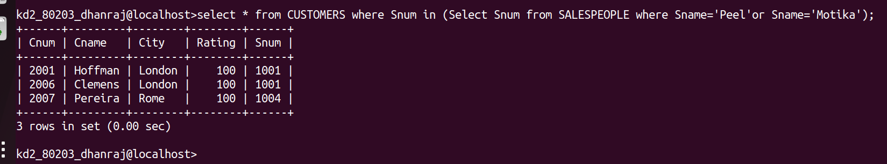
Q.3 --> Write a query that will produce all the customers whose names
begin with a letter from ‘A’ to ‘G’?

Ans-->
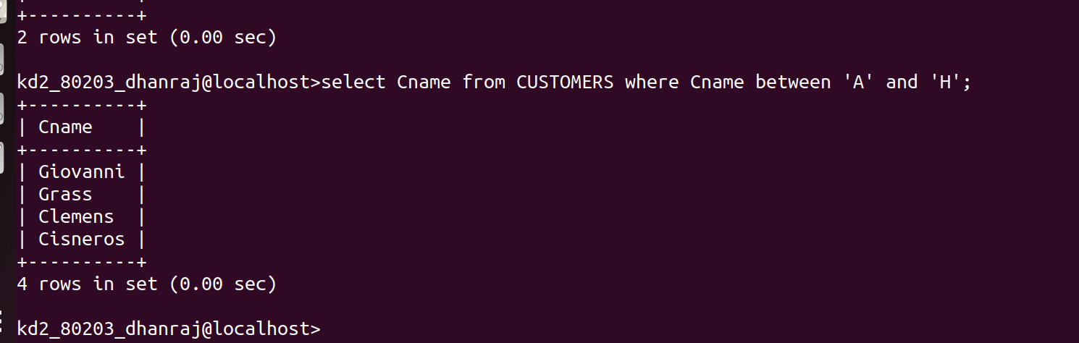

Q.4 --> Write a query that selects all customers whose names begin with
the letter ‘ c’?

Ans -->
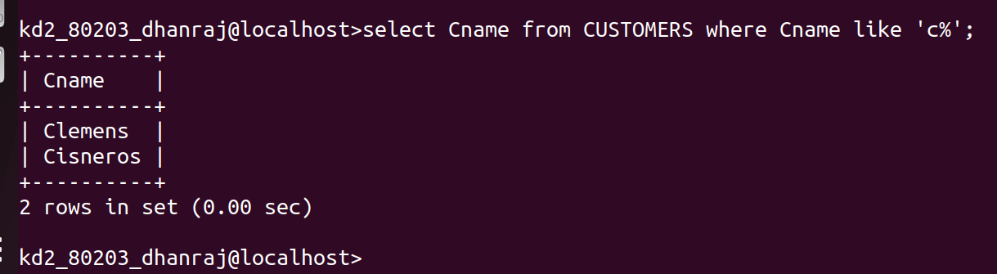

Q.5 --> Write a query that selects all Orders except those with zeroes or
NULL in the amt feild ?
Ans-->
