SQL_Assingment-5

Q.1--> Write a query that will give you all orders for more
than RS 1000 ?

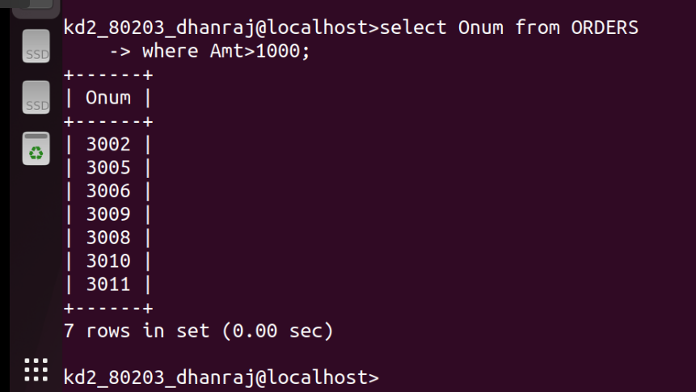
Ans -->

Q.2 --> Write a query that will give you the names and cities of
all salespeople in London with a commission above 0.10 ?

Ans -->
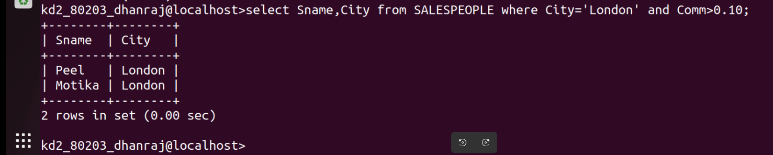

Q.3 --> Write a query on the customer table whose output will exclude
all customers with a rating <=100 , unless they are located in
Rome ?

Ans-->
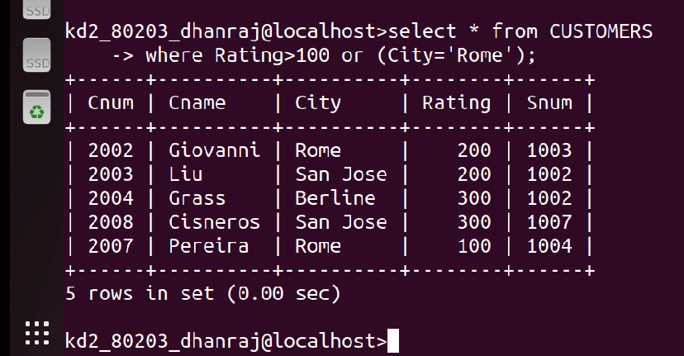

Q.4 --> What will be the output of following query ?

Select * from Orders
where (amt <1000 OR
NOT (odate =’1990-10-03’ AND cnum > 2003));

Ans -->
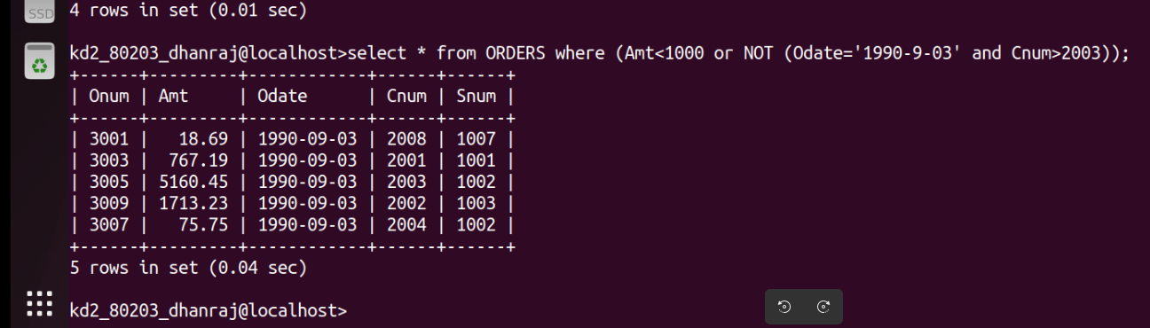

Q.5--> What will be the output of following query ?

Select * from Orders
where NOT ((odate = ‘1990-10-03’ OR snum > 1006)
AND amt >=1500);

Ans -->

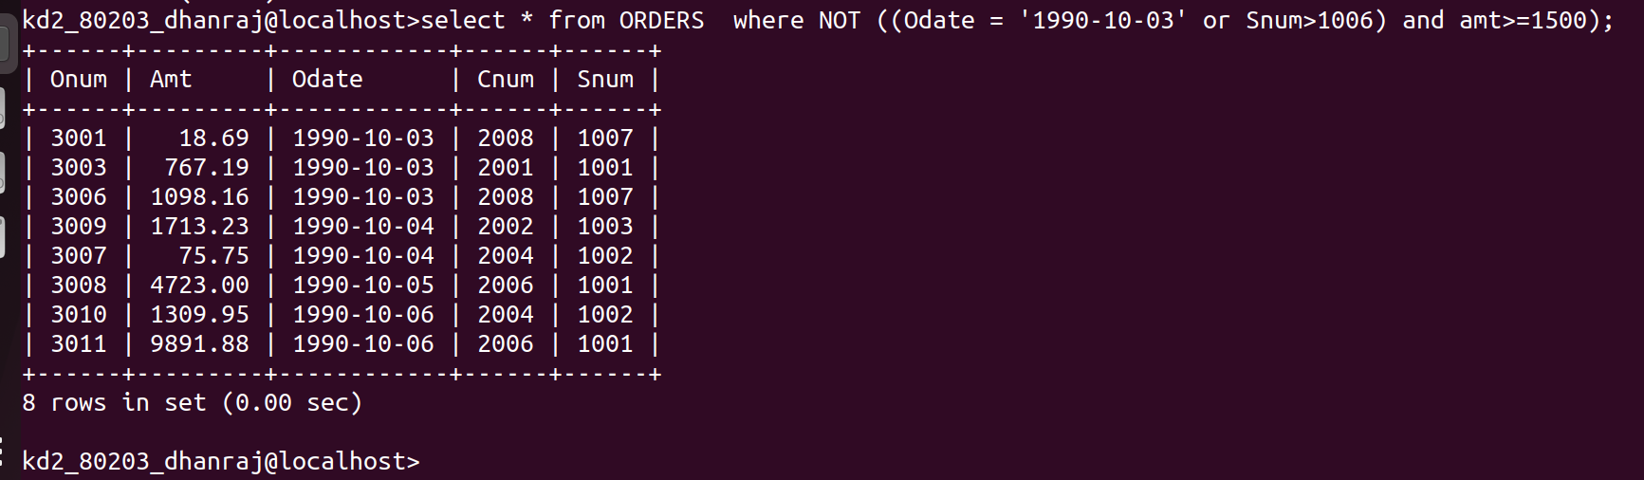

Q.6--> What is a simpler way to write this query ?

Select snum , sname , city , comm , from Salespeople
where (comm > 0.12 OR 0.14);
