SQL_Assingment-7

Q.1--> Write a query that counts all orders for October 3rd?

Ans -->

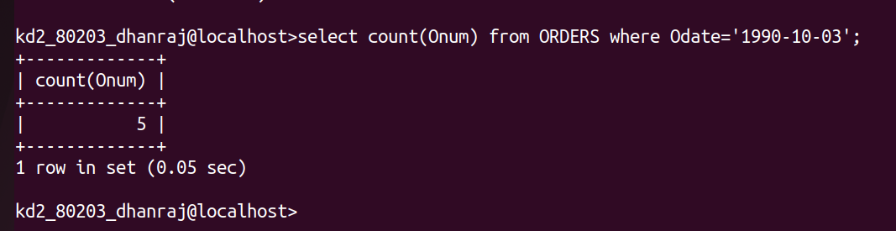

Q.2 --> Write a query that counts the number of different non-NULL
City values in the Customers table ?

Ans -->

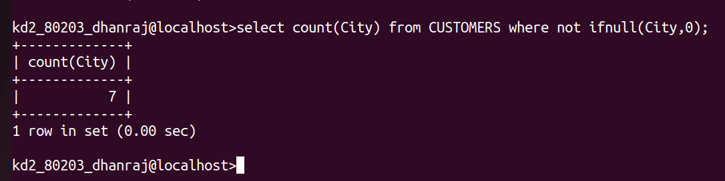

Q.3 --> Write a query that selects each customers’s smallest order ?

Ans-->
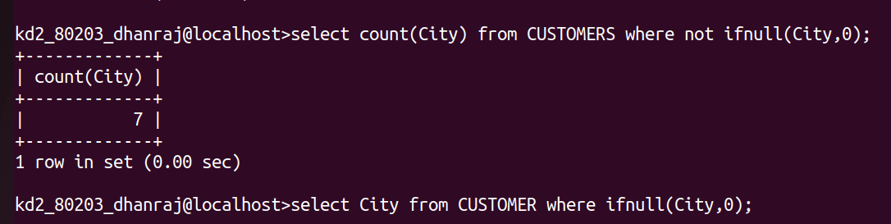

Q.4--> Write a query that selects all customers whosenames begin with . the letter ‘G’?

Ans-->
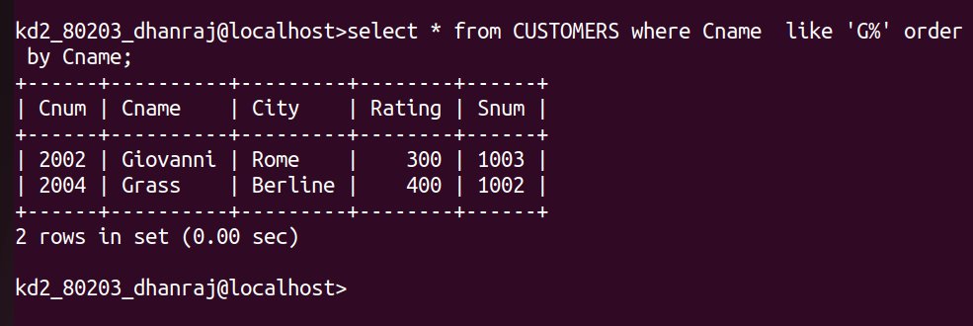

Q.5--> Write a query that selects the highest rating in each city.

Ans -->
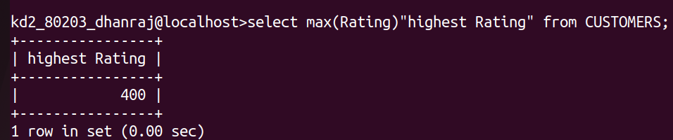

Q.6--> Write a query that counts the number of salespeople registering orders for each
day. (If a salesperson has more than one order on a given day, he or she should be
counted only once).

Ans -->
