SQL_Assingment-10

Q.1--> Write a query that produces all pairs of salespeople who are living in the same city.
Exclude combinations of salespeople with themselves as well as duplicate rows with the order reversed.

Ans -->
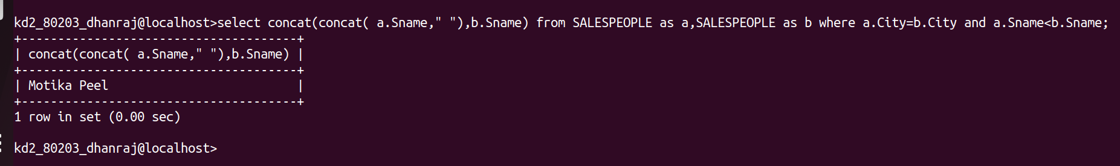

Q.2 -->Write a query that produces the names and cities of all customers with the same rating as Hoffman.
