SQL_Assingment-15

Q.1--> Assume there is a table called Multicust, with all of the same column definitionsas Salespeople. Write a command that inserts all salespeople with more than one
customer into this table.

Ans -->
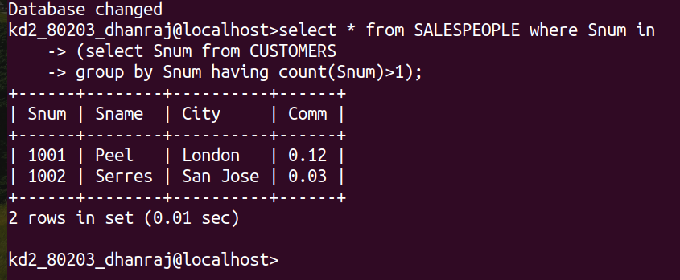

Q.2 -->Write a command that deletes all customers with no current orders.

Ans -->
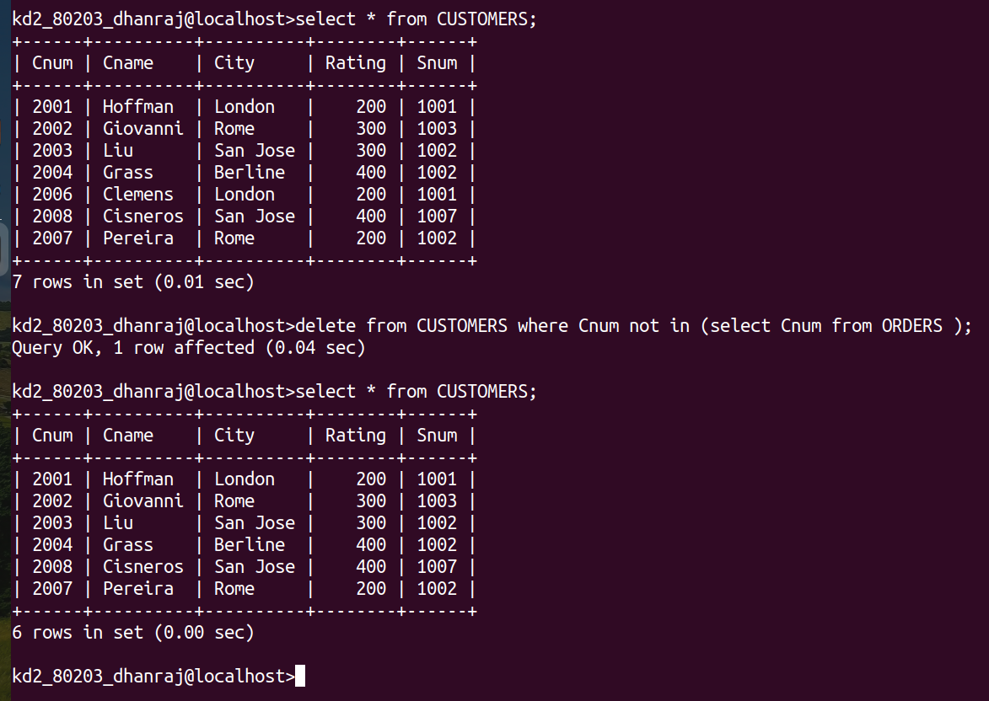

Q.3 --> Write a command that increases by twenty percent the commissions of all salespeople with total current orders above Rs. 3,000.
Ans-->
