Sql_Assingment-1

Q.1--> Create Salespeople table with column name
Snum int(4)
Sname varchar(10)
City varchar(10)
Comm float (3,2)

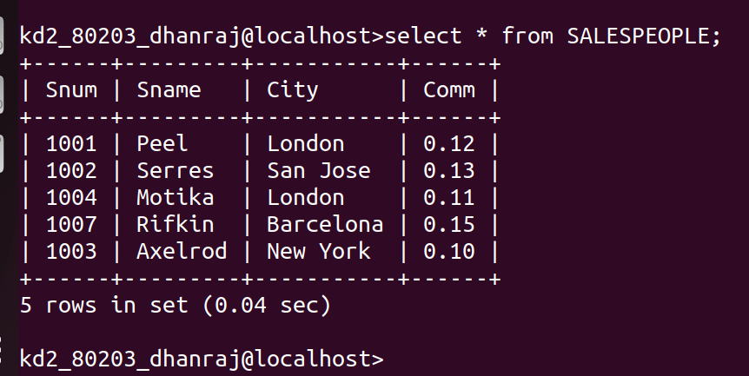

Q.2--> Create Customers table with column name
Cnum int(4)
Cname varchar(10)
City varchar(10)
Rating int(4)
Snum int(4)

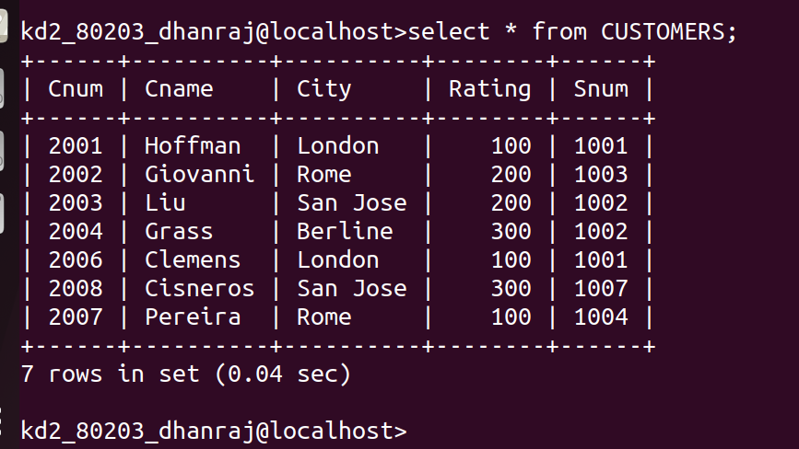

Q.3--> Create Oders table with column name
Onum int(4)
Amt float(7,2)
Odate date
Snum int(4)
Cnum int(4)

