SQL_Assingment-4

Q.1--> Write a select command that produces the order no, amount,and date for all rows in the Orders tables ?

Ans -->
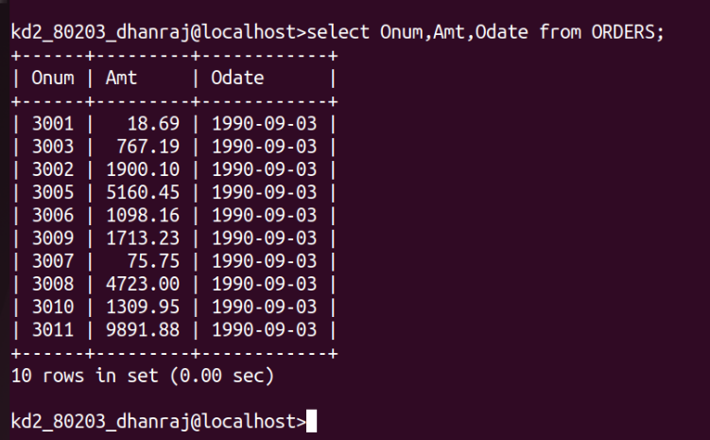

Q.2 --> Write a query that produces all rows from the customer table
for which sale person no is 1001 ?

Ans -->

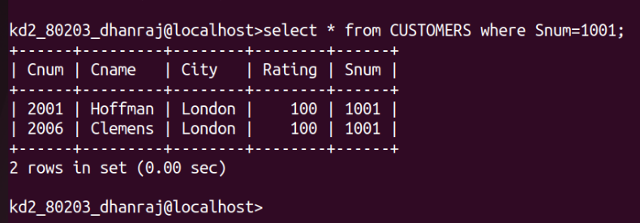

Q.3 --> Write a query that produces all rows from the Customers
table with the columns in the following order city , sname ,
snum , comm ?

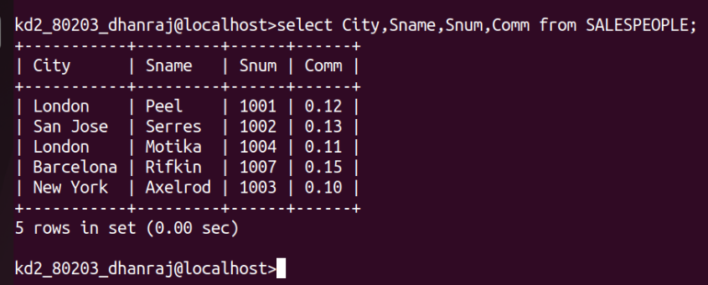
Ans-->

Q.4 --> Write a select command that produces the rating followed
by the name of each customer in san jose ?

Ans -->

