SQL_Assingment-11

Q.1--> Write a query that uses a subquery to obtain all orders for the customer named Cisneros. Assume you do not know his customer number (cnum).

Ans -->

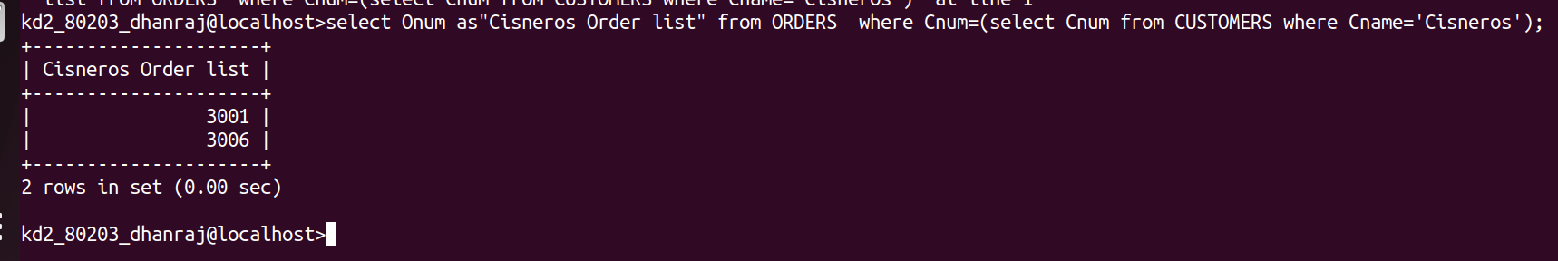

Q.2 -->Write a query that produces the names and ratings of all customers who have above-average orders.

Ans -->
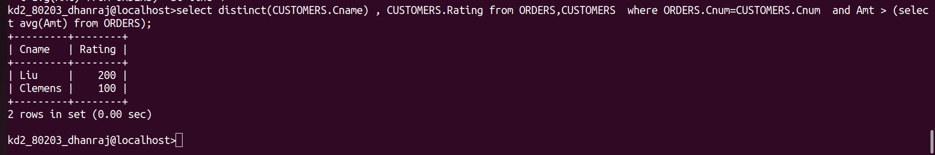

Q.3 --> Write a query that selects the total amount in orders for each salesperson for whom this total is greater than the amount of the largest order in the table.
Ans-->
