SQL_Assingment-9

Q.1--> Write a query that lists each order number followed by the name of the customer
who made the order.

Ans -->
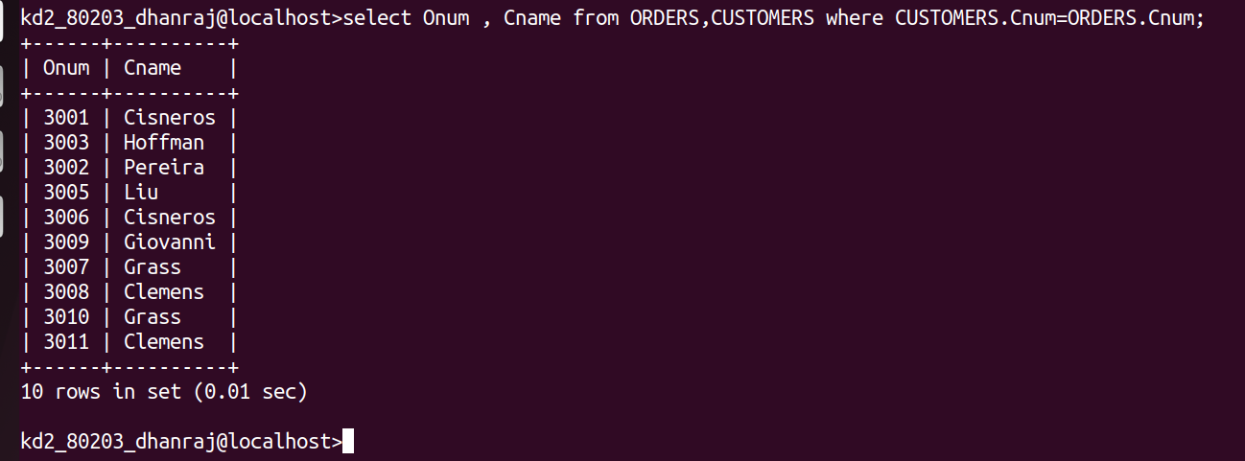

Q.2 -->Write a query that gives the names of both the salesperson and the customer for
each order along with the order number

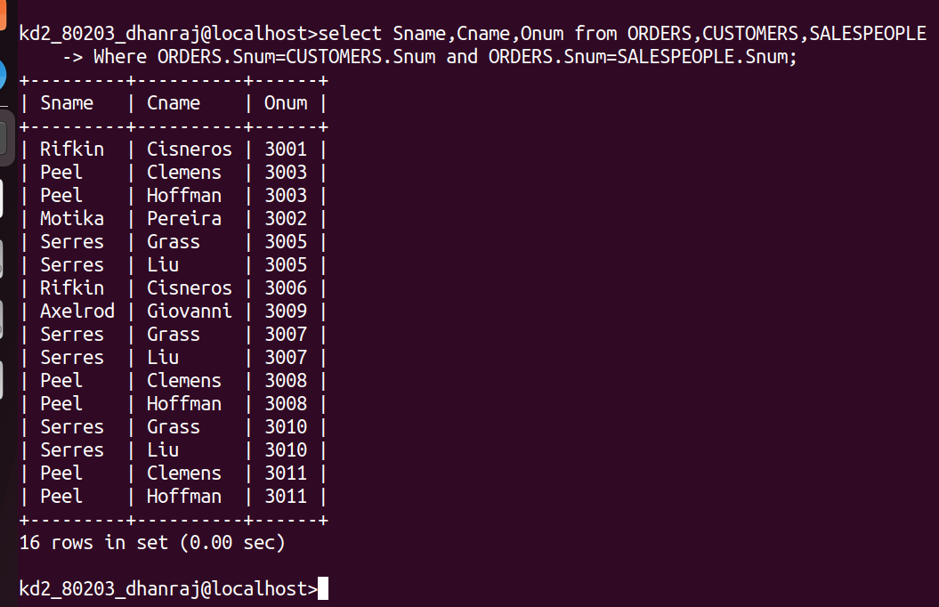
Ans -->

Q.3 --> Write a query that produces all customers serviced by salespeople with a
commission above 12%. Output the customer’s name, the salesperson’s name,
and the salesperson’s rate of commission

Ans-->
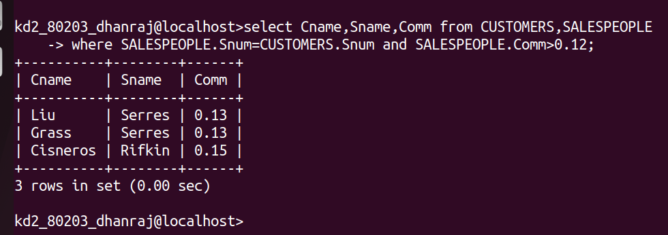

Q.4 --> Write a query that calculates the amount of the salesperson’s commission on each
order by a customer with a rating above 100

Ans -->
