SQL_Assingment-8

Q.1--> Assume each salesperson has a 12% commission. Write a query on the orders
table that will produce the order number, the salesperson number, and the amount
of the salesperson’s commission for that order.

Ans -->
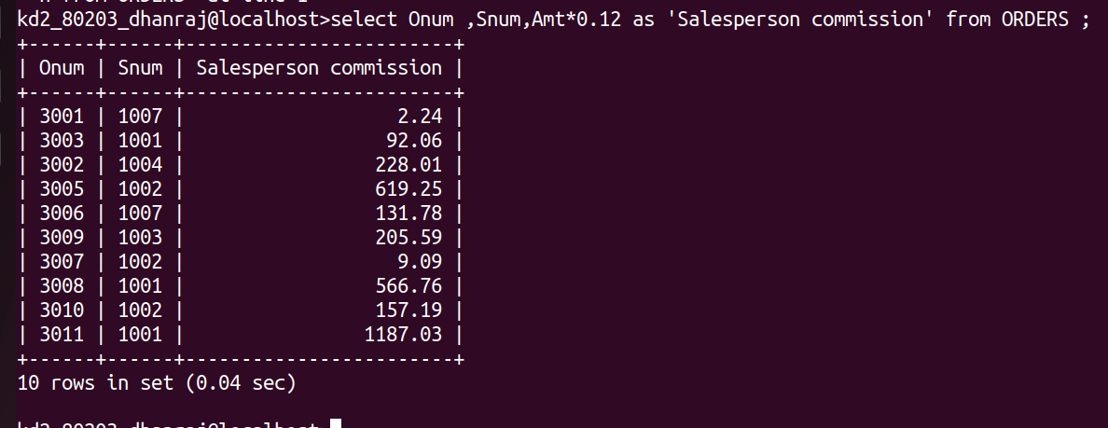

Q.2 --> Write a query on the Customers table that will find the highest rating in each city.
Put the output in this form:

Ans -->
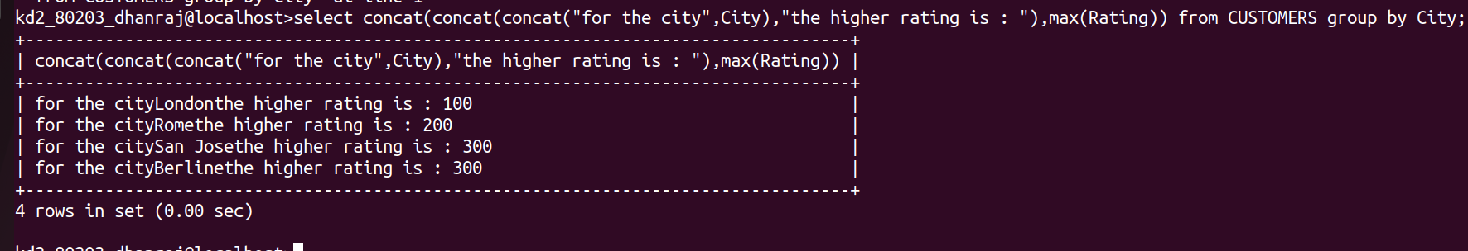

Q.3 --> For the city (city), the highest rating is : (rating).
Write a query that lists customers in descending order of rating. Output the rating
field first, followed by the customer’s name and number.

Ans-->
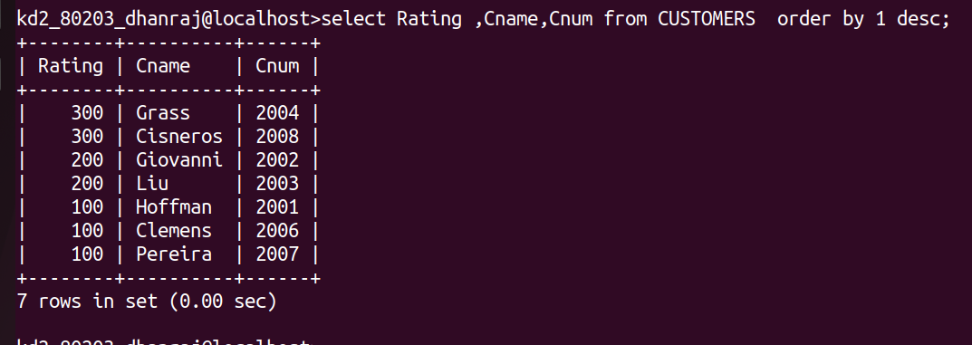

Q.4 --> Write a query that totals the orders for each day and places the results in
descending order.

Ans -->
