CLOUD SECURITY CAPSTONE
Deploy a Secure Three-Tier Application on AWS Using Terraform
Submitted by: Dhanshri Nehe
PRN:2124UCSM1127

1. Project Overview
This project uses Terraform to define an AWS VPC with public and private subnets, an internet-facing Application Load Balancer, a private EC2 application server, and a private RDS database. It also configures routing, security groups, VPC Flow Logs, and CloudTrail.

2. Architecture
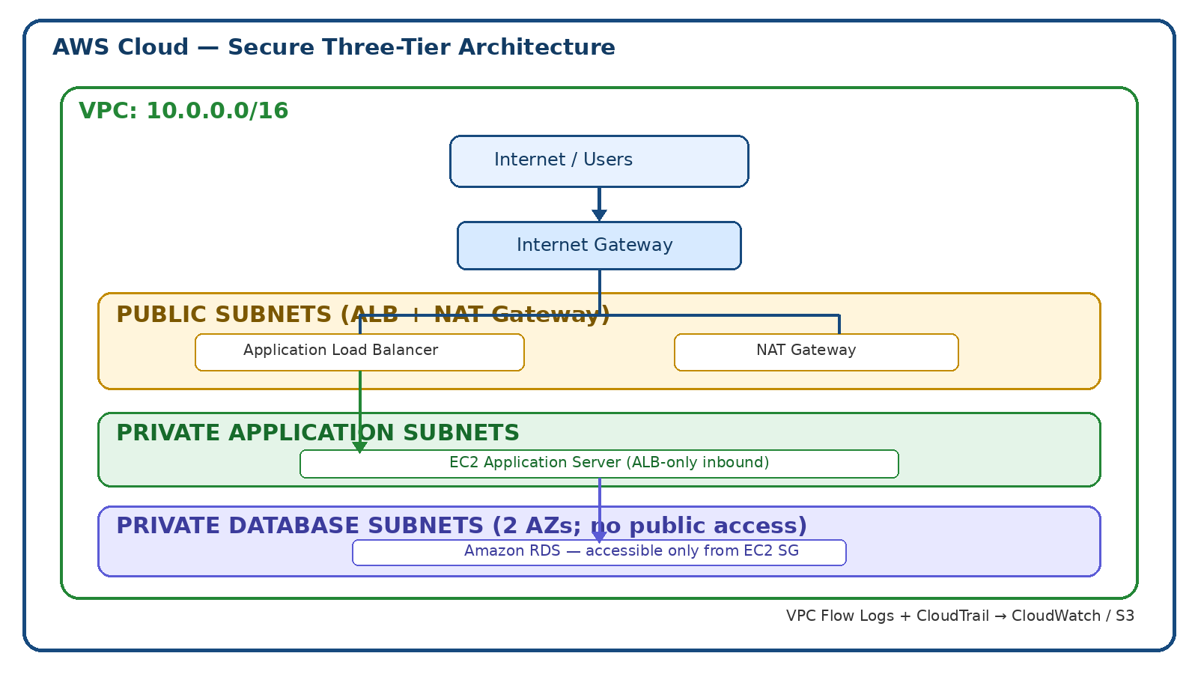

3. Security Design
- ALB is placed in public subnets.
- EC2 is in a private application subnet without a public IP.
- RDS uses private DB subnets and is configured with public access disabled.
- Application traffic is allowed only from the ALB security group.
- MySQL traffic is allowed only from the application security group.
- VPC Flow Logs and CloudTrail provide network and account activity monitoring.

4. Terraform Deployment
From the terraform directory, run terraform init, terraform fmt -recursive, terraform validate, terraform plan, and terraform apply. Supply the database password securely through TF_VAR_db_password. Review the plan before applying.

5. Validation Checklist
Verify ALB status and target health, private EC2 subnet placement, RDS Publicly accessible = No, DB inbound port 3306 restricted to the app security group, VPC Flow Log delivery, and CloudTrail logging. Capture fresh screenshots from your own AWS account for final proof.

6. Cost and Safety Note
NAT Gateway, ALB, EC2, and RDS can incur AWS charges. Destroy resources after testing if no longer required. Do not upload passwords, keys, or Terraform state files to GitHub.

7. Step-by-Step Console Reference Screenshots
These are supplied reference images arranged by task. They may show sample values and should not be represented as proof of deployment in the user's account.

Step 1 — Create a VPC
Choose VPC-only or create the VPC with the networking wizard. Use a consistent IPv4 CIDR such as 10.0.0.0/16.
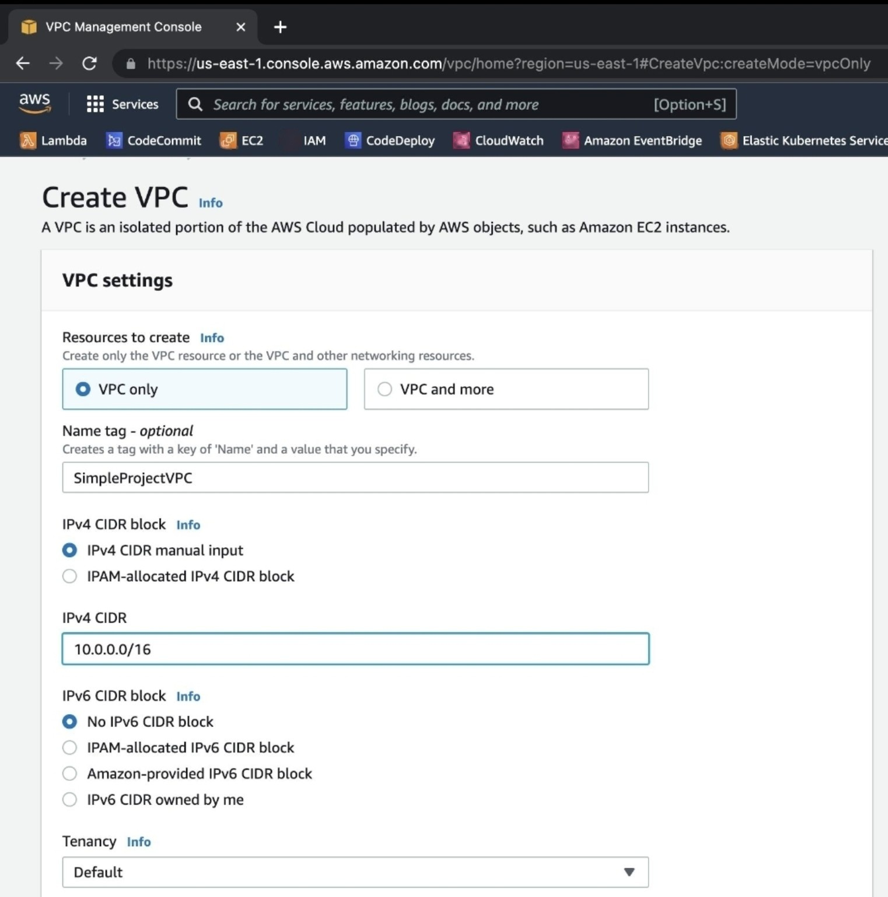

Step 2 — Create a private subnet
Choose the target VPC, Availability Zone, and a subnet CIDR contained inside the VPC CIDR.
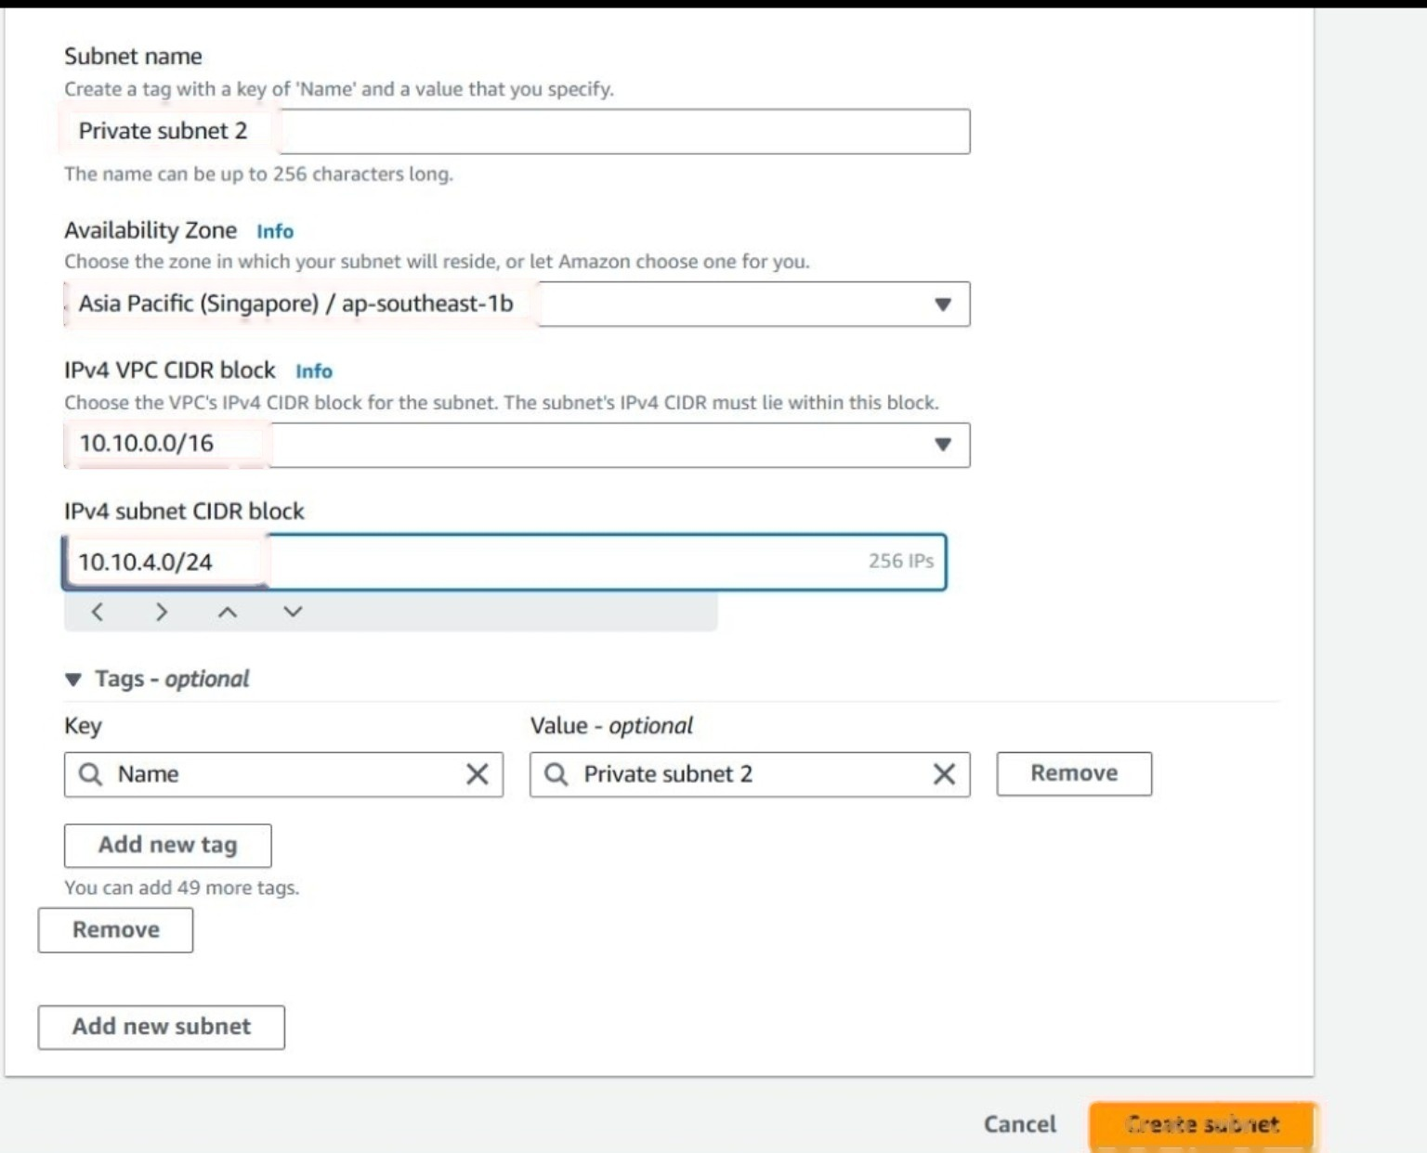

Step 3 — Attach an Internet Gateway
Attach the Internet Gateway to the correct VPC; route public subnet internet traffic through it.
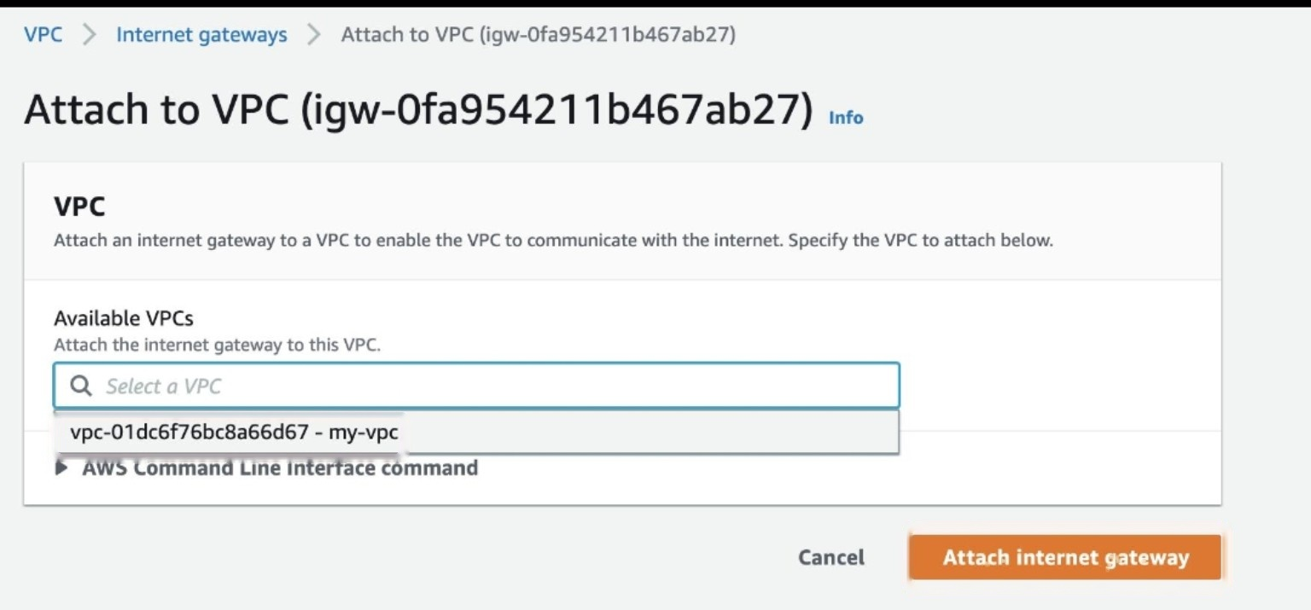

Step 4 — Create a NAT Gateway
Create the NAT Gateway in a public subnet and route private application subnet outbound traffic through it.
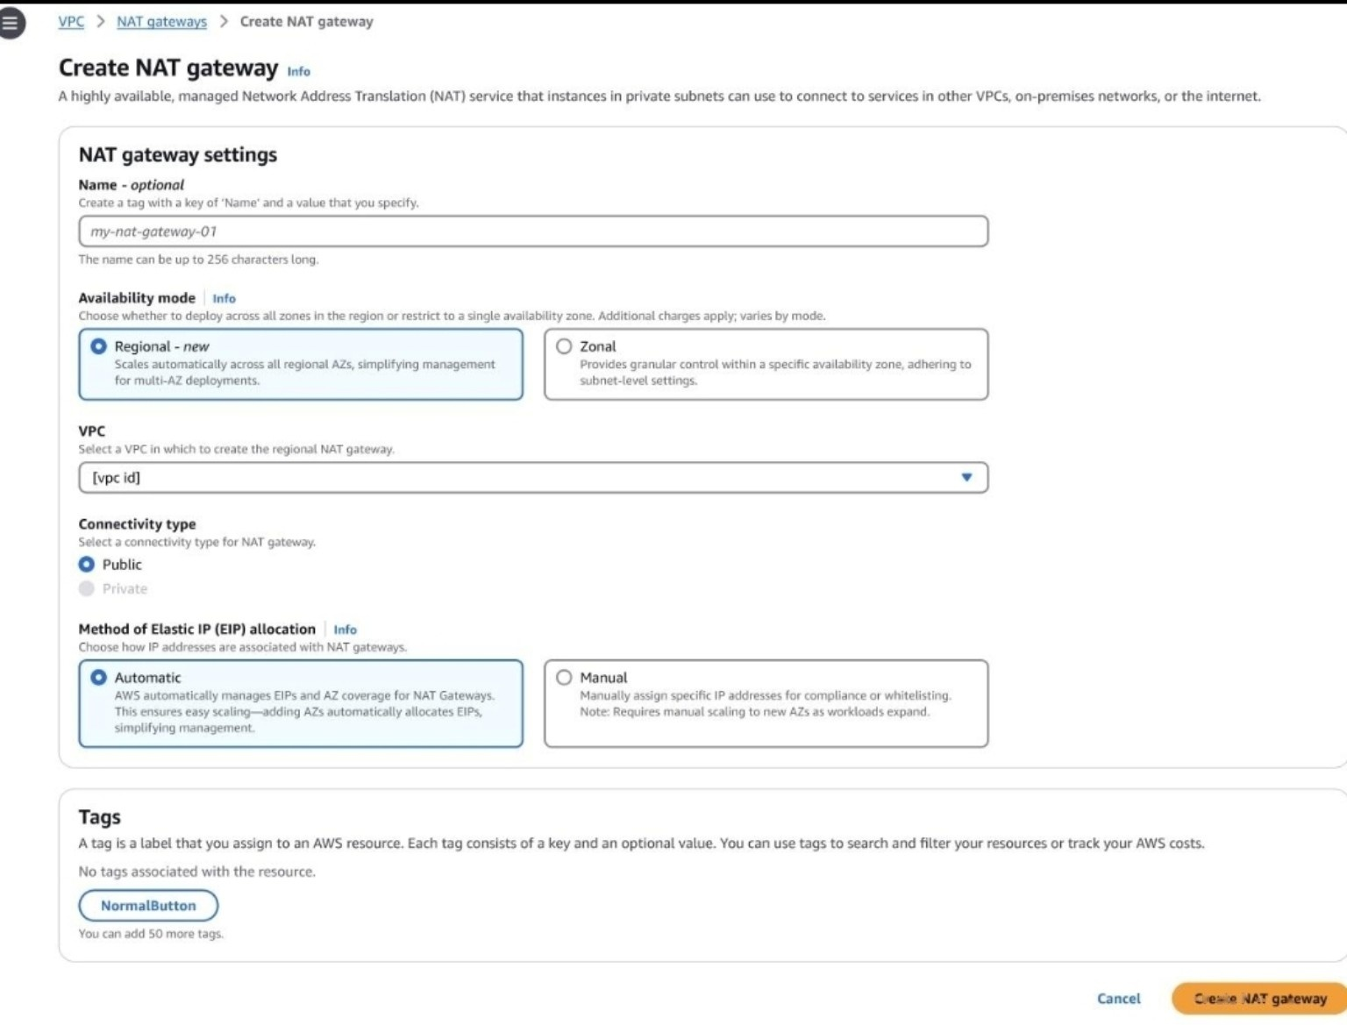

Step 5 — Configure Security Group rules
Use least privilege. Do not expose SSH or database ports to the entire internet.
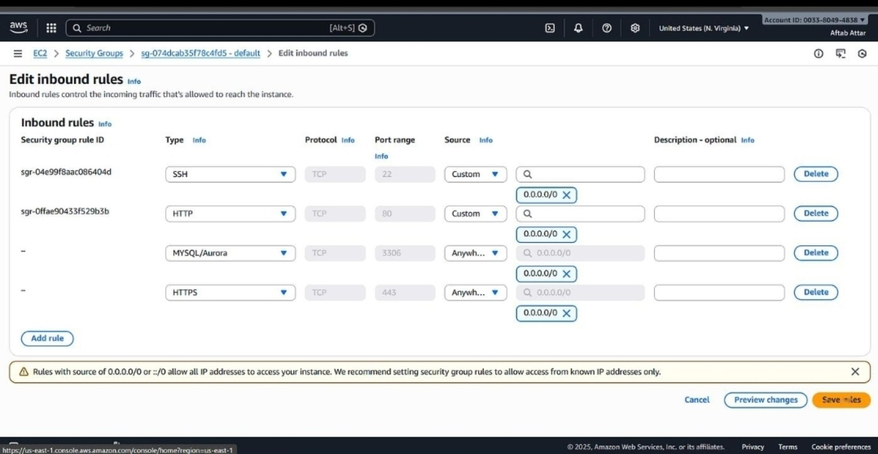

Step 6 — Launch an EC2 instance
The application instance belongs in a private subnet and should not have a public IP.
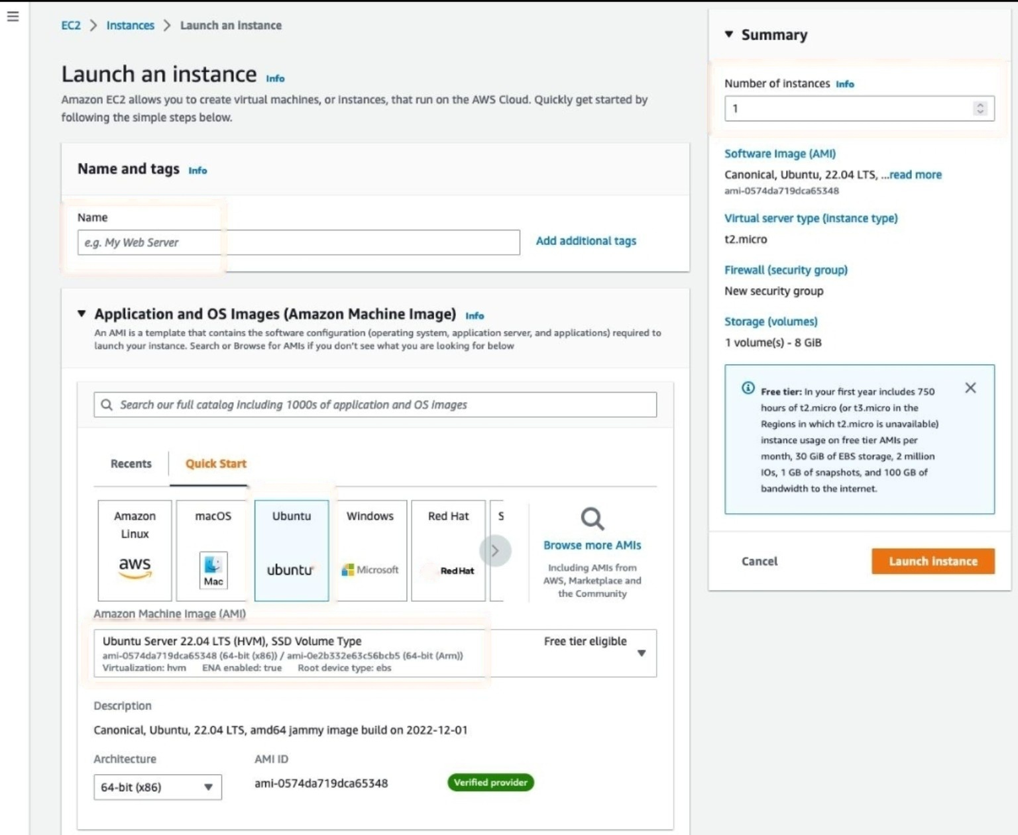

Step 7 — Create an Application Load Balancer
Use public subnets and forward listener traffic to the application target group.
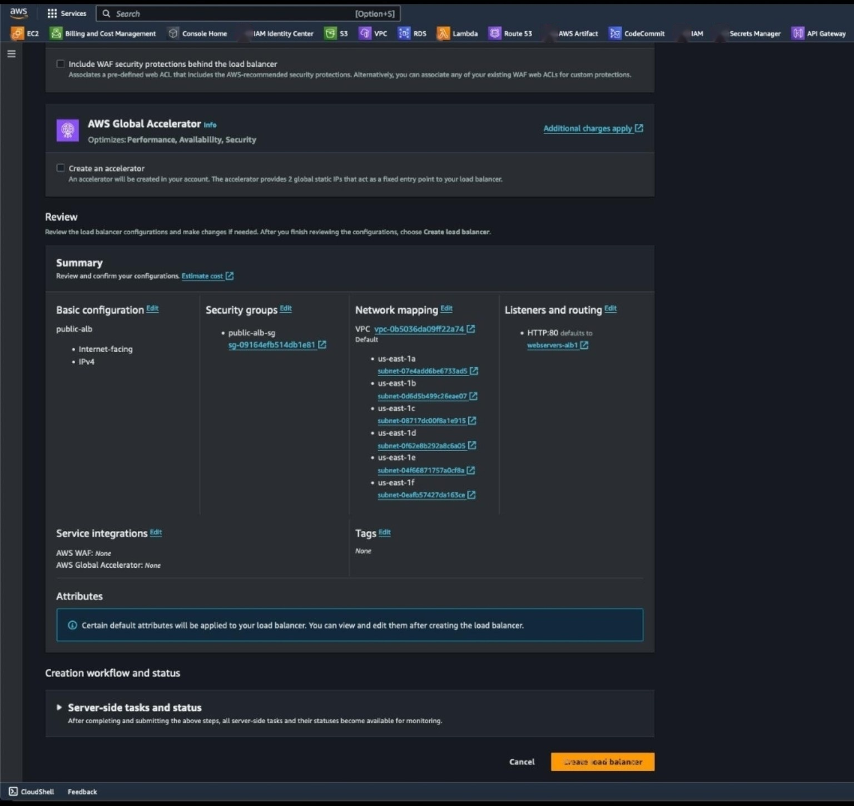

Step 8 — Create an RDS database
Use private DB subnets, disable public access, and allow MySQL only from the app security group.
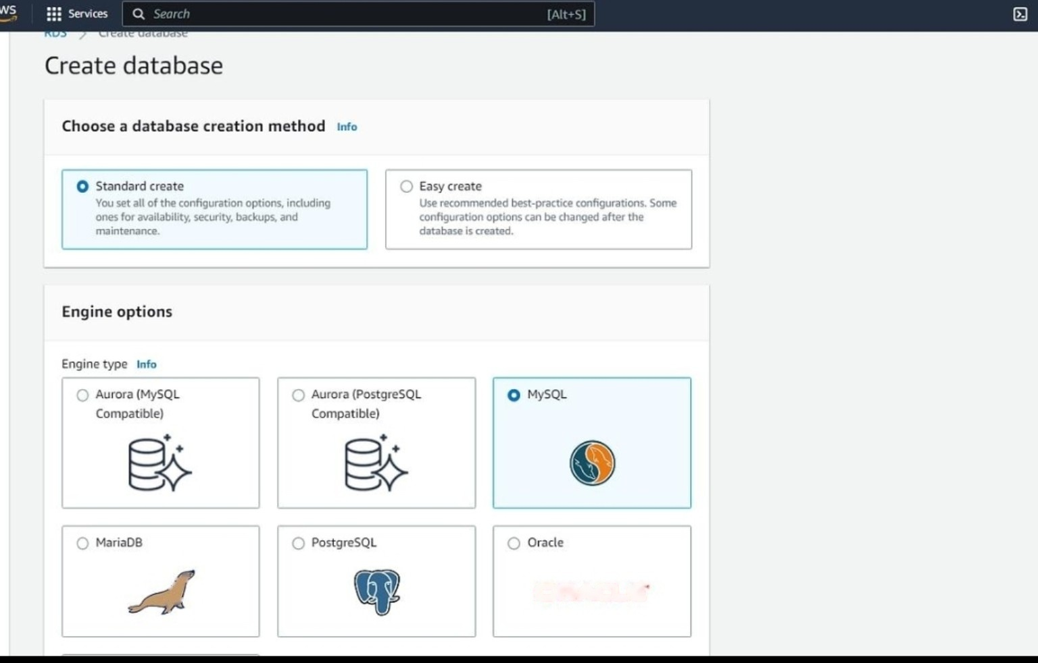

Step 9 — Enable VPC Flow Logs
Capture accepted/rejected/all traffic and send records to CloudWatch Logs or S3.
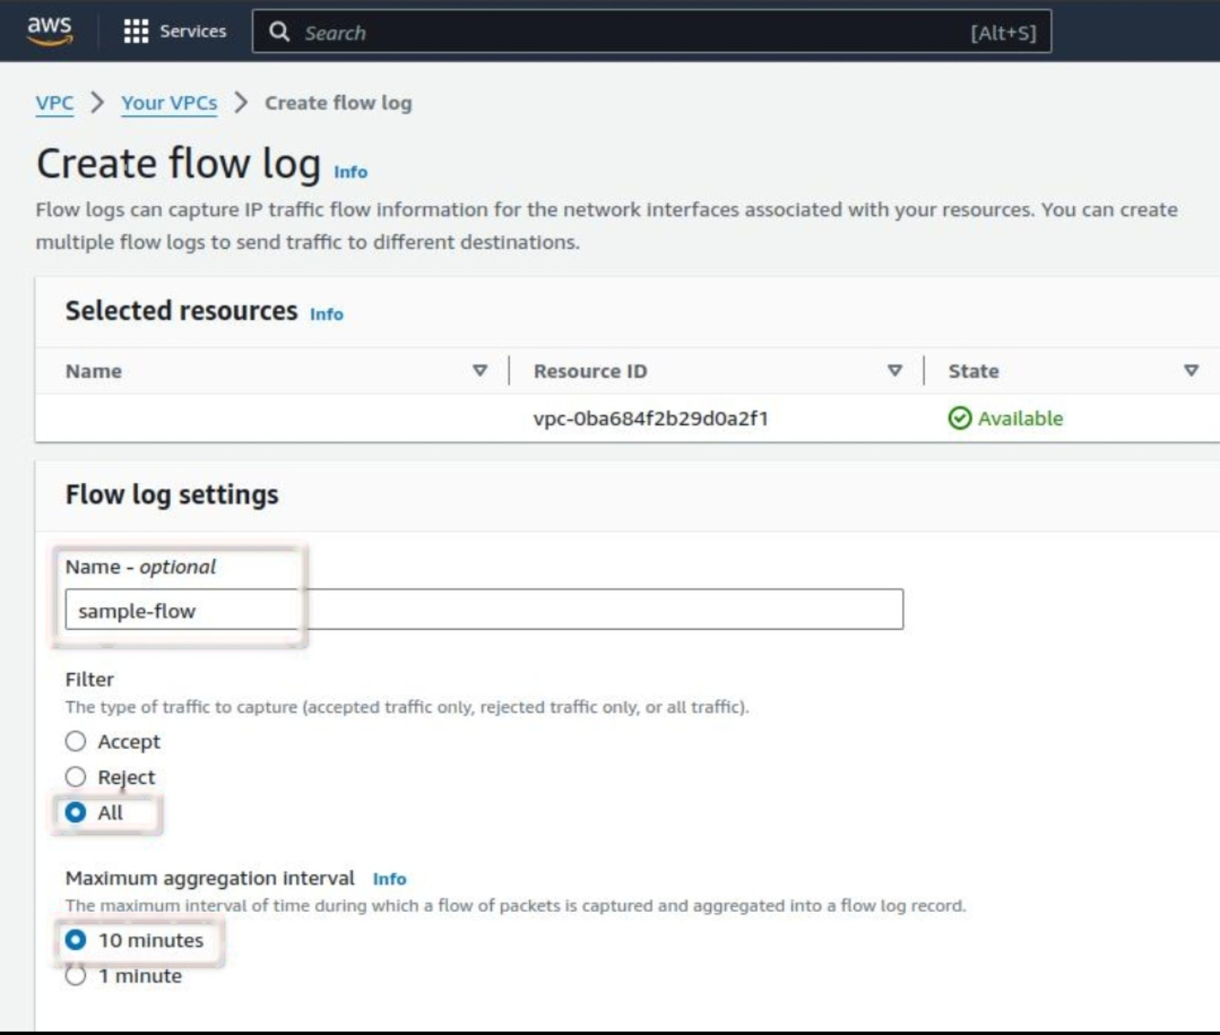

Step 10 — Create a CloudTrail trail
Configure a trail and protected S3 destination to record account activity.


