Use Case Specification

DMT/RM01/TMP

|  |  |
| --- | --- |
| Project Code | PRJ_Airline Reservation System _001 |
| Project Name | Airline Reservation System |

|  |  |  |
| --- | --- | --- |
| Prepared/Modified by | Role | Date of Preparation |
| Dhanalakshmi | Software Analyst | 24th February, 2018 |
| Reviewed by | Role | Date of Review |
| Dayanand Patil | Mentor |  |
| Approved by | Role | Date of Approval |
| Dayanand Patil | Mentor |  |
| Circulation List |  | Version Number of the template:1.1 |
| Version Number | 1.1 |  |

<<Customer>> REVIEW HISTORY

<<Customer comments on the Use case along with the signed off is tracked here>>

|  |  |  |  |  |  |  |
| --- | --- | --- | --- | --- | --- | --- |
| Version | 1.0 |  |  |  |  |  |
| Date | <<Date of Review>> |  |  |  |  |  |
| Reviewed by | << Reviewer Name>> |  |  |  |  |  |
| Reviewed UI Specification doc | << Whether UI Specification doc is reviewed >> |  |  |  |  |  |
| All Open Queries/issues closed | << Whether all the open queries and issues resolved>> |  |  |  |  |  |
| Agreement on Assumptions | <<Whether all the assumptions have been agreed upon by the customer>> |  |  |  |  |  |
| Sign Off | <<Signature>> |  |  |  |  |  |

Disclaimer:

The scope of the project ‘**Airline Reservation System’** is restricted to the contents of this signed off use case.

TABLE OF CONTENTS

1. Use Case Name: Login to the Airline Reservation System 5

2. Actor(s) 5

3. Preconditions 5

4. Flow of Events 5

4.1 Basic Flow 5

4.2 Alternative Flows 5

4.2.1 Alternate Flow 1: successful login to OBS on second attempt 5

4.2.2 Alternate Flow 2 : Login to the OBS using Apply for Courses option 6

4.2.3 Alternate Flow 3 6

Exception Flow 1: Exceeded Login Attempts 6

Exception Flow 2: Web Server Down 6

Exception Flow 3: Database Connectivity Error 6

Exception Flow 4: Network Connectivity Error 7

5. Post Conditions 7

6. Special Requirements 8

Performance 8

Availability 8

Admin Interface 8

Security 8

7. Extension Points 8

Extension in Alternate Flow 1: 8

Extension in Alternate Flow x: 8

8. Business Rules 8

9. Diagrams 9

Use Case Diagram for 9

10. Scenarios 10

Success Scenarios 10

Failure Scenarios 10

11. Issues 10

12. UI Specifications 10

13. Inter System Dependencies 10

14. Integration with an already existing System of the <<Customer>> 10

15. Assumptions 11

1. Use Case Name: Login to the Account holder registration

**Use Case ID:**  ARS.EXECUTIVE.LOGIN_001

**Brief Description:** This Use Case describes the process by which executive logs into the Airline Reservation Application.

1. Actor(s)
2. Executive
3. Preconditions
4. Executive has already registered on the Airline Reservation Portal.
5. Executive has entered the valid URL of Airline Reservation Portal and is directed to the home page Airline Reservation Portal
6. Executive has valid User name and the password
7. Flow of Events

4.1 Basic Flow

Name: Successful login to the Airline Reservation Portal

1. Executive clicks on the Authority Login link on the Airline Reservation System.
2. The system displays the Login for Authorities page
3. Executive enters User name
4. Executive enters Password
5. Executive clicks on the Login button
6. The system validate User name & Password
7. The system navigates executive to the Home page
   1. Alternative Flows

4.2.1 Alternate Flow 1: successful login to ARS on second attempt

1. Executive clicks on the Authority Login link on the Airline Reservation System home page
2. The system displays Login for Authorities page
3. Executive enters User name
4. Executive enters Password
5. Executive clicks on the Login button
6. The system validates User name & Password
7. The system validation fails due to invalid Executive credentials
8. The step 3 of Basic flow is followed.

4.3 exception flows

Exception Flow 1: Web Server Down

1. Executive clicks on the Authority Login link on the Airline Reservation Portal home page
2. The system displays an error message regarding web server unavailability problem

Exception Flow 2: Database Connectivity Error

1. Executive clicks on the Authority Login link on the Airline Reservation Portal home page.
2. The system displays Login for Authorities page.
3. Executive enters User name
4. Executive enters Password
5. Executive clicks on the Login button
6. The system validates user name & Password
7. The system displays an error message regarding database connectivity problem.

Exception Flow 3: Network Connectivity Error

1. Executive clicks on the Authority Login link on the Airline Reservation Portal System home page.
2. The system displays Login for Authorities page.
3. Executive enters executive name
4. Executive enters Password
5. Executive clicks on the Login button
6. The system validates user name & Password
7. The system displays an error message regarding network connectivity problem.
8. Post Conditions

| Flow Name | Post Condition |
| --- | --- |
| Successful Executive login to the Airline Reservation System | Executive will be logged in to the ARS successfully and system should navigate Executive to the Details Page |
| Login to the Airline Reservation Portal on second attempt | Executive will be logged in to the ARS successfully and system should navigate Executive to the Details Page |
| Web Server Down | The system should display an error message to the Executive regarding web server unavailability problem |
| Database Connectivity Error | The system should display an error message to the Executive regarding the database connectivity problem |
| Network Connectivity Error | The system should display an error message to the Executive regarding the network connectivity problem |

1. Business Rules

| Business Rule Name | Business Rule Description | System action (if BR fails) |
| --- | --- | --- |
| BR01 | Executive credentials must be valid | Displays error message “Invalid Credentials” |

1. Diagrams

Use Case Diagram for ADMIN FUNCTIONALITIES

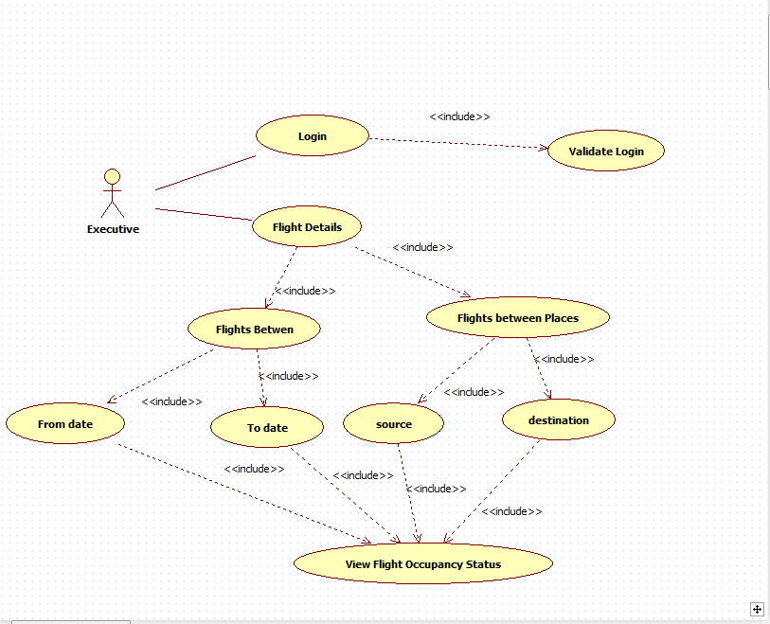

1. Scenarios

Success Scenarios

* Successful executive login to the Airline Reservation Portal
* Login to the Airline Reservation Portal on second attempt

Failure Scenarios

* Web Server Down
* Database Connectivity Error
* Network Connectivity Error

1. Issues

* What is the maximum size of user id and password that a executive can have ?
* What if the executive is blocked after invalid login attempts for three times ?

1. UI Specifications

<< Provide a link to the UI specification document of the Use case. Please don’t embed the document here>>

1. Integration with an already existing System of the <<Customer>>

<< This is especially applicable if the project at hand is an enhancement to an existing system.>>

1. Assumptions

<< List down all the assumptions considered by this use case>>

* 1. Executive have a valid username and password.

2. Executive has already registered on the Airline Reservation Portal.

REVISION HISTORY OF THE WORK PRODUCT

<to be maintained by projects>

|  |  |  |  |  |  |
| --- | --- | --- | --- | --- | --- |
| # | Date | Version # | Section Changed | Details of changes made | Approved By |
| 1 |  |  |  |  |  |
| 2 |  |  |  |  |  |