Use Case Specification

DMT/RE03/TMP

Project Code | PRJ_Airline Reservation system_001
Project Name | Airline Reservation System

Prepared/Modified by | Role | Date of Preparation
Abhijit Panda | Software analyst | 24th february, 2018
Reviewed by | Role | Date of Review
Dayanand Patil | Mentor
Approved by | Role | Date of Approval
Dayanand Patil | Mentor
Circulation List |  | Version Number of the template:1.0
Version Number | 1.0

<<Customer>> REVIEW HISTORY
<<Customer comments on the Use case along with the signed off is tracked here>>

Version | <<Version number>>
Date | <<Date of Review>>
Reviewed by | << Reviewer Name>>
Reviewed UI Specification doc | << Whether UI Specification doc is reviewed >>
All Open Queries/issues closed | << Whether all the open queries and issues resolved>>
Agreement on Assumptions | <<Whether all the assumptions have been agreed upon by the customer>>
Sign Off | <<Signature>>

Disclaimer:

The scope of the project ‘<<Project Name>>’ is restricted to the contents of this signed off use case.

TABLE OF CONTENTS

1. Use Case Name: Update & manage flight details in Airline Reservation System 4
2. Actor(s) 4
3. Preconditions 4
4. Flow of Events 4
4.1 Basic Flow 4
4.2 Alternative Flows 5
4.2.1 Alternate Flow 1 5
4.2.2 Alternate Flow 2 5
4.2.3 Alternate Flow 3 5
4.2.4 Alternate Flow 4 5
4.2.5 Alternate Flow 5 5
4.2.6 Alternate Flow 6 5
5. Post Conditions 6
6. Scenarios 6
Success Scenarios 6
Failure Scenarios 6
7. Assumptions 6

Use Case Name: Update & manage flight details in airline reservation system
Use Case ID: ADMIN.UPDATEFLIGHT_001

Brief Description: This Use Case describes the process by which the administrator can update flight details from the existing flight details database.

Actor(s)
- Administrator

Preconditions
- Administrator is an employee of Airline Reservation System.
- Administrator has an access to the Airline Reservation System.
- Administrator has valid user name and the password.
- Administrator has already logged into the Airline Reservation System.

Flow of Events
3.1BASIC Flow
3.1.1 Name: Successfully Update Of flight Details
- Administrator clicks on the Update Flight Details link available on the Admin Home Page.
- Administrator will be navigated to update flight details web page.
- Administrator enters the flight Id.
- Administrator enters the flight name.
- Administrator enters the source.
- Administrator enters the destination.
- Administrator enters the date of departure.
- Administrator enters the time of departure.
- Administrator enters a halt airport if any is applicable
- Administrator clicks on the Update button to complete the process of updating of a flight detail.
- The system updates the detail to the flight details list

  - Alternative Flows
3.2.1.Alternate Flow 1:Wrong Attempts with null flight Id
- Administrator clicks on the Update flight Details link available on the Admin Home Page.
- Administrator will be navigated to update flight details web page.
- Administrator enters the flight name.
- Administrator enters the source.
- Administrator enters the destination.
- Administrator enters the date of departure.
- Administrator enters the time of departure.
- Administrator enters a halt airport if any is applicable

- Administrator clicks on the Update button to complete the process of updating of a flight detail.
- The system asks the administrator to enter the flight Id.
- The system takes administrator to the Step 3 of Basic Flow

    - Alternate Flow 2: Wrong Attempts with null date and time of departure
1. Administrator clicks on the Update flight Details link available on the Admin Home Page.
2. Administrator will be navigated to update flight details web page.
3. Administrator enters the flight name.
4. Administrator enters the source.
5. Administrator enters the destination
6. Administrator enters a halt airport if any is applicable

7.Administrator clicks on the Update button to complete the process of updating of a flight detail.

8.The system asks the administrator to enter the departure date and time.
9.The system takes administrator to the Step 7 of Basic Flow
3.2.1.Alternate Flow 3: Wrong Attempts with Invalid flight ID
- Administrator clicks on the Update Airline Details link available on the Admin Home Page.
- Administrator will be navigated to update flight details web page.
- Administrator enters the flight Id.
- Administrator enters the flight name.
- Administrator enters the source.
- Administrator enters the destination.
- Administrator enters the date of departure.
- Administrator enters the time of departure.
- Administrator enters a halt airport if any is applicable
- Administrator clicks on the Update button to complete the process of updating a new flight.
- The system asks the administrator to enter the flight Id and it should not contain any special characters.
- The system takes administrator to the Step 3 of Basic Flow

3.2.1.Alternate Flow 3: Wrong Attempts with same destination and source name
1. Administrator clicks on the Update Flight Details link available on the Admin Home Page.
2. Administrator will be navigated to update flight details web page.
3. Administrator enters the flight Id.
4. Administrator enters the flight name.
5. Administrator enters the source.
6. Administrator enters the destination.
7. Administrator enters the date of departure.
8. Administrator enters the time of departure.
9. Administrator enters a halt airport if any is applicable
10.Administrator clicks on the Update button to complete the process of updating of a flight detail.
11. The system asks the administrator to enter distinct source and destination name.
12. The system takes administrator to the Step 5 of Basic Flow

3.2.2.Alternate Flow 8
Exception Flow 1: Web Server Down
- Administrator visits the Admin Homepage of Airline reservation System using any standard browser
- The system displays an error message regarding web server unavailability problem
Exception Flow 2: Database Connectivity Error

- Administrator visits the Admin Homepage of airline reservation System using any standard browser
- Administrator clicks on the Update flight Details link available on the Admin Home Page.
- Administrator will be navigated to update a flight web page.
- Administrator enters the flight Id.
- Administrator enters the flight name.
- Administrator enters the source
. 7. Administrator enters the destination.
8. Administrator enters the date of departure.
9. Administrator enters the time of departure
10. Administrator clicks on the Update button to complete the process of updating a new flight.
11. The system displays an error message regarding database connectivity problem.
Exception Flow 3: Network Connectivity Error

- Administrator visits the Admin Homepage of airline reservation System using any standard browser
- Administrator clicks on the update Flight Details link available on the Admin Home Page.
- Administrator will be navigated to update a flight web page.
- Administrator enters the flight Id.
- Administrator enters the flight name.
- Administrator enters the source
. 7. Administrator enters the destination.
8. Administrator enters the date of departure.
9. Administrator enters the time of departure
10. Administrator clicks on the Update button to complete the process of updating a new flight.
11. The system displays an error message regarding network connectivity problem.

Post Conditions
<< Post conditions are the STATE where the system, sub-system and /or entities will be after Basic and /or Sub flow and/or Alternate flows are executed.
State the Post conditions for Basic flow + each and every Sub flow and Alternate flow.>>

Flow Name | Post Condition
Successful administrator Update asset to Airline Reservation System | Administrator will open the link update flight and successfully able to update flight details.
Wrong Attempts with null flight Id | Administrator will open the link update flight and successfully able to update flight details.
Wrong Attempts with null Flight date and time of departure | Administrator will open the link update flight and successfully able to update flight details.
Wrong Attempts with Invalid flight Id | Administrator will open the link update flight and successfully able to update flight details.
Wrong Attempts with same destination and source name | Administrator will open the link update flight and successfully able to update flight details.
Web Server Down | The system should display an error message to the administrator regarding web server unavailability problem
Database Connectivity Error | The system should display an error message to the administrator regarding the database connectivity problem
Network Connectivity Error | The system should display an error message to the administrator regarding the network connectivity problem

5.Diagrams
Use Case Diagram for ADMIN FUNCTIONALITIES
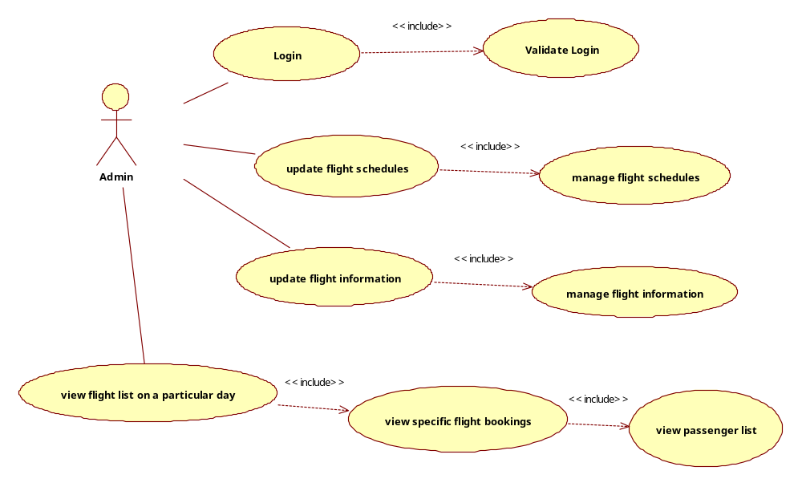

6.Scenarios
[Identify the scenarios using Basic Flow, Sub flow and Alternate flows]
Success Scenarios
[List different success scenario.]

- Successful administrator Update asset to Airline Reservation System
- Wrong Attempts with null flight Id
- Wrong Attempts with null Flight date and time of departure
- Wrong Attempts with Invalid flight Id
- Wrong Attempts with same destination and source name

Failure Scenarios
[List different failure scenarios]
- Web Server Down
- Database Connectivity Error
- Network Connectivity Error

7.Assumptions
<< List down all the assumptions considered by this use case>>

- The Airline reservation System Portal is up and running

REVISION HISTORY OF THE WORK PRODUCT
<to be maintained by projects>

# | Date | Version # | Section Changed | Details of changes made | Approved By
1
2

