**TABLE OF CONTENTS**

**CERTIFICATE ii**

**DECLARATION iii**

**ACKNOWLEDGEMENT iv**

**ABSTRACT v**

**TABLE OF CONTENTS 1**

**LIST OF FIGURES** **3**

CHAPTER 1 4

INTRODUCTION 4

1.1 Background and overview 4

1.2 Objectives 5

CHAPTER 2 6

WI-VI TECHNOLOGY 6

2.1 Working 6

2.2 Challenges faced in designing wi-vi technology 7

2.2.1 Flash effect 7

2.2.2 Nulling to remove flash 8

2.2.3 Identifying and tracking humans 9

CHAPTER 3 10

METHODOLOGY 10

3.1 Algorithm for pseudo wi-vi nulling 10

3.2 Identifying and tracking humans 11

3.2.1 Tracking a single human 11

3.2.2 Tracking multiple humans 14

CHAPTER 4 18

DESIGN AND IMPLEMENTATION 18

4.1 MIMO 18

4.2 Gesture based communication 19

4.3 Gesture Encoding 19

4.3.1 Gesture Decoding 21

4.4 Implementation of Wi-Vi Technology 22

CHAPTER 5 24

TESTING AND RESULTS ANAYLSIS 24

5.1 Testing 24

5.2 Result Analysis 26

CHAPTER 6 27

ADVANTAGES AND LIMITATIONS 27

6.1 Advantages 27

6.2 Limitations 27

CHAPTER 7 28

APPLICATIONS 28

CHAPTER 8 30

CONCLUSION AND FUTURE SCOPE 30

REFERENCES 31

LIST OF FIGURES

**Figure No. Description Page No.**

Fig.1.1 Basic Idea of WI-VI 4

Fig.2.1 working of wi-vi technology 6

Fig.2.2 Flash Effect 8

Fig.2.3 Nulling to remove the Flash 9

Fig.3.1 Steps for Elimination of FLASH effects 10

Fig.3.2 Tracking a person’s movements 11

Fig.3.3 Time Samples as Antenna Arrays 14

Fig.3.4 (a)Experimental Setup (b)Wi-Vi’s output 15

Fig.4.1 Eliminating the Wall’s Reflection 18

Fig.4.2 Gestures As Angles(Output) 20

Fig.4.3 Output Of Gesture Encoding 21

Fig.4.4 Gesture Decoding 22

Fig.4.5  Emulates An Antenna 23

Fig.5.1 Cdf of The Gesture Sensors 25

Fig.5.3 Gesture Detection in Different Building Structures 25

Fig.7.1 Law enforcement 28

Fig.7.2 Emergency situations 28

Fig.7.3 Smart Sensing 28

Fig.7.4 Personal Security 29

Fig.7.5 User Interface Design 29

# 

INTRODUCTION

## Background and overview

Wireless Vision (Wi-Vi) technology has emerged as a revolutionary advancement in the realm of wireless communications and imaging. By harnessing the principles of radar and Wi-Fi signals, Wi-Vi technology enables the visualization of objects through obstacles, offering a unique perspective that transcends traditional line-of-sight limitations. This innovative approach has the potential to redefine how we perceive and interact with our surroundings, opening up new possibilities for applications in security, search and rescue operations, structural monitoring, and beyond. The below figure says the basic idea of Wi-Vi.

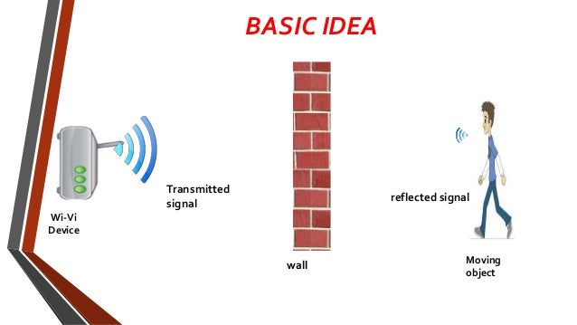

Fig.1.1 Basic Idea of WI-VI

The evolution of Wi-Vi technology stems from the need to overcome the challenges posed by conventional imaging methods, which often struggle to penetrate physical barriers such as walls. By utilizing wireless signals to detect and track moving objects in real-time, Wi-Vi systems provide a non-invasive means of visualizing hidden scenes, enhancing situational awareness and enabling proactive decision-making in various scenarios. The fusion of radar principles with Wi-Fi technology has paved the way for a new era of wireless imaging capabilities that hold immense promise for diverse industries and research domains.

## Objectives

The objective of this paper is to enable a see-through-wall technology that is low-bandwidth, low-power, compact, and accessible to non-military entities. To this end, the paper introduces Wi-Vi, to a see-through-wall device that employs Wi-Fi signals in the 2.4 GHz ISM band. Wi-Vi limits itself to a 20 MHz-wide Wi-Fi channel, and avoids ultra-wideband solutions used today to address the flash effect. It also disposes of the large antenna array, typical in past systems, and uses instead a smaller 3-antenna MIMO radio‘s, We observe that we can adapt recent advances in MIMO communication to through-wall imaging.

In MIMO, multiple Antenna systems can encode their transmissions so that the signal is nulled (i.e., sums up to zero) at a particular receive antenna. MIMO systems use this capability to eliminate interference to unwanted Receivers. In contrast, we use nulling to eliminate reflections from static objects, including the wall.

Specifically, a Wi-Vi device has two transmit antennas and a single receive antenna. Wi-Vi operates in two stages. In the first stage, it measures the channels from each of its two transmit antennas to its receive antenna. In stage 2, the two transmit antennas use the channel measurements from stage 1 to null the signal at the receive antenna. Since wireless signals (including Reflections) combine linearly over the medium.

Wi Vi based on capturing the reflections of its own transmitted signals off moving objects behind a wall or door in order to track them. Wi-Vi operation does not require any access to any device on the other side of the wall. Specifically, when it is interact with a non-metallic wall, some form of the RF signal would traverse the wall; reflect off objects and humans.

# 

WI-VI TECHNOLOGY

## Working

Wi-vi begins its work by sending a wi-fi signal through any kind of barriers (closed doors or walls) and measures the shape and type of the object by measuring the way how the wi-fi signals are bounded back. Everytime when wi-fi signals hit the moving objects, size and shape of the object leaves some effect on signals that prove to be helpful in recognition of the shape and kind of object. It demonstrates the use of interfaces which rely on using reflections of a transmitted RF signal. It makes use of MIMO to nullify static object and targets motion of objects which is treated as antenna and resulting RF signal is tracked. Hand held devices like cell phones can also be built with the Wi-vi technology, this will open up a lot of uses for it. Army can also be benefited from the portable tool Wi-vi. The below figure says the working of Wi-Vi technology.

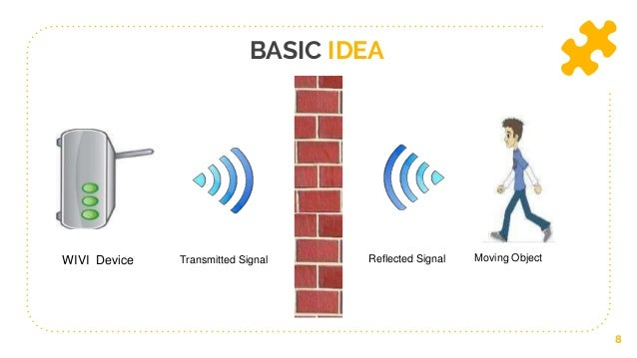

Fig.2.1 working of wi-vi technology

Wi-Vi is a wireless device that captures moving objects behind a wall. It leverages the ubiquity of Wi-Fi chipsets to make through wall imaging relatively low-power, low-cost, low bandwidth, and accessible to average users. To this end, Wi-Vi uses Wi-Fi OFDM signals in the ISM band (at 2.4 GHz) and typical Wi-Fi hardware.

Wi-Vi is essentially a 3-antenna MIMO device: two of the antennas are used for transmitting and one is used for receiving. It also employs directional antennas to focus the energy toward the wall or room of interest.

For Its design incorporates two main components:

1. the first component eliminates the flash reflected off the wall by performing MIMO nulling.
2. the second component tracks a moving object by treating the object itself as an antenna array using a technique called inverse SAR.

Wi-Vi can be used in one of two modes, depending on the user‘s choice.

In mode 1: It can be used to image moving objects behind the wall and track them.

In mode 2: On the other hand, Wi-Vi functions as a gesture-based interface from behind a wall that enables humans to compose messages and send them to the Wi-Vi receiver.

## Challenges faced in designing wi-vi technology

### **Flash effect**

Flash effect term refers to ―The reflection from the entire stationary object behind the wall rather than just wall‖, which is much stronger than the reflection from the object inside the closed room. This is due to the attenuation which electromagnetic signals suffer when penetrating through the dense obstacles. one-way attenuation experienced by Wi-Fi signals in construction materials. For example- once the signal is traversed through solid wood door or interior hollow wall, the Wi-Fi signal power is reduced by 6dB and 9dB. Electromagnetic signal produces important attenuation dense obstacles that results in stronger flash signals than the other mirrored signals off the article. Considering the tables on top of within which a method RF attenuation of signal is determined through Wi-Fi signal. As mirrored signal on each the reflection constant because the cross-sectional of object owing to that the particular mirrored signal becomes weaker. Hence, Wi-Vi increases the sensitivity to the reflection of interest by victimization the development of nulling the interference or by power boosting. The below figure says the Flash effect.

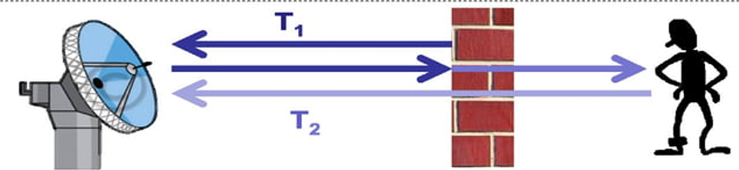

Fig.2.2 Flash Effect

### **Nulling to remove flash**

Wi-Vi however, avoids mistreatment associate antenna array for 2 reasons: First, so as to get a slender beam and thus come through a decent resolution, one wants an oversized antenna array with several antenna components. This might end in a large and dearly-won device. Second, since Wi-Vi eliminates the flash result mistreatment MIMO nulling, adding multiple receive antennas would need nulling the signal at every of them. This might need adding additional transmit antenna.

A few points square measure value noting concerning Wi-Vi procedure to eliminate the flash effect:

To eliminate the flash result we've got to get rid of mirrored signal received from stationary objects each in front off and behind the wall and direct signals from sending antenna to receiving antenna.

Wi-Vi’s uses nulling rule that provides a 42dB mean reduction in signal power that is enough to remove the flash result. Nulling is performed within the presence of objects moving behind the wall and front of the wall.

Hence, Wi-Vi increases the sensitivity to the reflection of interest by victimization the development of nulling the interference or by power boosting. The below figure says the nulling to remove flash effect.

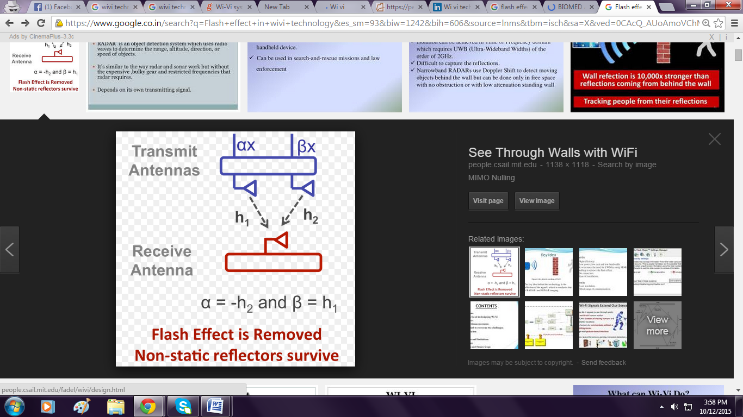

Fig.2.3 Nulling to remove the Flash

### **Identifying and tracking humans**

**A. Tracking A Single Human**

In advanced, through all systems antenna array is employed to trace the human motion. They steer the arrays beam to see the direction of most energy and this direction corresponds to the signals abstraction angle of arrival. By following that angle in time, it is possible to infer however the thing moves in area.

However, Wi-Vi avoids using an antenna array for two reasons: First is in order to obtain a narrow beam that means achieve a good resolution, one needs a large antenna array with many antenna elements. This would result in a bulky and expensive device.

Second is, since Wi-Vi eliminates the flash effect using MIMO nulling, adding multiple receive antennas would require nulling the signal at each of them. This requires adding more transmit antennas so the device will become bulkier and more expensive.

**B. Tracking Multiple Humans**

With multiple humans, the noise increases significantly. On one hand, each human is not just one object because of different body parts moving in a loosely coupled way and on the other hand, the signal reflected off all of these humans which are correlated in time, hence they all reflect the transmitted signal. The lack of independence between the reflected signals is important.

# 

METHODOLOGY

## Algorithm for pseudo wi-vi nulling

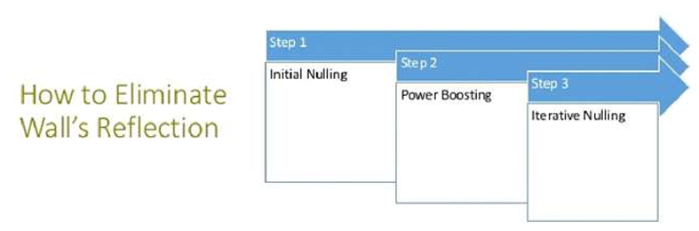

Fig.3.1 Steps for Elimination of FLASH effects

**NULLING MIMO**: To remove flash

**INITIAL NULLING:** Channel Estimation

Tx ant. 1 sends x; Rx receives y; hˆ1 ← y/x

Tx ant. 2 sends x; Rx receives y; hˆ2 ← y/x

pre-coding: p ← −hˆ1/hˆ2

**POWER BOOSTING:**

Tx antennas boost power Tx ant. 1 transmits x, Tx ant. 2 transmits px concurrently

ITERATIVE NULLING:

i ← 0

repeat

Rx receives y; hres ← y/x

if i even then

hˆ1 ← hres + hˆ1

else

hˆ2 ←(1 − hres/hˆ1)hˆ2

p ← −hˆ1/hˆ2

Tx antennas transmit concurrently

i ← i + 1

until Converges

Wi-vi eliminates flash using MIMO nulling. It limits itself to the size of 20 MHZ. Higher performance of wireless network act as a foundation for mobile business-providing employees to communicate, collaborate everywhere every time.

## Identifying and tracking humans

### **Tracking a single human**

This is a demonstration of the technology that makes use of Wi-Fi to let the users ‘see’ a person moving behind a wall. The below figure says the tracking a persons movements.

[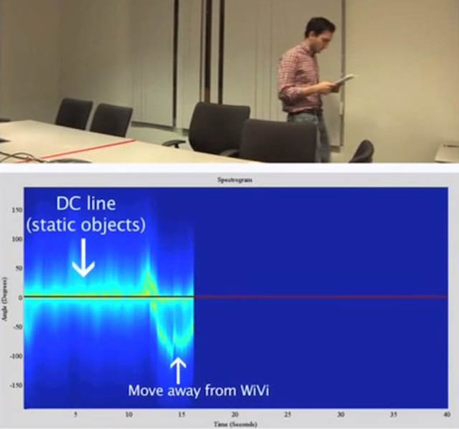](http://wonderfulengineering.com/wi-vi-uses-wifi-signals-to-track-humans/wi-vi-output/)

Fig.3.2 Tracking a person’s movements

The name is a combination of Wi-Fi and vision; get that? Wi and Vi combined! It has been proven that delicate reflections of wireless inter signals that bounce off a human can be used to track the person’s movements. However, these methods were tiresome and required either a Wi-Fi router in the same room as the person or as Professor Katabi puts it; ‘a whole truck just to carry the radio’.

Now that we have eliminated the impact of static objects in the environment, we can focus on tracking moving objects. We will refer to moving objects as humans since they are the primary subjects of interest for our application; however, our system is general, and can capture other moving bodies. Below, we first explain how Wi-Vi tracks the motion of a single human. We then show how to extend our approach to track multiple moving humans. Tracking a Single Human Most prior through-wall systems track human motion using an antenna array.

They steer the array’s beam to determine the direction of maximum energy. This direction corresponds to the signal’s spatial angle of arrival. By tracking that angle in time, they infer how the object moves in space. Wi-Vi, however, avoids using an antenna array for two reasons: First, in order to obtain a narrow beam and hence achieve a good resolution, one needs a large antenna array with many antenna elements. This would result in a bulky and expensive device. Second, since Wi-Vi eliminates the flash effect using MIMO nulling, adding multiple receive antennas would require nulling the signal at each of them. This would require adding more transmit antennas, thus making the device even bulkier and more expensive. To capture the benefits of an antenna array while avoiding its drawbacks, Wi-Vi leverages a technique called inverse synthetic aperture radar (ISAR). ISAR exploits the movement of the target to emulate an antenna array. Existing systems which use antenna arrays capture the signal reflected off a target from spatially spaced antennas and processes this information to identify the direction of the target with respect to the array. In contrast, in ISAR, there is only one receive antenna; hence, at any point in time, the receiver captures a single measurement. However, as the target moves, he/she samples the received signal at successive locations in space, as if we had a receive antenna at each of these points. Furthermore, because of channel reciprocity, successive time samples received by Wi-Vi correspond to successive spatial locations of the moving target. Hence, Wi-Vi effectively receives in time what an antenna array would receive in space. By treating consecutive time samples as spatial samples, Wi-Vi can emulate an antenna array and use it to track motion behind the wall. In what follows, we formalize the above discussion. Let y[n] be the signal sample received by Wi-Vi at a discrete time point n. Define the spatial angle θ as the angle between the line connecting the human to Wi-Vi and the normal to the motion. Note that the sign of θ is positive when the vector from the human to Wi-Vi and the vector of the motion are in the same direction, and negative when these two vectors are in opposite directions. We are interested in computing A[θ, n], a function that measures the signal along the spatial direction θ at time n. To compute this value, Wi-Vi first processes the received samples to remove the effect of the transmitted signal, and obtain the channel as a function of time, i.e., h[n] = y[n]/x[n]. ,…………………………….…(1)

To emulate an antenna array of size w, Wi-Vi considers w consecutive channel measurements h[n] ... h[n + w]. Wi-Vi then computes A[θ, n] by applying standard antenna array equations as follows:

A[θ, n] = %w i=1 h[n + i]e j 2π λ i∆ sin θ ,………………………………(2)

where λ is the wavelength, and ∆ is the spatial separation between successive antennas in the array. At any point in time n, the value of θ that produces the highest value in A[θ, n] will correspond to the direction along which the object is moving. To compute A[θ, n] from the above equation, we need to estimate ∆, the antenna spacing in the emulated array. Since human motion emulates the antennas in the array, ∆ = vT, where T is Wi-Vi’s sampling period, and v is the velocity of the motion. Of course, Wi-Vi does not know the exact speed at which the human is moving. However, the range of speeds that humans have in a confined room is fairly narrow. Hence, we can substitute a value for v that matches comfortable walking (our default is v = 1m/s). Note that errors in the value of v translate to an underestimation or an overestimation of the exact direction of the human. Errors in velocity, however, do not prevent Wi-Vi from tracking that the human is moving closer (i.e., angle is positive) or moving away from the Wi-Vi device (angle is negative). In other words, because we do not know the exact v, we cannot pinpoint the location of the human, but we can track her/his relative movements. Fig shows results from one of our experiments. In particular, Fig 3.2 shows a diagram of the movement, and plots the magnitude of A[θ, n] (in dB) as a heat map. There are two lines the first one is a zero line, which represents the DC (i.e., the average energy from static elements). This line is present regardless of the number of moving objects. Second, there is a curved line with a changing angle. This line tracks the human motion. Around n = 0 seconds, the person starts moving towards the Wi-Vi device. As a result, the spatial angle θ is positive and decreasing. (It is positive because the vector of motion and the line from the human to Wi-Vi are in the same direction, and it is decreasing because the absolute angle between the normal on the motion and the line from the human to Wi-Vi is getting smaller.) Around n = 1.8s, the person crosses in front of the Wi-Vi device, at which time his angle becomes zero. From n = 1.8s to n = 3s, the person is moving away from Wi-Vi, and hence, his angle is negative. But the absolute value of the angle is decreasing. At n = 3, the person turns and starts moving inward, causing the angle to go back toward zero, but the signal becomes weaker as he is now relatively far from the Wi-Vi receiver.

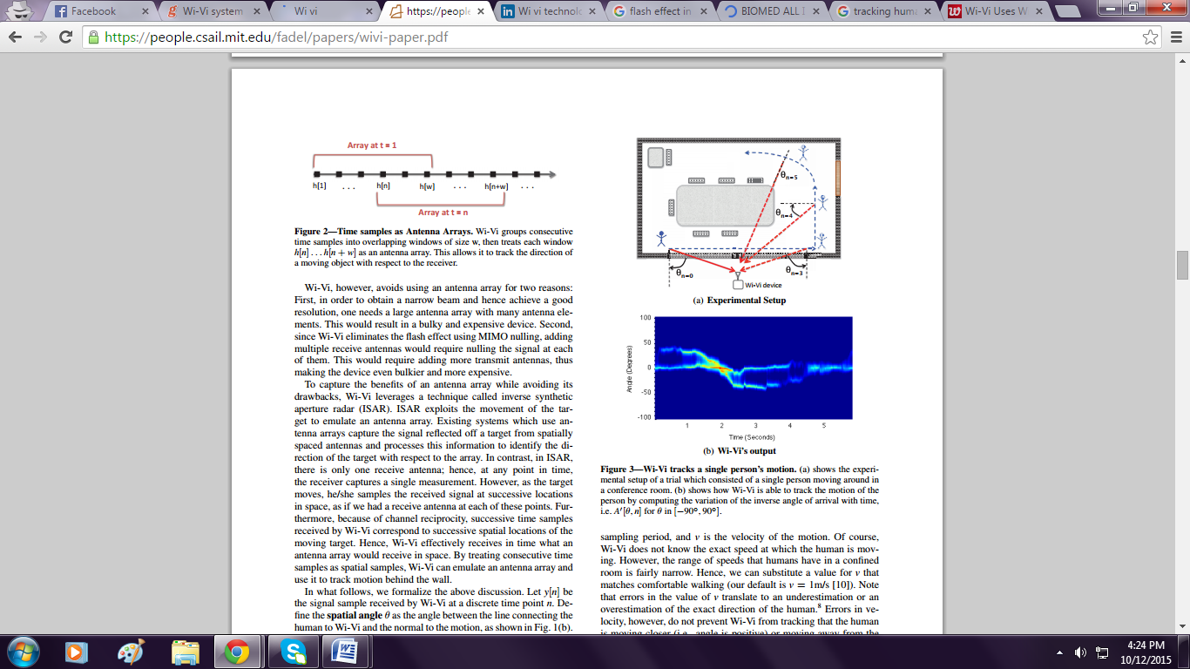

Fig.3.3 Time Samples as Antenna Arrays

### **Tracking multiple humans**

In this section, we show how Wi-Vi extends its tracking procedure to multiple humans. Our previous discussion about using human motion to emulate an antenna array still holds. However, each human will emulate a separate antenna array. Since Wi-Vi has a single antenna, the received signal will be a superposition of the antenna arrays of the moving humans. In particular, instead of having one curved line at any time, there will be as many curved lines as moving humans at that point in time.

However, with multiple humans, the noise increases significantly. On one hand, each human is not just one object because of different body parts moving in a loosely coupled way. On the other hand, the signal reflected off all of these humans is correlated in time, since they all reflect the transmitted signal. The lack of independence between the reflected signals is important. For example, the reflections of two humans may combine systematically to dim each other over some period of time. The below figure says the Experimental setup and wi-vi output.

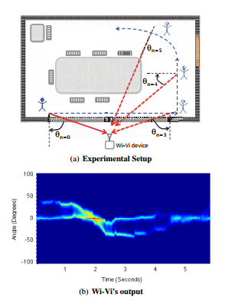

Fig.3.4 (a)Experimental Setup (b)Wi-Vi’s output

The problem of disentangling correlated super-imposed signals is well studied in signal processing. The basic approach for processing such signals relies on the smoothed MUSIC algorithm. Similar to the standard antenna array processing, smoothed MUSIC computes the power received along a particular direction, which we call A! [θ, n] because it estimates the same function in but in manner more resilient to noise and correlated signals. For a given antenna array h = (h[n], ... , h[n + w]) of size w, MUSIC first computes the w × w correlation matrix R[n]: R[n] = E[hhH], where H refers to the hermitian (conjugate transpose) of the vector. It then performs an eigen decomposition of R[n] to remove the noise and keep the strongest eigenvectors, which in our case correspond to the few moving humans, as well as the DC value. For example, in the presence of only one human, MUSIC would produce one main eigenvector (in addition to the DC eigenvector). On the other hand, if 2 or 3 humans were present, it would discover 2 or 3 eigenvectors with large eigen values (in addition to the DC eigenvector).

MUSIC partitions the eigenvector matrix U[n] into 2 subspaces: the signal space US[n] and the noise space UN[n], where the signal space is the span of the signal eigenvectors, and the noise space is the span of the noise eigenvectors. MUSIC then projects all directions θ on the null space, then takes the inverse. This causes the θ’s corresponding to the real signals (i.e., moving humans) to spike. More formally, MUSIC computes the power density along each angles θ as:

**………………………..(3)**

where K is the total number of noise eigenvectors. In comparison to the conventional MUSIC algorithm described above, smoothed MUSIC performs an additional step before it computes the correlation matrix. It partitions each array h of size w into overlapping sub-arrays of size w! < w. It then computes the correlation matrices for each of these sub-arrays. Finally, it combines the different correlation matrices by summing them up before performing the eigen decomposition. The additional step performed by smoothed MUSIC is intended to de-correlate signals arriving from spatially different entities. Specifically, by taking different shifts for the same antenna array, reflections from different bodies get shifted by different amounts depending on the distance and orientation of the reflector, which helps de-correlating them Fig.3.4 shows the result of applying smoothed MUSIC on the signal captured from two moving humans. Similar to Fig. 3.4(b), the y-axis corresponds to the angle, and the x-axis corresponds to time. As before, the zero line corresponds to DC. At any point in time, we see significant energy at two angles (besides the DC). For example, at time n = 0.5s, both humans have negative angles and, hence, are moving away from Wi-Vi. Between n = 1s and n = 2s, only one angle is present. This may be because the other human is not moving or he/she is too far inside the room. Again, from n = 2s to n = 3s, we see both humans, one moving towards the device and the other moving away (since one has a positive angle while the other has a negative angle). One point is worth emphasizing: the smoothed MUSIC algorithm is conceptually similar to the standard antenna array beam forming; both approaches aim at identifying the spatial angle of the signal. However, by projecting on the null space and taking the inverse norm, MUSIC achieves sharper peaks, and hence is often termed a super-resolution technique.

Because smoothed MUSIC is similar to antenna array beamforming, it can be used even to detect a single moving object, i.e., the presence of a single person. Any human can be only at one location at any point in time. Thus, at any point in time, the larger the number of humans, the higher the spatial variance. The spatial variance is computed as follows. First, Wi-Vi computes the spatial centroid as a function of time:

………………………….(4)

It then computes the spatial variance as:

………………..(5)

This variance is then averaged over the duration of the experiment to return one number that describes the spatial variance in the room for the duration of the measurement. Wi-Vi uses a training set and a testing set to learn the thresholds that separate the spatial variances corresponding to 0, 1, 2, or 3 humans. The testing and training experiments are conducted in different rooms. We evaluate this scheme and measure its ability at automatically capture the number of moving humans.

# 

DESIGN AND IMPLEMENTATION

## MIMO

Wi-Vi limits itself to a 20 MHz-wide Wi-Fi channel, and avoids ultra-wideband solutions used today to address the flash effect. It also disposes of the large antenna array, typical in past systems, and uses instead a smaller 3-antenna MIMO radio. So, how does Wi-Vi eliminate the flash effect without using GHz of bandwidth. We observe that we can adapt recent advances in MIMO communications to through-wall imaging. In MIMO, multiple antenna systems can encode their transmissions so that the signal is nulled (i.e., sums up to zero) at a particular receive antenna. MIMO systems use this capability to eliminate interference to unwanted receivers. In contrast, we use nulling to eliminate reflections from static objects, including the wall. Specifically, a Wi-Vi device has two transmit antennas and a single receive antenna.

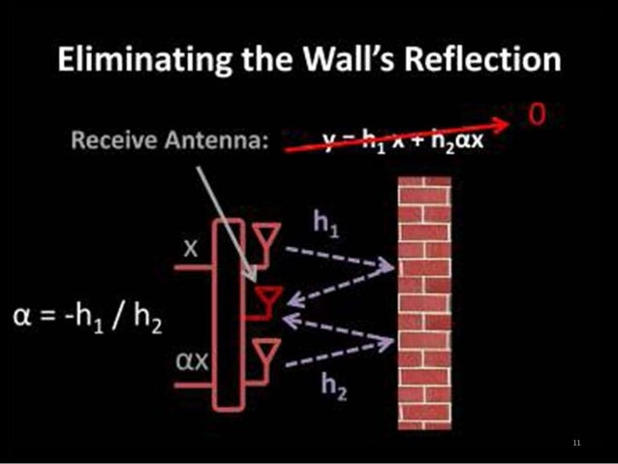

Fig.4.1 Eliminating the Wall’s Reflection

Wi-Vi uses Wi-Fi OFDM signals in the ISM band (at 2.4GHz) and typical Wi-Fi hardware. It is a 3-antenna MIMO device: Two of the antennas being transmitters and the other a receiver. It also employs directional antennas to focus the energy toward the wall or room of interest. Its design incorporates two main components:

1. The ﬁrst component eliminates the ﬂash reﬂected off the wall.

2. The second component tracks a moving object by treating the object itself as an antenna array.

## Gesture based communication

For a human to transmit a message to a computer wirelessly, she typically has to carry a wireless device. In contrast, Wi-Vi can enable a human who does not carry any wireless device to communicate commands or short messages to a receiver using simple gestures. Wi-Vi designates a pair of gestures as a ‘0’ bit and a ‘1’ bit. A human can compose these gestures to create messages that have different interpretations. Additionally, Wi-Vi can evolve by borrowing other existing principles and practices from today’s communication systems, such as adding a simple code to ensure reliability, or reserving a certain pattern of ‘0’s and ‘1’s for packet preambles. At this stage, Wi-Vi’s interface is still very basic, yet we believe that future advances in through-wall technology can render this interface more expressive. Below, we describe the gesture-based communication channel that we implemented with Wi-Vi.

## Gesture Encoding

At the transmitter side, the ‘0’ and ‘1’ bits must be encoded using some modulation scheme. Wi-Vi implements this encoding using gestures. One can envision a wide variety of gestures to represent these bits. However, in choosing our encoding we have imposed three conditions:

1. the gestures must be composable – i.e. at the end of each bit, whether ‘0’ or ‘1’, the human should be back in the same initial state as the start of the gesture. This enables the person to compose multiple such gestures to send a longer message.
2. The gestures must be simple so that a human finds it easy to perform them and compose them.
3. The gestures should be easy to detect and decode without requiring sophisticated decoders, such as machine learning classifiers.

Given the above constraints, we have selected the following gestures to modulate the bits: a ‘0’ bit is a step forward followed by a step backward; a ‘1’ bit is a step backward followed by a step forward. This modulation is similar to Manchester encoding, where a ‘0’ bit is represented by a falling edge of the clock, (i.e., an increase in the signal value followed by a decrease,) and a ‘1’ bit is represented by a rising edge of the clock, (i.e., a reduction in signal value followed by an increase). These gestures are simple, composable and easy to decode. Fig.4.1 shows the signal captured by Wi-Vi, at the output of the smoothed MUSIC algorithm for each of these two gestures. Taking a step forward towards the Wi-Vi device produces a positive angle, whereas taking a step backward produces a negative angle. The exact values of the produced angles depend on whether the human is exactly oriented towards the device. Recall that the angle is between the vector orthogonal to the motion and the line connecting the human to the Wi-Vi device, and its sign is positive when the human is moving toward Wi-Vi and negative when the human moves away from Wi-Vi. As shown in Fig.4.1, if the human is directly oriented towards the device, the two angles are +90◦ and -90◦. If the human does not know the exact location of the Wi-Vi device and simply steps in its general direction, the absolute value of the angle is smaller, but the shape of the bit is maintained.

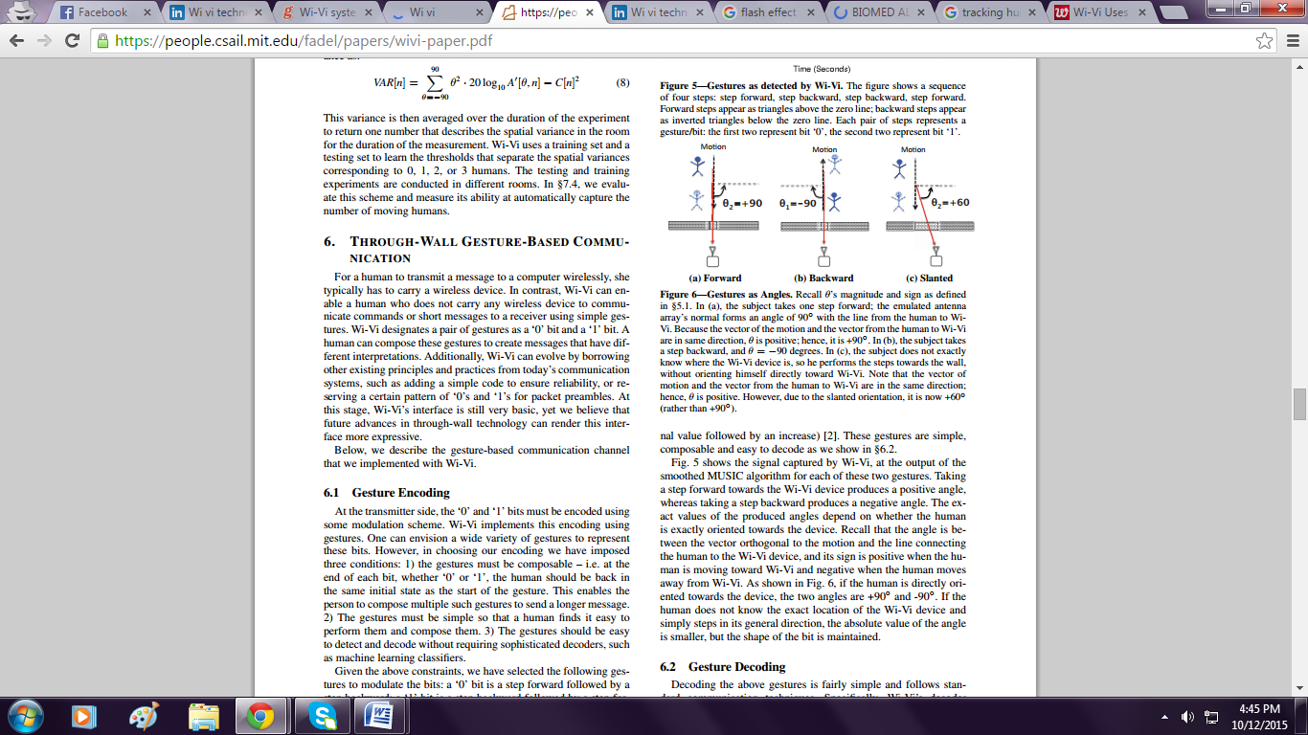

Fig.4.2 Gestures As Angles(Output)

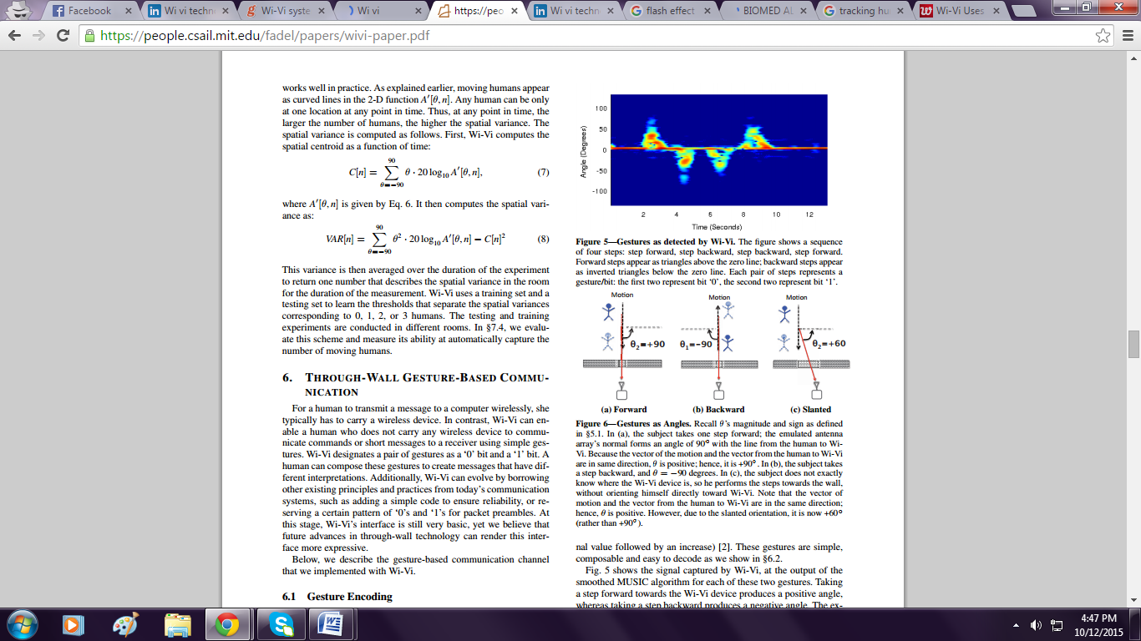

Fig.4.3 Output Of Gesture Encoding

### **Gesture Decoding**

Decoding the above gestures is fairly simple and follows standard communication techniques. Specifically, Wi-Vi’s decoder takes as input A[θ, n]. Similar to a standard decoder, Wi-Vi applies a matched filter on this signal. However, since each bit is a combination of two steps, forward and backward, Wi-Vi applies two matched filters: one for the step forward and one for the step backward. Because of the structure of the signal shown in Fig. 4.2, the two matched filters are simply a triangle above the zero line, and an inverted triangle below the zero line. Wi-Vi applies these filters separately on the received signal, then adds up their output. Fig. 4.3 shows the results of applying the matched filters on the received signal in

Note that the signal after applying the matched filters looks fairly similar to a BPSK signal, where a peak above the zero line represents a ‘1’ bit and a trough below the zero line represents a ‘0’ bit. (Though, in Wi-Vi, our encoding is such that a peak or a trough alone only represents half a bit.) Next, WiVi uses a standard peak detector to detect the peaks/troughs and match them to the corresponding bits. Fig.4.2 shows the identified peaks and the detected bits for the two-bit message. The below figure says the Gesture decoding.

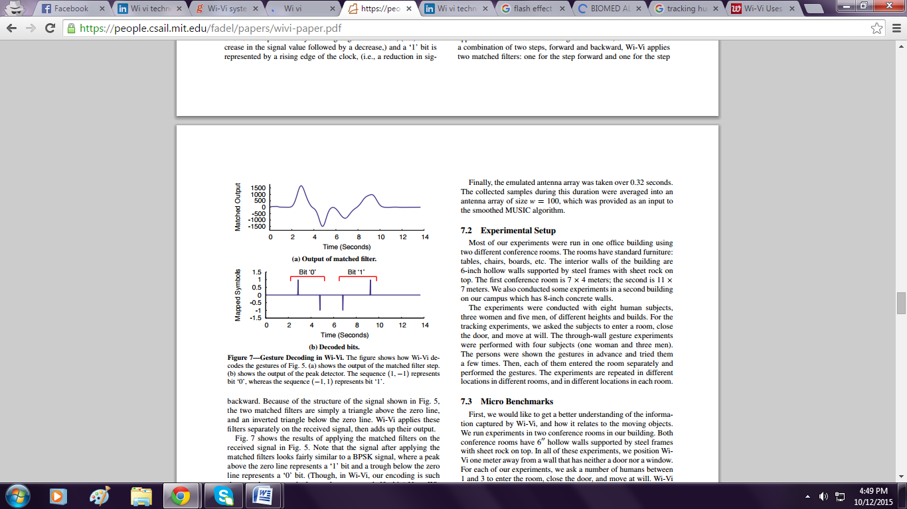

Fig.4.4 Gesture Decoding

Wi-Vi’s ability to decode the bits associated with the gestures. In each experiment, a human is asked to stand at a particular distance from the wall that separates the room from our device, and perform the two gestures corresponding to bit ‘0’ and bit ‘1’. Each human took steps at a length they found comfortable. Typical step sizes were 2-3 feet. The experiments are repeated at various distances in the range [1m, 9m]. All experiments are conducted in the same conference rooms described above and under the same experimental conditions.

One of our conference rooms is only 7m wide, whereas the other is 11m wide. Hence, the experiments with distances larger than 6 meters are conducted in the larger conference room, whereas for all distances less than or equal 6 meters, our experiments included trials from both rooms. The obtained traces are processed using the matched filter.

## Implementation of Wi-Vi Technology

Wi-Vi operates in two stages. In the first stage, it measures the channels from each of its two transmit antennas to its receive antenna. In stage 2, the two transmit antennas use the channel measurements from stage 1 to null the signal at the receive antenna.

Since wireless signals (including reflections) combine linearly over the medium, only reflections off objects that move between the two stages are captured in stage 2. Reflections off static objects, including the wall, are nulled in this stage.

We can refine this basic idea by introducing iterative nulling, which allows us to eliminate residual flash and the weaker reflections from static objects behind the wall.

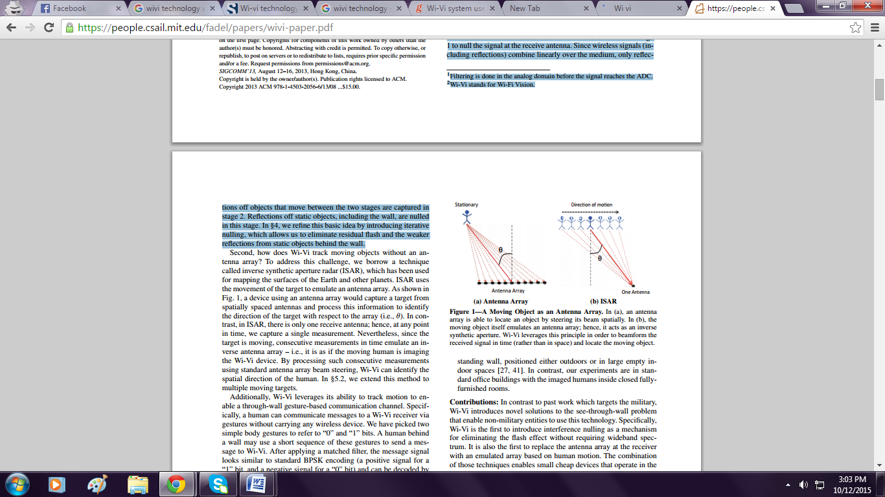

Fig.4.5 Antenna Array Fig.4.6 The Moving Object

Emulates An Antenna

Second, how does Wi-Vi track moving objects without an antenna array? To address this challenge, we borrow a technique called inverse synthetic aperture radar (ISAR), which has been used for mapping the surfaces of the Earth and other planets. ISAR uses the movement of the target to emulate an antenna array. As shown in Fig.4.5, a device using an antenna array would capture a target from spatially spaced antennas and process this information to identify the direction of the target with respect to the array (i.e., θ). In contrast, in ISAR, there is only one receive antenna; hence, at any point in time, we capture a single measurement. Nevertheless, since the target is moving, consecutive measurements in time emulate an inverse antenna array – i.e., it is as if the moving human is imaging the Wi-Vi device. By processing such consecutive measurements using standard antenna array beam steering, Wi-Vi can identify the spatial direction of the human. Later, we extend this method to multiple moving targets.

Additionally, Wi-Vi leverages its ability to track motion to enable a through-wall gesture-based communication channel. Specifically, a human can communicate messages to a Wi-Vi receiver via gestures without carrying any wireless device. We have picked two simple body gestures to refer to “0” and “1” bits.

A human behind a wall may use a short sequence of these gestures to send a message to Wi-Vi. After applying a matched filter, the message signal looks similar to standard BPSK encoding (a positive signal for a “1” bit, and a negative signal for a “0” bit) and can be decoded by considering the sign of the signal. The system enables law enforcement personnel to communicate with their team across a wall, even if their communication devices are confiscated.

# 

TESTING AND RESULTS ANAYLSIS

## Testing

Evaluating Wi-Vi’s performance with different building materials. Thus, in addition to the two conference rooms described before, we also test Wi-Vi in a second building in our university campus, where the walls are different. In particular, we experiment with 4 types of building materials: 8cm concrete wall, 6cm hollow wall supported by steel frames with sheet rock on top, 1.75cm solid wood door, and tinted glass. In addition, we perform experiments in free space with no obstruction between Wi-Vi and the subject.

In each experiment, the subject is asked to stand 3 meters away from the wall (or Wi-Vi itself in the case of no obstruction) and perform the ‘0’ bit gesture described above. For each type of building material, we perform 8 experiments. Wi-Vi’s performance across different building materials. Specifically, the detection rate as the fraction of experiments in which Wi-Vi correctly decoded the gesture, whereas the average SNRs of the gestures.

The figures show that Wi-Vi can detect humans and identify their gestures across various indoor building materials: tinted glass, solid wood doors, 6’’ hollow walls, and to a large extent 8!! concrete walls. As expected, the thicker and denser the obstructing material, the harder it is for Wi-Vi to capture reflections from behind it. Detecting humans behind different materials depends on Wi-Vi’s power as well as its ability to eliminate the flash effect. plots the CDF of the amount of nulling (i.e., reduction in SNRs) that WiVi achieves in various experiments. The plot shows Wi-Vi’s nulling reduces the signal from static objects by a median of 40 dB. This number indicates that Wi-Vi can eliminate the flash reflected off common building material such as glass, solid wood doors, interior walls, and concrete walls with a limited thickness.

However, it would not be able to see through denser material like re-enforced concrete. To improve the nulling, one may use a circulator at the analog front end or leverage recent advances in full-duplex radio.

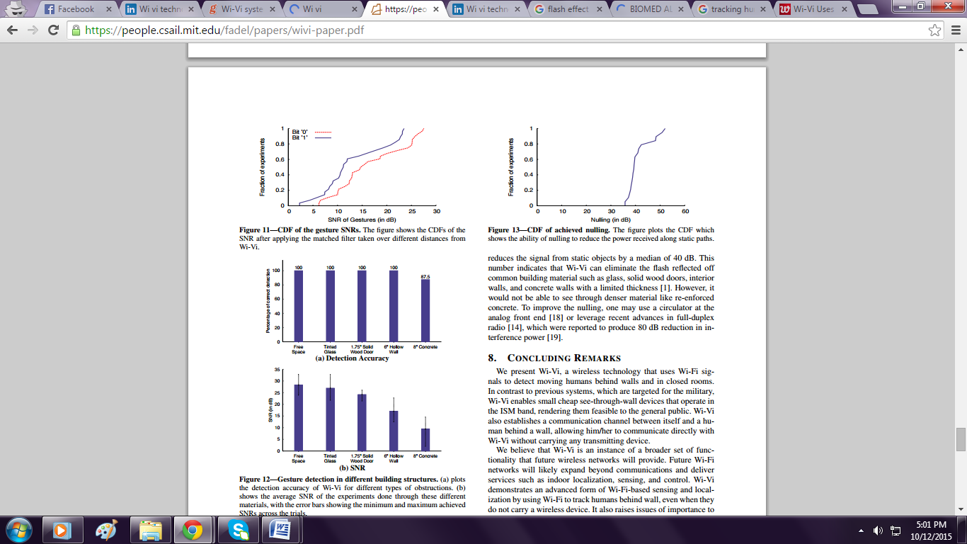.

Fig.5.1 Cdf of The Gesture Sensors Fig.5.2 Cdf of Achieved Nulling



Fig.5.3 Gesture Detection in Different Building Structures

## Result Analysis

* Wi-Vi can detect objects and humans moving behind opaque structural obstructions. This applies to 8!! concrete walls, 6’’ hollow walls, and 1.75’’ solid wooden doors.
* A Wi-Vi device pointed at a closed room with 6’’ hollow walls supported by steel frames can distinguish between 0, 1, 2, and 3 moving humans in the room. Computed over 80 trials with 8 human subjects, Wi-Vi achieves an accuracy of 100%, 100%, 85%, and 90% respectively in each of these cases.
* In the same room, and given a single person sending gesture-based messages, Wi-Vi correctly decodes all messages performed at distances equal to or smaller than 5 meters. The decoding accuracy decreases to 75% at distances of 8 meters, and the device stops detecting gestures beyond 9 meters. For 8 volunteers who participated in the experiment, on average, it took a person 8.8 seconds to send a message of 4 gestures.
* In comparison to the state-of-the-art ultra-wideband see-through wall radar, Wi-Vi is limited in two ways. First, replacing the antenna array by ISAR means that the angular resolution in Wi Vi depends on the amount of movement. To achieve a narrow beam the human needs to move by about 4 wavelengths (i.e., about 50 cm). Second, in contrast to, we cannot detect humans behind concrete walls thicker than 8’’. This is due to both the much lower transmit power from our USRPs and the residual flash power from imperfect nulling.
* On the other hand, nulling the flash removes the need for GHz bandwidth. It also removes clutter from all static reflectors, rather than just one wall. This includes other walls in the environments as well as furniture inside and outside the imaged room.

# 

ADVANTAGES AND LIMITATIONS

## Advantages

* Emergency responders can make use of it.
* It Can be used for gaming purpose.
* Intruder detection and even monitoring children/elder for personal security.
* It also enables to send and receives the messages.
* It enables end-users to get convenient, with high speed, access, thereby maintaining a peace of mind.
* Causes extension of human vision beyond visible electromagnetic range, allowing to detect object.
* Wi-Vi is relatively a low-power, low-cost, low- bandwidth, and accessible to average users.
* Wi-Vi requires only few MHz of bandwidth and operates in the same range as Wi-Fi. It operates in ISM band.
* Wi-Vi can perform through-wall imaging without access to any device the other side of the wall.
* Wi-Vi employs signals whose wavelengths are 12.5 cm.
* Extend human vision beyond the visible electromagnetic range, allowing us to detect objects in the dark or in smoke.

## Limitations

* Display has very low resolution.
* We cannot detect humans behind concrete walls thicker than 8".
* To achieve a narrow beam the human needs to move by about 4 wavelengths

(i.e., about 50 cm).

# 

APPLICATIONS

**Law enforcement**: Law enforcement personal can use the device to avoid walking into an ambush, and minimize causalities in hostage and standoffs situations.

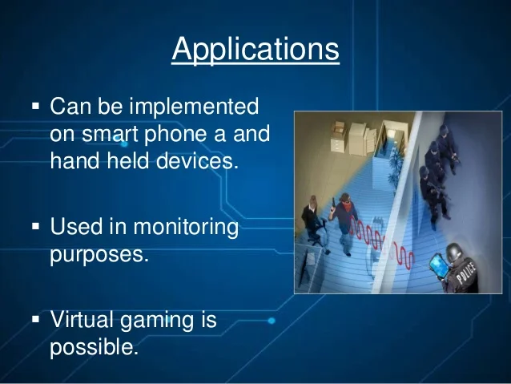

Fig.7.1 Law enforcement

**Emergency situations**: Emergency responders can use wi-vi to see through rubble and collapsed structures.

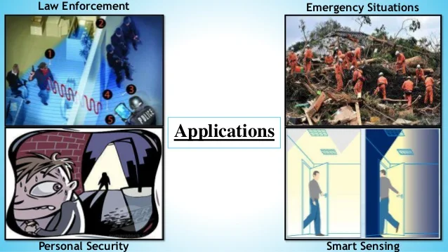

Fig.7.2 Emergency situations

**Smart Sensing**: This Wi-Vi technology can be extended to sense motion in different parts of a building and allow automated control of heating or cooling and lighting systems.



Fig.7.3 Smart Sensing

**Personal Security**: Common users can use it for intrusion detection and when stepping into dark alleys and unknown places.

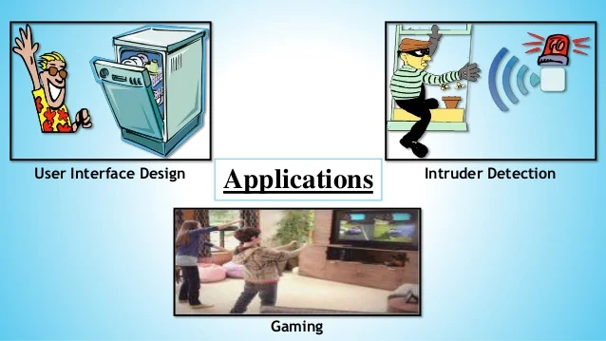

Fig.7.4 Personal Security

**Entertainment**: It enables a new dimension for input output devices in gaming which does not affect on occlusion and works in non-line-of-sight.

**User Interface Design**: This technology may also be leveraged in the future to enable the controlling household appliances via gestures, and non-invasive monitoring of children and elderly.



Fig.7.5 User Interface Design

# 

CONCLUSION AND FUTURE SCOPE

“Seeing through walls is not yet the stuff of superheroes, it is becoming a reality in our day to day life with wireless vision technology”. Wi-vi is tend to be the technology that is affordable, cheap and simple. It can be easily accessible for any kind of public. It can be therefore termed as modern evolution for communication that provides safety in problems, alert during the danger, make as smart from its features gives as the ability to defend the problems. Wi-vi is the technology with full power and its believed to become more powerful in future with virtual reality.

Future Scope Evolution of seeing humans through denser building material and with a longer range. Wi-Vi could be built into a Smartphone or a special handheld device. Wi-Vi, a wireless technology that uses Wi-Fi signals to detect moving humans behind walls and in closed rooms. In contrast to previous systems, which are targeted for the military, Wi-Vi enables small cheap see-through-wall devices that operate in the ISM band, rendering them feasible to the general public, without carrying any transmitting device.

* + - Wi-vi could be built in a smartphone or special handheld devices.
    - Evolution of seeing human beings through denser building material with longer range.
    - High quality images.

Wi-Vi, a wireless technology that uses Wi- Fi signals to detect moving humans behind walls or doors and also in closed rooms. Wi-Vi also builds a communication channel between a human behind a wall or in a closed room and device itself, allowing person to communicate directly with Wi-Vi without carrying any of transmitting device. We believe that Wi-Vi has a set of functionality that future Wireless networks will provide. Future Wi-Fi networks will likely expand beyond communications and deliver facilities such as indoor localization, sensing as well as control. Wi-Vi gives evidence of advanced form of Wi- Fi-based sensing and localization by using Wi-Fi to track humans behind wall without carrying any wireless device.

REFERENCES

1. Vidyasagar S.D, Seema, “A Study on Applications of Wi-Vi Technology”, International Journal of Computer Sciences and Engineering, 2019.
2. Sudarshan Adeppa, “Detection of Objects across the Walls with Wi-Fi Technology”, International Journal on Emerging Technologies, 2015.
3. Adib, Fadel, and Dina Katabi, “See through Walls with Wi-Fi,” Proceedings of the ACM SIGCOMM Conference, 2013.
4. Prerna Garg, Shikha, “Wi-Vi Technology”, International Journal of Advance Research In Science And Engineering, Vol. No.2, Issue No.9, September 2013.
5. K. Chetty, G. Smith, and K. Woodbridge, “Through-the-wall sensing of personnel using passive bistatic Wi-Fi radar at standoff distances,” IEEE Trans. Geoscience and Remote Sensing, 2012.
6. S. Ram and H. Ling, “Through-wall tracking of human movers using join doppler and array processing,” IEEE Geoscience and Remote Sensing Letters, 2008.