**ACS 545 CRYPTOGRAPHY AND NETWORK SECURITY**

**LAB1**

**DHANUSHA MALLAVAJJALA**

**STEP1-**

Install Virtual Box.

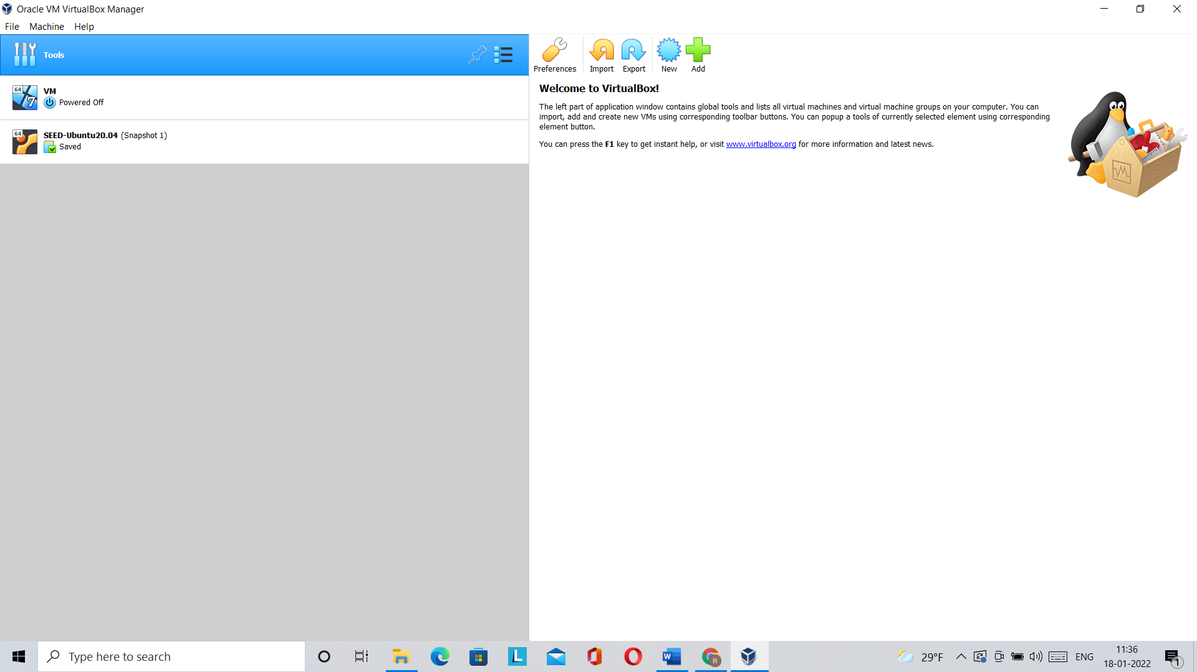

**STEP 2-**

Creating New VM in Virtual Box and providing name and memory size.

**STEP 3-**

Selecting Pre-built VM File and then configure VM and enable copy paste options.

**STEP 4-**

Modify info about CPU, Display, Network

**Details of VM-**

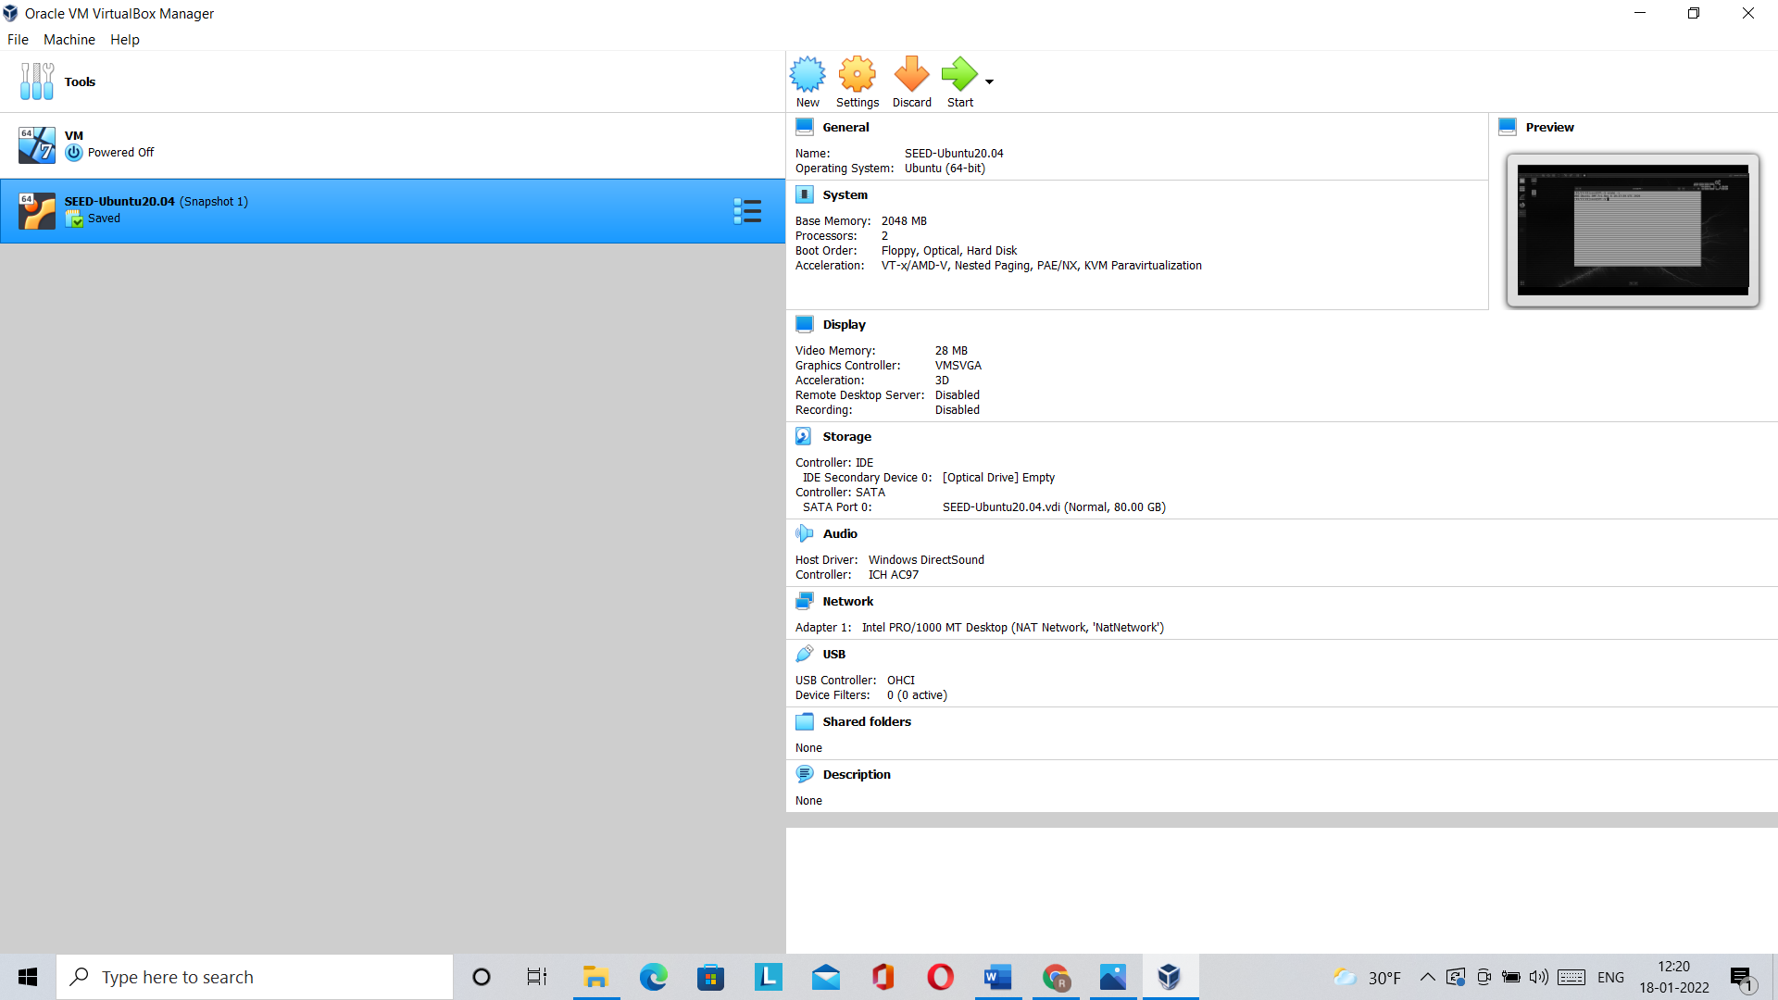

**Final Output-**

