RAG with Built-In Evaluation, Guardrails & Observability

The Problem
Most RAG systems are built and shipped without any way to know if they're actually working. Teams eyeball a few outputs, decide "looks good," and ship — then the system hallucinates, retrieves irrelevant context, or silently degrades when a chunking parameter or embedding model changes. There's no feedback loop: no automated way to catch a regression before a user does.
This project treats that gap as the actual problem to solve. Instead of building a naive RAG app, it builds a production-grade RAG pipeline with an automated measurement and guardrail system attached to it — every configuration change (chunk size, retrieval strategy, reranker on/off, query expansion) is run through a fixed evaluation set and scored, so decisions are based on numbers instead of vibes.

Architecture
Markdown docs -> Ingestion (src/ingest.py) LlamaIndex: structure-aware chunking
|
Chroma (dense) + BM25 (sparse)
|
Multi-Query Expansion & RRF
|
Cross-encoder reranker
|
Generation (src/rag_chain) LangChain + Groq / OpenAI / Ollama
|
RAGAS eval | LangSmith trace | Prometheus metrics | Groundedness Guardrail
|
eval_results/history.csv -> Streamlit dashboard (dashboard/app.py)

Why each piece is there
Component | Purpose
Structure-aware chunking (LlamaIndex) | Splits on Markdown headers first, preserving section context, instead of blind fixed-size splitting
Hybrid retrieval (Chroma + BM25 + RRF) | Dense search misses exact terms (error codes, names); BM25 catches them; RRF fuses both rankings seamlessly
Multi-Query Expansion | Generates alternative query perspectives using LLM heuristics and fuses candidate sets for higher recall
Cross-encoder reranker | First-stage retrieval is fast but approximate; reranking re-scores top candidates with a cross-encoder model
Real-Time Groundedness Guardrail | Evaluates response claims against retrieved source documents to detect potential hallucinations before display
RAGAS evaluation harness | Quantifies 4 core metrics (faithfulness, answer relevancy, context precision, context recall) against a golden dataset
LangSmith + Prometheus + Grafana | Per-query tracing + time-series metric tracking (latency breakdown, request counts) for production monitoring
Multi-Provider Support | Works with local Ollama or cloud providers (Groq, OpenAI) via environment configuration

Setup
python -m venv venv && source venv/bin/activate # Windows: .\venv\Scripts\activate
pip install -r requirements.txt
# (Optional) For cloud deployment, set your API key in .env
echo "GROQ_API_KEY=your_groq_key_here" > .env

Running It
1. Ingest the corpus:
python src/ingest.py --config-name default --chunk-size 512 --chunk-overlap 64
2. Interactive Chat Application (Streamlit):
streamlit run chat_app.py
3. Run evaluation across pipeline configurations:
python src/eval.py --config-name default --retrieval-mode dense --run-label "dense only"
python src/eval.py --config-name default --retrieval-mode hybrid --run-label "hybrid, no rerank"
python src/eval.py --config-name default --retrieval-mode hybrid --use-reranker --run-label "hybrid + rerank"
python src/eval.py --config-name default --retrieval-mode hybrid --use-reranker --use-query-expansion --run-label "hybrid + rerank + multi-query"
4. View the Evaluation & Benchmark Dashboard:
streamlit run dashboard/app.py
5. Containerized Docker / Observability Stack:
docker build -t rag-eval-observability .
docker run -p 8501:8501 rag-eval-observability
cd monitoring && docker compose up -d

Screenshots

Auth & onboarding
Registration and login are gated per-user, and each user gets an isolated Chroma collection ("adi1" in the example below) so knowledge bases don't bleed across accounts.
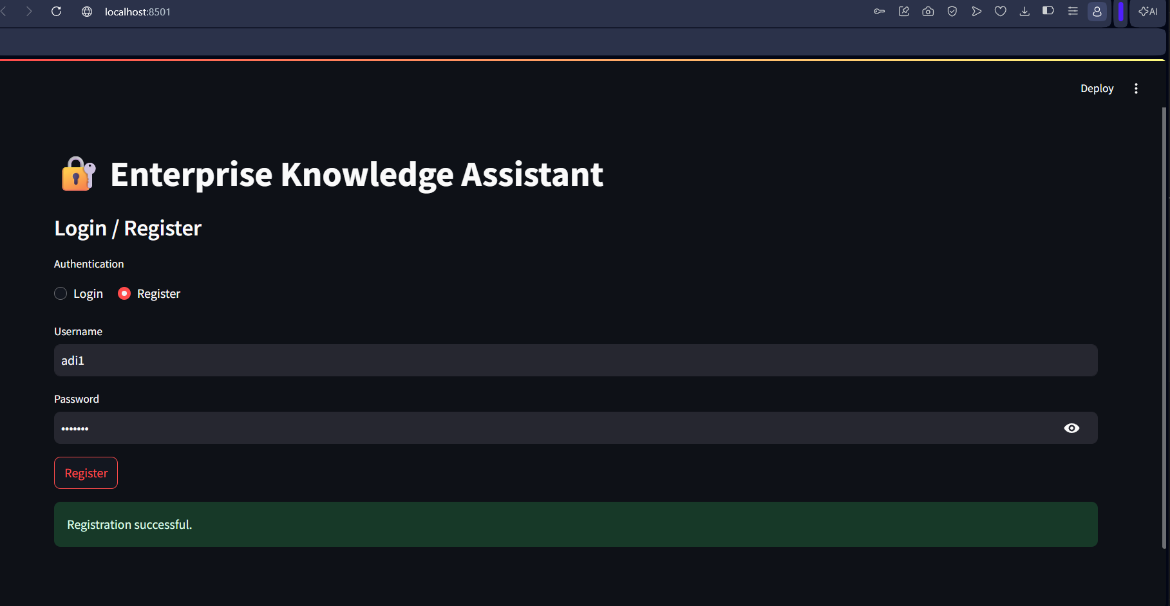
Registration
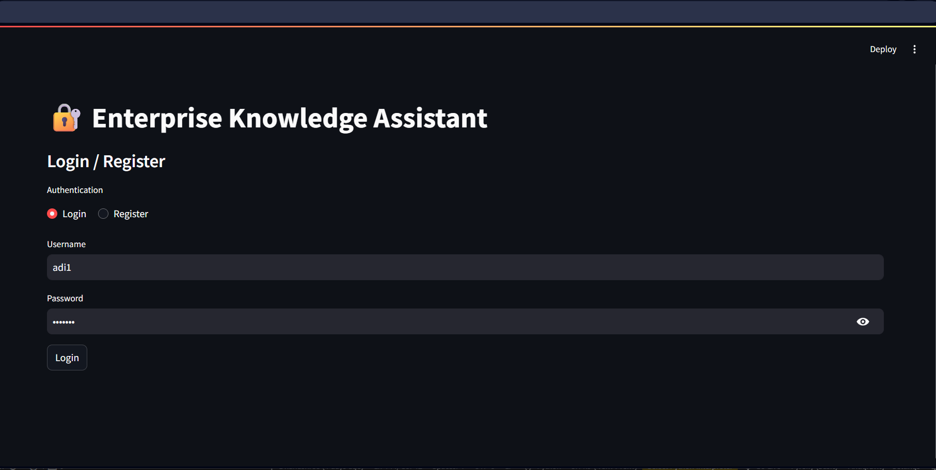
Login
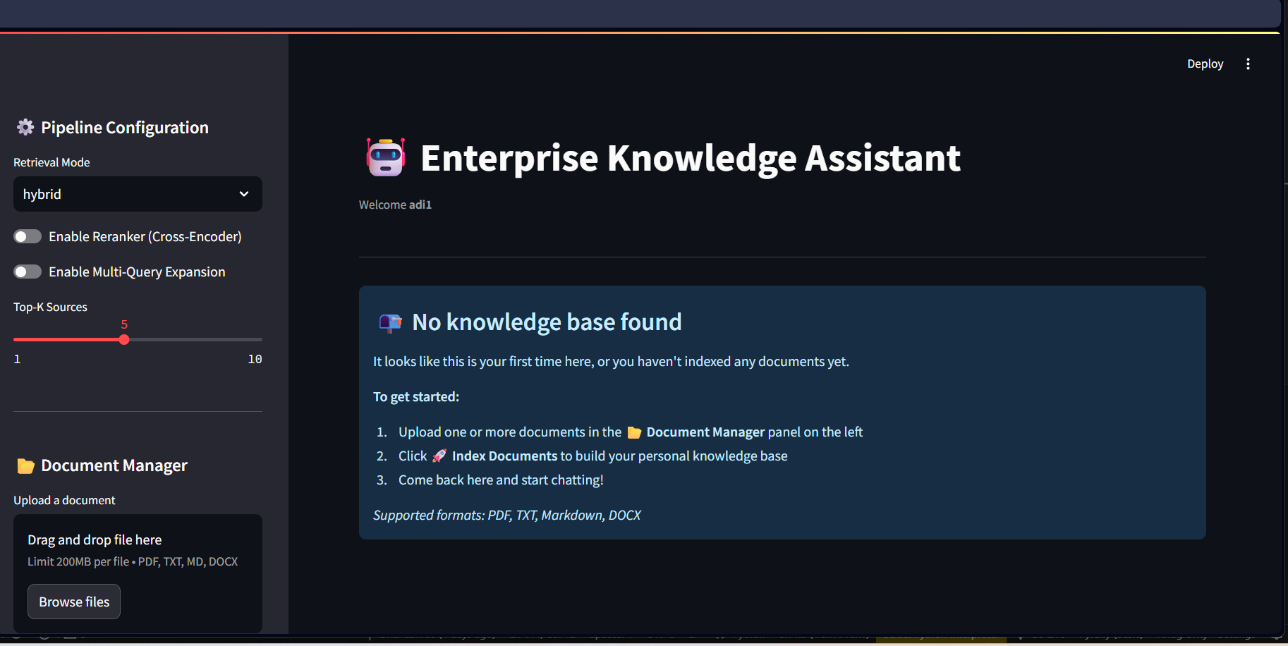
Empty state before any documents are indexed

Ingestion in the terminal
src/ingest.py chunking and embedding a document, then indexing into both the dense (Chroma) and sparse (BM25) stores.
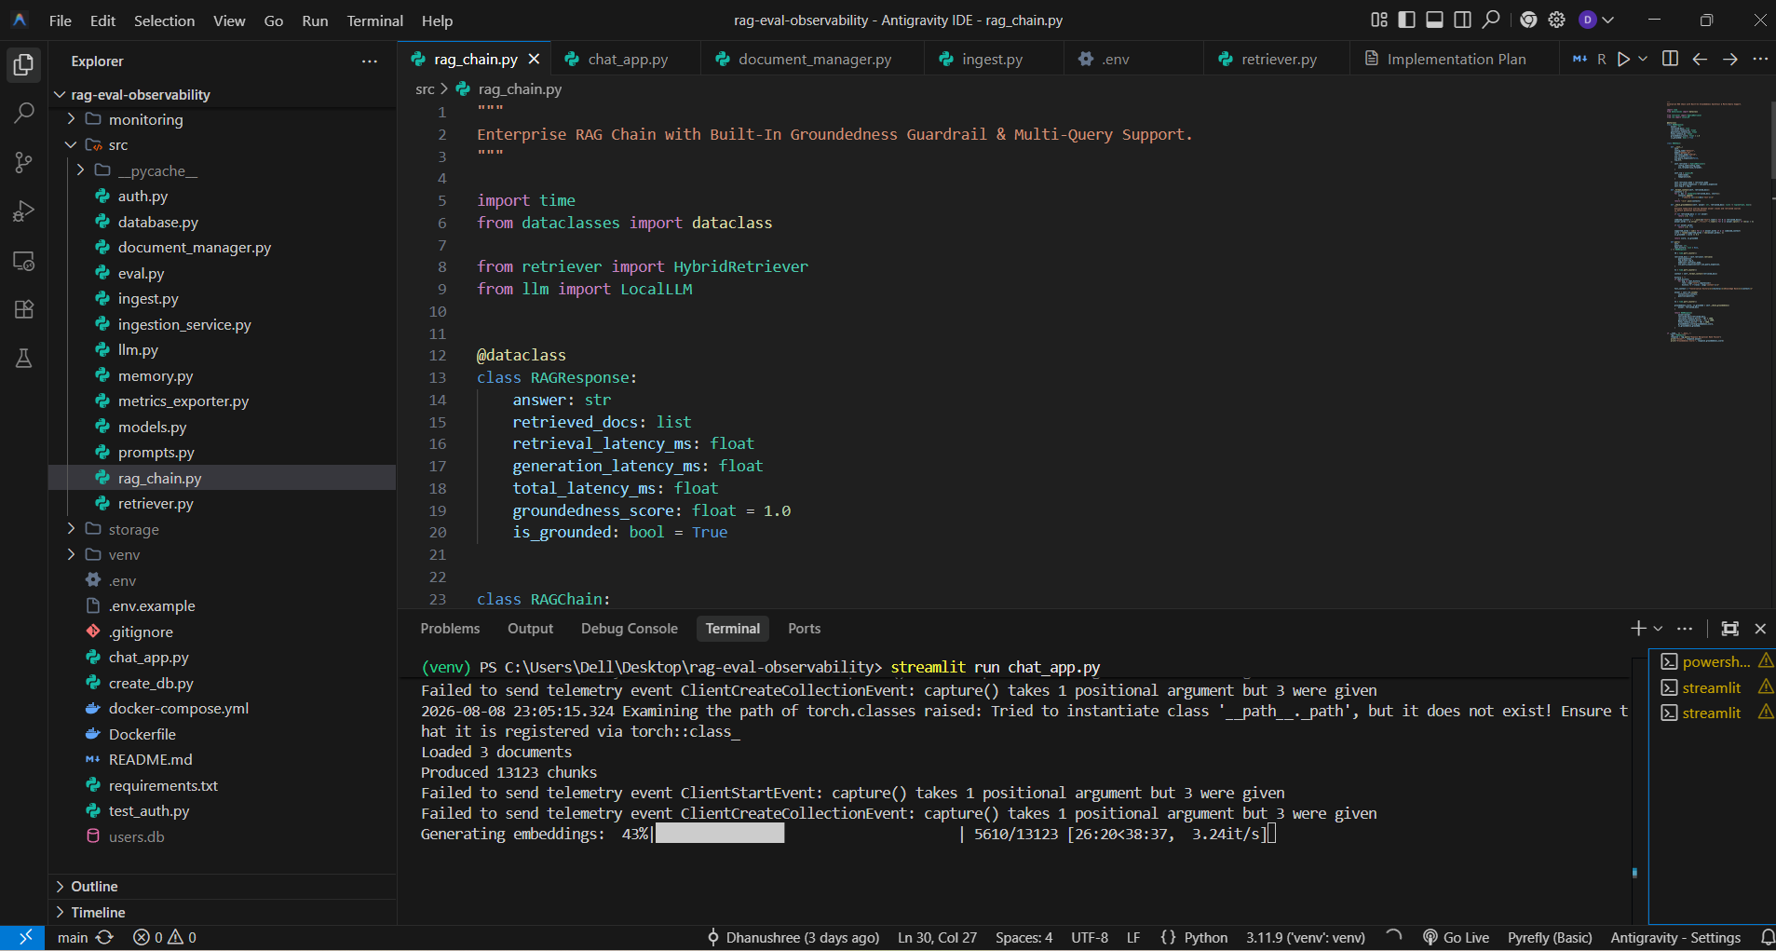
Embedding generation in progress
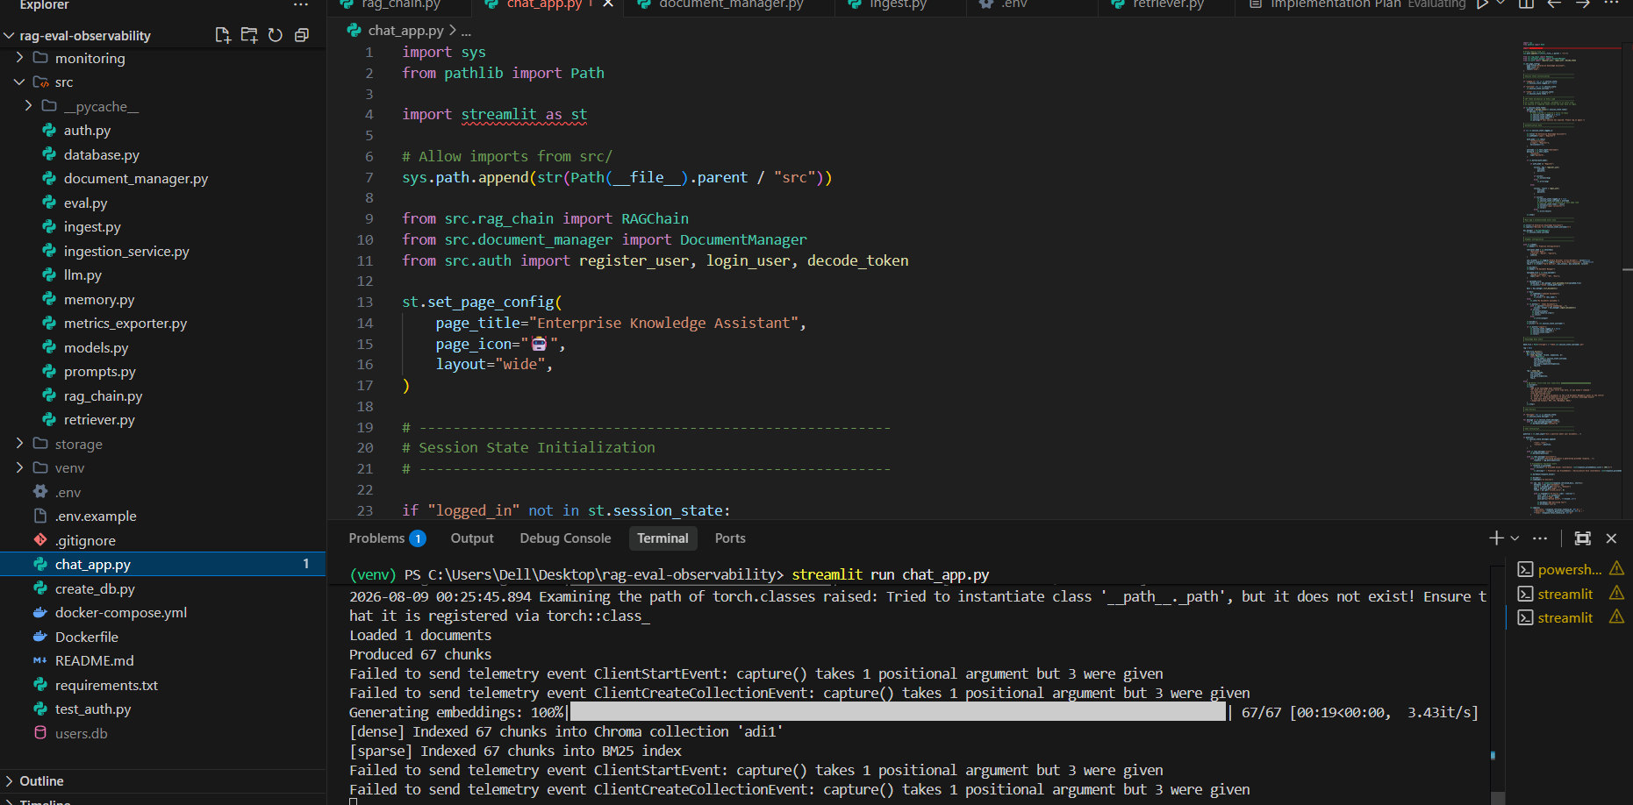
Indexed into Chroma (dense) and BM25 (sparse)
Note: the "Failed to send telemetry event... capture() takes 1 positional argument but 3 were given" lines are a known, harmless ChromaDB/PostHog telemetry version-mismatch warning — they don't affect ingestion or retrieval.

Chat app
Hybrid retrieval answering questions with inline source citations, and the groundedness guardrail surfacing a confidence score alongside expandable source chunks.
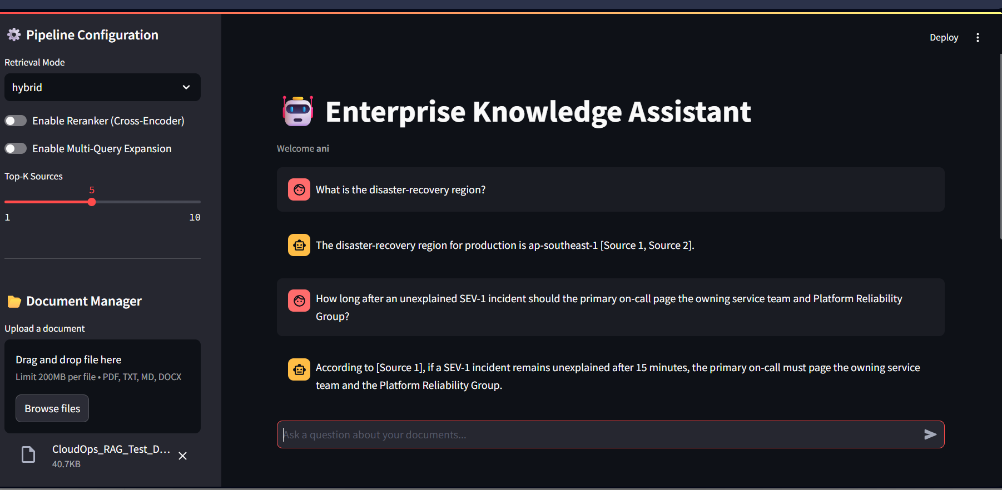
Chat Q&A with cited sources
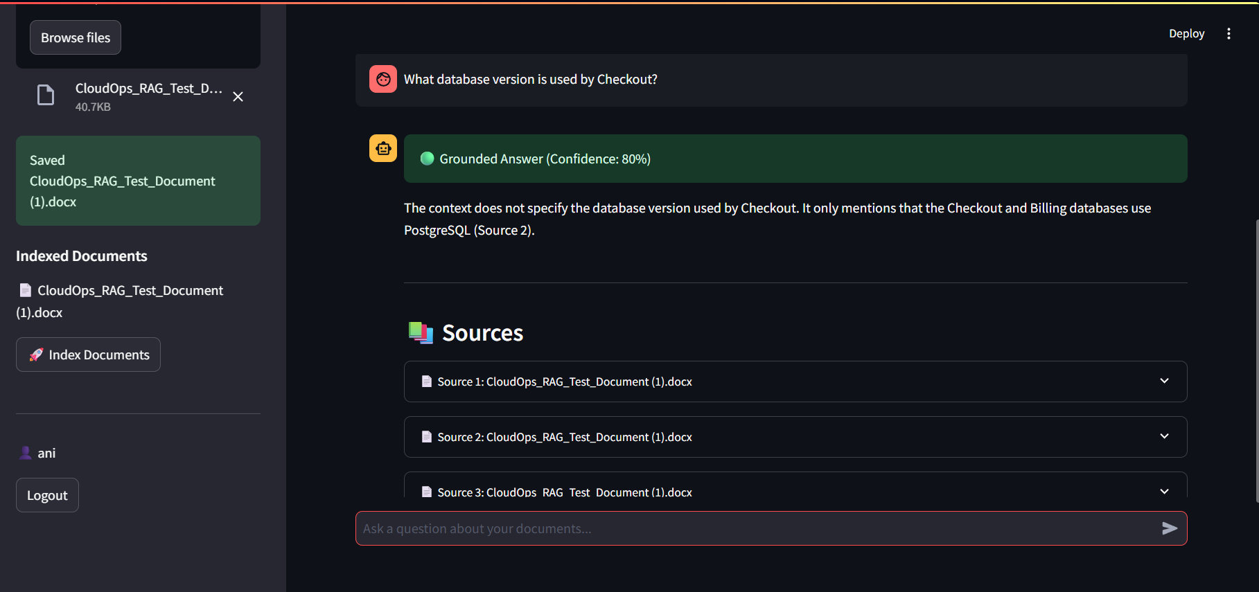
Grounded answer with confidence score and expandable sources

Evaluation dashboard
Triggering a RAGAS run from the UI, latest-run scorecards, metric trends over time, the latency-vs-quality trade-off across configs, and full run history for comparison.
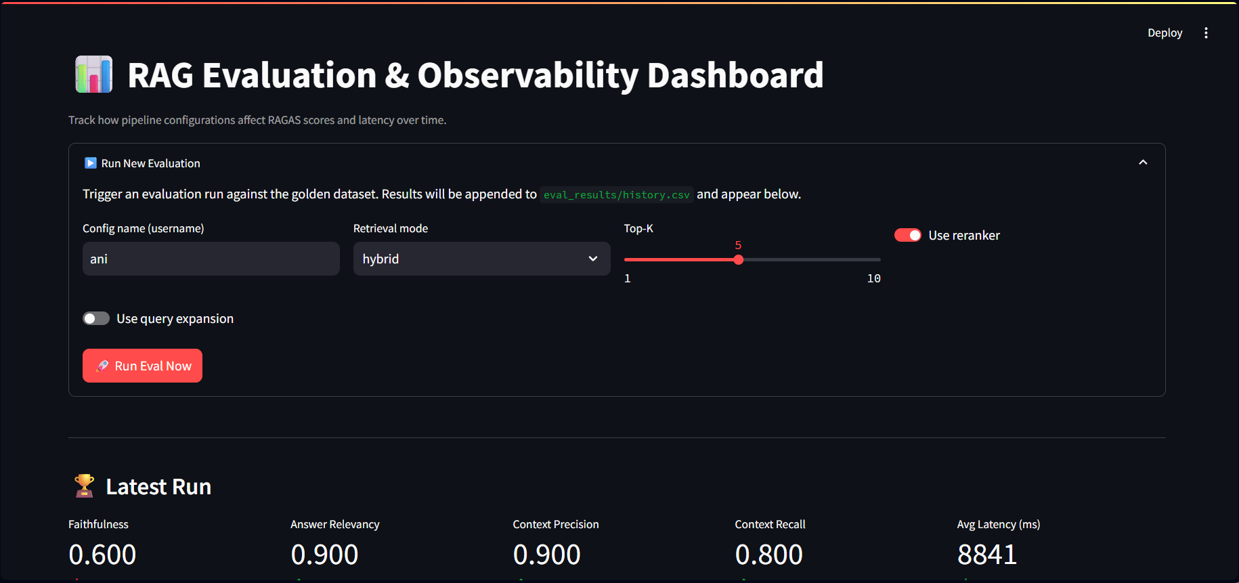
Run New Evaluation + Latest Run scorecards
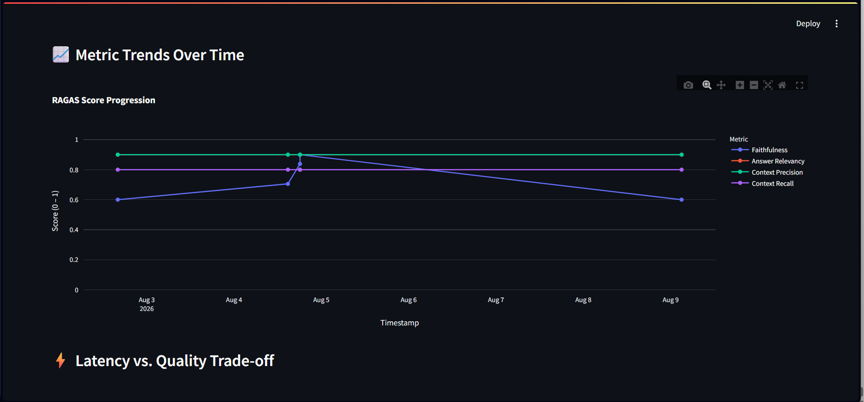
RAGAS score progression over time
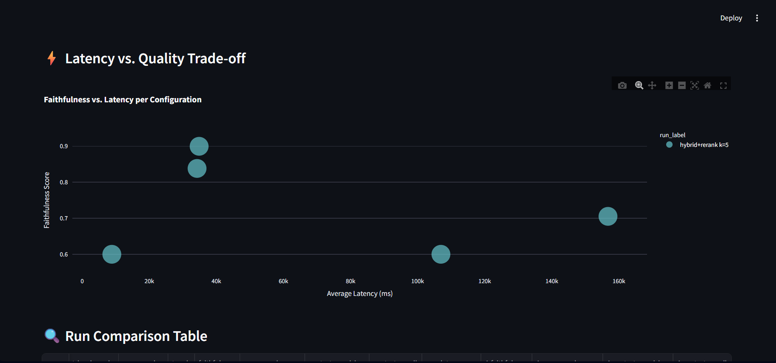
Latency vs. quality trade-off across configs
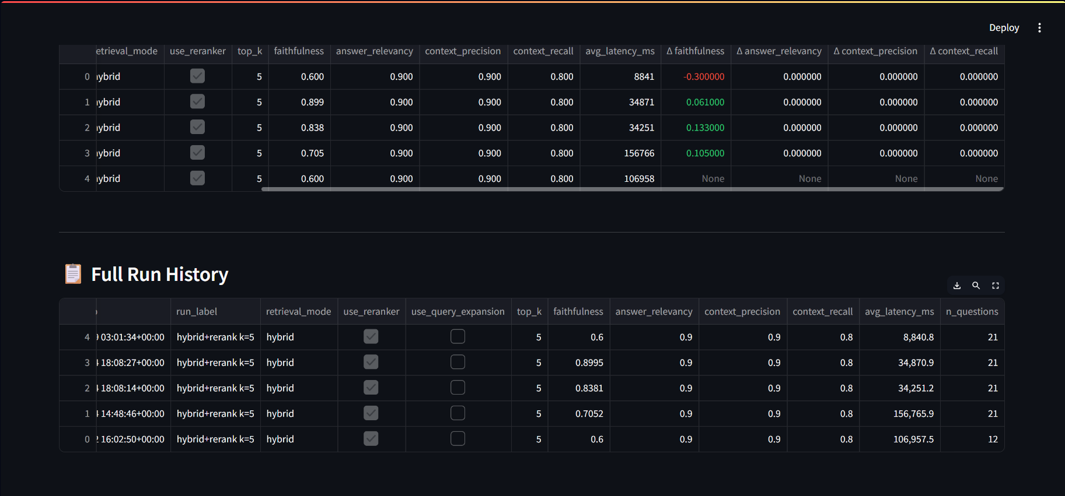
Run comparison and full run history

Resume & Interview Bullet Point
Built a Production-Grade RAG Pipeline with Automated Evaluation & Observability
- Architected a hybrid retrieval pipeline using ChromaDB (dense), BM25 (sparse), Reciprocal Rank Fusion (RRF), Multi-Query Expansion, and Cross-Encoder Reranking.
- Built an automated RAGAS evaluation harness to empirically benchmark pipeline configurations across Faithfulness, Answer Relevancy, Context Precision, and Context Recall.
- Developed a real-time Groundedness Guardrail to detect hallucination risks and integrated Prometheus + Grafana time-series latency monitoring alongside LangSmith tracing.

The strongest interview question this unlocks: "How do you ensure your RAG application isn't hallucinating and degrading in production?" — you have an actual, concrete system with empirical metrics and automated guardrails.

