
DEPARTMENT OF COMPUTER SCIENCE AND ENGINEERING
(Artificial Intelligence and Machine Learning)

A Project Report on

Parking Lot Management System

Submitted in partial fulfilment for the course

Database Management System (CIOE03)

for the award of degree in

Bachelor of Engineering in
Electronics and Communication Engineering

Submitted by

1MS23EC081 N Dhanush Gowda

Under the guidance of
Bhagyashree Hosmani
Assistant professor
CSE (AI ML)

M. S. Ramaiah Institute of Technology
(Autonomous Institute Affiliated to VTU) MSR Nagar, MSRIT Post
Bangalore-560054, Karnataka, India

Academic Year: 2025 - 2026
CERTIFICATE

This is to certify that N Dhanush Gowda ( USN: 1MS23EC081 ) have successfully
completed the mini project titled "Parking Lot Management System" in partial
fulfilment of the requirements of the course CIOE03 Database Management System
offered by Ramaiah Institute of Technology, Bengaluru in partial fulfillment for the award
of Bachelor of Engineering in ECE (Electronics and communication Engineeging) of the
Visvesvaraya Technological University, Belagavi during the year 2025-26.

Bhagyashree Hosmani
Faculty Incharge

Marks Allotment:
Total Marks | Marks Obtained

Signature of Faculty with Date

TABLE OF CONTENTS

Sl. No. | Title | Page No.
1 | Abstract | 4
2 | Introduction | 5
3 | Project Organization  3.1 Software Process Model  3.2 Roles and Responsibilities  3.3 Software and Hardware Requirements | 6
4 | Database Design | 7
5 | ER Diagram | 8
6 | Scope of Study | 9
7 | Findings / Case Study | 10
8 | Implementation | 11
9 | Code Explanation | 12
10 | Results / Screenshots | 14
11 | Conclusion | 16

1. Abstract
The Parking Lot Management System is a web-based application developed to automate and streamline the process of managing vehicle parking in commercial or institutional parking facilities. The system is built using Flask (Python) as the backend framework, MySQL as the relational database, and Bootstrap-based HTML templates for the frontend interface. The combination of these technologies ensures a lightweight, efficient, and responsive application that can be deployed with minimal infrastructure.

The primary objective of this project is to eliminate manual parking record-keeping and replace it with a digital, real-time system that accurately tracks vehicle entries, parking slot allocation, duration of stay, and fee calculation upon exit. The system supports employee-based authentication to ensure that only authorized personnel can operate the parking terminals.

Key features of the system include secure employee login using session management, vehicle entry with automatic slot assignment based on vehicle type (Car or Bike), a real-time check for slot availability, prevention of duplicate parking records, automatic computation of parking fees based on hours spent, and updating slot status upon vehicle exit. The application integrates four core database tables — employee, vehicle, parking_slot, and parking_record — to maintain normalized, consistent, and relational data.

This system serves as a practical demonstration of applying Database Management System (DBMS) concepts — including normalization, foreign key constraints, transactional operations, and query optimization — within a real-world web application context.

2. Introduction
In modern urban environments, vehicle parking has become one of the most pressing logistical challenges for institutions, shopping centers, hospitals, and commercial complexes. The conventional approach of manually recording vehicle entries and exits using paper registers or simple spreadsheets is inefficient, error-prone, and fails to scale with increasing vehicle volumes. This creates a need for an automated, digital system that can handle parking operations efficiently in real time.

The Parking Lot Management System addresses this gap by providing a centralized, database-driven web application that automates the complete lifecycle of a parking transaction — from vehicle entry and slot allocation to fee computation and slot release upon exit. The system is designed to be operated by trained parking attendants (employees), who log in using their credentials and use the system interface to register vehicles and process exits.

2.1 Problem Statement
Traditional parking management relies heavily on manual processes that are susceptible to human error, delays, and inefficient use of available slots. There is a lack of real-time visibility into slot occupancy and no systematic method to calculate and record parking fees accurately. This project aims to solve these issues through digitization and automation.

2.2 Objectives
- To design and implement a fully functional web-based parking management system.
- To automate vehicle entry, exit, slot allocation, and fee calculation using a relational database.
- To enforce role-based access control through employee authentication.
- To demonstrate practical application of DBMS concepts in a real-world scenario.
- To maintain accurate and persistent records of all parking transactions.

2.3 Scope
The system is intended for use in small to medium-sized parking facilities. It supports two vehicle types — Cars and Bikes — and manages their respective parking slots independently. The system provides a clean, minimal interface accessible via any standard web browser without the need for additional client-side installation.

3. Project Organization

3.1 Software Process Model
The project followed the Incremental Development Model, which combines aspects of waterfall and iterative approaches. Development was divided into increments — each adding a functional layer to the system. The first increment covered database schema design and employee authentication. The second increment implemented vehicle entry and slot allocation. The third increment addressed vehicle exit, fee calculation, and flash messaging. This model allowed continuous testing at each stage and rapid integration of new features.

3.2 Roles and Responsibilities
- Backend Developer: Designed Flask routes, integrated MySQL, managed sessions, and implemented fee calculation logic.
- Frontend Developer: Developed responsive HTML templates and forms using Bootstrap.
- Database Designer: Designed normalized database schema, table relationships, and SQL queries.
- Tester: Performed route testing, session validation, and edge case handling.
- Project Lead: Coordinated team activities, managed integration, and handled final documentation and review.

3.3 Software and Hardware Requirements
Software Requirements
- Python 3.x (Programming Language)
- Flask (Web Framework)
- MySQL 8.x (Database)
- HTML5 ,Bootstrap 5.3 (Frontend)
- Visual Studio Code (IDE)
- Google Chrome(Browser)

Hardware Requirements
• Processor – Intel i3 or higher
• RAM – Minimum 4 GB
• Storage – Minimum 10 GB free space
• Network – Internet connectivity for Bootstrap CDN
• Operating System – Windows 10/11 or Ubuntu 20.04+

4. Database Design
The database follows the principles of relational database design, with normalization up to the Third Normal Form (3NF). Foreign key relationships are used to maintain referential integrity across tables. The database is named parking_system and is hosted on a local MySQL server.

4.1 Table: employee
Stores credentials and identity information of parking lot employees who are authorized to operate the system.
Field | Data Type | Constraints | Description
employee_id | INT | PRIMARY KEY, AUTO_INCREMENT | Unique identifier for each employee
name | VARCHAR(100) | NOT NULL | Full name of the employee
phone | VARCHAR(15) | UNIQUE, NOT NULL | Mobile number used for login
password | VARCHAR(255) | NOT NULL | Password for system access

4.2 Table: vehicle
Maintains a master record of all vehicles that have ever entered the parking facility.
Field | Data Type | Constraints | Description
vehicle_id | INT | PRIMARY KEY, AUTO_INCREMENT | Unique vehicle identifier
vehicle_number | VARCHAR(20) | UNIQUE, NOT NULL | License plate number
vehicle_type | ENUM('Car','Bike') | NOT NULL | Category of the vehicle

4.3 Table: parking_slot
Tracks all available parking slots, their type, and current occupancy status.
Field | Data Type | Constraints | Description
slot_id | INT | PRIMARY KEY, AUTO_INCREMENT | Unique slot identifier
slot_number | VARCHAR(10) | NOT NULL | Human-readable slot label (e.g., C-01)
slot_type | ENUM('Car','Bike') | NOT NULL | Type of vehicle the slot accommodates
status | ENUM('Free','Occupied') | DEFAULT 'Free' | Current occupancy status of the slot

4.4 Table: parking_record
The central transactional table that records each parking session, linking vehicle, slot, and employee.
Field | Data Type | Constraints | Description
record_id | INT | PRIMARY KEY, AUTO_INCREMENT | Unique record identifier
vehicle_id | INT | FOREIGN KEY (vehicle) | References vehicle.vehicle_id
slot_id | INT | FOREIGN KEY (parking_slot) | References parking_slot.slot_id
employee_id | INT | FOREIGN KEY (employee) | References employee.employee_id
entry_time | DATETIME | NOT NULL | Timestamp when vehicle entered
exit_time | DATETIME | DEFAULT NULL | Timestamp when vehicle exited
fee | DECIMAL(8,2) | DEFAULT NULL | Computed parking fee in INR

5. ER Diagram Description
The Entity-Relationship (ER) diagram of the Parking Lot Management System consists of four entities connected by three relationships:
- EMPLOYEE (employee_id, name, phone, password) — An employee MANAGES many parking_records (1:N).
- VEHICLE (vehicle_id, vehicle_number, vehicle_type) — A vehicle ASSOCIATED_WITH many parking_records (1:N).
- PARKING_SLOT (slot_id, slot_number, slot_type, status) — A slot ASSIGNED_IN many parking_records (1:N).
- PARKING_RECORD (record_id, vehicle_id, slot_id, employee_id, entry_time, exit_time, fee) — Central transactional entity.
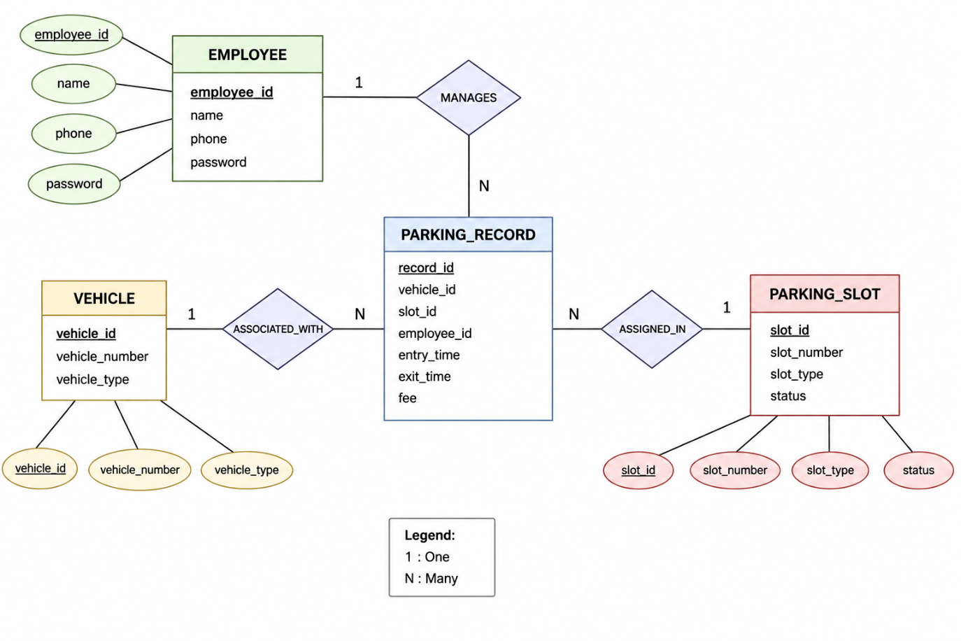

6. Scope of Study
The Parking Lot Management System serves as a comprehensive case study in the practical application of Database Management System concepts within a full-stack web application. The key areas covered under the scope of this project are outlined below:

6.1 Relational Database Design and Normalization
The project applies relational database principles including entity identification, attribute definition, primary and foreign key constraints, and normalization up to 3NF. The schema ensures minimal data redundancy and maximum data integrity across all four tables.

6.2 Transactional Data Management
Every parking session is treated as a database transaction. Entry records are inserted atomically along with slot status updates. On exit, multiple UPDATE operations are committed together. The use of db.commit() ensures data consistency and prevents partial updates.

6.3 Session-Based Authentication
The system explores secure session handling in web applications. Employee credentials are verified against the database, and a session token (employee_id) is stored server-side to maintain authenticated state across multiple requests without re-authentication.

6.4 Dynamic Slot Allocation Algorithm
The project demonstrates algorithmic slot management — dynamically querying for the first available slot of the required type using SQL, assigning it, and updating its status in the same transaction. This mirrors real-world resource allocation problems solved using DBMS.

6.5 Fee Computation using Business Logic
The system implements a tiered fee calculation model based on vehicle type and duration. This demonstrates how DBMS can store raw data (entry_time, exit_time) while the application layer derives meaningful computed values (fee) from it.

6.6 Scalability and Practical Applications
While currently designed for a single facility, the architecture is scalable. Multiple branches can be supported by adding a branch_id field. The system can be extended with an admin dashboard, online payments, QR-based entry, and camera-based license plate recognition for future use.

7. Findings / Case Study
Through the implementation and testing of the Parking Lot Management System, several key organizational and technical findings were observed:

7.1 Employee Authentication and Session Security
The login system correctly validates employee credentials by querying the employee table using phone number and password. Upon successful authentication, Flask's session dictionary stores the employee_id, which persists across requests using a signed cookie. Protected routes (/entry, /exit) verify the session at the start of each request and redirect unauthenticated users to the login page, effectively enforcing access control.

7.2 Duplicate Entry Prevention
A critical finding was the importance of checking for existing active parking records before inserting a new one. The system queries parking_record for any record where vehicle_id matches and exit_time IS NULL. This prevents the same vehicle from being registered twice simultaneously, maintaining data integrity and preventing slot double-booking.

7.3 Vehicle Master Data Reuse
The vehicle table functions as a master data repository. When a vehicle enters, the system first checks if its license plate already exists. If found, the existing vehicle_id is reused rather than creating a duplicate record. This demonstrates efficient use of primary keys and UNIQUE constraints in preventing redundancy.

7.4 Fee Calculation Logic
Vehicle Type | First Hour Rate | Additional Hour Rate
Bike | Rs. 10 | Rs. 5 per hour
Car | Rs. 20 | Rs. 10 per hour
Other | Rs. 15 | Rs. 7 per hour

The fee is calculated by computing the difference between exit_time and entry_time in total seconds, dividing by 3600 (seconds per hour), and adding 1 to account for partial hours. This ensures fair charging — a vehicle parked for 1 hour 5 minutes is charged for 2 hours.

7.5 Slot Status Management
The parking_slot table is used as a real-time status board. When a vehicle enters, its assigned slot's status is updated from 'Free' to 'Occupied'. On exit, the same slot is reset to 'Free', making it available for the next vehicle. This two-way status management ensures accurate slot availability at all times.

8. Implementation

8.1 Backend Implementation (app.py)
The backend is implemented as a single Python file, app.py, using the Flask framework. At startup, a persistent MySQL connection is established using mysql.connector.connect() with the database name parking_system. Flask's secret key is set for session signing. The application defines six routes, each handling specific parking operations.

8.2 Flask Routes
Route | Method | Description
/ | GET | Renders the home dashboard (index.html) with flash messages
/login | GET, POST | GET: renders login form. POST: validates credentials, sets session
/entry | GET, POST | GET: renders entry form. POST: processes vehicle entry and slot allocation
/exit | GET, POST | GET: renders exit form. POST: processes exit, calculates fee, frees slot
/logout | GET | Clears the session and redirects to /login

8.3 Vehicle Entry Logic
The entry route performs the following database operations in sequence:
- Check if vehicle_number already exists in the vehicle table (SELECT).
- If not found, insert a new vehicle record (INSERT INTO vehicle).
- Check if vehicle is already parked by looking for an open parking_record (SELECT WHERE exit_time IS NULL).
- Query for the first available slot of the matching vehicle_type (SELECT WHERE status='Free' LIMIT 1).
- Update the slot status to 'Occupied' (UPDATE parking_slot).
- Insert a new parking_record with entry_time = datetime.now() (INSERT INTO parking_record).
- Commit the transaction (db.commit()).

8.4 Vehicle Exit Logic
The exit route executes the following sequence:
- Retrieve vehicle record by vehicle_number from the vehicle table.
- Find the active parking record (WHERE vehicle_id = %s AND exit_time IS NULL).
- Calculate hours_parked from entry_time to current time.
- Apply vehicle-type-specific fee formula to compute the total parking fee.
- Update parking_record with exit_time = NOW() and computed fee.
- Update parking_slot status back to 'Free'.
- Commit and flash a success message with the fee amount.

8.5 Frontend Implementation
All four HTML templates use Bootstrap 5.3 loaded from the CDN. The login.html page features a centered card with a gradient background and customized form styling. The index.html dashboard displays flash messages using Bootstrap alert components. The entry.html and exit.html pages provide simple form interfaces with a vehicle number input field and appropriate action buttons. Jinja2 templating is used to render flash messages and error variables passed from Flask.

9. Code Explanation

9.1 Database Connection
A persistent MySQL connection is established at application startup:
db = mysql.connector.connect(
host='localhost',
user='root',
password='<password>',
database='parking_system',
port=3306
)
This connection is reused across all requests. In production, a connection pool (mysql.connector.pooling) should be used instead.

9.2 Login Route
The login function queries the employee table using both phone and password. Dictionary cursor (dictionary=True) returns rows as Python dictionaries, making attribute access intuitive (emp['employee_id']):
cursor.execute(
'SELECT * FROM employee WHERE phone=%s AND password=%s',
(phone, password)
)
emp = cursor.fetchone()
if emp:
session['employee_id'] = emp['employee_id']
return redirect('/')

9.3 Slot Allocation
The system queries the first available slot matching the vehicle type, using LIMIT 1 for efficiency:
cursor.execute(
"SELECT slot_id FROM parking_slot"
" WHERE status='Free' AND slot_type=%s LIMIT 1",
(vehicle_type,)
)
slot = cursor.fetchone()

9.4 Fee Calculation
The fee calculation converts the time difference to hours and applies a tiered pricing model:
entry_time = r['entry_time']
hours = int((datetime.now() - entry_time).total_seconds() / 3600) + 1

if vehicle_type == 'Bike':
first_hour, extra_per_hour = 10, 5
elif vehicle_type == 'Car':
first_hour, extra_per_hour = 20, 10

fee = first_hour if hours <= 1 else first_hour + (hours - 1) * extra_per_hour

9.5 Flash Messaging
Flask's flash() function is used to pass one-time messages between redirects. On index.html, Jinja2 iterates over flashed messages with their categories:
{% with messages = get_flashed_messages(with_categories=true) %}
{% for category, msg in messages %}
<div class='alert alert-{{ category }}'>{{ msg }}</div>
{% endfor %}
{% endwith %}

10. Results / Screenshots
The following screenshots illustrate the key functional screens of the Parking Lot Management System as observed during testing:

10.1 Login Page
The login page displays a visually appealing, centered card with a blue gradient background. Employees enter their registered phone number and password to access the system. Invalid credentials trigger an error message within the card.
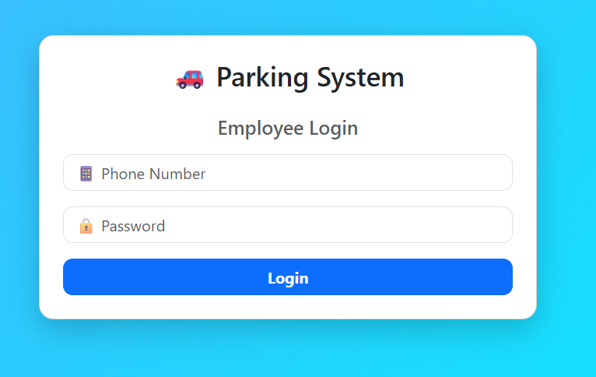

Figure 10.1 — Employee Login Page

10.2 Home Dashboard
After successful login, the employee is directed to the dashboard, which provides navigation links to Vehicle Entry, Vehicle Exit, and Logout. Flash messages for completed operations are displayed prominently using Bootstrap alert components.
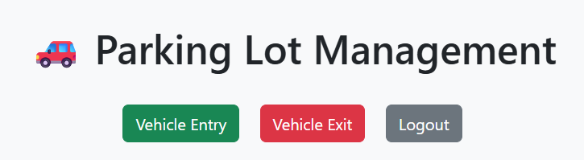

Figure 10.2 — Home Dashboard with Navigation and Flash Messages

10.3 Vehicle Entry Page
The vehicle entry form accepts a vehicle number (license plate) and vehicle type (Car or Bike) via a dropdown. On submission, the system allocates the nearest available slot and confirms the entry. If no slot is available or the vehicle is already parked, an appropriate message is returned.
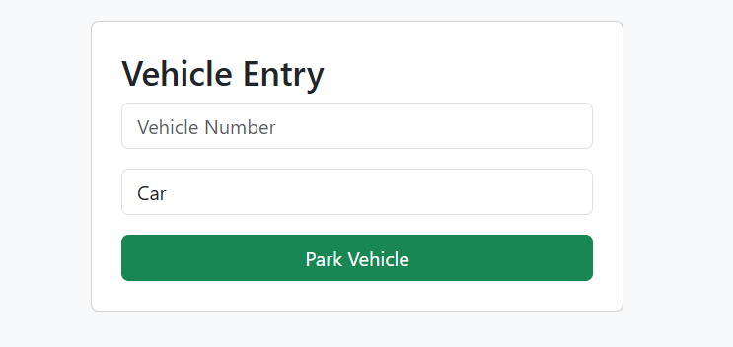

Figure 10.3 — Vehicle Entry Form

10.4 Vehicle Exit Page
The vehicle exit form takes the vehicle number as input. The system retrieves the active parking record, computes the fee based on duration and vehicle type, records the exit time, frees the slot, and displays the computed fee as a flash message on the dashboard.
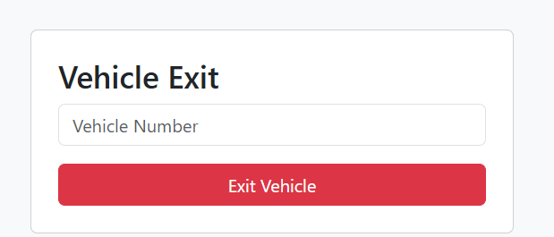
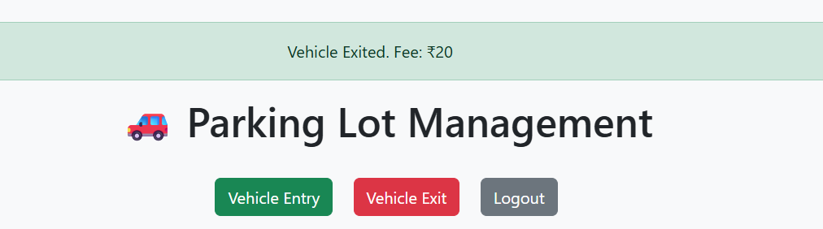
Figure 10.4 — Vehicle Exit Form and Fee Display

11. Conclusion
The Parking Lot Management System successfully demonstrates the practical integration of core Database Management System concepts with modern web development technologies. By leveraging Flask as the backend framework, MySQL as the relational database, and Bootstrap for the frontend interface, the system delivers a functional, real-world application that automates the complete lifecycle of a parking transaction.

The project effectively illustrates DBMS principles including schema normalization, primary and foreign key relationships, CRUD operations, transactional consistency, and parameterized query execution. The four-table relational schema (employee, vehicle, parking_slot, parking_record) provides a clean, normalized data model that supports the system's core operations without redundancy.

From a software engineering perspective, the system demonstrates important patterns such as session-based authentication, role-based access control, flash messaging for user feedback, and the separation of concerns between the presentation, application, and data layers. The fee calculation logic encapsulates real-world business rules within the application layer while relying on the database for persistent storage of raw transactional data.

In conclusion, this mini-project bridges the gap between theoretical DBMS knowledge and practical software development, providing a deployable solution to a common real-world problem. It lays a strong foundation for future enhancements such as automated license plate recognition, online payment integration, and advanced analytics, making it a scalable starting point for a production-grade parking management solution.

