AI-Driven Public Health Chatbot
for Disease Awareness
June 01 – June 15, 2026

Activity Summary — June 01 to June 15, 2026
Day | Date | Activity | Status
Day 1 | June 01 | Project Title Finalization | Completed
Day 2 | June 02 | Requirement Gathering | Completed
Day 3 | June 03 | Objective Definition | Completed
Day 4 | June 04 | User & Module Identification | Completed
Day 5 | June 05 | Use Case Diagram Preparation | Completed
Day 6 | June 06 | Database Requirement Analysis | Completed
Day 7 | June 07 | ER Diagram Design | Completed
Day 8 | June 08 | Database Schema Creation | Completed
Day 9 | June 09 | UI Wireframe Design | Completed
Day 10 | June 10 | Login & Dashboard UI Design | Completed
Day 11 | June 11 | Navigation & Form Design | Completed
Day 12 | June 12 | Design Review | Completed
Day 13 | June 13 | Frontend Environment Setup | Completed
Day 14 | June 14 | Login Page Development | Completed
Day 15 | June 15 | Registration Page Development | Completed

Day 1 | June 01, 2026 | Project Title Finalization

1.1 Chosen Project Title
AI-Driven Public Health Chatbot for Disease Awareness

1.2 Why This Title Was Chosen
The title was finalized after evaluating the scope of the problem the project intends to solve. The phrase ‘AI-Driven’ immediately communicates that the system relies on artificial intelligence rather than a static FAQ page. ‘Public Health Chatbot’ explains the medium of interaction — a conversational system rather than a search portal. ‘For Disease Awareness’ anchors the purpose: the system informs and educates, it does not diagnose or prescribe.
Two alternative titles were considered before this was approved:
- Smart Health Assistant App — too generic; does not specify the disease-awareness focus or the AI/NLP core.
- Medical Information Chatbot — sounds clinical and could be mistaken for a diagnostic tool, which is outside the project’s scope.
The final title is descriptive, sets correct expectations about what the system will and will not do, and is suitable for both academic submission and a public GitHub repository.

1.3 Project Overview
The AI-Driven Public Health Chatbot for Disease Awareness is designed to give users instant, reliable health-related information about diseases, symptoms, prevention methods, and basic first-aid guidance. It uses AI and Natural Language Processing (NLP) techniques to interact with users in a conversational manner and improve public health awareness, without storing or acting on personal medical data.

1.4 Domain and Technology Stack
Domain: Public Health / Artificial Intelligence / Web-Based Application.
- Frontend: HTML, CSS, JavaScript
- Backend: Python (Flask / Django)
- NLP: NLTK / spaCy
- ML: Scikit-learn / TensorFlow
- Database: SQLite / MySQL / Firebase

1.5 Scope
- The system focuses on disease information, symptom awareness, preventive guidance, and basic first-aid suggestions delivered through natural-language conversation.
- It targets the general public, students, researchers, and health workers who need a quick, reliable first point of reference.
- The chatbot will advise users when a query needs professional medical attention; it does not replace a doctor or provide a clinical diagnosis.
- An admin module allows authorized staff to keep the disease knowledge base and awareness content up to date.
- No payment, e-commerce, or appointment-booking features are included in Version 1.0.

1.6 Deliverable Summary — Day 1
Item | Status
Project title finalized and approved | Completed — June 01, 2026
Project overview drafted | Completed — June 01, 2026
Domain and technology stack confirmed | Completed — June 01, 2026
Scope boundaries defined | Completed — June 01, 2026

Day 2 | June 02, 2026 | Requirement Gathering

2.1 Problem Statement
Most people search for health information through general web search engines or social media when they notice a symptom or want to learn about a disease. This information is often scattered, inconsistent, or written in technical medical language that is difficult for a non-expert to interpret correctly. In many cases it leads to either unnecessary panic or, worse, the dismissal of a symptom that actually needed medical attention.
Visiting a doctor or health worker for every minor query is not always practical, especially outside clinic hours or in areas with limited access to healthcare professionals. There is a clear need for a simple, conversational, and trustworthy first point of contact that can answer common health questions instantly, explain when a symptom is serious enough to warrant a doctor’s visit, and do all of this in plain, easy-to-understand language.

2.2 Functional Requirements
Functional requirements describe what the system must do:
FR-01: Conversational Query Handling: The system must accept user input in natural language (chat format) and identify disease-related queries using NLP.
FR-02: Disease and Symptom Information: The system must provide information about symptoms, causes, transmission, and preventive measures for supported diseases.
FR-03: First-Aid Guidance: The system must offer basic first-aid suggestions appropriate to the query, where applicable.
FR-04: Doctor-Consultation Guidance: The system must suggest when a user should consult a doctor based on the nature or severity of the query.
FR-05: FAQ Handling: The system must handle frequently asked health questions using a structured FAQ table.
FR-06: Conversation Context: The system must support multiple queries in a single conversation and maintain basic session context.
FR-07: Feedback Collection: The system must allow users to rate a response and leave comments, which are stored for quality improvement.
FR-08: Admin Content Management: An administrator must be able to log in separately to add, update, or remove disease records, articles, and FAQ entries.

2.3 Non-Functional Requirements
ID | Requirement | Detail
NFR-01 | Performance | Chatbot responses must be generated within a few seconds of the user submitting a query.
NFR-02 | Accuracy | All disease and health information returned must be reliable and reviewed before publishing to the knowledge base.
NFR-03 | Usability | The chat interface must be simple and require no technical knowledge to operate.
NFR-04 | Scalability | The system must support multiple users interacting with the chatbot simultaneously.
NFR-05 | Security | No personal medical data is stored without explicit user consent; passwords are stored as salted hashes.
NFR-06 | Availability | The system must be accessible 24/7 with minimal downtime.
NFR-07 | Maintainability | The disease knowledge base and AI model must be updatable without changes to the frontend.

2.4 Hardware and Software Requirements
Hardware Requirements
- Processor: i3 or higher (i5/i7 recommended for AI/NLP processing)
- RAM: Minimum 4GB (8GB preferred)
- Storage: 500MB–2GB depending on the size of the disease dataset
- A stable internet connection for API-based or cloud-hosted model access
Software Requirements
- Python 3.8 or above
- NLP libraries: NLTK / spaCy
- ML libraries: Scikit-learn / TensorFlow
- Web framework: Flask / Django
- Database: SQLite / MySQL / Firebase
- Frontend: HTML, CSS, JavaScript

2.5 Stakeholder Requirements
Stakeholder | What They Need | Priority
General Public / User | Simple chat interface, accurate answers in plain language, no login friction for basic queries | High
Healthcare Awareness Seeker | Structured, citable disease information for quick reference | High
System Administrator | Ability to update disease data and FAQs, monitor chatbot performance and usage | High
Project Evaluator / College | Clean code structure, ER diagram, documented schema, working demo | Medium

2.6 Constraints
- The project must be completed within the academic semester timeline.
- The chatbot provides awareness information only; it must never present its output as a medical diagnosis or prescription.
- Disease coverage in Version 1.0 is limited to common and seasonal diseases included in the curated knowledge base.
- The system will be hosted on a free-tier or campus server during development and evaluation.
- Version 1.0 supports English only; regional language support is planned for a future version.
This Problem Statement and requirement set was prepared based on the project guide’s review and primary observation of how people currently search for health information online.

Day 3 | June 03, 2026 | Objective Definition

3.1 Main Objective
To develop an intelligent conversational system that provides users with quick, accurate, and easy-to-understand information about various diseases and health-related topics using AI and Natural Language Processing technologies.

3.2 Primary Objectives
- Provide quick access to disease-related information.
- Increase public awareness about common and seasonal diseases.
- Offer preventive care suggestions.
- Reduce dependency on unverified, manual health information searches.
- Support users with basic health guidance in real time.
- Guide users on when to seek professional medical help.

3.3 Secondary Objectives
- Improve health-awareness accessibility through AI-driven conversation.
- Make healthcare information interactive and efficient to consume.
- Reduce the burden on healthcare systems by providing accurate first-level guidance before a clinical visit.

3.4 Objectives Mapped to Deliverables
Objective | Mapped Deliverable
Quick access to disease information | Disease Knowledge Base Module, Chat Interface
Increase public awareness | Awareness Content / Articles module
Preventive care suggestions | Recommendation and Awareness Module
Real-time basic guidance | AI Response Generation Module
Guidance on seeking professional help | Health-alert and consult-a-doctor logic in NLP module

3.5 Expected Outcomes
Objectives were defined and documented with the project guide. Scope is confirmed to focus on disease information, symptom awareness, prevention guidance, and basic first-aid using NLP-based conversational AI, with a clear boundary against clinical diagnosis.

Day 4 | June 04, 2026 | User & Module Identification

4.1 Identified Users
1. General Users (Public Users)
- Individuals seeking information about diseases and health awareness.
- Can ask queries related to symptoms, prevention, and basic first aid.
- No technical knowledge required; this is the primary user group of the chatbot.
2. Healthcare Awareness Seekers
- Students, researchers, or health workers.
- Use the chatbot for quick reference and structured disease information.
3. System Administrator
- Responsible for managing chatbot data and monitoring performance.
- Updates disease information and improves response quality.
- Maintains system security and content accuracy.

4.2 System Modules
1. User Interaction Module
Provides the chat interface, accepts natural-language input, and displays chatbot responses in real time.
2. NLP Module
Processes user queries, identifies intent (symptoms, prevention, or disease information), and converts input into a machine-understandable format.
3. Disease Knowledge Base Module
Stores structured information about diseases — symptoms, causes, prevention, and awareness details — and acts as the primary data source for responses.
4. AI Response Generation Module
Generates responses by matching input intent with the knowledge base or AI model output, keeping answers accurate and simple.
5. Recommendation and Awareness Module
Suggests preventive measures, shares health-awareness tips, and advises users when a medical consultation is required.
6. Database Management Module
Stores user queries (optionally), maintains disease datasets and chat logs, and supports continuous system improvement.
7. Admin Module
Lets the administrator update disease information, monitor chatbot performance, and ensure content accuracy and system security.

4.3 Module Interaction Summary
A user query enters through the User Interaction Module and is passed to the NLP Module for intent extraction. The extracted intent is matched against the Disease Knowledge Base Module, and the AI Response Generation Module composes the final reply, optionally invoking the Recommendation and Awareness Module for preventive tips or doctor-consultation guidance. All interactions are logged through the Database Management Module, which the Admin Module can review and curate.
Outcome: 3 user roles and 7 system modules identified and documented.

Day 5 | June 05, 2026 | Use Case Diagram Preparation

5.1 Actors
- User (General Public / Health Awareness Seeker)
- Admin (System Administrator)

5.2 Use Cases — User
- Ask Health Query
- Get Disease Information
- Get Symptom Details
- Get Prevention Tips
- Get First-Aid Guidance
- Know When to Consult a Doctor
- Provide Feedback

5.3 Use Cases — Administrator
- Login to Admin Panel
- Manage Disease Database
- Update Awareness Content
- Monitor Chatbot Performance
- View User Activity Reports

5.4 UML Diagrams Designed
1. Use Case Diagram
Represents how users and the admin interact with the chatbot system.
2. Class Diagram
Main classes: User, Chatbot, NLPProcessor, KnowledgeBase, ResponseGenerator, Admin — each with defined attributes and methods.
3. Activity Diagram
Flow: User sends query → NLP preprocessing → intent/entity extraction → knowledge-base search → response generation → optional feedback.
4. Sequence Diagram
Participants: User, Chatbot Interface, NLP Processor, Knowledge Base, Response Generator, Database — showing the end-to-end message flow.
5. Deployment Diagram
Components: User Device → Application Server (Flask/Django + NLP/ML model) → Database Server (MySQL/SQLite/Firebase).

5.5 CRUD API Endpoints
Method | Endpoint | Description
POST | /api/auth/register | Register a new user
POST | /api/auth/login | Authenticate a user and issue a session/JWT token
POST | /api/chat/query | Submit a health query and receive a chatbot response
GET | /api/diseases | Retrieve the list of diseases in the knowledge base
GET | /api/diseases/{id} | Retrieve details for a single disease
POST | /api/diseases | Admin: add a new disease record
PUT | /api/diseases/{id} | Admin: update an existing disease record
DELETE | /api/diseases/{id} | Admin: remove a disease record
GET | /api/faq | Retrieve frequently asked questions
POST | /api/feedback | Submit feedback/rating for a chatbot response
GET | /api/chat/history/{userId} | Retrieve a user’s past chat history
GET | /api/admin/reports | Admin: view chatbot usage and activity reports
Outcome: 12 use cases identified across 2 actors. All UML diagrams (use case, class, activity, sequence, deployment) and the CRUD API list were prepared and reviewed.
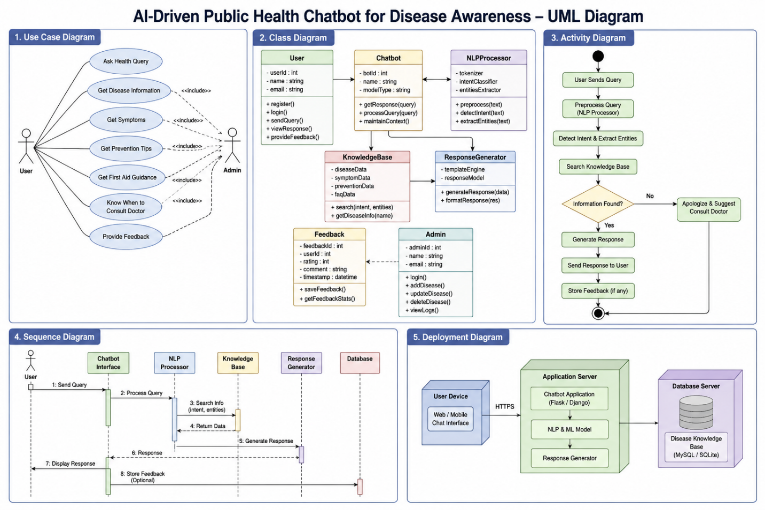
Day 6 | June 06, 2026 | Database Requirement Analysis

6.1 Why We Need a Database
The chatbot needs persistent storage for user accounts, the curated disease knowledge base, chat logs, awareness articles, feedback, and health alerts. A relational database keeps this data consistent, queryable, and easy for the admin module to maintain over time.

6.2 Data Storage Requirements
The architecture supports four broad categories of data:
1. Knowledge Base Data
Verified disease information (symptoms, causes, prevention, treatment) used to answer user queries.
2. Conversational Data
Chat logs, query/response pairs, and session timestamps.
3. Operational & User Data
User profiles, roles, and authentication credentials.
4. Awareness & Feedback Data
Awareness articles, FAQ entries, health alerts, and user feedback/ratings used to improve response quality.

6.3 Identified Tables
- users
- diseases
- chat_history
- health_tips / awareness_content
- articles
- feedback
- faq
- health_alerts

6.4 Data Volume Estimates
Table | Estimated Growth
users | Grows steadily with new registrations; low write frequency per record
chat_history | Highest-volume table; one row per query/response pair, grows continuously
diseases / articles / faq | Small, slow-growing reference tables maintained by the admin
feedback | Grows with usage; one row per rating submitted
health_alerts | Low volume; created only when an outbreak or seasonal alert is published

6.5 Non-Functional Database Requirements
- Low latency: chatbot response, including the database lookup, should complete within a few seconds.
- Security: passwords stored as hashed values; personal data separated from anonymous chat logs.
- Maintainability: disease and FAQ data must be editable by the admin without touching application code.
- Scalability: chat_history must support a growing number of rows without performance degradation.
Outcome: 8 tables identified with their purpose and growth pattern; the database design is ready to move into ER modelling.

Day 7 | June 07, 2026 | ER Diagram Design

7.1 Entities and Attributes
User
User_ID (PK), Name, Age, Gender, Email, Phone_Number, Location, Registration_Date
Chatbot
Bot_ID (PK), Bot_Name, Version, Language_Supported, Last_Updated
Disease
Disease_ID (PK), Disease_Name, Category, Symptoms, Causes, Prevention_Methods, Treatment_Information
Awareness_Content
Content_ID (PK), Title, Description, Content_Type, Publish_Date, Disease_ID (FK → Disease)
Health_Query
Query_ID (PK), User_ID (FK → User), Query_Text, Query_Date, Query_Status
Chat_Response
Response_ID (PK), Query_ID (FK → Health_Query), Bot_ID (FK → Chatbot), Response_Text, Response_Time
Feedback
Feedback_ID (PK), User_ID (FK → User), Response_ID (FK → Chat_Response), Rating, Comments, Feedback_Date
Health_Alert
Alert_ID (PK), Disease_ID (FK → Disease), Alert_Message, Alert_Date, Severity_Level

7.2 Relationships
- User submits Health_Query (1:M)
- Health_Query receives Chat_Response (1:M)
- Chatbot generates Chat_Response (1:M)
- Disease contains Awareness_Content (1:M)
- Disease triggers Health_Alert (1:M)
- User provides Feedback (1:M)
- Chat_Response receives Feedback (1:M)

7.3 ER Diagram

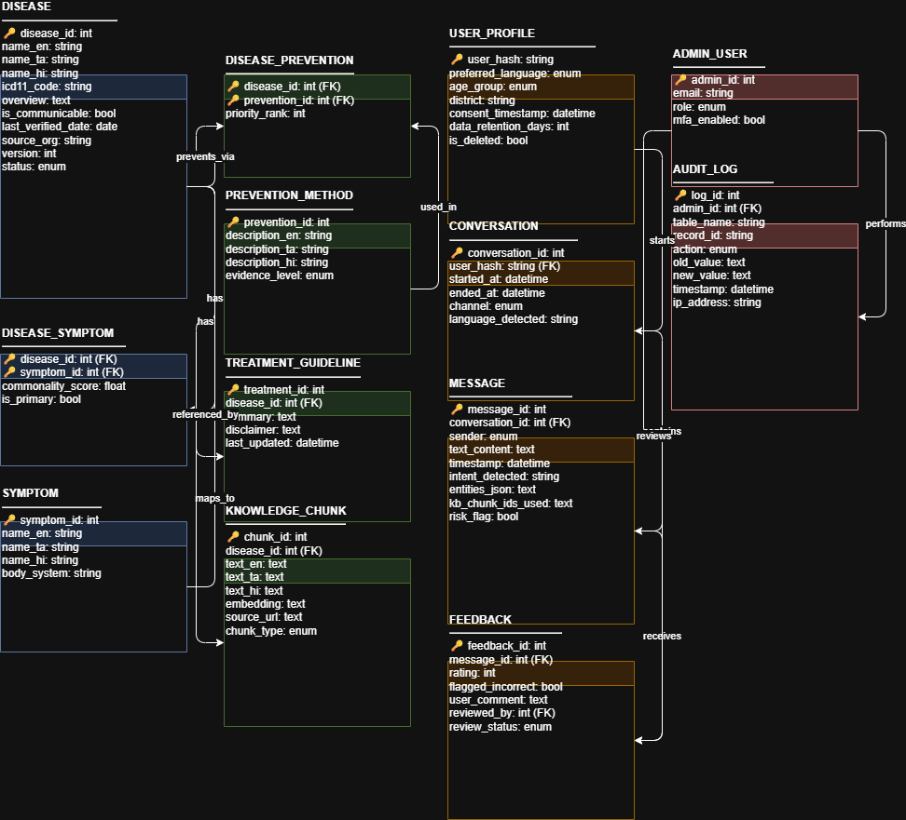

Day 8 | June 08, 2026 | Database Schema Creation

8.1 Overview
The database schema for the AI-Driven Public Health Chatbot for Disease Awareness consists of eight main tables that store user information, disease details, chatbot interactions, awareness content, feedback, and health alerts.

8.2 SQL Schema — Complete Table Definitions
CREATE DATABASE public_health_chatbot;
USE public_health_chatbot;
1. Users Table
CREATE TABLE users (
user_id INT AUTO_INCREMENT PRIMARY KEY,
full_name VARCHAR(100) NOT NULL,
email VARCHAR(100) UNIQUE NOT NULL,
password VARCHAR(255) NOT NULL,
role ENUM('user','admin') DEFAULT 'user',
created_at TIMESTAMP DEFAULT CURRENT_TIMESTAMP
);
2. Diseases Table
CREATE TABLE diseases (
disease_id INT AUTO_INCREMENT PRIMARY KEY,
disease_name VARCHAR(100) NOT NULL,
symptoms TEXT,
causes TEXT,
prevention TEXT,
treatment TEXT,
created_at TIMESTAMP DEFAULT CURRENT_TIMESTAMP
);
3. Chat History Table
CREATE TABLE chat_history (
chat_id INT AUTO_INCREMENT PRIMARY KEY,
user_id INT,
user_query TEXT NOT NULL,
bot_response TEXT NOT NULL,
chat_time TIMESTAMP DEFAULT CURRENT_TIMESTAMP,
FOREIGN KEY (user_id) REFERENCES users(user_id)
);
4. Health Tips Table
CREATE TABLE health_tips (
tip_id INT AUTO_INCREMENT PRIMARY KEY,
tip_title VARCHAR(200) NOT NULL,
tip_description TEXT,
created_at TIMESTAMP DEFAULT CURRENT_TIMESTAMP
);
5. Health Alerts Table
CREATE TABLE health_alerts (
alert_id INT AUTO_INCREMENT PRIMARY KEY,
disease_id INT,
alert_message TEXT NOT NULL,
severity_level ENUM('low','medium','high') DEFAULT 'low',
alert_date TIMESTAMP DEFAULT CURRENT_TIMESTAMP,
FOREIGN KEY (disease_id) REFERENCES diseases(disease_id)
);
6. Disease Awareness Articles Table
CREATE TABLE articles (
article_id INT AUTO_INCREMENT PRIMARY KEY,
title VARCHAR(200) NOT NULL,
content TEXT NOT NULL,
disease_id INT,
created_at TIMESTAMP DEFAULT CURRENT_TIMESTAMP,
FOREIGN KEY (disease_id) REFERENCES diseases(disease_id)
);
7. User Feedback Table
CREATE TABLE feedback (
feedback_id INT AUTO_INCREMENT PRIMARY KEY,
user_id INT,
response_id INT,
rating INT CHECK (rating BETWEEN 1 AND 5),
comments TEXT,
submitted_at TIMESTAMP DEFAULT CURRENT_TIMESTAMP,
FOREIGN KEY (user_id) REFERENCES users(user_id)
);
8. FAQ Table
CREATE TABLE faq (
faq_id INT AUTO_INCREMENT PRIMARY KEY,
question TEXT NOT NULL,
answer TEXT NOT NULL
);
Outcome: Database schema creation completed. All 8 tables created and verified in MySQL. Foreign-key relationships established between users, diseases, chat_history, articles, health_alerts, and feedback tables.

Day 9 | June 09, 2026 | UI Wireframe Design

9.1 Design Overview
Design style: clean, modern healthcare dashboard using a blue-and-green color theme, with a fully mobile-responsive layout.

9.2 Screen 1: Home Page
- Header: project logo, project name, navigation menu (Home | Disease Info | Chatbot | Awareness | Contact)
- Hero section: welcome message, short description of the project, primary ‘Start Chat’ button
- Features section: Disease Information, Symptom Awareness, Health Tips, AI Chat Assistance
- Footer: contact information, privacy policy, social media icons

9.3 Screen 2: User Login / Registration
- Login form: email field, password field, login button
- Registration form: name, email, mobile number, password fields, register button

9.4 Screen 3: AI Chatbot Interface
- Header: chatbot name and user profile icon
- Left sidebar: chat history, saved conversations, disease categories
- Main chat area: user messages, AI responses, typing indicator
- Bottom input area: message text box, voice-input button, send button

9.5 Screen 4: Disease Awareness Module
- Search bar for disease lookup
- Disease categories: COVID-19 | Dengue | Diabetes | Hypertension | Malaria
- Information card: disease name, symptoms, causes, prevention, treatment suggestions

9.6 Screen 5: Health Tips Dashboard
- Daily health tips section
- Preventive-measure cards
- Nutrition and exercise recommendations
- Vaccination awareness section

9.7 Screen 6: Admin Dashboard
- Sidebar navigation: Dashboard | Manage Diseases | Manage Awareness Content | User Management | Reports
- Main dashboard metrics: total users, total chat sessions, disease searches, awareness-campaign statistics
- Charts & analytics: user activity graph, disease query trends, monthly usage report
Outcome: UI wireframes designed for all 6 screens, covering the complete user journey from the home page to the admin dashboard. The mobile-responsive layout with the blue-and-green healthcare theme was finalized and is ready for development.

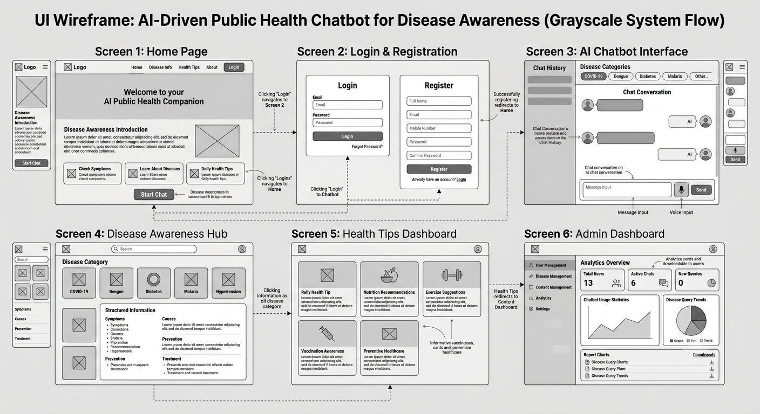
Day 10 | June 10, 2026 | Login & Dashboard UI Design

10.1 Login Screen — Component Specification
Component | Detail
Visual style | Clean, clinical white-and-teal color system for a calm, trustworthy healthcare feel
Layout | Centered login card with email field, password field, and a primary ‘Login’ button
Supporting links | ‘Forgot Password’ link and a ‘Create an account’ link to the registration screen
Validation | Inline error styling for empty or invalid fields, shown before submission

10.2 Dashboard — Screen Layout
The dashboard uses a grid-based widget system designed for readability and clear spacing, suited to users seeking quick disease-awareness information.
- Top bar: app name, user avatar, and a shortcut to start a new chat session.
- Widget grid: live disease/symptom trend card, daily public-health tip card, and a shortcut panel that launches the chatbot directly.
- Quick-access panel: links to Disease Info, Health Tips, and Chat History.

10.3 Dashboard Component Breakdown
Component | Data Source
Disease trend card | diseases table + chat_history query aggregation
Daily health tip card | health_tips table
Chat shortcut panel | Routes directly into the chatbot interface (Screen 3)
Recent activity list | chat_history table, filtered by logged-in user_id
Outcome: High-fidelity login and dashboard layouts were prepared and frozen, ready to move into navigation and form design.

Day 11 | June 11, 2026 | Navigation & Form Design

11.1 Navigation Structure
A persistent sidebar links every primary module so a user can move between the dashboard, chatbot, awareness content, and emergency contacts without losing context.
- Dashboard View
- AI Chat Assistant
- Disease Awareness / Health Articles
- Emergency Contacts Directory
- Profile / Logout

11.2 Form Validation Rules
Field | Rule
Full Name | Required; letters and spaces only
Email | Required; must match a valid email pattern
Password | Required; minimum 8 characters
Phone / Contact (optional) | If provided, must be 10 digits

11.3 Prototype Flow
- User opens the app → lands on the Login page.
- After login → redirected to the Dashboard with recent activity shown.
- User selects ‘AI Chat Assistant’ → navigates to the chatbot interface.
- User types a health query → a typing indicator appears while the response is generated.
- The chatbot reply appears with optional preventive tips and a ‘Was this helpful?’ feedback prompt.
Outcome: Multi-view navigation and form-validation rules were finalized, and a responsive interface navigation map was prepared for handoff to development.

Day 12 | June 12, 2026 | Design Review

12.1 Review Summary
All design artifacts created from Day 1 to Day 11 were reviewed with the project guide on June 12, 2026. The review checked that each deliverable is internally consistent, complete, and ready for the development phase beginning on Day 13.

12.2 Review Checklist
Day | Deliverable | Review Finding | Status
1 | Approved Project Title | Title is clear and sets correct expectations about scope | Approved
2 | Problem Statement & Requirements | Requirements are grounded in a real, common problem; not generic | Approved
3 | Project Objectives | Objectives map cleanly to deliverables with no overlap | Approved
4 | Module List | 7 modules identified, each with a clear purpose | Approved
5 | Use Cases & CRUD APIs | All major user actions covered; API endpoints follow REST conventions | Approved
6 | Database Table List | All 8 tables justified with realistic volume estimates | Approved
7 | ER Diagram | Relationships and keys are correct and complete | Approved
8 | SQL Schema | All foreign-key constraints present | Approved
9 | Wireframes | All 6 screens complete and consistent with the design theme | Approved
10 | Login & Dashboard UI | Component specifications and data sources documented | Approved
11 | Navigation & Form Design | All routes and validation rules complete | Approved

12.3 Modifications and Optimizations
- Screen color-contrast values were adjusted on key components to remain readable under lower screen resolutions.
- Border styles, font sizes, and chat-bubble spacing inside the chatbot layout were refined for visual consistency.
- The feedback table was linked to response_id as well as user_id so individual responses can be rated, not just the conversation as a whole.

12.4 Sign-Off
Document Section | Approved By | Date
Project Title and Overview | Project Developer | June 12, 2026
Requirements and Objectives | Project Developer | June 12, 2026
ER Diagram and SQL Schema | Project Developer | June 12, 2026
UI Wireframes and Prototype Flow | Project Developer | June 12, 2026
Outcome: Design review sign-off obtained, and the frozen interface wireframes were handed off to the development environment.

Day 13 | June 13, 2026 | Frontend Environment Setup

13.1 Setup Steps Completed Today
- Initialized the project workspace and Flask boilerplate for serving HTML templates.
- Created the baseline folder structure, splitting static assets (CSS, JS, images) from render templates.
- Set up the global stylesheet (style.css) and linked it to the base template.
- Configured local environment variables needed for the development server.
- Initialized a Git repository, created a .gitignore (excluding venv/ and instance/ files), and made the first commit.
- Created a GitHub repository named ‘ai-public-health-chatbot’ and pushed the initial commit.

13.2 Folder Structure Created
public-health-chatbot/
├── static/
│ ├── css/
│ │ └── style.css ← Global stylesheet, blue-green healthcare theme
│ ├── js/
│ │ └── chat.js ← Chat interface logic
│ └── images/
├── templates/
│ ├── base.html ← Shared layout (header, sidebar, footer)
│ ├── index.html ← Home page
│ ├── login.html
│ ├── registration.html
│ ├── dashboard.html
│ ├── chatbot.html
│ └── disease_info.html
├── app.py ← Flask app entry point and routes
├── models.py ← Database models
├── requirements.txt
├── .env ← FLASK_ENV, DATABASE_URL
├── .gitignore
└── README.md

13.3 Technical Outcome
The local client execution environment was prepared, the static/template folder split was verified to render correctly, and the repository was pushed to GitHub with the initial commit. The project is ready to begin page-level development.

Day 14 | June 14, 2026 | Login Page Development

14.1 Structure Code Implementation (login.html)
- Semantic Markup: Wrote a clean, standard semantic structure for the login page using HTML form elements.
- Style Binding: Linked the login form to the global stylesheet using consistent id and class naming so it follows the white-and-teal theme defined in the wireframes.

14.2 Form Submission Handling
Built the email and password input fields with the required attributes set, so the form cannot be submitted with empty fields. The form posts to the /api/auth/login route, which checks the submitted credentials against the users table and starts a session on success.

14.3 Technical Outcome
The login page (login.html) was built successfully and verified across multiple desktop screen widths, matching the Day 10 component specification.

Day 15 | June 15, 2026 | Registration Page Development

15.1 Profile Enrollment Code Implementation (registration.html)
- Data Input Layer: Built the registration form to collect Full Name, Email Address, Mobile Number, and Password, matching the fields defined in the Day 11 form-design rules.
- Field Validation: Added the required attribute and basic pattern checks on each field so the form enforces the validation rules before submission.

15.2 Interface Styling
Merged the registration page layout with the shared stylesheet, keeping it visually consistent with the login page and the rest of the healthcare-themed interface.

15.3 Technical Outcome
The registration page (registration.html) was completed and integrated into the application’s routing, posting new users to the /api/auth/register endpoint, which writes a new row into the users table.

Sprint Completion Summary
Phase | Days | Status
Project Definition (Title, Requirements, Objectives) | Day 1 – Day 3 | Complete
System Design (Modules, Use Cases, APIs) | Day 4 – Day 5 | Complete
Database Design (Table List, ER Diagram, SQL Schema) | Day 6 – Day 8 | Complete
UI Design (Wireframes, Screens, Prototype) | Day 9 – Day 11 | Complete
Review and Frontend Setup | Day 12 – Day 13 | Complete
Page-Level Development (Login, Registration) | Day 14 – Day 15 | Complete

