INTRODUCTION:

A recursive mutex in FreeRTOS is a synchronization mechanism that allows
the same task to acquire the mutex multiple times without causing a deadlock.
Unlike a standard mutex, which only allows a task to lock it once before
releasing it, a recursive mutex maintains a lock count. Each time the task
acquires the mutex, the count increases, and the mutex is only fully released
when the same task gives it back as many times as it was taken. This is
particularly useful in scenarios where a function acquires a mutex and then
calls another function that also needs to acquire the same mutex.
The advantage of using a recursive mutex becomes evident in complex systems
where functions may be deeply nested. In such cases, if a function locks a
standard mutex and then calls another function that tries to acquire the same
mutex, a deadlock occurs because the task is blocked waiting for itself. With a
recursive mutex, the task can safely lock the mutex multiple times, ensuring
smooth execution. However, recursive mutexes come with a slight
performance overhead because FreeRTOS needs to track the locking count,
making them slightly slower than normal mutexes.
In FreeRTOS, a recursive mutex is created using
xSemaphoreCreateRecursiveMutex(), and tasks use
xSemaphoreTakeRecursive() and xSemaphoreGiveRecursive() to acquire and
release it, respectively. They are typically used in reentrant functions, where
the same task might need to acquire the mutex multiple times due to nested
function calls. While recursive mutexes prevent deadlocks in such cases,
developers should use them only when necessary because excessive use can
lead to unnecessary complexity and increased processing time.

CODE FOR RECURSIVE MUTEX :

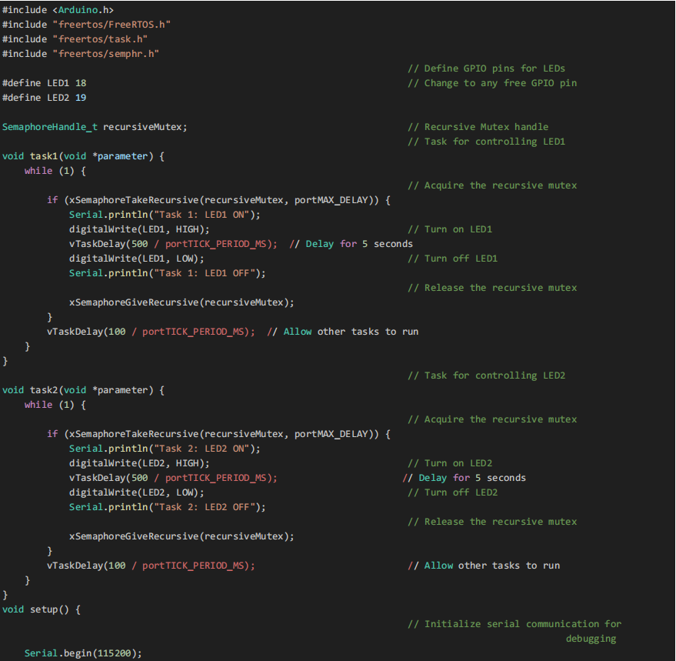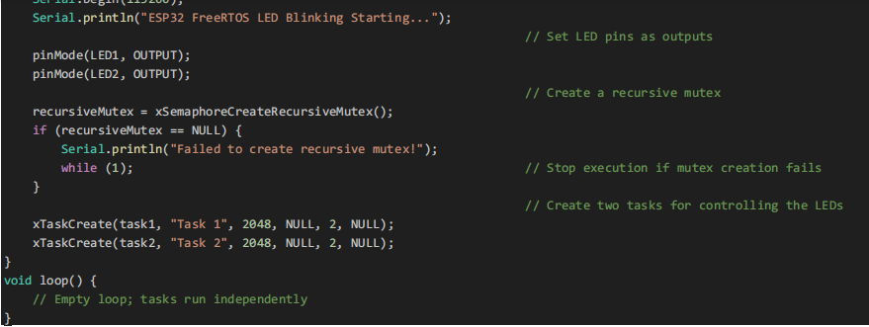

EXPLANATION OF CODE:

- Including Required Libraries
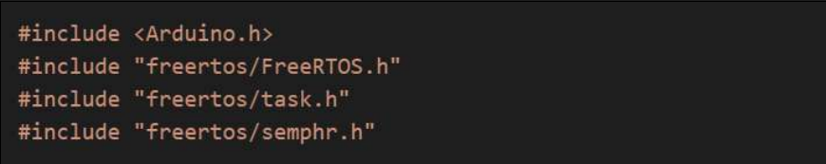

These headers allow the program to use FreeRTOS features, such as task scheduling and
synchronization using semaphores (mutexes).

2. Defining GPIO Pins for LEDs

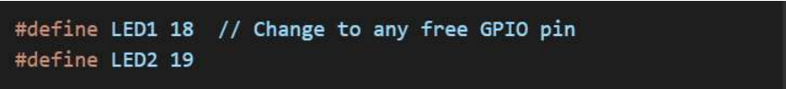

● Two GPIO pins are defined for controlling two LEDs.
● These LEDs will be turned ON and OFF by separate FreeRTOS tasks.

3. Declare a Recursive Mutex

● Declares a recursive mutex handle (recursiveMutex), which allows the same task to
lock the mutex multiple times before releasing it.
● Recursive mutexes allow a task to lock a mutex multiple times without getting blocked.
● They are different from normal mutexes, which would cause a deadlock if a task tries to
acquire them multiple times.

- Task for Controlling LED1

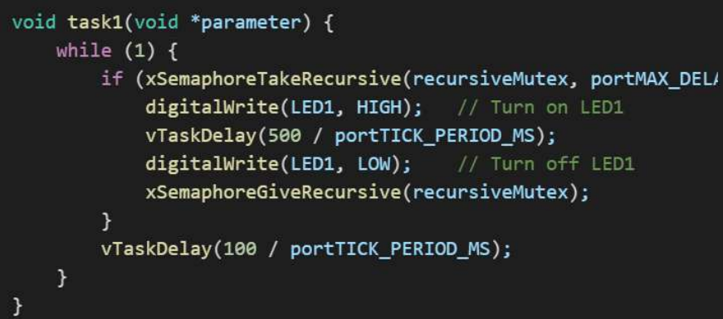

● The task continuously tries to acquire the recursive mutex.
● If successful, it turns LED1 ON, waits for 500ms, and then turns LED1 OFF.
● The mutex is then released before allowing other tasks to run.

5. Task for Controlling LED2
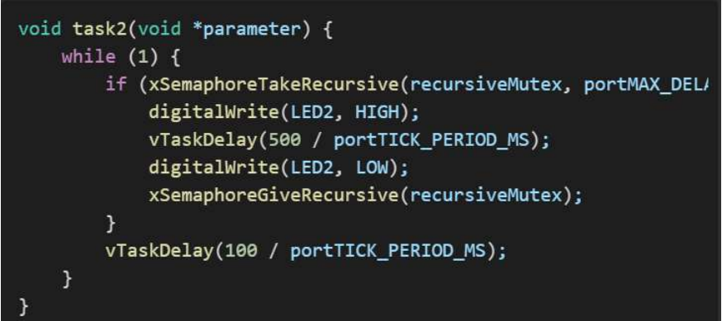

● Works the same way as task1, but controls LED2.

- Setting Up the System

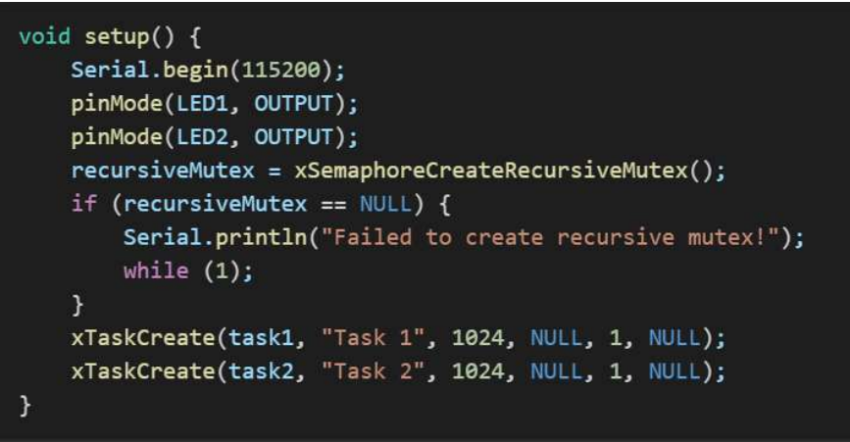

● Initializes serial communication and sets LED pins as outputs.
● Creates a recursive mutex and ensures it is successfully initialized.
● Creates two tasks that control the LEDs independently.
● If multiple tasks have the same priority, FreeRTOS schedules them using time-slicing.
● If a higher-priority task is ready, it preempts lower-priority tasks.

- Empty Loop (Main Execution)

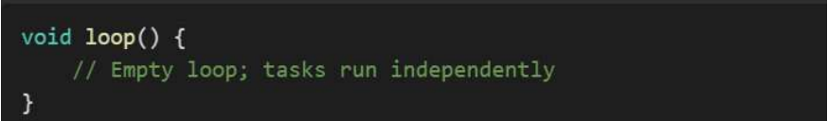

● The loop() function is empty because FreeRTOS handles the tasks independently.

CONCLUSION :
This program efficiently uses a recursive mutex to control two LEDs
in an ESP32 running FreeRTOS. The mutex ensures safe access to
shared resources, preventing race conditions while allowing the
same task to acquire the mutex multiple times. This approach is
particularly useful in applications requiring safe multitasking and
resource synchronization in embedded systems.

