Performance Test

Report

**Fiver Project Performance Test**

**Submitted To:**

**Version: 1.0**

**Prepared By: Dhanuka Dulanjana**

**Date: 09/11/2023**

|  |  |  |
| --- | --- | --- |
| **Performance Test Report** | | |
| **Environment :** Production | **Portal Names: Internal Portal** | |
| **Client :** Fiver Project | | |
| **PREPARED BY :** | | |
| **Name :** Dhanuka Dulanjana | **Designation :** Software Quality Assurance Engineer | |
| **Signature :** | **Date :** 11-November -2023 | |
|  | |  |

|  |  |  |  |
| --- | --- | --- | --- |
| DOCUMENT REVISION HISTORY: | | | |
| **Version**  **No.** | Date | Description | Author  (name) |
| 1.0 | 11-November -2023 | Performance Test Result - Phase 1 | Dhanuka Dulanjana |
|  |  |  |  |
|  |  |  |  |

# Tested Environment and Pre-requisites:

## Software

|  |  |
| --- | --- |
| Name | Details |
| Jmeter | v5.5 |
| Grafana | v9.0.2 |
| InfluxDB | v 1.8.0 |

# Execution Results

## 1. Test Scenario: 25 Users – Internal Portal –Log In and Search Person

### 1.1 25 Users –3 Minutes (Passed)

Time Duration: 3 Minutes

No of Threads:- 25

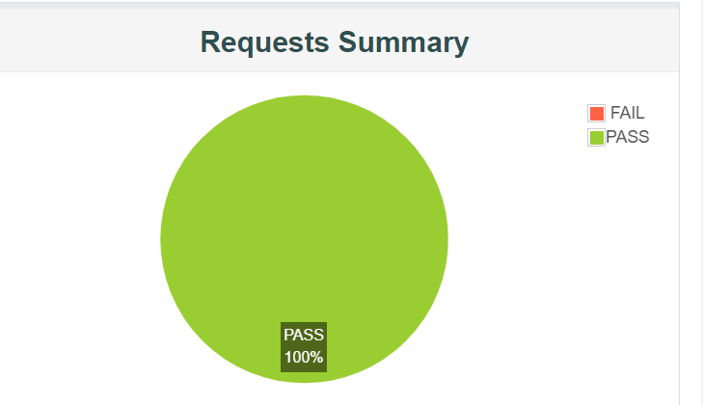

[Figure 1.11 – Thread Group Details]

**Figure 1.11 refers to how 25 concurrent users stayed in the system during the 3-minute execution time period.**

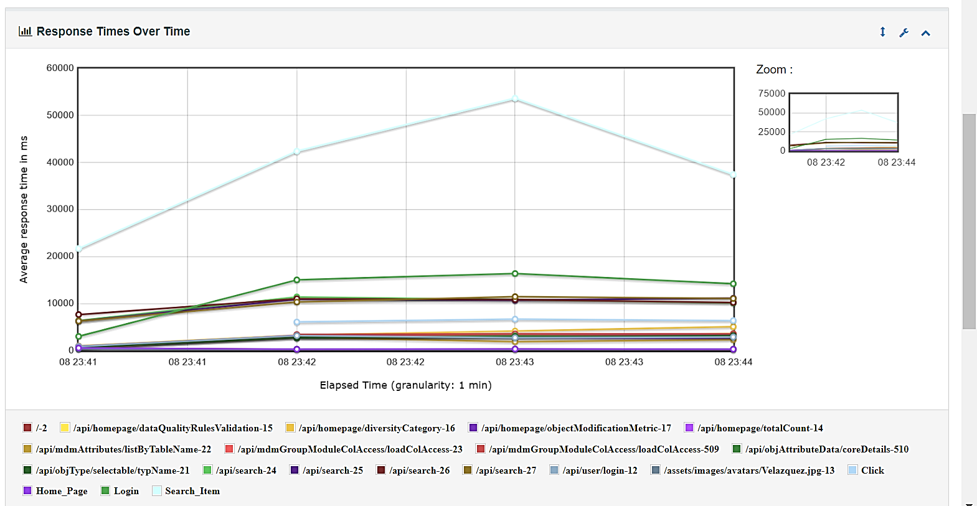

[Figure 1.1 – Summary Details]

**According to Figure 1.1 Response time is high for search scenario. To reduce the response time, Need to check Queries behind the search scenario and optimize it.**

## 2. Test Scenario: 50 Users – Internal Portal –Log In and Search Person

### 2.1 50 Users –3 Minutes (Passed)

Time Duration: 3 Minutes

No of Threads:- 25



[Figure 2.11 – Thread Group Details]

**Figure 2.11 refers to how 50 concurrent users stayed in the system during the 3-minute execution time period.**

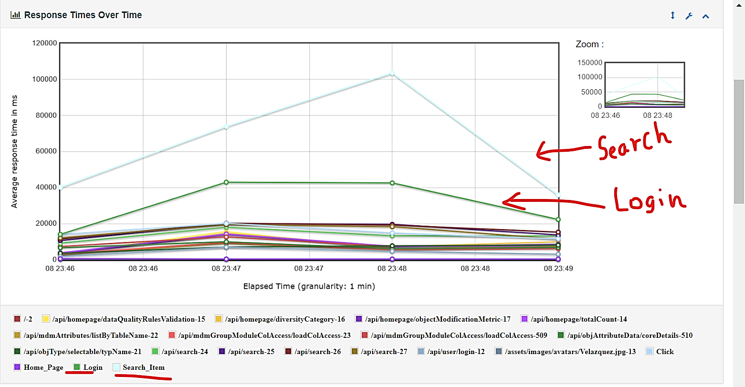

[Figure 2.1 – Summary Details]

**According to Figure 2.1 Response time is high for search scenario. To reduce the response time, Need to check Queries behind the search scenario and optimize it.**

**Also when the user count is increased from 25 to 50, Login Function also has a high response time.**

## 3. Test Scenario: 50 Users – Internal Portal –Log In and Search Person

### 3.1 100 Users –3 Minutes (Failed)

Time Duration: 3 Minutes

No of Threads:- 100

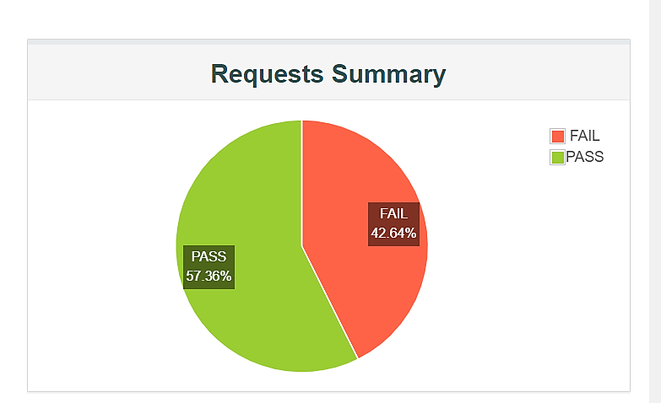

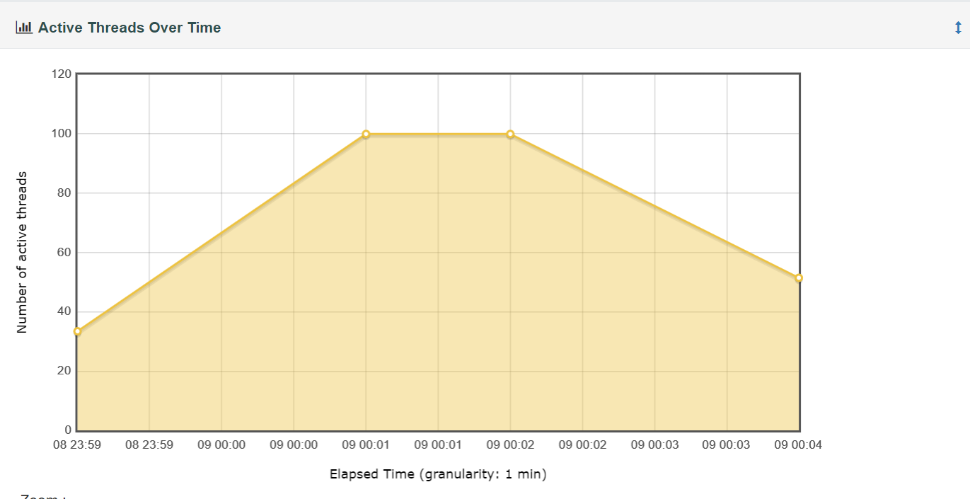

[Figure 3.11 – Thread Group Details]

**Figure 3.11 refers to how 100 concurrent users stayed in the system during the 3-minute execution time period.**

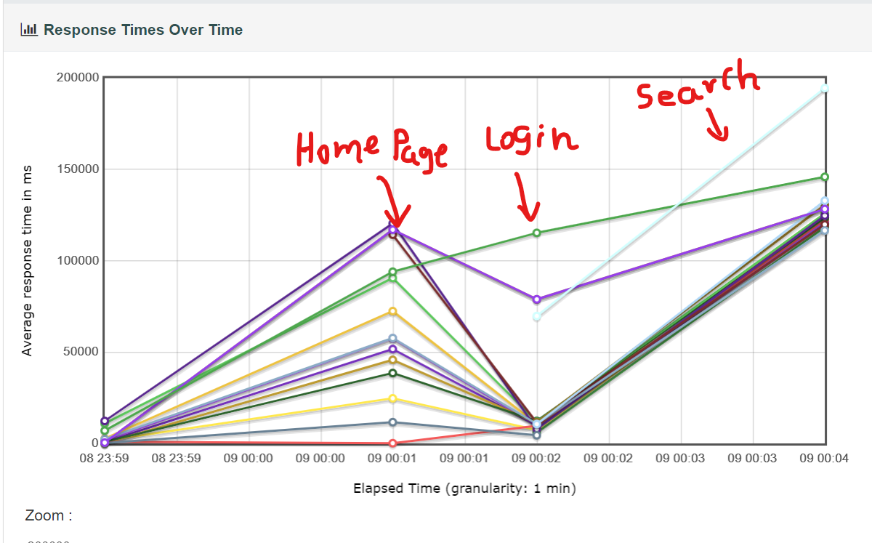

[Figure 3.1 – Summary Details]

**According to Figure 3.1 Response time is high for search scenario. To reduce the response time, Need to check Queries behind the search scenario and optimize it.**

**Also when the user count is increased from 50 to 100, Login Function also has a high response time.**

**\*\*System is not stable with 100 Users\*\***

# Conclusion

**25Users**

* System is stable with 25 Users.

**50Users**

* System is stable with 50 Users, but System gets bit slow with 50 users.

**100Users**

* **System is not stable with 100 Users.**