|  |  |
| --- | --- |
| **Student Registration Number** | **Student Name** |
| IT20207236 | Balasooriya B.M.D.B |
| IT20190798 | Rathnayaka R.M.S.Y |
| IT20491994 | Dilshani M.G.S.U |
| IT20905422 | Perera K.S.C |

INTRODUCTION:

The implemented publisher-subscriber scenario has developed using Eclipse Equinox OSGi framework and consist of eight publishers and eight consumers. furthermore, it can be categorized under commercial Domain. This Printing shop allows company owners to see printing cost of each categories which they have. Those categories are Card printing, Mug printing, T-shirt printing and Sticker printing. If They input necessary details printing cost will be calculated and display in the console. In addition to that, printing shop owner can see deliver cost when customer ask to delivery their order. In that case Owner can easily enter the weight and the distance of the pack.

INDIVIDUAL CONTRIBUTION:

|  |  |  |
| --- | --- | --- |
| Student ID | Implemented Bundle |  |
| IT20207236 |  |  |
| IT20190798 | Sticker_Publisher,Print_Sticker_Consumer,  Packing_Publisher, Print_Packing_Consumer |  |
| IT20491994 | Mug_Publisher, Print_Cost_calculation_Consumer, Transport_Publisher, Transport_Consumer. |  |
| IT20905422 |  |  |

**Service stop/start process**

**Run Configurations**

**Main Menu**

**Print Card Cost**

**Print Mug Price**

**Print Transport Charges**

**Print Sticker Cost**

**Print T-shirt Cost**

Card_Publisher_Manifest

Mug_Publisher_Manifest

Transport_Publisher_Manifest

Transport_Consumer_Manifest

Sticker_Publisher_Manifest

Print_Sticker_Consumer_ Manifest

Tshirt_Publisher_Manifest

Expense_Publisher_Manifest

Print_Expense_Consumer_Manifest

Print_Row_Materialsconsumer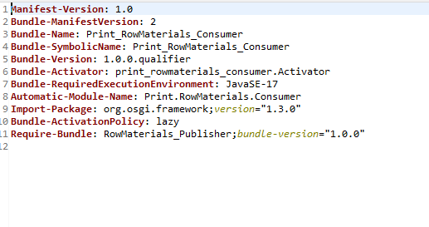

Print_Row_Materials_Publisher

