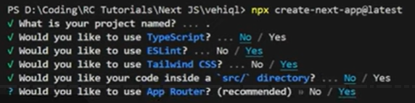

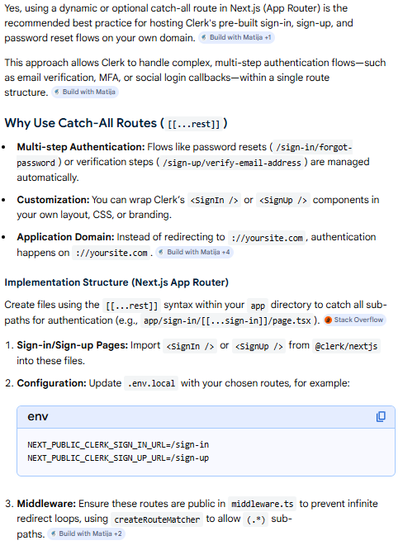

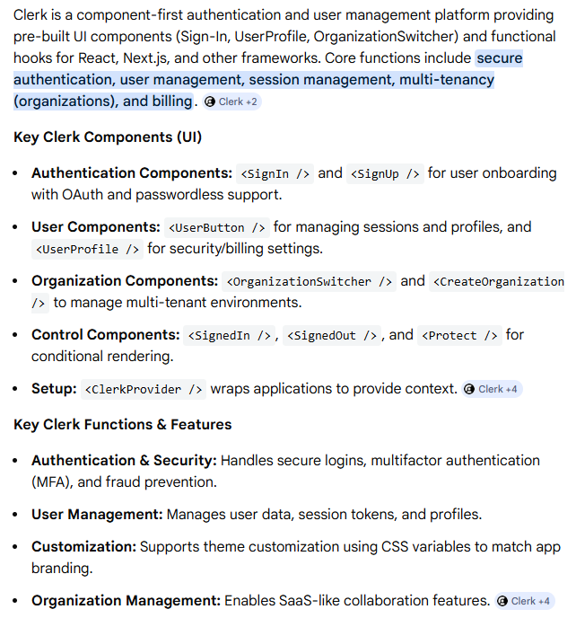

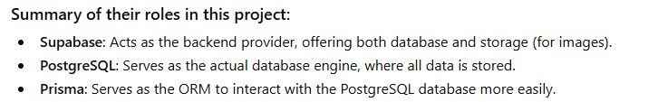

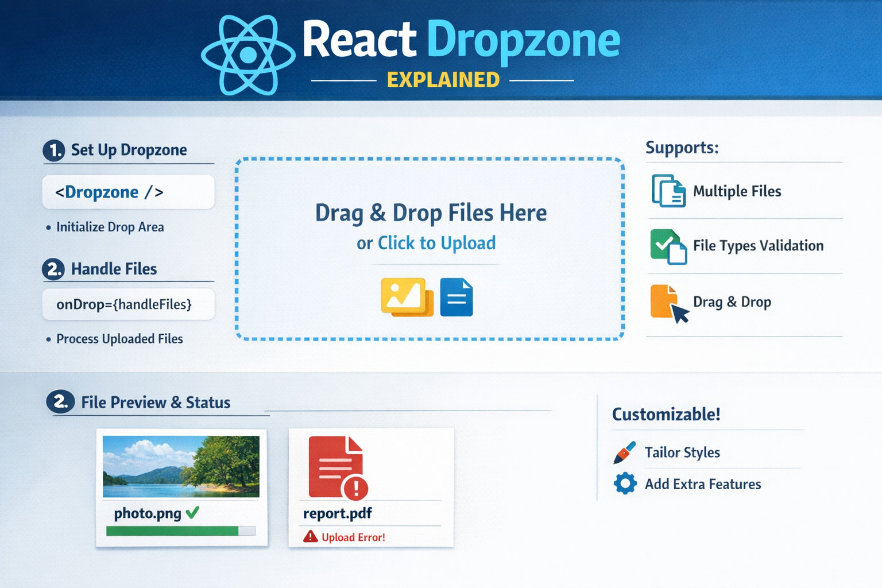

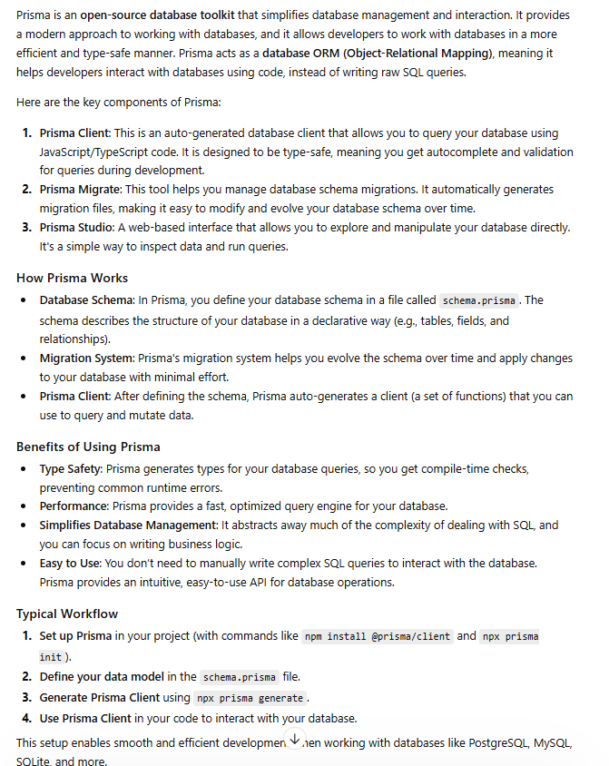
Here’s a breakdown:
- ORM for SQL Databases: In a MERN project, you might use Mongoose to interact with MongoDB (which is a NoSQL database). Prisma is like Mongoose, but instead of MongoDB, it works with SQL databases like PostgreSQL or MySQL.
- Schema-based Approach: Instead of manually writing raw SQL queries, you define your database schema (i.e., the structure of your tables and relationships) in a Prisma schema file (schema.prisma). This schema is kind of like how you'd define your MongoDB models with Mongoose.
  - For example, in a MongoDB schema with Mongoose, you'd define a model like User with fields like name, email, etc. Similarly, with Prisma, you define a User model but for a SQL database.
- Automated Query Generation: Prisma has a query engine that generates the SQL queries for you based on your schema. This makes database operations faster and easier without needing to manually write SQL.
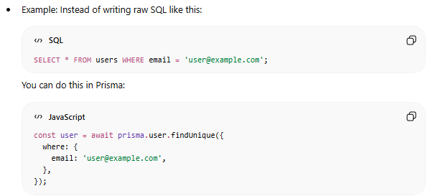
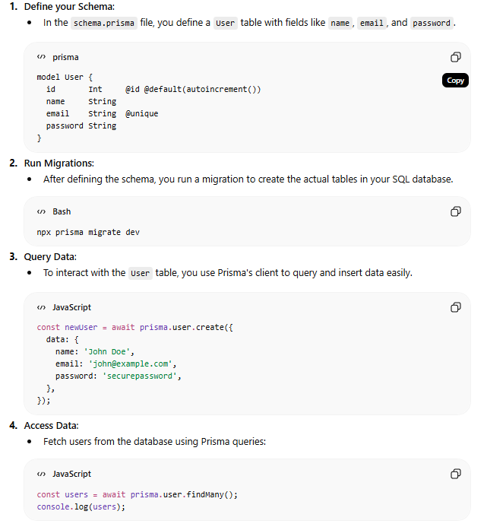

so here it is so obviously first of all we will be having our users table right now we
1:38:16
1 hour, 38 minutes, 16 seconds
are storing the data of our users inside of clerk but for the faster access I decided to store it inside of our database as well

Indexing

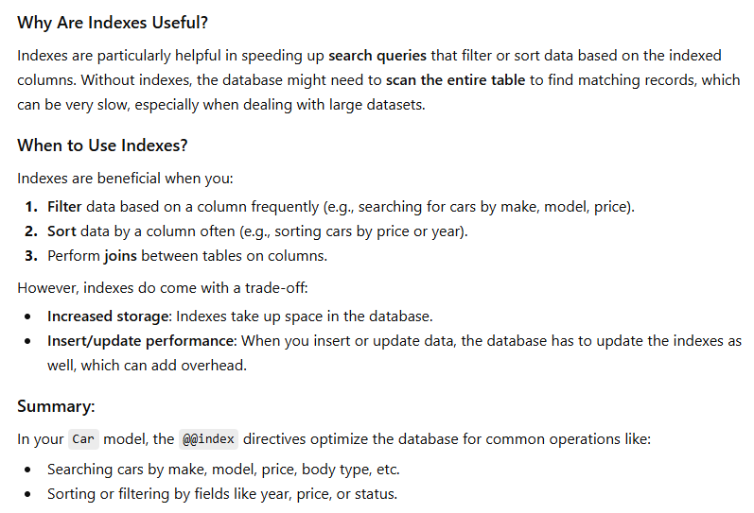
https://youtu.be/BIlFTFrEFOI?si=tWv3thArNs9piM-8
Assign foreign key in prisma

