EX NO:
DATE :
AIM:
To develop a mini web application using React and Vite demonstrating asynchronous REST API consumption, handling network requests with the fetch API, managing loading/error states, and dynamically rendering user profile data.
PROCEDURE:
1. Scaffold a React application using Vite by executing 'npm create vite@latest react-api-app -- --template react'.
2. Navigate into the project workspace, install required dependencies using 'npm install', and start the development server.
3. Declare state variables utilizing the 'useState' hook to manage fetched data, loading indicators, and error exceptions.
4. Implement an asynchronous handler function utilizing the 'fetch()' API and async/await syntax to request data from the REST endpoint.
5. Trigger the fetch operation via button click or 'useEffect' hook, dynamically format the JSON response in JSX, and verify via 'npm run dev'.
CODE:
Sample Application: Random User Profile Generator (src/App.jsx)
// src/App.jsx
import React, { useState, useEffect } from 'react';

function App() {
const [user, setUser] = useState(null);
const [loading, setLoading] = useState(false);
const [error, setError] = useState(null);

// Asynchronous function to fetch live data using fetch() API
const fetchRandomUser = async () => {
setLoading(true);
setError(null);
try {
const response = await fetch('https://randomuser.me/api/');
if (!response.ok) {
throw new Error('Failed to fetch data from API');
}
const data = await response.json();
const userData = data.results[0];
setUser({
name: `${userData.name.first} ${userData.name.last}`,
email: userData.email,
phone: userData.phone,
country: userData.location.country,
age: userData.dob.age,
picture: userData.picture.large
});
} catch (err) {
setError(err.message);
} finally {
setLoading(false);
}
};

// Initial fetch on component mount
useEffect(() => {
fetchRandomUser();
}, []);

return (
<div style={{ border: '1px solid #000', padding: '20px', maxWidth: '450px', margin: '20px auto', fontFamily: 'Times New Roman, serif', textAlign: 'center' }}>
<h2>Random User Profile Generator</h2>
<p style={{ fontStyle: 'italic' }}>API: https://randomuser.me/api/</p>

<button
style={{ border: '1px solid #000', background: '#fff', padding: '6px 14px', cursor: 'pointer', margin: '10px 0', fontWeight: 'bold' }}
onClick={fetchRandomUser}
disabled={loading}
>
{loading ? 'Fetching User...' : 'Generate User'}
</button>

{error && <p style={{ color: '#000', fontWeight: 'bold' }}>Error: {error}</p>}

{user && !loading && (
<div style={{ border: '1px solid #000', padding: '15px', marginTop: '15px', textAlign: 'left' }}>
<div style={{ textAlign: 'center', marginBottom: '10px' }}>
<img
src={user.picture}
alt="Profile"
style={{ border: '1px solid #000', borderRadius: '50%', width: '100px', height: '100px' }}
/>
</div>
<p><strong>Name:</strong> {user.name}</p>
<p><strong>Email:</strong> {user.email}</p>
<p><strong>Phone:</strong> {user.phone}</p>
<p><strong>Country:</strong> {user.country}</p>
<p><strong>Age:</strong> {user.age} years</p>
</div>
)}
</div>
);
}

export default App;
OUTPUT:
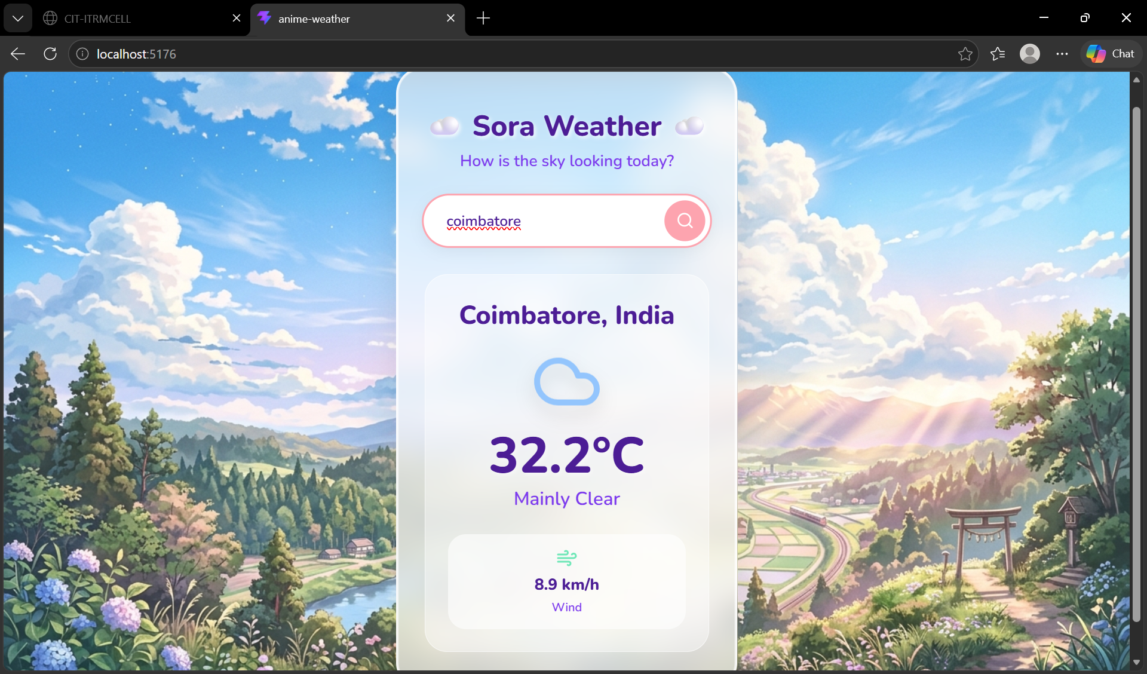
RESULT:
Thus, the React application demonstrating live API consumption using fetch was successfully developed and verified.

