EX NO:
DATE :
AIM:
To develop a Django web application to display a Student Information Webpage by configuring URL routing, defining view functions, passing contextual dictionary data, and rendering HTML templates using Django Template Language.
PROCEDURE:
1. Create a new Django project named 'studentproject' and scaffold the application named 'student' using django-admin.
2. Register the 'student' application within the INSTALLED_APPS list in 'studentproject/settings.py'.
3. Define the view function 'student_info()' in 'views.py' containing student dictionary data and returning render().
4. Map the view function to the application URL dispatcher in 'urls.py' using the path() method.
5. Create 'student.html' within the templates directory, render context variables using Django Template Language ({{ }}), and verify via 'python manage.py runserver'.
CODE:
1. View Function (student/views.py)
# student/views.py
from django.shortcuts import render

def student_info(request):
context = {
'college_name': 'COIMBATORE INSTITUTE OF TECHNOLOGY',
'student_name': 'RAM',
'roll_number': '101',
'course': 'M.Sc Software Systems',
'year': 'II Year',
'welcome_message': 'Welcome to CIT...!'
}
return render(request, 'student.html', context)
2. URL Configuration (studentproject/urls.py)
# studentproject/urls.py
from django.contrib import admin
from django.urls import path
from student.views import student_info

urlpatterns = [
path('admin/', admin.site.urls),
path('', student_info, name='student_info'),
]
3. HTML Template (student/templates/student.html)
<!-- student/templates/student.html -->
<!DOCTYPE html>
<html lang="en">
<head>
<meta charset="UTF-8">
<title>Student Information</title>
<style>
.container { max-width: 450px; margin: 30px auto; border: 1px solid #000; padding: 20px; font-family: 'Times New Roman', serif; text-align: center; }
.header { border-bottom: 1px solid #000; padding-bottom: 10px; }
.details { text-align: left; margin: 20px auto; width: 80%; }
.details p { margin: 8px 0; font-size: 16px; }
.footer-msg { font-style: italic; font-weight: bold; border-top: 1px solid #000; padding-top: 10px; }
</style>
</head>
<body>
<div class="container">
<div class="header">
<h3>{{ college_name }}</h3>
<h4>STUDENT INFORMATION</h4>
</div>
<div class="details">
<p><strong>Student Name</strong> : {{ student_name }}</p>
<p><strong>Roll Number</strong> : {{ roll_number }}</p>
<p><strong>Course</strong> : {{ course }}</p>
<p><strong>Year</strong> : {{ year }}</p>
</div>
<div class="footer-msg">
<p>{{ welcome_message }}</p>
</div>
</div>
</body>
</html>
OUTPUT:
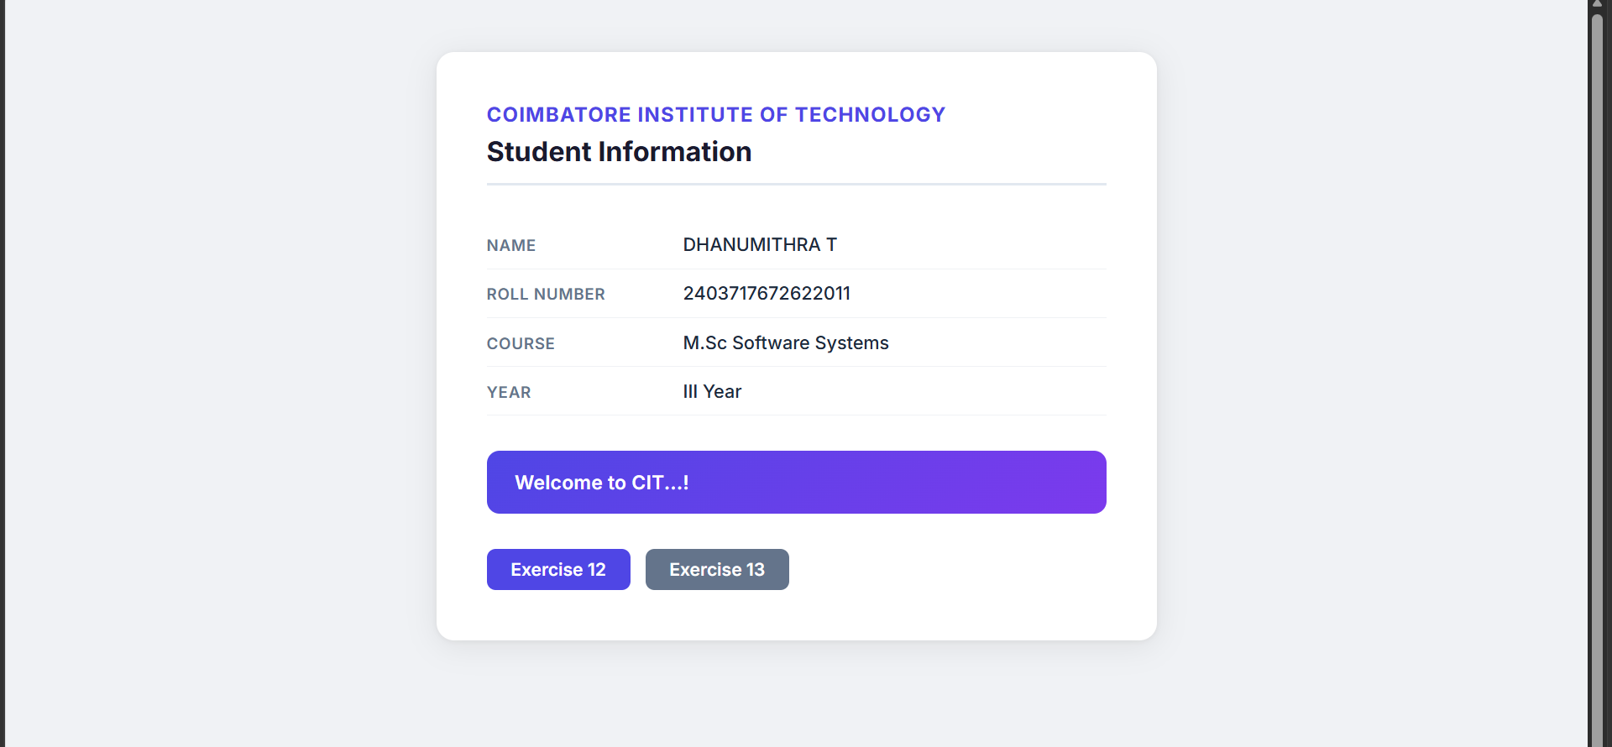
RESULT:
Thus, the Django web application using URLs, views, and templates was successfully developed and verified.

