EX NO:
DATE :
AIM:
To develop a multi-page Django web application implementing an in-memory Student Management System using URLs, views, and HTML templates to perform student listing, addition, updating, and deletion without database persistence.
PROCEDURE:
1. Scaffold a Django project and application, configuring template directories and registered apps in 'settings.py'.
2. Initialize an in-memory data store using Python lists and dictionaries within 'views.py' to simulate database storage.
3. Implement view functions to display student records, process POST requests for adding and updating entries, and handle deletions.
4. Configure application URL patterns in 'urls.py' to map paths with parameter routes for add, edit, and delete operations.
5. Design HTML templates with navigation menus and form controls, render data using Django Template Language, and verify via 'runserver'.
CODE:
1. Views with In-Memory Operations (student_app/views.py)
# student_app/views.py
from django.shortcuts import render, redirect

# In-memory data store simulating database records
students = [
{'roll_no': '101', 'name': 'RAM', 'course': 'M.Sc SS', 'year': 'II Year'},
{'roll_no': '102', 'name': 'PRIYA', 'course': 'M.Sc SS', 'year': 'II Year'}
]

def student_list(request):
return render(request, 'student_list.html', {'students': students})

def add_student(request):
if request.method == 'POST':
roll_no = request.POST.get('roll_no')
name = request.POST.get('name')
course = request.POST.get('course')
year = request.POST.get('year')
if roll_no and name:
students.append({'roll_no': roll_no, 'name': name, 'course': course, 'year': year})
return redirect('student_list')
return render(request, 'add_student.html')

def update_student(request, roll_no):
student = next((s for s in students if s['roll_no'] == roll_no), None)
if not student:
return redirect('student_list')
if request.method == 'POST':
student['name'] = request.POST.get('name')
student['course'] = request.POST.get('course')
student['year'] = request.POST.get('year')
return redirect('student_list')
return render(request, 'update_student.html', {'student': student})

def delete_student(request, roll_no):
global students
students = [s for s in students if s['roll_no'] != roll_no]
return redirect('student_list')
2. URL Dispatcher Configuration (student_project/urls.py)
# student_project/urls.py
from django.urls import path
from student_app import views

urlpatterns = [
path('', views.student_list, name='student_list'),
path('add/', views.add_student, name='add_student'),
path('update/<str:roll_no>/', views.update_student, name='update_student'),
path('delete/<str:roll_no>/', views.delete_student, name='delete_student'),
]
3. HTML Templates with Navigation Menu
<!-- templates/student_list.html (View Student List) -->
<!DOCTYPE html>
<html>
<head>
<title>Student Management</title>
<style>
.box { max-width: 600px; margin: 20px auto; border: 1px solid #000; padding: 15px; font-family: 'Times New Roman', serif; }
.nav a { margin-right: 15px; text-decoration: none; color: #000; font-weight: bold; }
table { width: 100%; border-collapse: collapse; margin-top: 15px; }
th, td { border: 1px solid #000; padding: 6px; text-align: center; }
</style>
</head>
<body>
<div class="box">
<h2>CIT - Student Management System</h2>
<div class="nav">
<a href="{% url 'student_list' %}">Student List</a> |
<a href="{% url 'add_student' %}">Add New Student</a>
</div>
<table>
<tr><th>Roll No</th><th>Name</th><th>Course</th><th>Year</th><th>Actions</th></tr>
{% for s in students %}
<tr>
<td>{{ s.roll_no }}</td><td>{{ s.name }}</td><td>{{ s.course }}</td><td>{{ s.year }}</td>
<td>
<a href="{% url 'update_student' s.roll_no %}">Edit</a> |
<a href="{% url 'delete_student' s.roll_no %}">Delete</a>
</td>
</tr>
{% empty %}
<tr><td colspan="5">No student records available.</td></tr>
{% endfor %}
</table>
</div>
</body>
</html>

<!-- templates/add_student.html (Add Student Page) -->
<!DOCTYPE html>
<html>
<head>
<title>Add Student</title>
<style>
.box { max-width: 450px; margin: 20px auto; border: 1px solid #000; padding: 15px; font-family: 'Times New Roman', serif; }
.form-group { margin-bottom: 10px; }
label { display: inline-block; width: 90px; }
</style>
</head>
<body>
<div class="box">
<h3>Add New Student</h3>
<a href="{% url 'student_list' %}">Back to List</a>
<form method="POST" style="margin-top: 12px;">
{% csrf_token %}
<div class="form-group"><label>Roll No:</label><input type="text" name="roll_no" required></div>
<div class="form-group"><label>Name:</label><input type="text" name="name" required></div>
<div class="form-group"><label>Course:</label><input type="text" name="course" required></div>
<div class="form-group"><label>Year:</label><input type="text" name="year" required></div>
<button type="submit">Add Student</button>
</form>
</div>
</body>
</html>
OUTPUT:
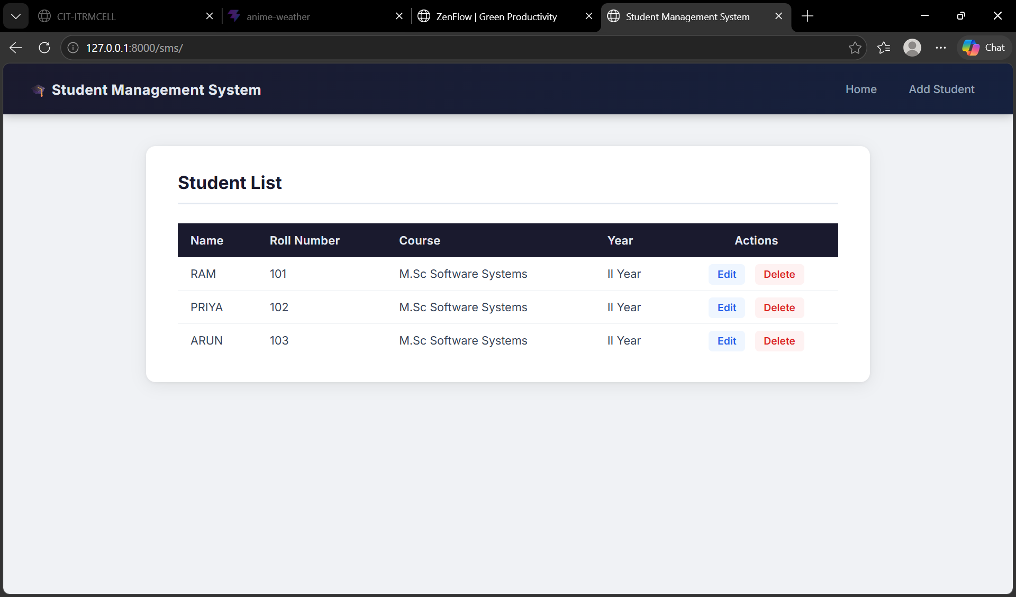
RESULT:
Thus, the Django web application implementing in-memory student management with URL navigation and templates was successfully developed and verified.

