EX NO:
DATE :
AIM:
To develop a Student Information Web Application using Django integrated with a MySQL database, retrieving student records via Django ORM models and rendering multi-page views with Bootstrap navigation and tables.
PROCEDURE:
1. Create a Django project and application, configuring MySQL database connection parameters within 'settings.py'.
2. Define the 'Student' model in 'models.py' with fields for roll number, name, department, and year.
3. Execute 'makemigrations' and 'migrate' to establish the schema in MySQL and populate sample student records.
4. Implement view functions for Home, Students, and About in 'views.py' and map corresponding routes in 'urls.py'.
5. Design HTML templates using a common Bootstrap navbar and tabular layout, render querysets using DTL, and verify via 'runserver'.
CODE:
1. Database Settings & Django Model (settings.py & models.py)
# settings.py (Database Configuration)
DATABASES = {
'default': {
'ENGINE': 'django.db.backends.mysql',
'NAME': 'student_db',
'USER': 'root',
'PASSWORD': 'password',
'HOST': 'localhost',
'PORT': '3306',
}
}

# student_app/models.py
from django.db import models

class Student(models.Model):
rollno = models.IntegerField(primary_key=True)
name = models.CharField(max_length=100)
department = models.CharField(max_length=100)
year = models.IntegerField()

def __str__(self):
return f"{self.rollno} - {self.name}"
2. Views and URL Routing (views.py & urls.py)
# student_app/views.py
from django.shortcuts import render
from .models import Student

def home(request):
return render(request, 'home.html')

def students(request):
student_list = Student.objects.all()
return render(request, 'students.html', {'students': student_list})

def about(request):
return render(request, 'about.html')

# student_project/urls.py
from django.contrib import admin
from django.urls import path
from student_app import views

urlpatterns = [
path('admin/', admin.site.urls),
path('', views.home, name='home'),
path('students/', views.students, name='students'),
path('about/', views.about, name='about'),
]
3. HTML Templates with Bootstrap Navigation & Table (base.html & students.html)
<!-- templates/base.html (Common Bootstrap Layout) -->
<!DOCTYPE html>
<html lang="en">
<head>
<meta charset="UTF-8">
<title>Student Information System</title>
<link href="https://cdn.jsdelivr.net/npm/bootstrap@5.3.0/dist/css/bootstrap.min.css" rel="stylesheet">
</head>
<body class="bg-light">
<nav class="navbar navbar-expand-lg navbar-dark bg-dark">
<div class="container">
<a class="navbar-brand" href="{% url 'home' %}">CIT Portal</a>
<div class="navbar-nav">
<a class="nav-link" href="{% url 'home' %}">Home</a>
<a class="nav-link" href="{% url 'students' %}">Students</a>
<a class="nav-link" href="{% url 'about' %}">About</a>
</div>
</div>
</nav>
<div class="container my-4">{% block content %}{% endblock %}</div>
</body>
</html>

<!-- templates/students.html (Students Data Table) -->
{% extends 'base.html' %}
{% block content %}
<div class="card shadow-sm p-4">
<h3 class="mb-3">Students Page</h3>
<table class="table table-bordered table-striped">
<thead class="table-dark">
<tr><th>Roll No</th><th>Name</th><th>Department</th><th>Year</th></tr>
</thead>
<tbody>
{% for s in students %}
<tr>
<td>{{ s.rollno }}</td><td>{{ s.name }}</td><td>{{ s.department }}</td><td>{{ s.year }}</td>
</tr>
{% empty %}
<tr><td colspan="4" class="text-center">No student records found.</td></tr>
{% endfor %}
</tbody>
</table>
</div>
{% endblock %}
OUTPUT:
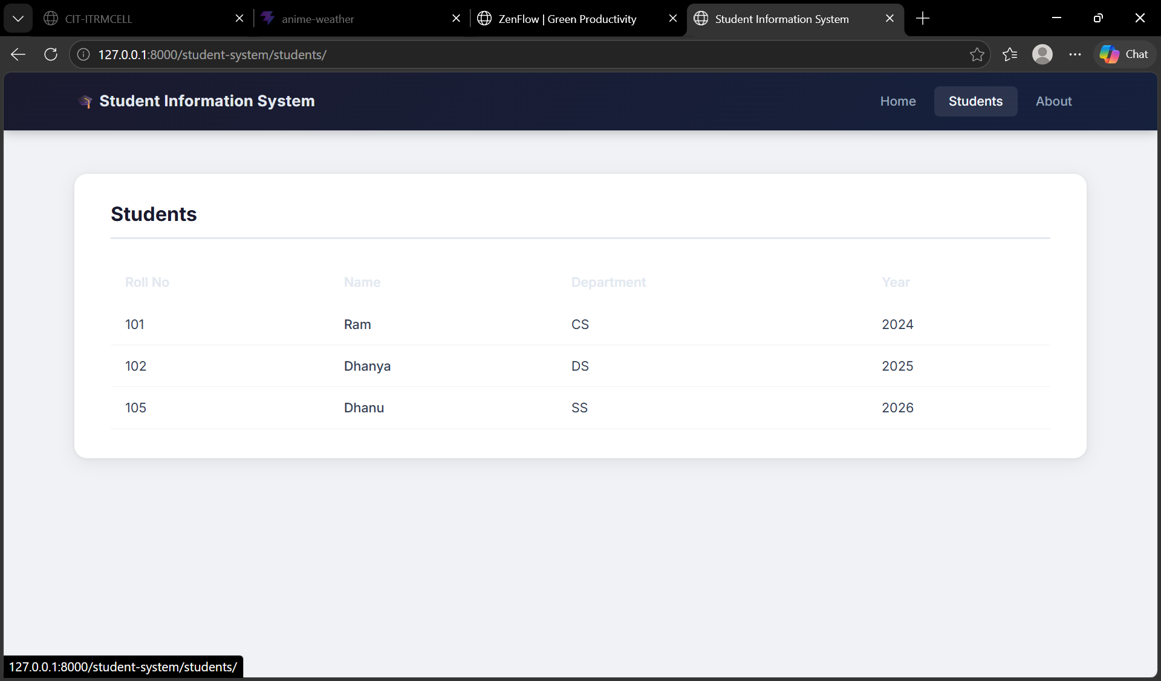
RESULT:
Thus, the Django web application integrated with MySQL and Bootstrap navigation was successfully developed and verified.

