EX NO:
DATE :
AIM:
To develop and implement TypeScript programs utilizing arrow functions for arithmetic and logical computations, and to build a foundational standalone Angular web application with customized UI components.
PROCEDURE:
1. Set up the Node.js development runtime and initialize the TypeScript compiler environment.
2. Implement arrow functions to handle numeric arithmetic operations, string transformations, and boolean condition checks.
3. Execute and verify the TypeScript modules using the TypeScript compiler (tsc) and Node runtime.
4. Generate a new Angular standalone application using the latest Angular CLI command 'ng new'.
5. Modify the root component template and styles to apply custom layout designs and verify the application via 'ng serve'.
CODE:
Part A: TypeScript Programs (Arrow Functions)
// Sample Code: TypeScript Arrow Functions (Arithmetic, String Length & Even Check)
const add = (a: number, b: number): number => a + b;
const subtract = (a: number, b: number): number => a - b;
const multiply = (a: number, b: number): number => a * b;
const divide = (a: number, b: number): number => (b !== 0 ? a / b : 0);
const getStringLength = (str: string): number => str.length;
const isEven = (num: number): boolean => num % 2 === 0;

// Execution
console.log("Addition (10 + 5):", add(10, 5));
console.log("Division (10 / 5):", divide(10, 5));
console.log("Length of 'TypeScript':", getStringLength("TypeScript"));
console.log("Is 4 Even?:", isEven(4));
Part B: Angular Application Development & Design Customization
// src/app/app.component.ts (Angular Latest Standalone Component)
import { Component } from '@angular/core';

@Component({
selector: 'app-root',
standalone: true,
imports: [],
template: `
<div class="card">
<h2>{{ title }}</h2>
<p>Customized Angular standalone component loaded successfully.</p>
<button (click)="showMessage()">Click Me</button>
<p *ngIf="message">{{ message }}</p>
</div>
`,
styles: [`
.card { border: 1px solid #000; padding: 20px; text-align: center; max-width: 400px; margin: 30px auto; }
button { border: 1px solid #000; background: #fff; padding: 6px 12px; cursor: pointer; }
`]
})
export class AppComponent {
title = 'My First Angular App';
message = '';

showMessage(): void {
this.message = 'Welcome to Full Stack Application Development!';
}
}
OUTPUT:
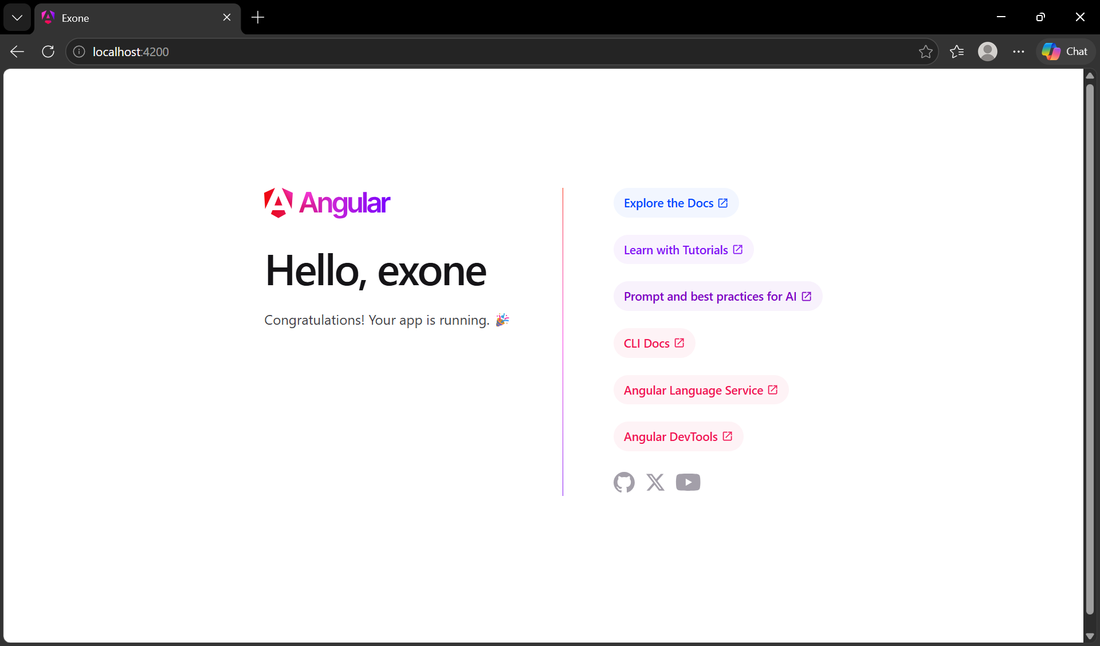
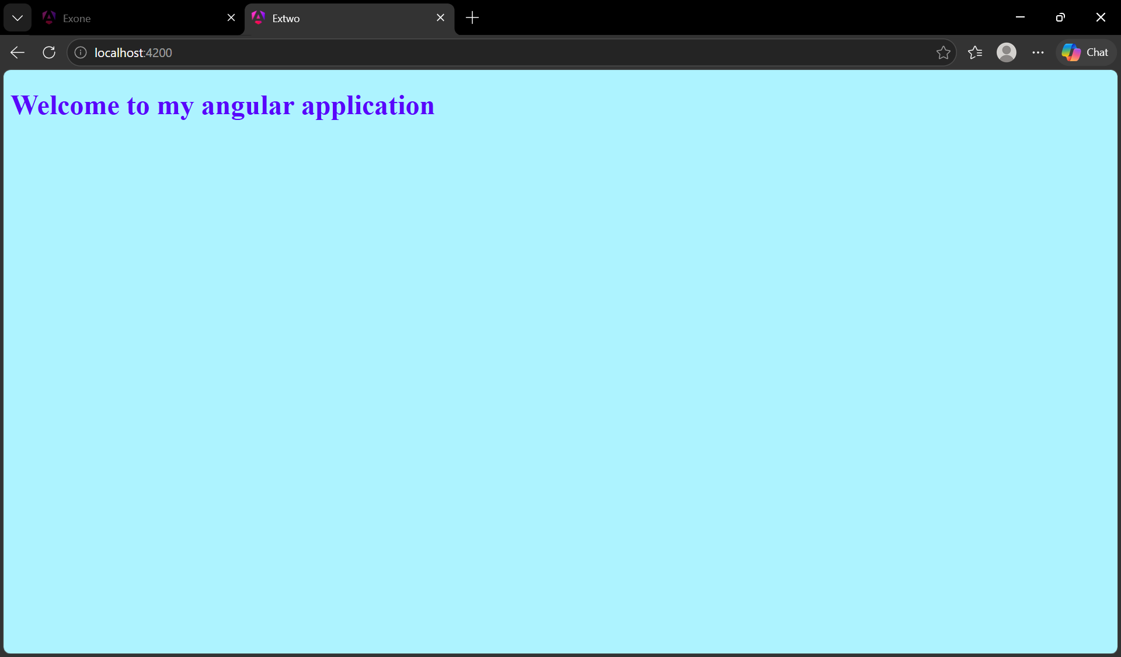
RESULT:
Thus, the TypeScript programs and Angular application were successfully developed and verified.

