EX NO:
DATE :
AIM:
To develop an Angular web application demonstrating core data binding mechanisms including string interpolation, property binding, event binding, and two-way data binding within a reactive standalone component architecture.
PROCEDURE:
1. Initialize a new standalone Angular application using the Angular CLI command 'ng new angular-data-binding'.
2. Import FormsModule into the component imports array to enable two-way data binding with ngModel.
3. Declare component state properties and handler methods for string interpolation, property states, and event handling.
4. Implement template bindings using {{ }} for interpolation, [property] for property binding, (event) for event binding, and [(ngModel)] for two-way binding.
5. Run the application using 'ng serve' and verify that user interactions and bidirectional data synchronization operate correctly.
CODE:
Angular Data Binding: String Interpolation, Property, Event & Two-Way Binding

Sample Application: Simple To-Do List Application
// src/app/app.component.ts (Angular Latest Standalone Component)
import { Component } from '@angular/core';
import { CommonModule } from '@angular/common';
import { FormsModule } from '@angular/forms';

@Component({
selector: 'app-root',
standalone: true,
imports: [CommonModule, FormsModule],
template: `
<div class="todo-card">
<!-- 1. String Interpolation: Display app title and dynamic task count -->
<h2>{{ appTitle }}</h2>
<p class="task-info">Total Pending Tasks: {{ tasks.length }}</p>

<!-- 2. Two-way Binding: Sync newTask input with component property -->
<div class="input-group">
<input type="text" [(ngModel)]="newTask" placeholder="Enter task description..." />

<!-- 3. Property Binding & 4. Event Binding: Disable button if empty & handle click -->
<button [disabled]="newTask.trim().length === 0" (click)="addTask()">Add Task</button>
</div>

<!-- Task List Display with Event Binding for Deletion -->
<ul class="task-list">
<li *ngFor="let task of tasks; let i = index">
<span>{{ task }}</span>
<button class="btn-del" (click)="deleteTask(i)">Delete</button>
</li>
</ul>
<p *ngIf="tasks.length === 0" class="empty-msg">No tasks remaining!</p>
</div>
`,
styles: [`
.todo-card { border: 1px solid #000; padding: 20px; max-width: 420px; margin: 20px auto; font-family: 'Times New Roman', serif; }
h2 { text-align: center; margin-bottom: 6px; }
.task-info { text-align: center; font-style: italic; margin-bottom: 15px; }
.input-group { display: flex; gap: 8px; margin-bottom: 16px; }
input { flex: 1; padding: 6px; border: 1px solid #000; }
button { border: 1px solid #000; background: #fff; padding: 6px 12px; cursor: pointer; }
button:disabled { background: #eee; cursor: not-allowed; border-color: #888; color: #888; }
.task-list { list-style: none; padding: 0; margin: 0; }
.task-list li { display: flex; justify-content: space-between; align-items: center; border-bottom: 1px solid #000; padding: 6px 0; }
.btn-del { border: 1px solid #000; background: #fff; padding: 2px 8px; font-size: 11px; cursor: pointer; }
.empty-msg { text-align: center; margin-top: 10px; font-weight: bold; }
`]
})
export class AppComponent {
appTitle: string = 'To-Do List Application';
newTask: string = '';
tasks: string[] = ['Complete FSAD Exercise 2', 'Verify Data Bindings'];

addTask(): void {
if (this.newTask.trim().length > 0) {
this.tasks.push(this.newTask.trim());
this.newTask = '';
}
}

deleteTask(index: number): void {
this.tasks.splice(index, 1);
}
}
OUTPUT:
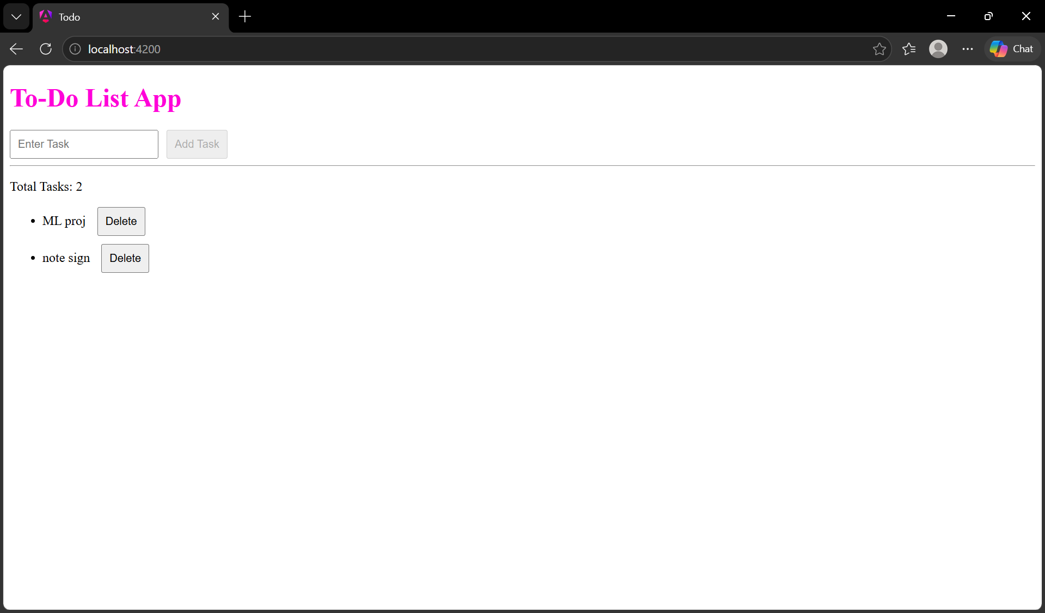
RESULT:
Thus, the Angular application demonstrating data binding concepts was successfully developed and verified.

