EX NO:
DATE :
AIM:
To develop an Angular web application demonstrating component hierarchy by creating child components (Header/Title, Side Menu, Main Body, and Account) and integrating them into the root parent AppComponent.
PROCEDURE:
1. Generate a new standalone Angular application using the Angular CLI command 'ng new angular-components'.
2. Create the child components (header-title, side-menu, main-body, and account) using 'ng generate component'.
3. Define template layouts and respective styles within each child component to reflect their architectural role.
4. Import and declare child standalone components within the imports array of the root parent 'AppComponent'.
5. Arrange child selectors (<app-header-title>, <app-side-menu>, <app-main-body>, <app-account>) inside 'app.component.html' and verify output using 'ng serve'.
CODE:
1. Child Components Definition (Header, Menu, Body, Account)
// src/app/header-title.component.ts
import { Component } from '@angular/core';

@Component({
selector: 'app-header-title',
standalone: true,
template: `<div class="box"><h3>1. Component Menu / Title</h3></div>`,
styles: [`.box { border: 1px solid #000; padding: 10px; text-align: center; }`]
})
export class HeaderTitleComponent {}

// src/app/account.component.ts
import { Component } from '@angular/core';

@Component({
selector: 'app-account',
standalone: true,
template: `<div class="box"><p>4. Component Account</p></div>`,
styles: [`.box { border: 1px solid #000; padding: 10px; text-align: center; }`]
})
export class AccountComponent {}

// src/app/side-menu.component.ts
import { Component } from '@angular/core';

@Component({
selector: 'app-side-menu',
standalone: true,
template: `<div class="box"><p>2. Component Menu</p></div>`,
styles: [`.box { border: 1px solid #000; height: 180px; padding: 10px; text-align: center; }`]
})
export class SideMenuComponent {}

// src/app/main-body.component.ts
import { Component } from '@angular/core';

@Component({
selector: 'app-main-body',
standalone: true,
template: `<div class="box"><p>3. Component Body</p></div>`,
styles: [`.box { border: 1px solid #000; height: 180px; padding: 10px; text-align: center; }`]
})
export class MainBodyComponent {}
2. Parent Component Integration (AppComponent)
// src/app/app.component.ts
import { Component } from '@angular/core';
import { HeaderTitleComponent } from './header-title.component';
import { AccountComponent } from './account.component';
import { SideMenuComponent } from './side-menu.component';
import { MainBodyComponent } from './main-body.component';

@Component({
selector: 'app-root',
standalone: true,
imports: [HeaderTitleComponent, AccountComponent, SideMenuComponent, MainBodyComponent],
template: `
<div class="layout-wrapper">
<div class="top-row">
<app-header-title class="header-comp"></app-header-title>
<app-account class="account-comp"></app-account>
</div>
<div class="bottom-row">
<app-side-menu class="menu-comp"></app-side-menu>
<app-main-body class="body-comp"></app-main-body>
</div>
</div>
`,
styles: [`
.layout-wrapper { border: 1px solid #000; padding: 12px; max-width: 650px; margin: 10px auto; }
.top-row { display: flex; gap: 8px; margin-bottom: 8px; }
.header-comp { flex: 3; }
.account-comp { flex: 1; }
.bottom-row { display: flex; gap: 8px; }
.menu-comp { flex: 1; }
.body-comp { flex: 3; }
`]
})
export class AppComponent {}
OUTPUT:
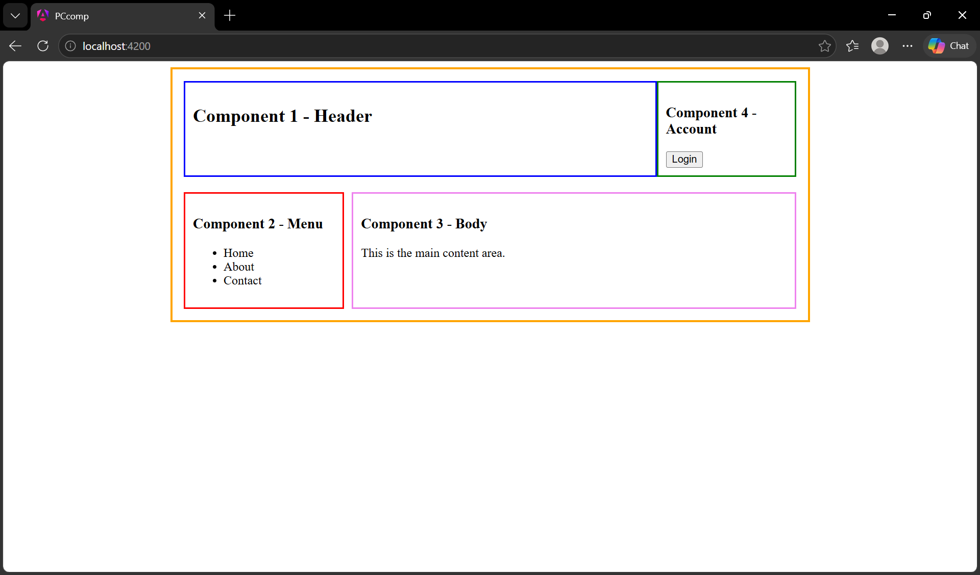
RESULT:
Thus, the Angular application demonstrating child component creation and parent mapping was successfully developed and verified.

