EX NO:
DATE :
AIM:
To develop an Angular web application demonstrating structural directives (@if, @for) and attribute directives ([style], [class]) to dynamically render conditional views, collections, and contextual styles within a dashboard.
PROCEDURE:
1. Initialize a new standalone Angular application using the Angular CLI command 'ng new angular-directives'.
2. Define a student data model containing attributes for student names, marks, attendance, status, and detail toggle state.
3. Implement the modern built-in structural control flow directive '@for' with track expressions to iterate through the student list.
4. Utilize the built-in '@if' directive to conditionally display detailed scorecards and attendance percentages on demand.
5. Apply attribute directives [class] and [style] to dynamically highlight passing/failing statuses and high-performing students, then verify via 'ng serve'.
CODE:
Angular Directives: Structural (@if, @for) and Attribute ([style], [class])
Sample Application: Student Dashboard
// src/app/app.component.ts (Angular Latest Standalone Component)
import { Component } from '@angular/core';

interface Student {
id: number;
name: string;
marks: number;
attendance: number;
isPassed: boolean;
showDetails: boolean;
}

@Component({
selector: 'app-root',
standalone: true,
imports: [],
template: `
<div class="dashboard-card">
<h2>Student Academic Dashboard</h2>
<p class="subtitle">Directives Demo: @if, @for, [class], [style]</p>

<table class="student-table">
<thead>
<tr>
<th>Roll No</th>
<th>Student Name</th>
<th>Marks</th>
<th>Action</th>
</tr>
</thead>
<tbody>
<!-- 1. Structural Directive: @for iteration with track expression -->
@for (student of students; track student.id) {
<tr [class.pass-row]="student.isPassed" [class.fail-row]="!student.isPassed">
<td>{{ student.id }}</td>

<!-- 2. Attribute Directive: [style] dynamic text weight & color for top performers -->
<td [style.font-weight]="student.marks >= 85 ? 'bold' : 'normal'"
[style.text-decoration]="student.marks >= 85 ? 'underline' : 'none'">
{{ student.name }}
</td>

<td>{{ student.marks }}</td>
<td>
<button (click)="toggleDetails(student)">
{{ student.showDetails ? 'Hide' : 'Show' }} Details
</button>
</td>
</tr>

<!-- 3. Structural Directive: @if condition to show/hide details -->
@if (student.showDetails) {
<tr class="details-row">
<td colspan="4">
<div class="detail-box">
<span>Attendance: {{ student.attendance }}%</span> |
<span>Status:
<!-- 4. Attribute Directive: [class] dynamic badge -->
<span [class]="student.isPassed ? 'badge-pass' : 'badge-fail'">
{{ student.isPassed ? 'PASSED' : 'FAILED' }}
</span>
</span>
</div>
</td>
</tr>
}
}
</tbody>
</table>
</div>
`,
styles: [`
.dashboard-card { border: 1px solid #000; padding: 18px; max-width: 600px; margin: 15px auto; font-family: 'Times New Roman', serif; }
h2, .subtitle { text-align: center; margin: 4px 0; }
.subtitle { font-style: italic; margin-bottom: 12px; }
.student-table { width: 100%; border-collapse: collapse; margin-top: 10px; }
th, td { border: 1px solid #000; padding: 6px 8px; text-align: center; }
th { background-color: #f2f2f2; }
.pass-row { background-color: #ffffff; }
.fail-row { background-color: #f9f9f9; }
.details-row td { background-color: #fafafa; }
.detail-box { padding: 4px; font-style: italic; }
.badge-pass { font-weight: bold; border: 1px solid #000; padding: 1px 4px; }
.badge-fail { font-weight: bold; border: 1px dashed #000; padding: 1px 4px; }
button { border: 1px solid #000; background: #fff; padding: 3px 8px; cursor: pointer; font-family: 'Times New Roman', serif; }
`]
})
export class AppComponent {
students: Student[] = [
{ id: 101, name: 'Alice Smith', marks: 92, attendance: 96, isPassed: true, showDetails: false },
{ id: 102, name: 'Bob Johnson', marks: 42, attendance: 65, isPassed: false, showDetails: false },
{ id: 103, name: 'Charlie Ray', marks: 88, attendance: 90, isPassed: true, showDetails: false }
];

toggleDetails(student: Student): void {
student.showDetails = !student.showDetails;
}
}
OUTPUT:
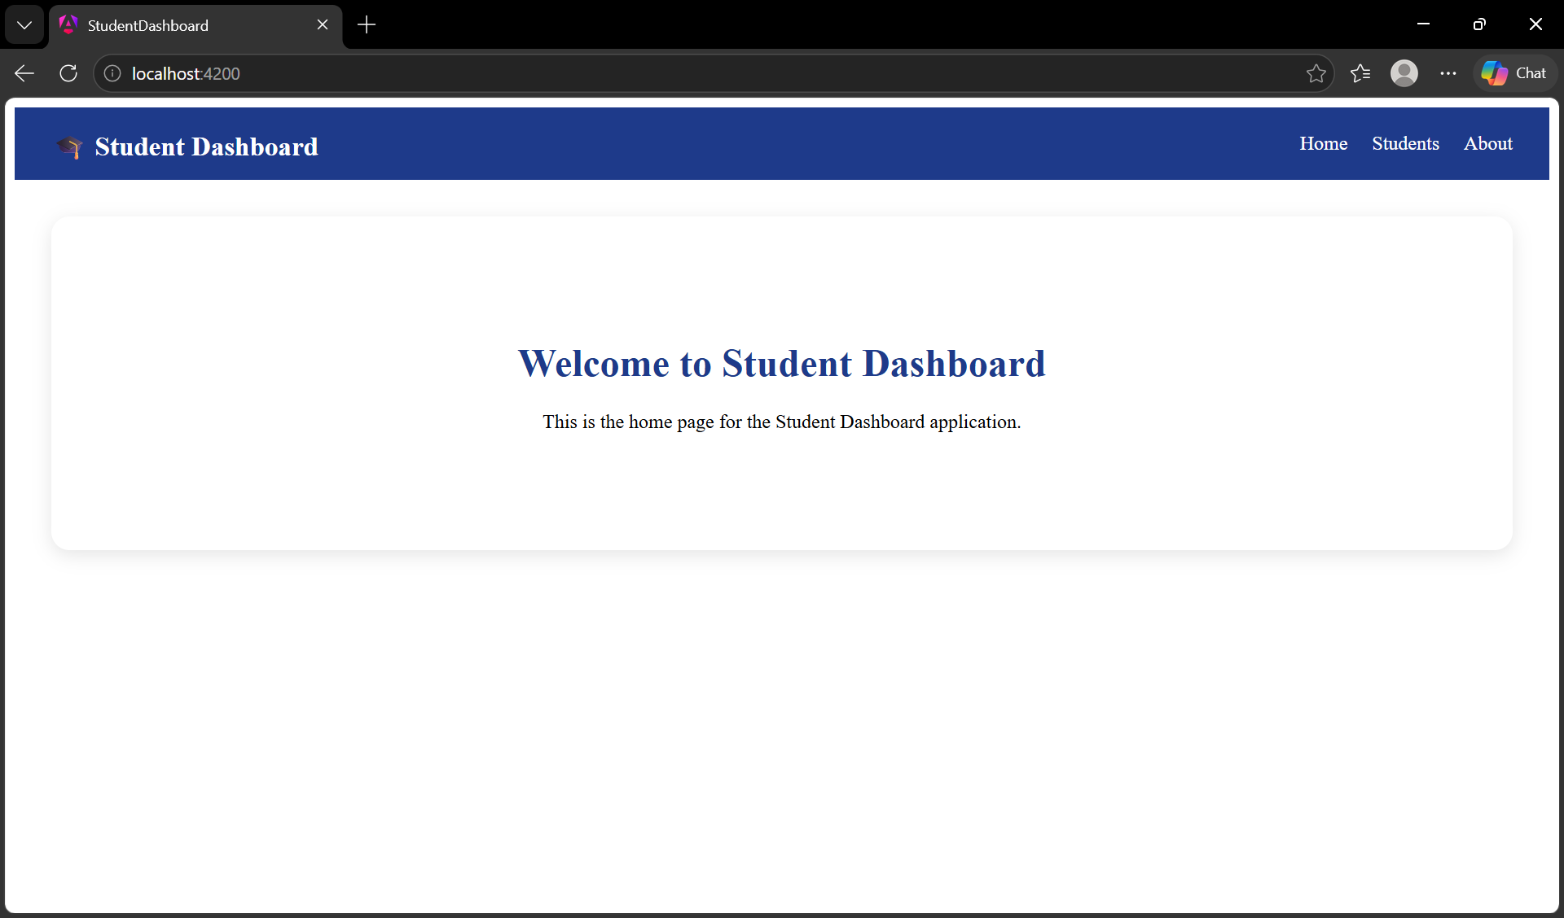
RESULT:
Thus, the Angular application demonstrating structural and attribute directives was successfully developed and verified.

