EX NO:
DATE :
AIM:
To develop a multi-page Angular web application demonstrating single-page navigation and component switching using the Angular Router, functional route configurations, navigation link menus, and router outlets.
PROCEDURE:
1. Initialize a new standalone Angular application with routing enabled using the Angular CLI command 'ng new angular-routing'.
2. Create independent feature components (Home, About, Services, and Contact) representing destination views.
3. Define application routes inside 'app.routes.ts' mapping path URL strings to their respective standalone component classes.
4. Configure provideRouter with appRoutes in 'app.config.ts' to register routing services in the application runtime.
5. Embed navigation links using routerLink and render active destination components dynamically via <router-outlet> in 'app.component.ts'.
CODE:
1. Route Configuration (app.routes.ts)
// src/app/app.routes.ts
import { Routes } from '@angular/router';
import { HomeComponent } from './pages/home.component';
import { AboutComponent } from './pages/about.component';
import { ServicesComponent } from './pages/services.component';
import { ContactComponent } from './pages/contact.component';

export const routes: Routes = [
{ path: '', redirectTo: 'home', pathMatch: 'full' },
{ path: 'home', component: HomeComponent },
{ path: 'about', component: AboutComponent },
{ path: 'services', component: ServicesComponent },
{ path: 'contact', component: ContactComponent },
{ path: '**', redirectTo: 'home' }
];
2. Page Components Sample (Home, About, Services, Contact)
// src/app/pages/home.component.ts
import { Component } from '@angular/core';

@Component({
selector: 'app-home',
standalone: true,
template: `<div class="page-view"><h3>Home Page</h3><p>Welcome to our institutional portal home page.</p></div>`,
styles: [`.page-view { padding: 12px; border: 1px solid #000; margin-top: 10px; }`]
})
export class HomeComponent {}

// src/app/pages/about.component.ts
import { Component } from '@angular/core';

@Component({
selector: 'app-about',
standalone: true,
template: `<div class="page-view"><h3>About Us</h3><p>Information regarding institutional programs and department profile.</p></div>`,
styles: [`.page-view { padding: 12px; border: 1px solid #000; margin-top: 10px; }`]
})
export class AboutComponent {}

// src/app/pages/services.component.ts
import { Component } from '@angular/core';

@Component({
selector: 'app-services',
standalone: true,
template: `<div class="page-view"><h3>Services</h3><p>Full stack web application development and laboratory resources.</p></div>`,
styles: [`.page-view { padding: 12px; border: 1px solid #000; margin-top: 10px; }`]
})
export class ServicesComponent {}

// src/app/pages/contact.component.ts
import { Component } from '@angular/core';

@Component({
selector: 'app-contact',
standalone: true,
template: `<div class="page-view"><h3>Contact</h3><p>Reach out at: admin@cit.edu.in | Coimbatore Institute of Technology</p></div>`,
styles: [`.page-view { padding: 12px; border: 1px solid #000; margin-top: 10px; }`]
})
export class ContactComponent {}
3. Main Application with Navigation Menu and Router Outlet (app.component.ts)
// src/app/app.component.ts
import { Component } from '@angular/core';
import { RouterOutlet, RouterLink, RouterLinkActive } from '@angular/router';

@Component({
selector: 'app-root',
standalone: true,
imports: [RouterOutlet, RouterLink, RouterLinkActive],
template: `
<div class="site-container">
<header class="navbar">
<h2>Department Portal - Angular Routing</h2>
<nav class="nav-menu">
<a routerLink="/home" routerLinkActive="active-link">Home</a>
<a routerLink="/about" routerLinkActive="active-link">About</a>
<a routerLink="/services" routerLinkActive="active-link">Services</a>
<a routerLink="/contact" routerLinkActive="active-link">Contact</a>
</nav>
</header>
<main class="content-container">
<router-outlet></router-outlet>
</main>
</div>
`,
styles: [`
.site-container { max-width: 650px; margin: 15px auto; border: 1px solid #000; padding: 16px; font-family: 'Times New Roman', serif; }
.navbar { border-bottom: 1px solid #000; padding-bottom: 10px; text-align: center; }
.nav-menu { display: flex; justify-content: center; gap: 15px; margin-top: 8px; }
.nav-menu a { text-decoration: none; color: #000; border: 1px solid #000; padding: 4px 10px; font-weight: bold; }
.nav-menu a.active-link { background-color: #000; color: #fff; }
.content-container { margin-top: 12px; min-height: 120px; }
`]
})
export class AppComponent {}
OUTPUT:
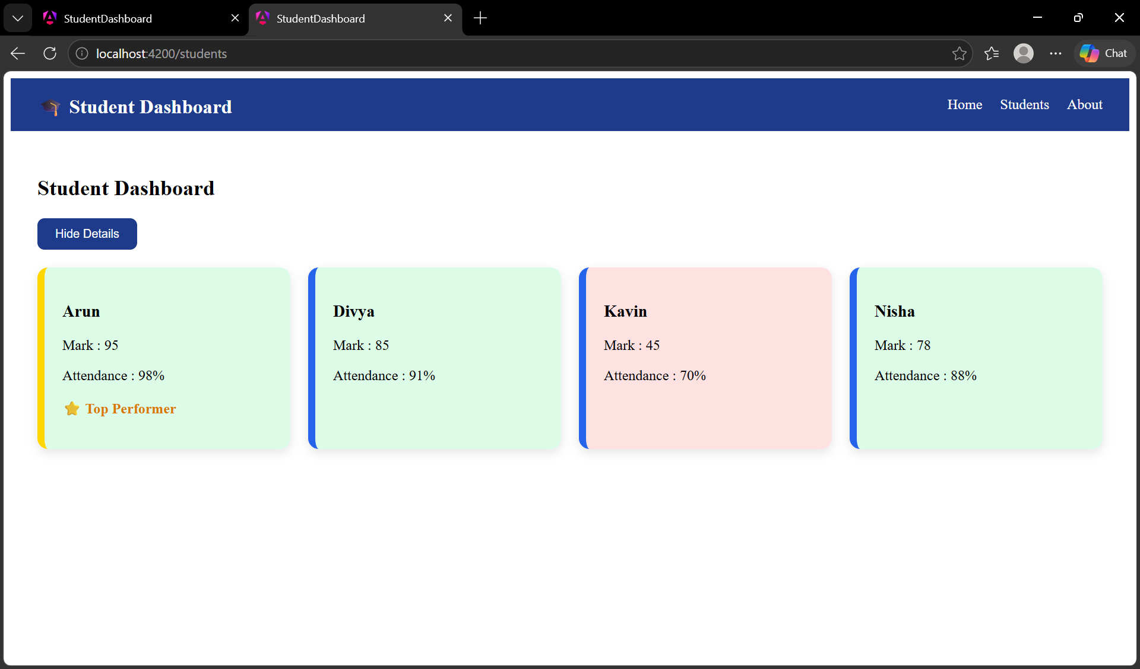
RESULT:
Thus, the Angular web application implementing routing and menu navigation was successfully developed and verified.

