EX NO:
DATE :
AIM:
To develop an Angular application demonstrating dependency injection of services across multiple components, and to perform data consumption, formatting, updating, and deletion operations utilizing live JSON API data.
PROCEDURE:
1. Initialize an Angular application and enable the HTTP client service provider using 'provideHttpClient()' in app.config.ts.
2. Generate an injectable service using 'ng g s api' with methods to fetch, update, and delete JSON records via HttpClient.
3. Create two distinct consumer components (Item List Component and Summary/Stats Component) to demonstrate multi-component dependency injection.
4. Inject the service into both components and bind returned API observables to template views using Angular pipes for data formatting.
5. Implement component handler functions to trigger update and delete operations and verify live synchronization using 'ng serve'.
CODE:
1. Angular Injectable Service with Live API Handling (api.service.ts)
// src/app/services/api.service.ts
import { Injectable, inject } from '@angular/core';
import { HttpClient } from '@angular/common/http';
import { Observable } from 'rxjs';

export interface Post {
id: number;
title: string;
body: string;
}

@Injectable({
providedIn: 'root'
})
export class ApiService {
private http = inject(HttpClient);
private apiUrl = 'https://jsonplaceholder.typicode.com/posts';

getPosts(): Observable<Post[]> {
return this.http.get<Post[]>(`${this.apiUrl}?_limit=4`);
}

updatePost(id: number, data: Partial<Post>): Observable<Post> {
return this.http.put<Post>(`${this.apiUrl}/${id}`, data);
}

deletePost(id: number): Observable<void> {
return this.http.delete<void>(`${this.apiUrl}/${id}`);
}
}
2. Components Demonstrating Service Injection (List & Counter Components)
// src/app/components/post-list.component.ts (Component 1)
import { Component, OnInit, inject } from '@angular/core';
import { CommonModule } from '@angular/common';
import { ApiService, Post } from '../services/api.service';

@Component({
selector: 'app-post-list',
standalone: true,
imports: [CommonModule],
template: `
<div class="list-container">
<h3>Active Posts (Live JSON Data)</h3>
<div *ngFor="let post of posts" class="post-item">
<h4>{{ post.id }}. {{ post.title | uppercase }}</h4>
<p>{{ post.body }}</p>
<button (click)="onUpdate(post)">Update Title</button>
<button (click)="onDelete(post.id)">Delete Post</button>
</div>
</div>
`,
styles: [`.post-item { border: 1px solid #000; margin: 8px 0; padding: 8px; } button { margin-right: 5px; cursor: pointer; }`]
})
export class PostListComponent implements OnInit {
private api = inject(ApiService);
posts: Post[] = [];

ngOnInit(): void {
this.api.getPosts().subscribe(data => this.posts = data);
}

onUpdate(post: Post): void {
this.api.updatePost(post.id, { title: 'Updated: ' + post.title }).subscribe(() => {
post.title = 'Updated: ' + post.title;
});
}

onDelete(id: number): void {
this.api.deletePost(id).subscribe(() => {
this.posts = this.posts.filter(p => p.id !== id);
});
}
}

// src/app/components/post-summary.component.ts (Component 2)
import { Component, inject } from '@angular/core';
import { ApiService } from '../services/api.service';

@Component({
selector: 'app-post-summary',
standalone: true,
template: `
<div class="summary-box">
<p><strong>Service Status:</strong> ApiService successfully injected into Summary Component.</p>
</div>
`,
styles: [`.summary-box { border: 1px dashed #000; padding: 10px; margin-top: 10px; }`]
})
export class PostSummaryComponent {
private api = inject(ApiService);
}
3. Root Component Template Mapping (app.component.ts)
// src/app/app.component.ts
import { Component } from '@angular/core';
import { PostListComponent } from './components/post-list.component';
import { PostSummaryComponent } from './components/post-summary.component';

@Component({
selector: 'app-root',
standalone: true,
imports: [PostListComponent, PostSummaryComponent],
template: `
<div class="wrapper">
<h2>Angular Services & Live JSON API Integration</h2>
<app-post-list></app-post-list>
<app-post-summary></app-post-summary>
</div>
`,
styles: [`.wrapper { border: 1px solid #000; padding: 15px; max-width: 600px; margin: 15px auto; font-family: 'Times New Roman', serif; }`]
})
export class AppComponent {}
OUTPUT:
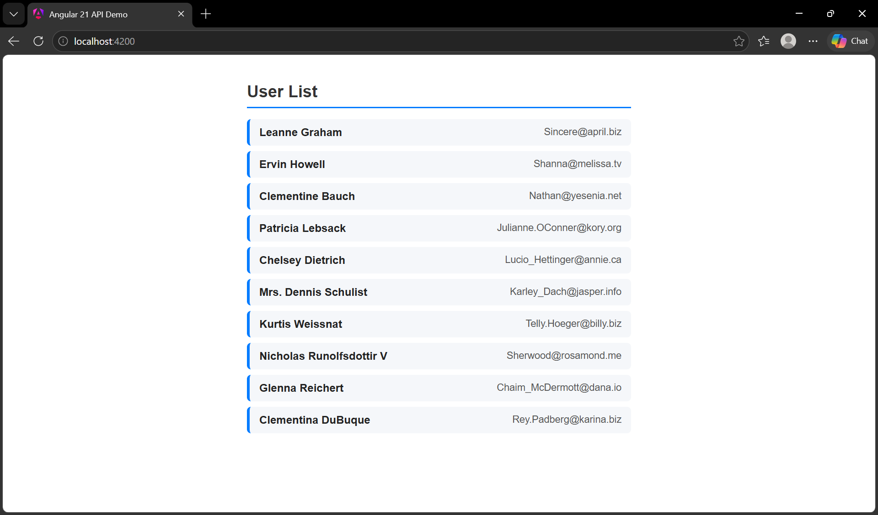
RESULT:
Thus, the Angular service injection across multiple components and live JSON API data operations were successfully developed and verified.

