EX NO:
DATE :
AIM:
To set up a React application using Vite and develop functional components demonstrating JSX rendering, parent-to-child prop passing, modular component files, inline styling, conditional rendering, and logical && evaluation.
PROCEDURE:
1. Scaffold a modern React application utilizing Vite by executing 'npm create vite@latest react-demo -- --template react'.
2. Navigate into the project directory, install core dependencies via 'npm install', and structure components in the 'src' directory.
3. Develop modular functional components in separate files to demonstrate component hierarchies and pass data using props.
4. Implement JSX elements showcasing inline style objects, conditional ternary expressions, and short-circuit logical && operators.
5. Launch the Vite development server with 'npm run dev' and verify component rendering and conditional UI states in the browser.
CODE:
1. Child Component in Separate File (src/components/UserCard.jsx)
// src/components/UserCard.jsx
import React from 'react';

// Functional Component receiving props (Parent to Child communication)
const UserCard = ({ user, isLoggedIn, notificationCount }) => {
// Inline CSS styling object
const cardStyle = {
border: '1px solid #000',
padding: '12px',
margin: '10px 0',
backgroundColor: '#ffffff'
};

return (
<div style={cardStyle}>
{/* Basic Element & JSX Data Rendering */}
<h4>User Profile: {user.name}</h4>
<p>Role: {user.role}</p>

{/* Conditional Rendering using Ternary Operator */}
<p>Status: {isLoggedIn ? 'Active User' : 'Guest Account'}</p>

{/* Logical && (AND) Rendering */}
{notificationCount > 0 && (
<p style={{ fontWeight: 'bold' }}>
Alerts: You have {notificationCount} unread notification(s)!
</p>
)}
</div>
);
};

export default UserCard;
2. Parent Component with Component Rendering (src/App.jsx)
// src/App.jsx
import React, { useState } from 'react';
import UserCard from './components/UserCard';

// Main Functional Component
function App() {
const [isLoggedIn, setIsLoggedIn] = useState(true);
const [unreadCount, setUnreadCount] = useState(3);

const currentUser = {
name: 'Dhanumithra',
role: 'Full Stack Developer'
};

// Inline styling
const containerStyle = {
border: '1px solid #000',
padding: '16px',
maxWidth: '500px',
margin: '20px auto',
fontFamily: 'Times New Roman, serif'
};

return (
<div style={containerStyle}>
<h2>React Vite Application</h2>
<p>Demonstrating Functional Components & JSX Rendering</p>

{/* Button to toggle state for conditional evaluation */}
<button
style={{ border: '1px solid #000', background: '#fff', padding: '6px 12px', cursor: 'pointer' }}
onClick={() => setIsLoggedIn(!isLoggedIn)}
>
Toggle Session Status
</button>

{/* Component Rendering & Prop Passing from Parent to Child */}
<UserCard
user={currentUser}
isLoggedIn={isLoggedIn}
notificationCount={unreadCount}
/>
</div>
);
}

export default App;
OUTPUT:
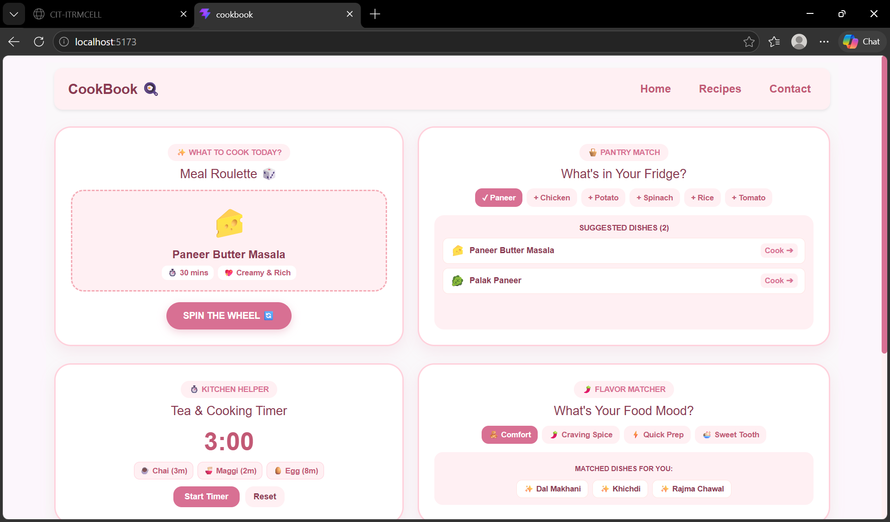
RESULT:
Thus, the Vite React application demonstrating JSX rendering, functional components, and conditional rendering was successfully developed and verified.

