EX NO:
DATE :
AIM:
To develop a React web application using Vite to demonstrate stateful and stateless functional components, incorporating various props options, the useState hook, and bidirectional parent-child component communication.
PROCEDURE:
1. Scaffold a new Vite React application by executing 'npm create vite@latest react-props-state -- --template react'.
2. Navigate into the workspace, install package dependencies via 'npm install', and create modular component files in 'src/components'.
3. Construct child functional components utilizing diverse prop options including primitive types, objects, default values, and function callbacks.
4. Implement state management in the parent component using the 'useState' hook to manage dynamic counters, strings, and collections.
5. Connect child components to the parent view sequentially, pass handler functions to manage state transitions, and verify using 'npm run dev'.
CODE:
1. Child Functional Component with Props Options (src/components/StudentCard.jsx)
// src/components/StudentCard.jsx
import React from 'react';

// Functional component demonstrating props destructuring, default props, and function props
const StudentCard = ({
id,
name,
details = { dept: 'Software Systems', year: 'III Year' }, // Default object prop
status = 'Active', // Default string prop
onStatusChange // Callback function prop
}) => {
return (
<div style={{ border: '1px solid #000', padding: '10px', margin: '8px 0' }}>
<h4>Roll No: {id} - {name}</h4>
<p>Department: {details.dept} | Academic Year: {details.year}</p>
<p>Enrollment Status: <strong>{status}</strong></p>
<button
style={{ border: '1px solid #000', background: '#fff', padding: '4px 8px', cursor: 'pointer' }}
onClick={() => onStatusChange(id)}
>
Toggle Status
</button>
</div>
);
};

export default StudentCard;
2. Parent Functional Component with Multiple States (src/App.jsx)
// src/App.jsx
import React, { useState } from 'react';
import StudentCard from './components/StudentCard';

function App() {
// 1. Primitive number state
const [totalStudents, setTotalStudents] = useState(2);

// 2. Object / Array state
const [students, setStudents] = useState([
{ id: 101, name: 'Alice Brown', dept: 'Software Systems', year: 'III Year', status: 'Active' },
{ id: 102, name: 'Charlie Green', dept: 'Software Systems', year: 'III Year', status: 'Inactive' }
]);

// Handler passed to child as callback prop (Child-to-Parent state update)
const handleToggleStatus = (id) => {
setStudents(students.map(s =>
s.id === id ? { ...s, status: s.status === 'Active' ? 'Inactive' : 'Active' } : s
));
};

const handleAddStudent = () => {
const newId = totalStudents + 101;
const newStudent = { id: newId, name: `Student ${newId}`, dept: 'Software Systems', year: 'III Year', status: 'Active' };
setStudents([...students, newStudent]);
setTotalStudents(totalStudents + 1);
};

return (
<div style={{ border: '1px solid #000', padding: '16px', maxWidth: '550px', margin: '15px auto', fontFamily: 'Times New Roman, serif' }}>
<h2>Student Information Management</h2>
<p>Total Enrolled: {totalStudents}</p>
<button
style={{ border: '1px solid #000', background: '#fff', padding: '6px 12px', cursor: 'pointer', marginBottom: '12px' }}
onClick={handleAddStudent}
>
Add Enrolled Student
</button>

{/* Sequential display of child components */}
<div>
{students.map(student => (
<StudentCard
key={student.id}
id={student.id}
name={student.name}
details={{ dept: student.dept, year: student.year }}
status={student.status}
onStatusChange={handleToggleStatus}
/>
))}
</div>
</div>
);
}

export default App;
OUTPUT:
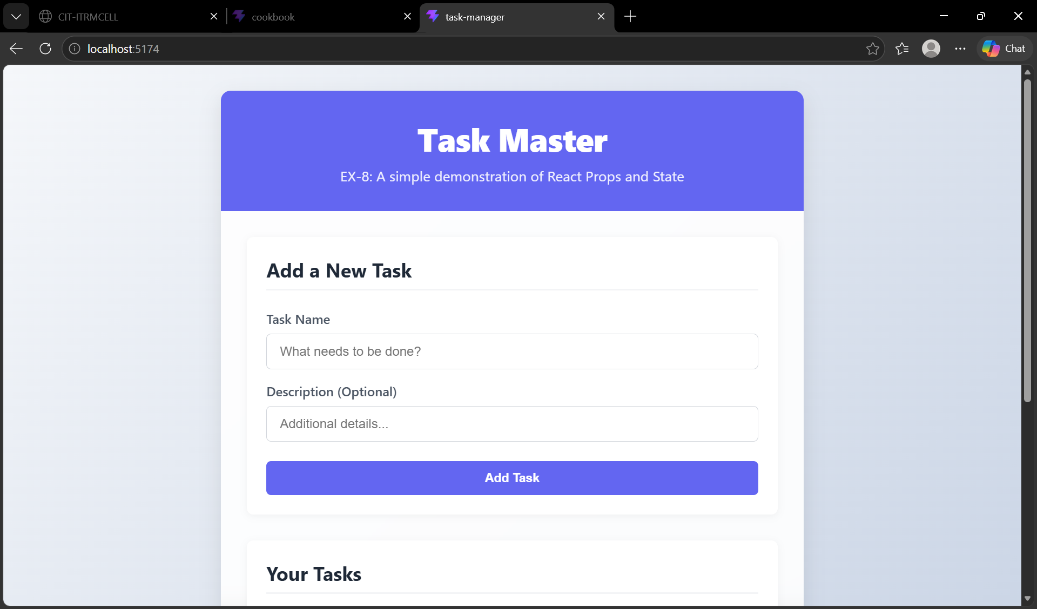
RESULT:
Thus, the React application demonstrating props, state management, and parent-child component connectivity was successfully developed and verified.

