EX NO:
DATE :
AIM:
To develop a mini web application using React and Vite demonstrating single-page navigation with React Router, incorporating a responsive navigation menu layout and route linking across multiple functional view components.
PROCEDURE:
1. Scaffold a React application using Vite ('npm create vite@latest react-router-app -- --template react') and install 'react-router-dom'.
2. Create independent page components (Home, Courses, and Contact) representing destination views inside 'src/pages'.
3. Design a navigation layout component with styled navbar links utilizing 'NavLink' or 'Link' from React Router.
4. Configure route mapping within 'App.jsx' using 'BrowserRouter', 'Routes', and 'Route' with explicit path declarations.
5. Execute the application using 'npm run dev' and verify seamless dynamic view transitions across menu routes without full page reloads.
CODE:
1. Page Components (src/pages/Pages.jsx)
// src/pages/Pages.jsx
import React from 'react';

export const Home = () => (
<div style={{ border: '1px solid #000', padding: '15px', marginTop: '10px' }}>
<h3>Home Page</h3>
<p>Welcome to the Department Portal built with React and Vite.</p>
</div>
);

export const Courses = () => (
<div style={{ border: '1px solid #000', padding: '15px', marginTop: '10px' }}>
<h3>Academic Courses</h3>
<p>20MSS55 - Full Stack Application Development Lab (M.Sc. Software Systems).</p>
</div>
);

export const Contact = () => (
<div style={{ border: '1px solid #000', padding: '15px', marginTop: '10px' }}>
<h3>Contact Us</h3>
<p>Department of Computing, Coimbatore Institute of Technology, Coimbatore.</p>
</div>
);
2. Navigation Bar Layout & Router Configuration (src/App.jsx)
// src/App.jsx
import React from 'react';
import { BrowserRouter, Routes, Route, NavLink, Navigate } from 'react-router-dom';
import { Home, Courses, Contact } from './pages/Pages';

const Navbar = () => {
const navStyle = {
display: 'flex',
gap: '12px',
borderBottom: '1px solid #000',
paddingBottom: '10px',
marginBottom: '15px'
};

const getLinkStyle = ({ isActive }) => ({
textDecoration: 'none',
color: isActive ? '#ffffff' : '#000000',
backgroundColor: isActive ? '#000000' : '#ffffff',
border: '1px solid #000000',
padding: '6px 14px',
fontWeight: 'bold',
fontSize: '14px'
});

return (
<nav style={navStyle}>
<NavLink to="/home" style={getLinkStyle}>Home</NavLink>
<NavLink to="/courses" style={getLinkStyle}>Courses</NavLink>
<NavLink to="/contact" style={getLinkStyle}>Contact</NavLink>
</nav>
);
};

function App() {
const containerStyle = {
border: '1px solid #000',
padding: '20px',
maxWidth: '600px',
margin: '20px auto',
fontFamily: 'Times New Roman, serif'
};

return (
<BrowserRouter>
<div style={containerStyle}>
<h2>CIT Institutional Portal - React Router</h2>
<Navbar />
<Routes>
<Route path="/" element={<Navigate to="/home" replace />} />
<Route path="/home" element={<Home />} />
<Route path="/courses" element={<Courses />} />
<Route path="/contact" element={<Contact />} />
<Route path="*" element={<Navigate to="/home" replace />} />
</Routes>
</div>
</BrowserRouter>
);
}

export default App;
OUTPUT:
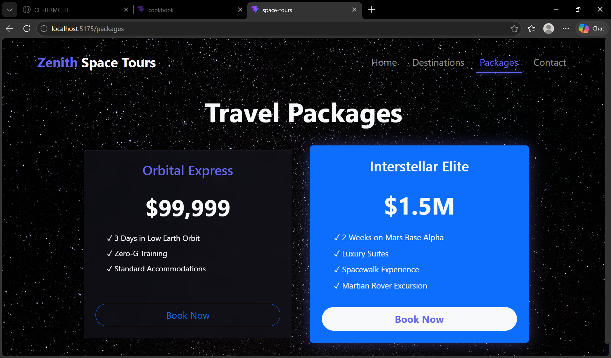
RESULT:
Thus, the React application implementing React Router with a menu layout and navigation links was successfully developed and verified.

