EX NO : 3  DATE : 22.06.26 | DATA ENGINEERING

AIM:
Data Preprocessing and Encoding for Employee Dataset

PROBLEM STATEMENT:
You have been provided with an employee dataset (emp-data.xlsx) containing both numerical and categorical attributes related to employee demographics, roles, performance, and compensation.

Perform the following preprocessing tasks:
1. Identify Categorical and Numerical Attributes
2. Apply Label Encoding to binary/ordinal categorical columns (Gender, Education)
3. Apply One-Hot Encoding to nominal categorical columns (Department, City, Work_Mode, Job_Role)
4. Apply StandardScaler to normalize numerical attributes
5. Apply MinMaxScaler to scale numerical attributes to [0,1] range
6. Visualize the effect of scaling using histograms and boxplots
7. Compare Label Encoding and One-Hot Encoding on the Department column

DATASET:
emp-data.xlsx — Employee data with attributes: Employee_ID, Name, Age, Gender, Education, Department, City, Work_Mode, Job_Role, Experience, Salary, Performance_Score

CODE:
import pandas as pd
import matplotlib.pyplot as plt
from sklearn.preprocessing import LabelEncoder, StandardScaler, MinMaxScaler

# Load Dataset
df = pd.read_excel("emp-data.xlsx")
print("========== ORIGINAL DATASET ==========")
print(df.head())

# Task 1: Identify Categorical and Numerical Attributes
print("\n========== TASK 1 ==========")
numerical_columns = df.select_dtypes(include=['int64', 'float64']).columns
categorical_columns = df.select_dtypes(include=['object']).columns
print("\nNumerical Attributes:")
print(list(numerical_columns))
print("\nCategorical Attributes:")
print(list(categorical_columns))

# Task 2: Label Encoding
print("\n========== TASK 2 ==========")
label_encoder = LabelEncoder()
df_label = df.copy()
df_label["Gender"] = label_encoder.fit_transform(df_label["Gender"])
df_label["Education"] = label_encoder.fit_transform(df_label["Education"])
print(df_label[["Gender", "Education"]].head())

# Task 3: One-Hot Encoding
print("\n========== TASK 3 ==========")
df_onehot = pd.get_dummies(
df_label,
columns=["Department", "City", "Work_Mode", "Job_Role"]
)
print(df_onehot.head())

# Task 4: StandardScaler
print("\n========== TASK 4 ==========")
standard_df = df_onehot.copy()
standard_scaler = StandardScaler()
columns_to_scale = [
"Age",
"Experience",
"Salary",
"Performance_Score"
]
standard_df[columns_to_scale] = standard_scaler.fit_transform(
standard_df[columns_to_scale]
)
print(standard_df[columns_to_scale].head())

# Task 5: MinMaxScaler
print("\n========== TASK 5 ==========")
minmax_df = df_onehot.copy()
minmax_scaler = MinMaxScaler()
minmax_df[columns_to_scale] = minmax_scaler.fit_transform(
minmax_df[columns_to_scale]
)
print(minmax_df[columns_to_scale].head())

# Task 6: Visualization
print("\n========== TASK 6 ==========")
plt.figure(figsize=(10,4))
plt.hist(df["Salary"], bins=10)
plt.title("Salary Before Standard Scaling")
plt.xlabel("Salary")
plt.ylabel("Frequency")
plt.show()

plt.figure(figsize=(10,4))
plt.hist(standard_df["Salary"], bins=10)
plt.title("Salary After Standard Scaling")
plt.xlabel("Scaled Salary")
plt.ylabel("Frequency")
plt.show()

plt.figure(figsize=(6,4))
plt.boxplot(df["Salary"])
plt.title("Salary Before Standard Scaling")
plt.show()

plt.figure(figsize=(6,4))
plt.boxplot(standard_df["Salary"])
plt.title("Salary After Standard Scaling")
plt.show()

print("\nInterpretation:")
print("StandardScaler changes the scale of Salary.")
print("The shape of the distribution remains the same.")
print("The mean becomes approximately 0 and the standard deviation becomes 1.")

# Task 7: Compare Label Encoding and One-Hot Encoding
print("\n========== TASK 7 ==========")
department_label = df.copy()
department_label["Department"] = LabelEncoder().fit_transform(
department_label["Department"]
)
print("\nLabel Encoding:")
print(department_label[["Department"]].head())

department_onehot = pd.get_dummies(
df[["Department"]],
columns=["Department"]
)
print("\nOne-Hot Encoding:")
print(department_onehot.head())

OUTPUT:

Task 1 – Numerical and Categorical Attributes:

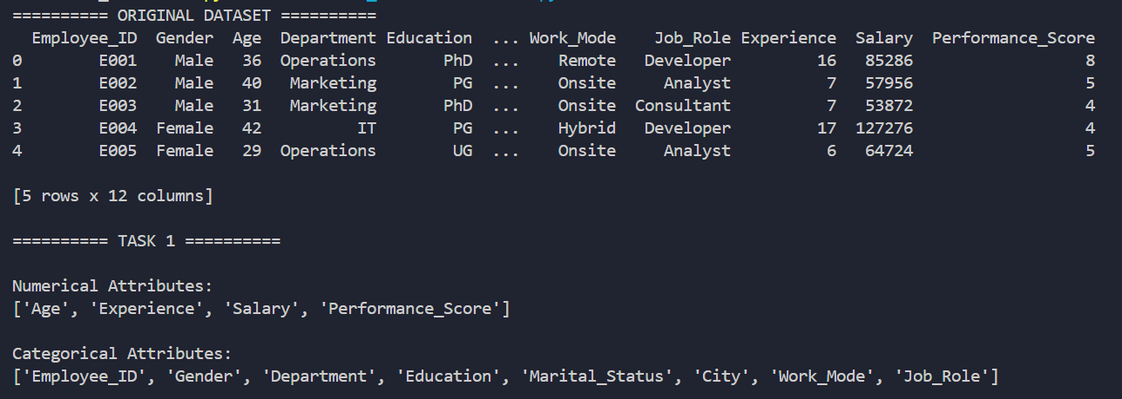

Task 2 – Label Encoding (Gender, Education):

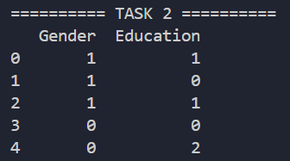

Task 3 – One-Hot Encoding:

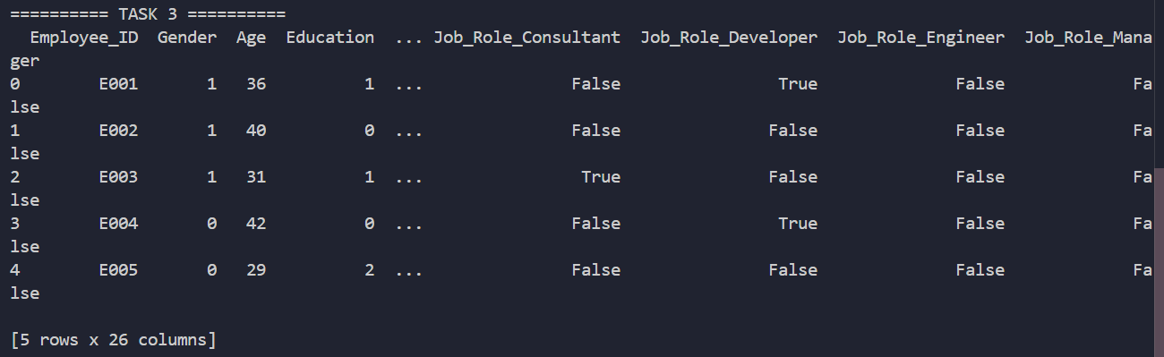

Task 4 – StandardScaler:

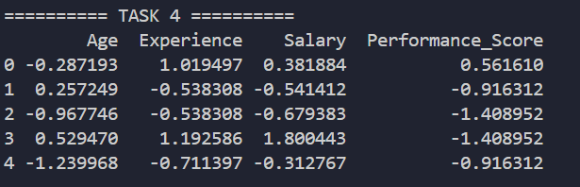

Task 5 – MinMaxScaler:

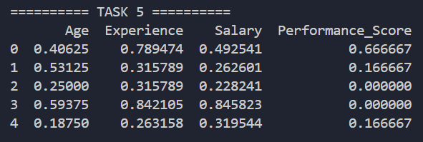

Task 6 – Visualization:

Histogram – Salary Before Standard Scaling:
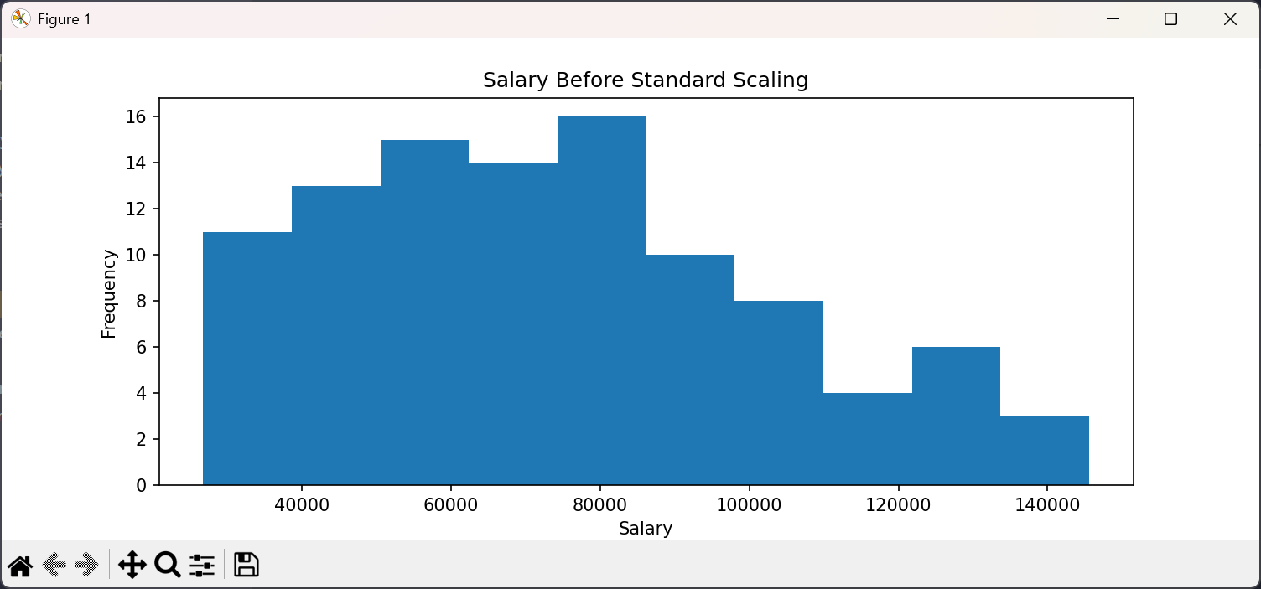

Histogram – Salary After Standard Scaling:
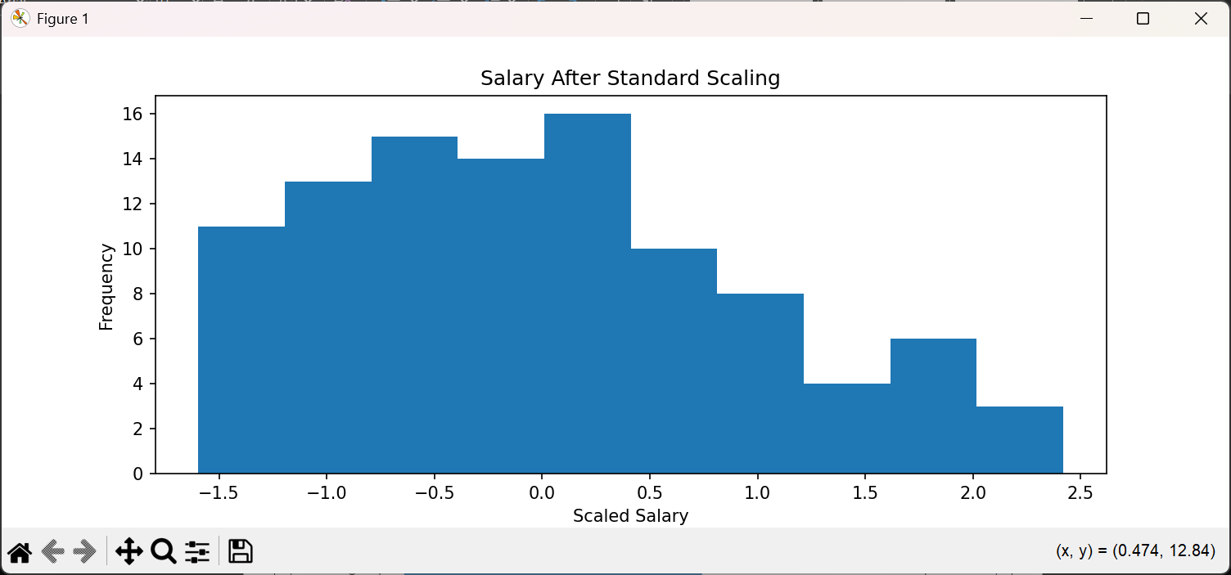

Boxplot – Salary Before Standard Scaling:
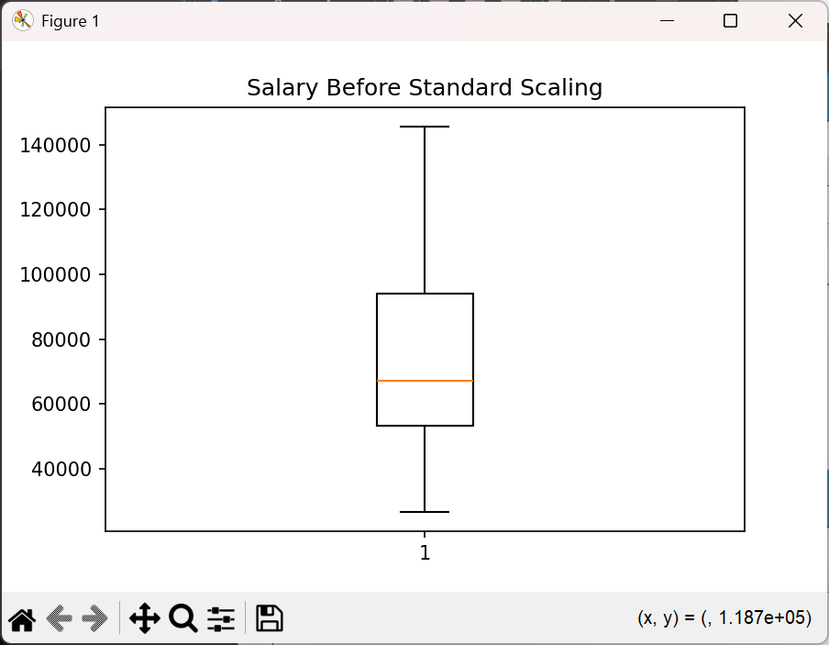

Boxplot – Salary After Standard Scaling:
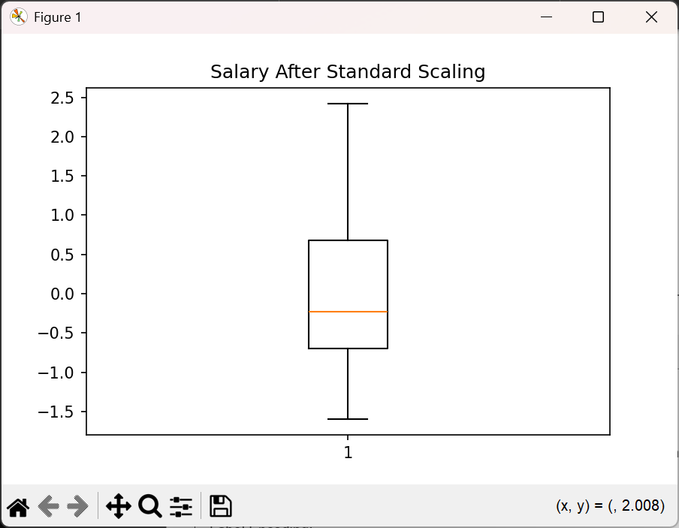
Interpretation:
StandardScaler changes the scale of Salary. The shape of the distribution remains the same. The mean becomes approximately 0 and the standard deviation becomes 1.

Task 7 – Label Encoding vs One-Hot Encoding (Department):

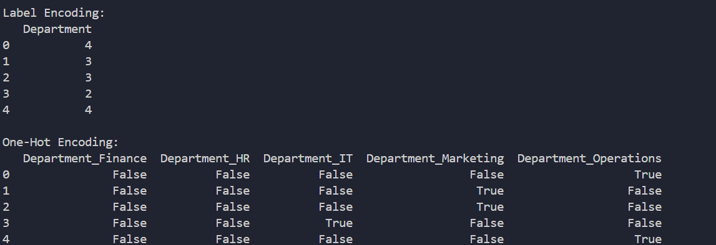

RESULT:
The employee dataset was successfully preprocessed. Categorical attributes were encoded using Label Encoding and One-Hot Encoding. Numerical attributes were scaled using StandardScaler and MinMaxScaler. The effect of scaling was visualized using histograms and boxplots, confirming that StandardScaler normalizes the distribution while preserving its shape.

