

VASIREDDY VENKATADRI INSTITUTE OF TECHNOLOGY
Approved by AICTE, Permanently Affiliated to JNTU, Kakinada
Accredited by NAAC with ‘A’ Grade - ISO 9001:2008 Certified
Nambur (V), Peda Kakani (M), Guntur Dt. - 522508 April, 2025.

A Project Report
on
PREDICTIVE ANALYSIS OF HEART DISEASE

submitted for partial fulfillment for the award of the degree of

BACHELOR OF TECHNOLOGY
in
Computer Science and Engineering
by

MUVVA RADHIKA - 23BQ1A05E9
SURAGANI DHANUMJAY - 24BQ5A0523
PANAKALA USHA SRI - 23BQ1A05G8
MEDAGAM SATHVIKA - 23BQ1A05D7

Under the Guidance of
Dr. VAMSI
Associate Professor, CSE



CERTIFICATE

This is to certify that the Project Report titled “Predictive Analysis of Heart Disease” is being submitted by, Ms. RADHIKA, Mr. SURAGANI DHANUMJAY, Ms. PANAKALA USHA SRI, Ms. MEDAGAM SATHVIKA, bearing Registered Numbers 23BQ1A05, 23BQ1A05, 23BQ1A05G8, and 24BQ5A05 respectively of III B.Tech II semester Computer Science & Engineering is a record Bonafide work carried out by them. The results embodied in this report have not been submitted to any other University for the award of any degree.

Project Guide Head of Department
(Dr. P. Ravi Kumar, Associate Professor) (Dr. V. Ramachandran, Professor)

Submitted for Viva-voce Examination held on

Internal Examiner External Examiner

DECLARATION

We, Ms. MUVVA RADHIKA, Mr. SURAGANI DHANUMJAY, Ms. PANAKALA USHA SRI, Ms. MEDAGAM SATHVIKA, hereby declare that the Project Report entitled “Predictive Analysis of Heart Disease” done by us under the guidance of Dr.VAMSI, Associate Professor at Vasireddy Venkatadri Institute of Technology (A) is submitted in partial fulfillment of the requirements for the award of Bachelor of Technology in Computer Science & Engineering. The results embodied in this report have not been submitted to any other university for the award of any degree.

DATE :

PLACE :

SIGNATURE OF THE CANDIDATE(s)

1.

2.

3.

4.

ACKNOWLEGMENT

We take this opportunity to express my deepest gratitude and appreciation to all those people who made this project work easier with words of encouragement, motivation, discipline, and faith by offering different places to look to expand our ideas and helped us towards the successful completion of this project work.
First and foremost, we express our deep gratitude to Sri. Vasireddy Vidya Sagar, Chairman, Vasireddy Venkatadri Institute of Technology (A) for providing necessary facilities throughout the B Tech program.
We express our sincere thanks to Dr. Y. Mallikarjuna Reddy, Principal, Vasireddy Venkatadri Institute of Technology (A) for his constant support and cooperation throughout the B. Tech program.
We express our sincere gratitude to Dr. V. Ramachandran, Professor & HOD, Computer Science & Engineering, Vasireddy Venkatadri Institute of Technology (A) for his constant encouragement, motivation and faith in offering different places to look to expand our ideas.
We would like to express our sincere gratefulness to our Guide Dr. P. Ravi Kumar, Associate Professor, CSE for his insightful advice, motivating suggestions, invaluable guidance, help and support in the successful completion of this project.
We would like to express our sincere heartfelt thanks to our Project Coordinator Dr. Vidya Sagar Uppuluri, Professor, CSE for his valuable advices, motivating suggestions, moral support, help and coordination among us in successful completion of this project.
We would like to take this opportunity to express our thanks to all the Teaching and Non-Teaching Staff in the Department of Computer Science & Engineering, VVIT for their invaluable help and support.

Names of Students

MUVVA RADHIKA 23BQ1A05E9
SURAGANI DHANUMJAY 24BQ1A0523
PANAKALA USHA SRI 23BQ1A05G8
MEDAGAM SATHVIKA 23BQ1A05D7



INSTITUTE VISSION

To impart quality education through exploration and experimentation and generate socially conscious engineers, embedding ethics and values, for the advancement in Science and Technology.

INSTITUTE MISSION

- To educate students with practical approach to dovetail them to industry needs.
- To govern the institution with a proactive and professional management with passionate teaching faculty.
- To provide holistic and integrated education and achieve over all development of students imparting scientific and technical, social and cognitive, managerial and organizational skills.
- To compete with the best and be the most preferred institution of the studious and the scholarly.
- To forge strong relationships and linkage with the industry.



DEPARTMENT VISSION

Providing quality education to enable the generation of socially conscious software engineers who can contribute to the advancement in the field of computer science and engineering.

DEPARTMENT MISSION

- To equip the graduates with the knowledge and skills required to enable them to be industry ready.

- To train socially responsible, disciplined engineers who work with good leadership skills and can contribute for nation building.

- To make our graduates proficient in cutting edge technologies through student centric teaching- learning process and empower them to contribute significantly to the software industry.

- To shape the department into a centre of academic and research excellence.





PEO1 | To provide the graduates with solid foundation in computer science and engineering along with fundamentals of Mathematics and Sciences with a view to impart in them high quality technical skills like modelling, analyzing, designing, programming and implementation with global competence and helps the graduates for life-long learning.
PEO2 | To prepare and motivate graduates with recent technological developments related to core subjects like programming, databases, design of compilers and Network Security aspects and future technologies so as to contribute effectively for Research & Development by participating in professional activities like publishing and seeking copy rights.
PEO3 | To train graduates to choose a decent career option either in high degree of employability / Entrepreneur or, in higher education by empowering students with ethical administrative acumen, ability to handle critical situations and training to excel in competitive examinations.
PEO4 | To train the graduates to have basic interpersonal skills and sense of social responsibility that paves them a way to become good team members and leaders.



The B.Tech CSE program has documented measurable outcomes that are based on the needs of the program’s stakeholders. The program outcomes, which are derived from ABET criteria, were first drafted in the academic year 2009–10 and later revised in 2010–11. The program outcomes that the department presently adopts are as follows:

1 | Engineering knowledge | Apply the knowledge of mathematics, science, engineering fundamentals and an engineering specialization to the solution of complex engineering problems.
2 | Problem analysis | Identify, formulate, review research literature, and analyze complex engineering problems reaching substantiated conclusions using first principles of mathematics, natural science and engineering sciences.
3 | Design/development of solutions | Design solutions for complex engineering problems and design system components or processes that meet the specified needs with appropriate consideration for the public health and safety, and the cultural, societal and environmental considerations.
4 | Conduct investigations of complex problems | Use research based knowledge and research methods including design of experiments, analysis and interpretation of data, and synthesis of the information to provide valid conclusions.
5 | Modern tool usage | Create, select and apply appropriate techniques, resources and modern engineering and IT tools including prediction and modeling to complex engineering activities with an understanding of the limitations.



6 | The Engineer and Society | Apply reasoning informed by the contextual knowledge to assess societal, health, safety, legal and cultural issues and the consequent responsibilities relevant to the professional engineering practice.
7 | Environment and Sustainability | Understand the impact of the professional engineering solutions in the societal and environmental contexts, and demonstrate the knowledge of, and need for sustainable development.
8 | Ethics | Apply ethical principles and commit to professional ethics and responsibilities and norms of the engineering practice.
9 | Individual and Team Work | Function effectively as an individual and as a member or leader in diverse teams, and in multidisciplinary settings.
10 | Communication | Communicate effectively on complex engineering activities with the engineering community and with society at large, such as being able to comprehend and write effective reports and design documentation, make effective presentations, and give and receive clear instructions.
11 | Project Management and Finance | Demonstrate knowledge and understanding of the engineering and management principles and apply these to one’s own work, as a member and leader in a team, to manage projects and in multidisciplinary environments.
12 | Lifelong Learning | Recognize the need for, and have the preparation and ability to engage in independent and lifelong learning in the broadest context of technological change.



 |  | 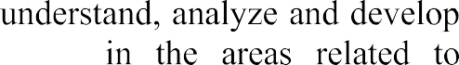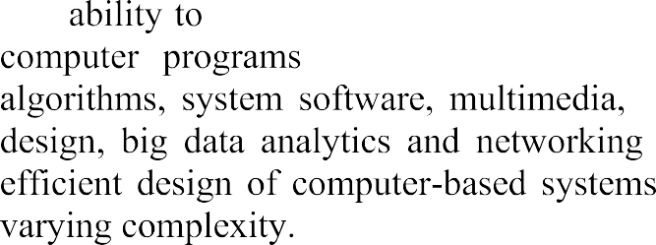
 |  | 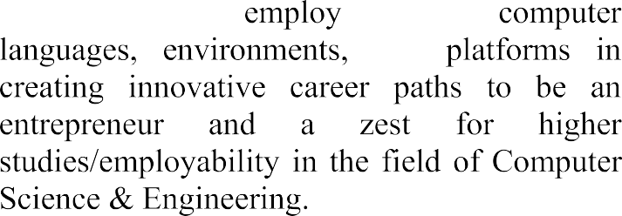







 | PO1 | PO2 | PO3 | PO4 | PO5 | PO6 | PO7 | PO8 | PO9 | PO10 | PO11 | PO12 | PSO1 | PSO2
CO1 | 1 | 2 | 1 |  |  | 2 | 2 | 3 |  | 2 |  |  | 1
CO2 | 2 | 2 | 3 | 2 | 2 |  | 2 | 1 | 2 | 2 | 2 | 1 | 3 | 1
CO3 |  | 1 | 1 | 1 | 3 |  |  |  |  |  |  | 1 | 1
CO4 | 1 |  |  |  |  |  |  |  | 3 | 3 |  |  | 1 | 1
CO5 |  | 1 |  |  |  |  |  | 2 | 3 | 3 | 2 |  | 1 | 2

ABSTRACT

In today’s world, heart disease is one of the leading causes of death, and early detection is essential to reduce health risks and improve patient outcomes. However, many individuals lack access to regular health checkups and are unaware of their health condition. This creates a need for a system that can predict heart disease risk quickly and efficiently.

The Heart Disease Prediction System is developed to address this problem by using machine learning techniques to analyze medical data and predict the likelihood of heart disease. The system allows users to enter basic clinical parameters such as age, blood pressure, cholesterol levels, and other health indicators through a web-based interface.

The application uses the XGBoost algorithm to process the input data and generate prediction results. Based on the analysis, the system determines whether the user is at risk of heart disease and provides instant feedback.

The system is designed to be simple, user-friendly, and accessible, allowing individuals to perform an initial health assessment without the need for complex medical procedures. It acts as a supportive tool for early detection and encourages users to take preventive measures.

By integrating machine learning with web technology, the system provides an effective solution for heart disease prediction. It helps in improving health awareness, enabling early diagnosis, and supporting better healthcare decision-making.

INDEX

CH No | TITLE | PAGE NO
CHAPTER 1 | INTRODUCTION | 1–3
 | 1.1 Introduction
CHAPTER 2 | AIM AND SCOPE | 4-8
 | 2.1 Existing System
 | 2.2 Proposed System
CHAPTER 3 | CONCEPT AND METHODS | 9-16
 | 3.1 Problem Description
 | 3.2 Proposed Solution
 | 3.2.1 Dataset
 | 3.2.2 Data Preparation
 | 3.2.3 Data Preprocessing
 | 3.2.4 Data Augmentation
 | 3.2.5 System Models/Working Mechanism
 | 3.2.6 Performance Metrics
CHAPTER 4 | IMPLEMENTATION | 17-31
 | 4.1 Tools Used
 | 4.2 Code
 | 4.3 Results and Screenshots
CHAPTER 5 | CONCLUSION AND FUTURE SCOPE | 32-34
 | REFERENCES
 | APPENDIX
 | Conference Publication Certificate(s)
 | Published Article in the Journal / Proceedings

CHAPTER – 1

INTRODUCTION

In the modern world, technology plays a crucial role in improving healthcare systems and supporting medical decision-making. With the rapid growth of digital technologies, healthcare services are becoming more accessible, efficient, and accurate. One of the major areas where technology has made a significant impact is in the early detection and diagnosis of diseases. Among various health issues, heart disease is one of the leading causes of death worldwide. Early prediction and timely treatment of heart disease can significantly reduce the risk of severe complications and improve patient survival rates.
Heart disease often develops silently, and many individuals may not experience noticeable symptoms until the condition becomes serious. Regular health checkups and diagnostic tests are essential for early detection. However, many people do not have easy access to healthcare facilities or may neglect routine checkups due to time constraints, financial issues, or lack of awareness. As a result, heart disease is often diagnosed at later stages, making treatment more difficult and less effective. This highlights the need for a system that can assist in early risk prediction using easily available medical information.
With the advancement of Machine Learning (ML) and Artificial Intelligence (AI), it is now possible to analyze medical data and predict the likelihood of diseases with high accuracy. Machine learning algorithms can process large amounts of data, identify hidden patterns, and make predictions based on input parameters. These technologies can be used to develop intelligent systems that support doctors and individuals in assessing health risks. By using such systems, it becomes easier to detect potential heart disease at an early stage and take preventive measures.
Many individuals face difficulty in understanding their health condition and assessing their risk level without consulting medical professionals. Additionally, existing healthcare systems may not provide instant results or may require complex diagnostic procedures. There is a need for a simple, user-friendly, and cost-effective solution that allows users to check their heart disease risk quickly and easily. A web-based application can effectively address this problem by providing a platform where users can enter their health details and receive immediate predictions.
To overcome these challenges, this project proposes a Predictive Analysis of Heart Disease, which uses machine learning techniques to estimate the risk of heart disease. The main objective of this system is to provide an accessible and efficient tool for early detection of heart-related issues. The application allows users to input basic clinical parameters such as age, blood pressure, cholesterol levels, and other relevant health indicators. Based on this data, the system analyzes the input and predicts whether the user is at risk of heart disease.
The system uses the XGBoost algorithm, which is a powerful and efficient machine learning model known for its high prediction accuracy and performance. The algorithm processes the input data, compares it with trained datasets, and generates a prediction result. This helps in identifying patterns that indicate the presence or absence of heart disease. By using this approach, the system provides reliable and quick results that can assist users in understanding their health condition.
In addition to prediction, the system aims to promote awareness about heart health and encourage individuals to take preventive actions. Users can use the application as an initial screening tool before consulting medical professionals. Although the system does not replace medical diagnosis, it acts as a supportive tool for early risk assessment and decision-making. This can help in reducing the burden on healthcare systems and improving overall public health.
The application is developed using modern web technologies to ensure ease of use and accessibility. The frontend is designed using HTML, CSS, and JavaScript to provide an interactive and user-friendly interface. The backend is responsible for handling data processing and prediction logic, ensuring smooth communication between the user interface and the machine learning model. The system is designed to deliver fast and accurate results with minimal user effort.
Furthermore, the integration of machine learning in this application enhances its ability to provide intelligent predictions. By analyzing user inputs and applying trained models, the system can assist in identifying potential health risks at an early stage. This makes the application a valuable tool for both individuals and healthcare awareness programs.
Overall, the Heart Disease Prediction System provides a practical and effective solution for early detection of heart disease. By combining machine learning and web technologies, the system offers a simple, reliable, and accessible platform for health risk prediction. This project contributes to preventive healthcare by helping individuals understand their health condition and take necessary actions to maintain a healthy lifestyle.

CHAPTER – 2
The project titled “Predictive Analysis of Heart Disease” aims to develop an intelligent web-based application that helps in the early prediction of heart disease using machine learning techniques. In today’s world, heart disease is one of the leading causes of death, and early detection plays a very important role in preventing serious health complications. However, many people are unaware of their health condition or do not undergo regular medical checkups. This project aims to solve this problem by providing a simple and accessible platform where users can check their risk of heart disease based on basic medical information.
The main goal of this system is to assist in early diagnosis by analyzing user-provided health data and predicting the likelihood of heart disease. The system uses machine learning algorithms to identify patterns in medical data and provide accurate predictions. By doing so, it helps individuals understand their health condition and take preventive measures at the right time.
Another important objective of this project is to make healthcare support more accessible and cost-effective. Instead of relying only on hospital visits and expensive diagnostic tests, users can get a basic health risk assessment through this web application. This is especially useful for people living in remote areas or those who do not have easy access to healthcare facilities.
The system is designed as a web application so that it can be easily accessed by anyone using a browser. It provides a user-friendly interface where users can enter their clinical details such as age, blood pressure, cholesterol levels, and other health-related parameters. Based on this input, the system processes the data and generates a prediction result indicating whether the user is at risk of heart disease.
2.1 EXISTING SYSTEMS
Currently, the detection of heart disease mainly depends on traditional medical methods such as physical examinations, laboratory tests, and expert diagnosis by doctors. Although these methods are accurate, they have certain limitations when it comes to early prediction and accessibility.
1. Manual Diagnosis by Doctors
Doctors analyze patient symptoms, medical history, and test reports to diagnose heart disease. While this method is reliable, it has some limitations:
- Requires physical visits to hospitals or clinics
- Time-consuming and sometimes costly
- Not suitable for quick or early-stage risk assessment
- Depends heavily on availability of medical professionals
2. Medical Tests and Diagnostic Procedures
Various tests such as ECG, blood tests, and angiography are used to detect heart conditions. These tests provide accurate results but:
- They are expensive
- Require specialized equipment and facilities
- Not easily accessible to everyone
- Time delay in getting results
3. Online Health Information Platforms
Many websites and applications provide general health information and awareness about heart disease. However:
- They do not provide personalized predictions
- Users cannot analyze their own health data directly
- Information may be generic and not specific to individuals
4. Limitations of Existing Systems
Although current systems are useful, they have several drawbacks:
- Lack of early prediction tools
- Limited accessibility for common users
- No instant analysis of health data
- High dependency on medical infrastructure
- Absence of simple and user-friendly systems
Because of these limitations, there is a need for a system that can provide quick, reliable, and accessible heart disease prediction.
2.2 PROPOSED SYSTEM
To overcome the limitations of existing systems, this project proposes a Heart Disease Prediction Web Application, which uses machine learning to predict the risk of heart disease based on user input data. The system is designed to be simple, efficient, and accessible for all users.
1. Heart Disease Prediction using Machine Learning
The main feature of the proposed system is the use of a machine learning algorithm (XGBoost) to predict heart disease. Users enter their health details, and the system analyzes the data to determine whether they are at risk.
2. User-Friendly Interface
The system provides a simple and interactive interface where users can easily input their medical details without any technical knowledge. This makes the system easy to use for all age groups.
3. Instant Prediction Results
The system processes the input data quickly and provides immediate results. This helps users understand their health condition without waiting for long periods.
4. Early Risk Detection
The application acts as an early warning system by identifying potential risks before the disease becomes severe. This allows users to take preventive measures such as consulting a doctor, improving lifestyle, or undergoing further medical tests.
5. System Implementation
The proposed system is developed using modern technologies:
- Frontend: HTML, CSS, JavaScript
- Backend: Python(flask)
- Machine Learning Model: XGBoost Algorithm
- Dataset: Medical dataset used for training the model
The system ensures smooth interaction between the user interface and the prediction model to provide accurate results.
6. Benefits of the Proposed System
The Heart Disease Prediction System offers several advantages:
- Provides early detection of heart disease risk
- Easy to use and accessible through web browsers
- Reduces dependency on frequent hospital visits
- Saves time and cost for users
- Supports preventive healthcare

CHAPTER – 3

3.1 PROBLEM DESCRIPTION
In today’s world, heart disease has become one of the leading causes of death globally. Many people suffer from heart-related problems due to unhealthy lifestyles, stress, lack of physical activity, and poor dietary habits. Early detection of heart disease is very important because timely treatment can reduce serious complications and save lives. However, many individuals do not undergo regular health checkups due to lack of awareness, high medical costs, or limited access to healthcare facilities.
Most people depend on hospitals and medical professionals to diagnose heart disease through various tests such as ECG, blood tests, and other clinical examinations. While these methods are accurate, they are often time-consuming, expensive, and not easily accessible to everyone. In rural or remote areas, access to healthcare services may be limited, making it difficult for individuals to get early diagnosis.
Another major issue is that many people are unable to assess their own health condition based on basic symptoms or medical parameters. There is no simple system available for common users to check their risk of heart disease instantly. Existing online health platforms mainly provide general information about diseases but do not offer personalized prediction based on individual health data.
In addition, traditional diagnosis methods do not always provide quick results, and patients may have to wait for medical reports. This delay can lead to late detection and increased health risks. Therefore, there is a need for a system that can quickly analyze user health data and provide early prediction of heart disease.
The main problem addressed in this project is the lack of a simple, accessible, and intelligent system that can analyze health parameters and predict the risk of heart disease at an early stage.
The Heart Disease Prediction System aims to solve this problem by providing a web-based platform that uses machine learning techniques to predict the likelihood of heart disease based on user input data.
3.2 PROPOSED SOLUTION
To overcome the challenges identified in the problem description, this project proposes a Heart Disease Prediction Web Application that provides an efficient and user-friendly solution for early risk detection.
The proposed system allows users to enter their basic clinical details such as age, blood pressure, cholesterol levels, heart rate, and other relevant parameters through a web interface.
The system then processes this data using a machine learning algorithm (XGBoost) to predict whether the user is at risk of heart disease. The model is trained using a medical dataset that contains various attributes related to heart conditions.
The system provides instant prediction results, which helps users understand their health condition quickly. This enables early detection and encourages users to take preventive measures such as consulting a doctor or improving their lifestyle.
By integrating machine learning with web technology, the system provides:
- Quick and accurate prediction of heart disease
- Easy access through a web application
- Reduced dependency on frequent hospital visits
- Early risk awareness for users
Thus, the proposed system acts as a supportive tool for healthcare by assisting in early diagnosis and preventive care.
3.2.1 DATASET
The dataset used in the Heart Disease Prediction System consists of medical data collected from patients. This dataset is used to train the machine learning model to identify patterns related to heart disease.
The dataset includes the following attributes:
- Age
- Sex
- Chest Pain Type
- Resting Blood Pressure
- Cholesterol Level
- Fasting Blood Sugar
- Resting ECG Results
- Maximum Heart Rate Achieved
- Exercise-Induced Angina
- ST Depression
- Slope of Peak Exercise ST Segment
- Number of Major Vessels
- Thalassemia
- Target (Presence or Absence of Heart Disease)
This dataset helps the system learn the relationship between different health parameters and the occurrence of heart disease.
3.2.2 DATA PREPARATION
Data preparation is an important step to ensure that the dataset is clean, structured, and suitable for machine learning.
The following steps are involved:
Data Collection
Medical datasets are collected from reliable sources such as healthcare databases or publicly available datasets.
Data Cleaning
- Removal of missing or null values
- Elimination of duplicate records
- Correction of inconsistent data
Data Structuring
The dataset is organized into a structured format (rows and columns) where each row represents a patient and each column represents a feature.
Data Encoding
Categorical values (such as gender or chest pain type) are converted into numerical form for processing.
Data Storage
The cleaned dataset is stored and used for training the machine learning model.
3.2.3 DATA PREPROCESSING
Data preprocessing is performed to improve the performance of the machine learning model.
The following operations are carried out:
Feature Selection
Important features that influence heart disease prediction are selected.
Normalization/Scaling
Data values are scaled to a uniform range to improve model accuracy.
Data Splitting
The dataset is divided into:
- Training Data (to train the model)
- Testing Data (to evaluate the model)
Model Training
The XGBoost algorithm is trained using the prepared dataset.
Prediction
The trained model predicts whether the user has a risk of heart disease based on input data.
3.2.4 DATA AUGMENTATION
Data augmentation improves the dataset to make the model more effective and accurate. This includes:
- Adding more patient records to increase dataset size
- Including diverse data from different age groups and conditions
- Updating dataset with new medical parameters if required
- Improving data quality for better predictions
This helps in enhancing the performance and reliability of the system.
3.2.5 SYSTEM MODELS / WORKING MECHANISMS
The working mechanism of the Heart Disease Prediction System follows these steps:
- User Input
User enters health details through the web interface.
- Data Processing
Input data is processed and converted into the required format.
- Model Application
The XGBoost model analyzes the input data.
- Prediction Generation
The system predicts whether the user is at risk of heart disease.
- Result Display
The result is displayed to the user instantly.
This workflow ensures quick and accurate prediction.
3.2.6 PERFORMANCE METRICS
Performance metrics are used to evaluate the effectiveness of the system.
Accuracy
Measures how correctly the model predicts heart disease.
Precision
Indicates how many predicted positive cases are actually correct.
Recall
Measures how well the model identifies actual heart disease cases.
F1-Score
Balances precision and recall for better evaluation.
System Response Time
Measures how quickly the system provides prediction results.
Reliability
Ensures consistent performance without errors.
These metrics help in analyzing the performance and reliability of the prediction system.

CHAPTER – 4

IMPLEMENTATION
4.1 TOOLS USED
The development of the Heart Disease Prediction System requires various tools and technologies to design, develop, and deploy the application efficiently. These tools help in building the user interface, processing data, implementing machine learning algorithms, and managing system operations.
The major tools used in the implementation of the project are described below:
1. Programming Language
Python
Programming languages are used to implement the core functionality of the system such as data processing, model training, and prediction generation.
Python is mainly used because:
- It supports machine learning and data analysis
- Provides libraries like NumPy, Pandas, and Scikit-learn
- Easy to implement algorithms like XGBoost
These help in:
- Processing user input
- Training the machine learning model
- Performing prediction analysis
- Handling backend logic
2. Frontend Technologies
HTML (Hypertext Markup Language)
HTML is used to design the structure of the web pages. It defines elements such as input forms, buttons, and result display sections.
CSS (Cascading Style Sheets)
CSS is used to improve the appearance of the application. It helps in designing layouts, colors, fonts, and responsive design.
JavaScript
JavaScript is used to make the application interactive by enabling:
- Form validation
- Dynamic content updates
- User interaction
3. Backend Technology
Python(flask)
The backend handles the core logic of the system. It processes user requests, sends data to the machine learning model, and returns prediction results.
The backend is responsible for:
- Handling user input
- Connecting frontend with ML model
- Processing prediction requests
- Sending output results to the user
4. Machine Learning Model
XGBoost Algorithm
The XGBoost algorithm is used for predicting heart disease risk. It is a powerful and efficient model that provides high accuracy.
It helps in:
- Learning patterns from medical data
- Predicting heart disease based on input parameters
- Improving prediction performance
5. Database
MongoDB
A database is used to store system data such as:
- User input data (if stored)
- Model data
- Prediction history (optional)
It ensures secure storage and easy data retrieval.
6. Development Environment
Visual Studio Code
This tool is used for writing, editing, and debugging code.
It provides features such as:
- Code highlighting
- Debugging tools
- Extensions for Python and web development
- Easy project management
7. Version Control System
Git
Git is used to manage project versions and track code changes.
It helps in:
- Maintaining project history
- Collaboration among team members
- Backup of code
8. Web Browser
Browsers such as Google Chrome, Mozilla Firefox, or Microsoft Edge are used to run and test the web application.
4.2 CODE STRUCTURE
The Heart Disease Prediction System is developed using a modular code structure, where different functionalities are divided into separate modules. This improves maintainability, readability, and scalability of the system.
The main modules in the code structure include:
1. User Input Module
This module allows users to:
- Enter personal and medical details
- Input parameters like age, BP, cholesterol, etc.
This data is used as input for prediction.
2. Data Processing Module
This module processes the user input data:
- Converts input into required format
- Performs data preprocessing
- Prepares data for the ML model
3. Prediction Module
This is the core module of the system.
It performs:
- Loading the trained XGBoost model
- Applying the model on input data
- Generating prediction results
4. Result Display Module
This module:
- Displays prediction results to the user
- Shows whether the user is at risk or not
- Provides output in a simple and understandable format
5. Model Training Module
This module is used during development:
- Trains the XGBoost model using dataset
- Evaluates model performance
- Saves the trained model for future use
6. Database Module
This module handles:
- Storing user data
- Managing records
- Retrieving stored information
7. System Integration Module
This module ensures smooth communication between:
- Frontend (user interface)
- Backend (server logic)
- Machine learning model
Overall Working
The system works in the following flow:
- User enters medical data
- Data is processed and sent to backend
- Machine learning model analyzes the data
- Prediction is generated
- Result is displayed to the user

4.3 RESULTS AND OUTPUT SCREENS

After implementing the system, the Predictive Analysis of Heart Disease application successfully performs the following operations through multiple interactive screens:

1. Welcome Page

The welcome page acts as the entry point of the application.
It provides an overview of the system and options for users to get started.
The design is simple and attractive to ensure a good first impression.

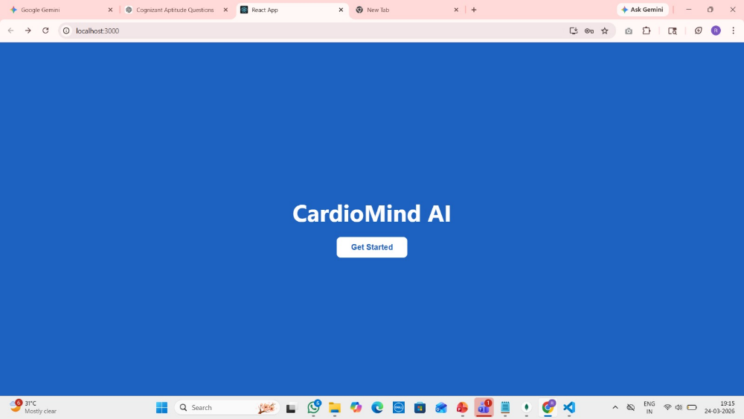

2. Sign Up Page

New users can create an account by entering details such as:
- Name
- Email
- Password

The system validates the inputs and securely stores user data in the database.

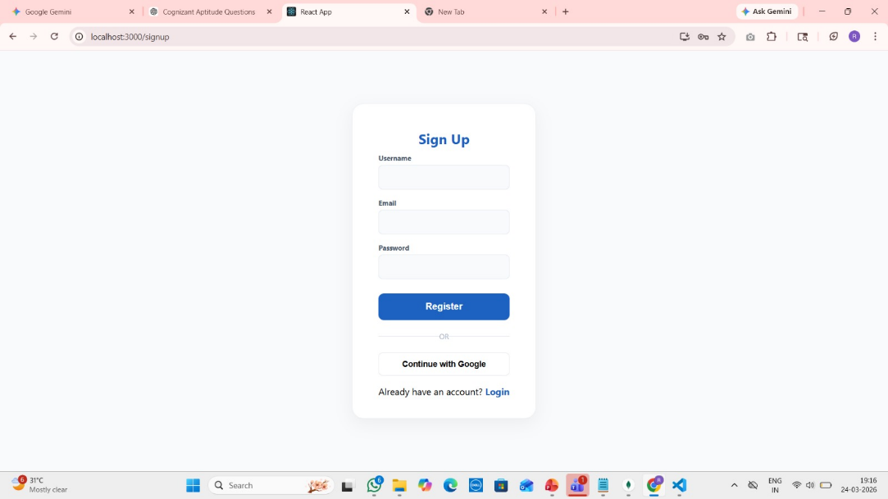

3. Login Page

Registered users can log in using their email and password.
The system verifies credentials and provides secure access to the application.

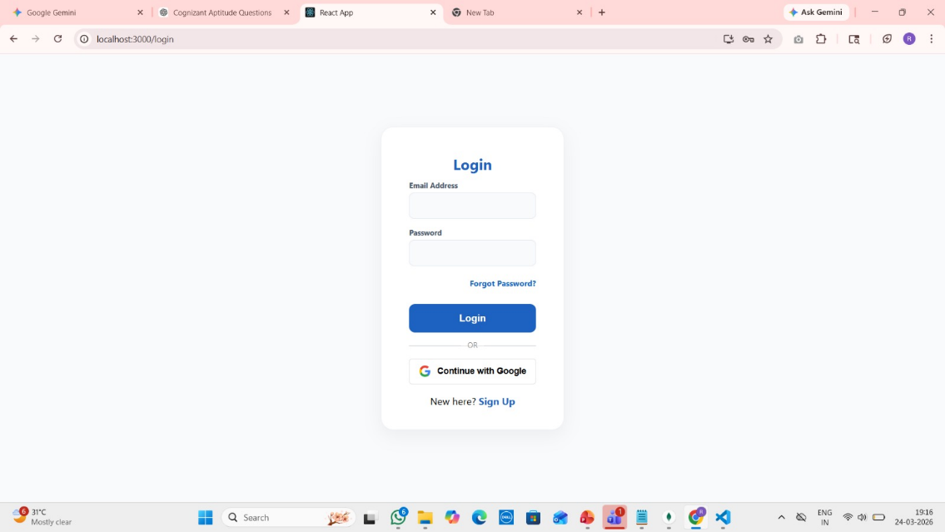

4. Reset Password Page

If users forget their password, they can reset it through this page.
An email-based or secure method is used to update the password safely.

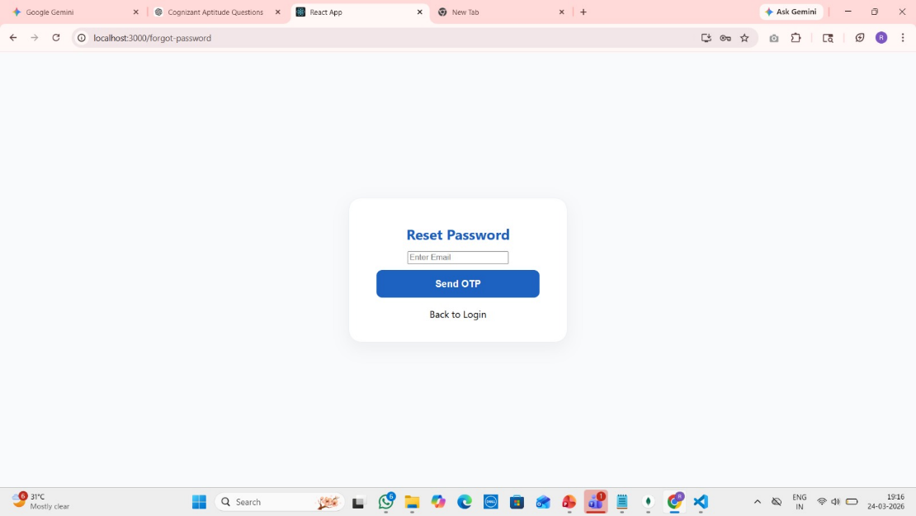

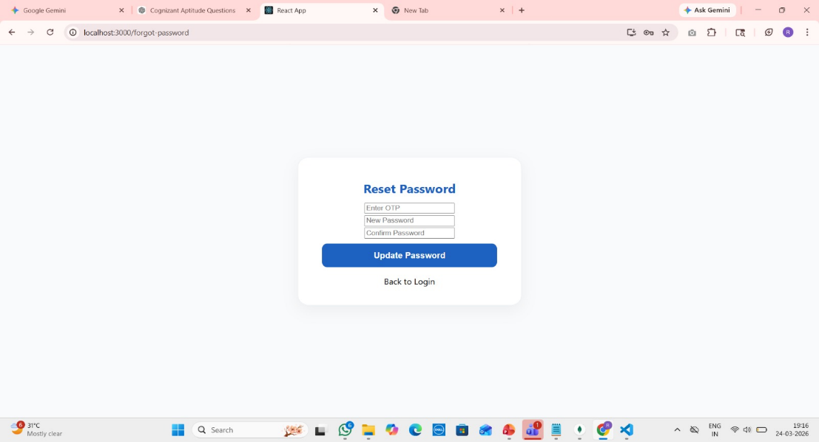

5. Dashboard

After login, users are redirected to the dashboard.
This page provides navigation options such as:
- Enter Health Data
- Upload Files
- View Results
- Recommendations

It acts as the central control panel of the system.

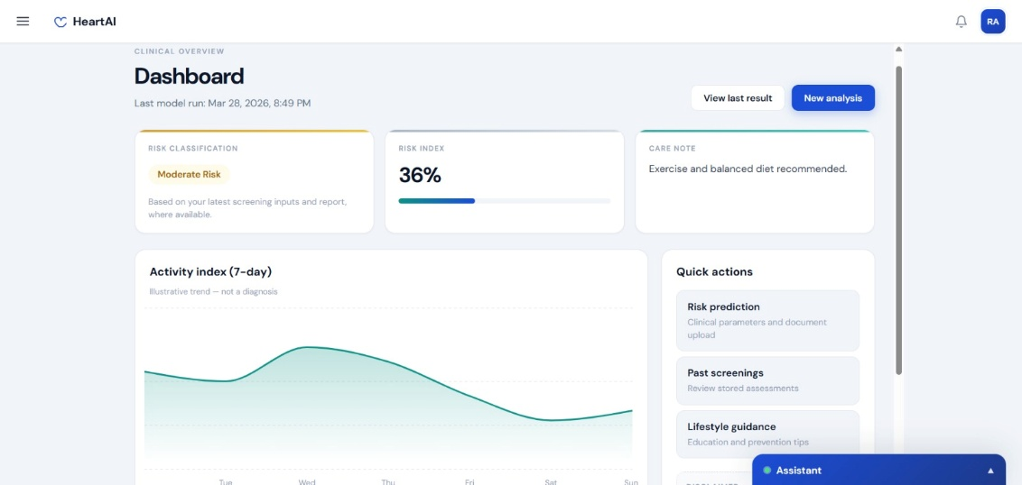

6. Input Form Page

Users can manually enter their medical details such as:
- Age
- Blood Pressure
- Cholesterol Level
- Heart Rate
- Other health parameters

The system performs validation to ensure correct and meaningful input.

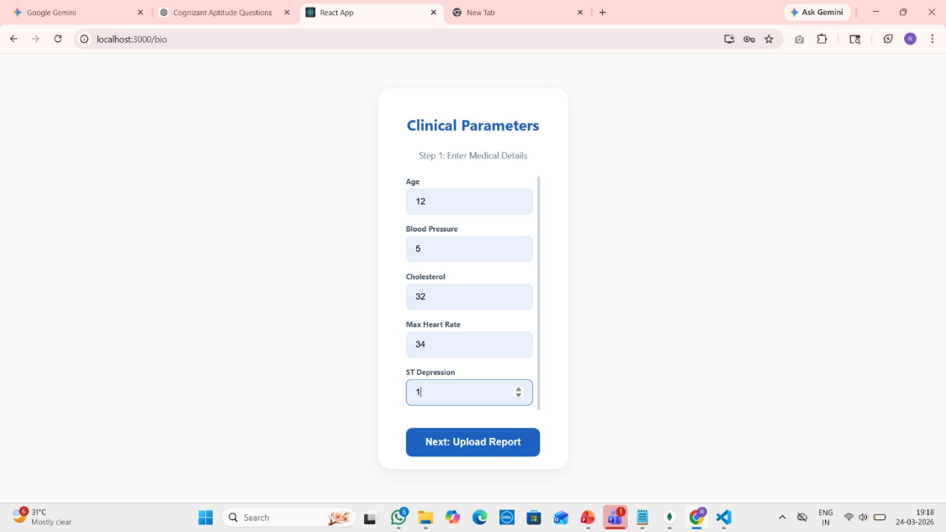

7. File Upload Page

Users can upload medical data files (like CSV).
The system reads the file, extracts relevant data, and prepares it for prediction.

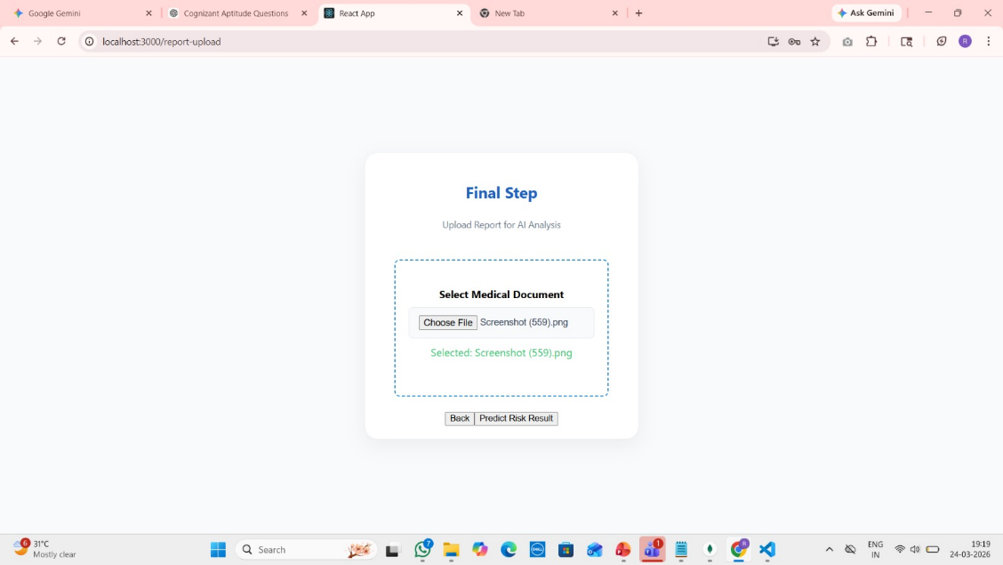

8. Data Processing

The system processes both manually entered data and uploaded data.
It converts the data into a suitable format required by the machine learning model and ensures accuracy through preprocessing steps.

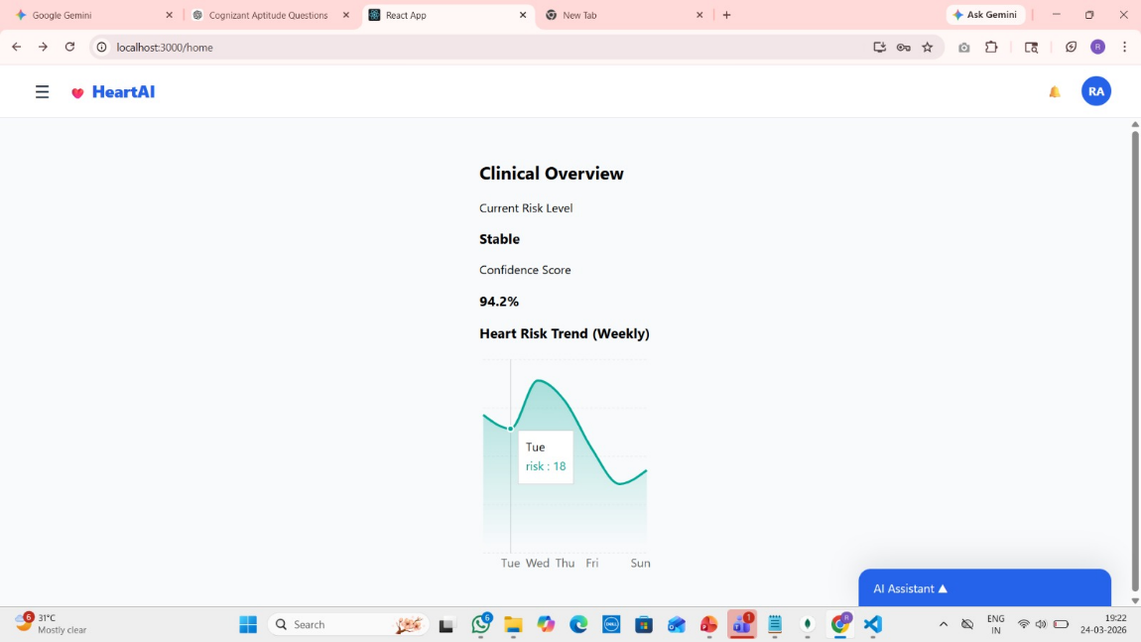

9. Prediction Result Page

The system applies the trained XGBoost model to predict heart disease risk.
The results include:
- Whether the user is at risk or not
- Clear and easy-to-understand output message

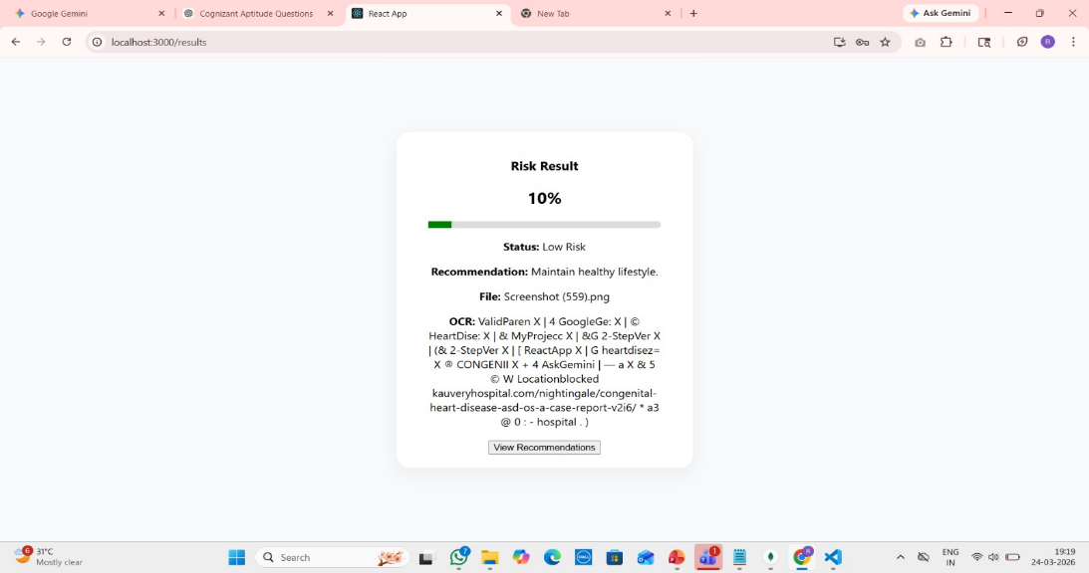

10. Recommendations Page

Based on the prediction, the system provides useful suggestions such as:
- Lifestyle improvements
- Diet recommendations
- Medical consultation advice

This helps users take preventive actions.

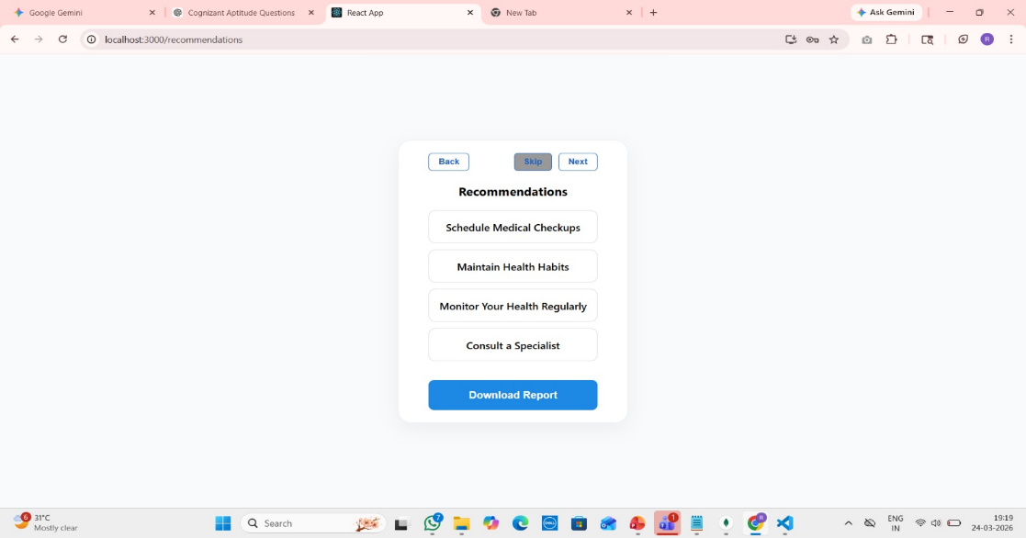

CHAPTER – 5

CONCLUSION AND SCOPE

CONCLUSION

The Heart Disease Prediction System is developed to provide an efficient and reliable solution for early detection of heart disease using machine learning techniques. In today’s world, heart disease is a major health concern, and early diagnosis plays a critical role in preventing serious complications and saving lives.

This system allows users to enter basic medical details and receive instant predictions about their heart disease risk. By using the XGBoost algorithm, the system analyzes health parameters and identifies patterns that indicate the presence or absence of heart disease. This helps users gain a better understanding of their health condition.

One of the key advantages of this system is its simplicity and accessibility. Users do not require advanced medical knowledge to use the application. The web-based platform ensures that the system can be accessed anytime and anywhere, making it useful for a wide range of users.

The system also helps in reducing dependency on frequent hospital visits for initial screening. It acts as a supportive tool for early risk assessment and encourages users to take preventive measures such as consulting doctors, improving lifestyle habits, and undergoing further medical tests if necessary.

Overall, the Heart Disease Prediction System provides a practical approach to preventive healthcare by combining machine learning and web technologies. It improves awareness, supports early diagnosis, and contributes to better health management.

FUTURE SCOPE

Although the Heart Disease Prediction System provides accurate and useful predictions, there are several opportunities to enhance the system in the future.

One possible improvement is the integration of advanced Artificial Intelligence techniques to improve prediction accuracy and provide more detailed health insights. The system can be enhanced to suggest personalized health recommendations based on user data.

Another enhancement could involve integrating the system with hospital databases or wearable health devices. This would allow real-time data collection such as heart rate and activity levels, leading to more accurate and dynamic predictions.

The application can also be extended by developing a mobile version, which would allow users to access the system anytime and anywhere using smartphones. This would increase usability and reach a larger audience.

Future versions of the system may include additional features such as:
- Detailed health reports
- Risk level categorization (low, medium, high)
- Lifestyle and diet recommendations
- Doctor consultation suggestions

The dataset used for training can also be expanded to include more diverse and real-world medical data, which will further improve model performance.

With these improvements, the Heart Disease Prediction System has the potential to become a powerful healthcare support tool that promotes early detection, preventive care, and better health outcomes.

