Docker-01

1)Setup a virtual machine using Ubuntu image.

✅ What is a Virtual Machine
A Virtual Machine (VM) is a software-based computer that runs inside your real computer/server.
It behaves like a real system with:
- its own OS (Ubuntu, Windows, etc.)
- its own CPU, RAM, Disk
- its own IP address (network)

Example:
Your laptop is Windows → inside it you run Ubuntu VM
That Ubuntu VM acts like a separate computer.

✅ Why do we use Virtual Machines?
We use VMs to:
- Run multiple OS on one machine
- Create test environments
- Run servers without buying new hardware
- Isolate applications safely
- Save cost and resources

Setup Virtual Machine using Ubuntu

Step 1: Install VirtualBox (VM software)
On Windows:
- Download VirtualBox from Oracle site
- Install it
On Linux:
sudo apt update
sudo apt install virtualbox -y

Step 2: Download Ubuntu ISO
Download Ubuntu ISO file like:
ubuntu-22.04.iso

Step 3: Create a New VM in VirtualBox
- Open VirtualBox
- Click New
- Give name: Ubuntu-VM
- Type: Linux
- Version: Ubuntu (64-bit)

Step 4: Allocate RAM and CPU
Example:
- RAM: 2048 MB (2GB) minimum
- CPU: 2 cores

Step 5: Create Virtual Hard Disk
Choose:
- Create a virtual hard disk now
- VDI format
- Dynamically allocated
- Size: 20GB minimum

Step 6: Attach Ubuntu ISO
- Select your VM
- Click Settings
- Go to Storage
- Under Controller IDE → click empty
- Choose ISO file (Ubuntu ISO)

Step 7: Start the VM
Click Start
Ubuntu installer will open.

Step 8: Install Ubuntu OS
Follow installer:
- Choose language
- Choose Normal Installation
- Choose Erase disk (only VM disk, not your system)
- Set username + password
- Install
After installation:
- Remove ISO when asked
- Restart VM
✅ Now Ubuntu VM is ready.

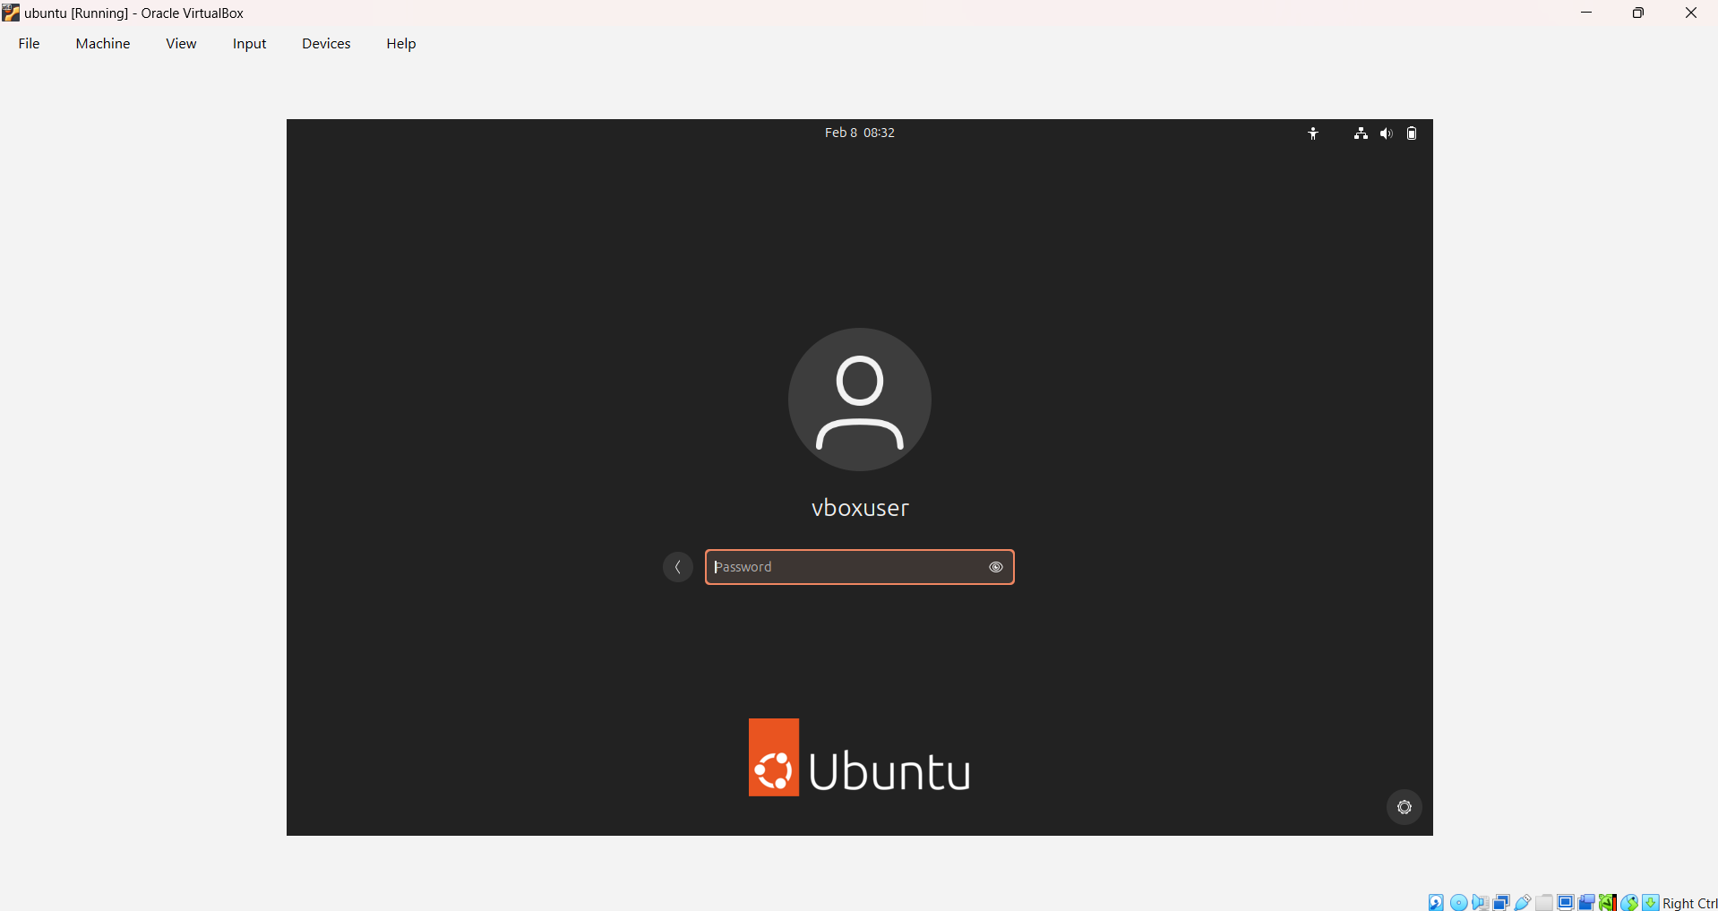
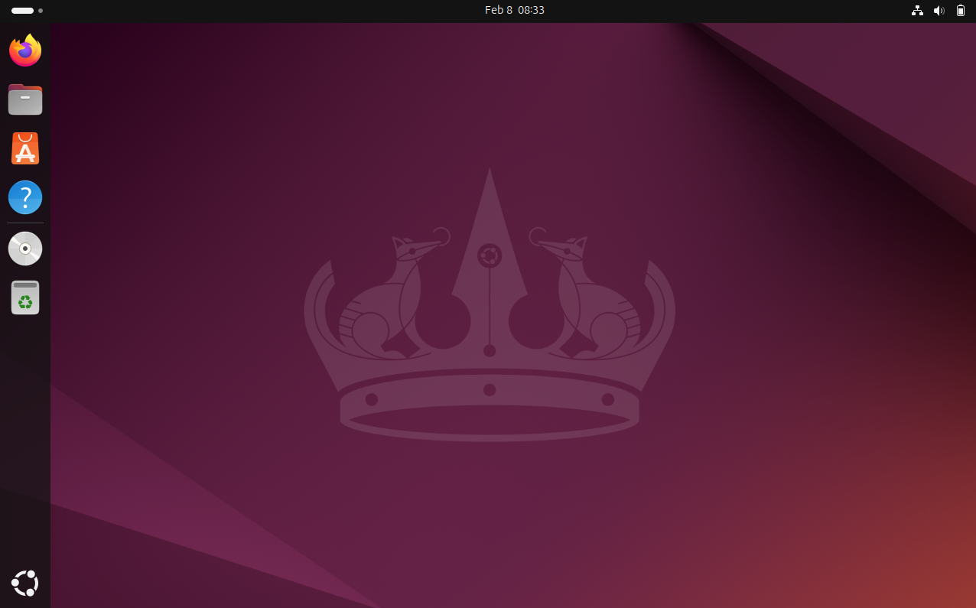
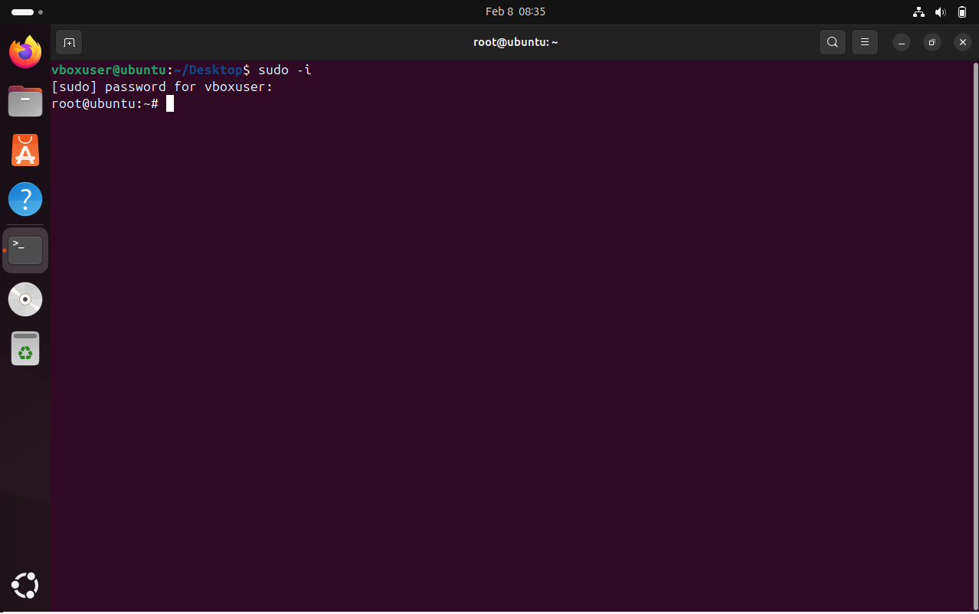

2) Install docker on ec2.
Launch an EC2 instance and connect to instance using ssh
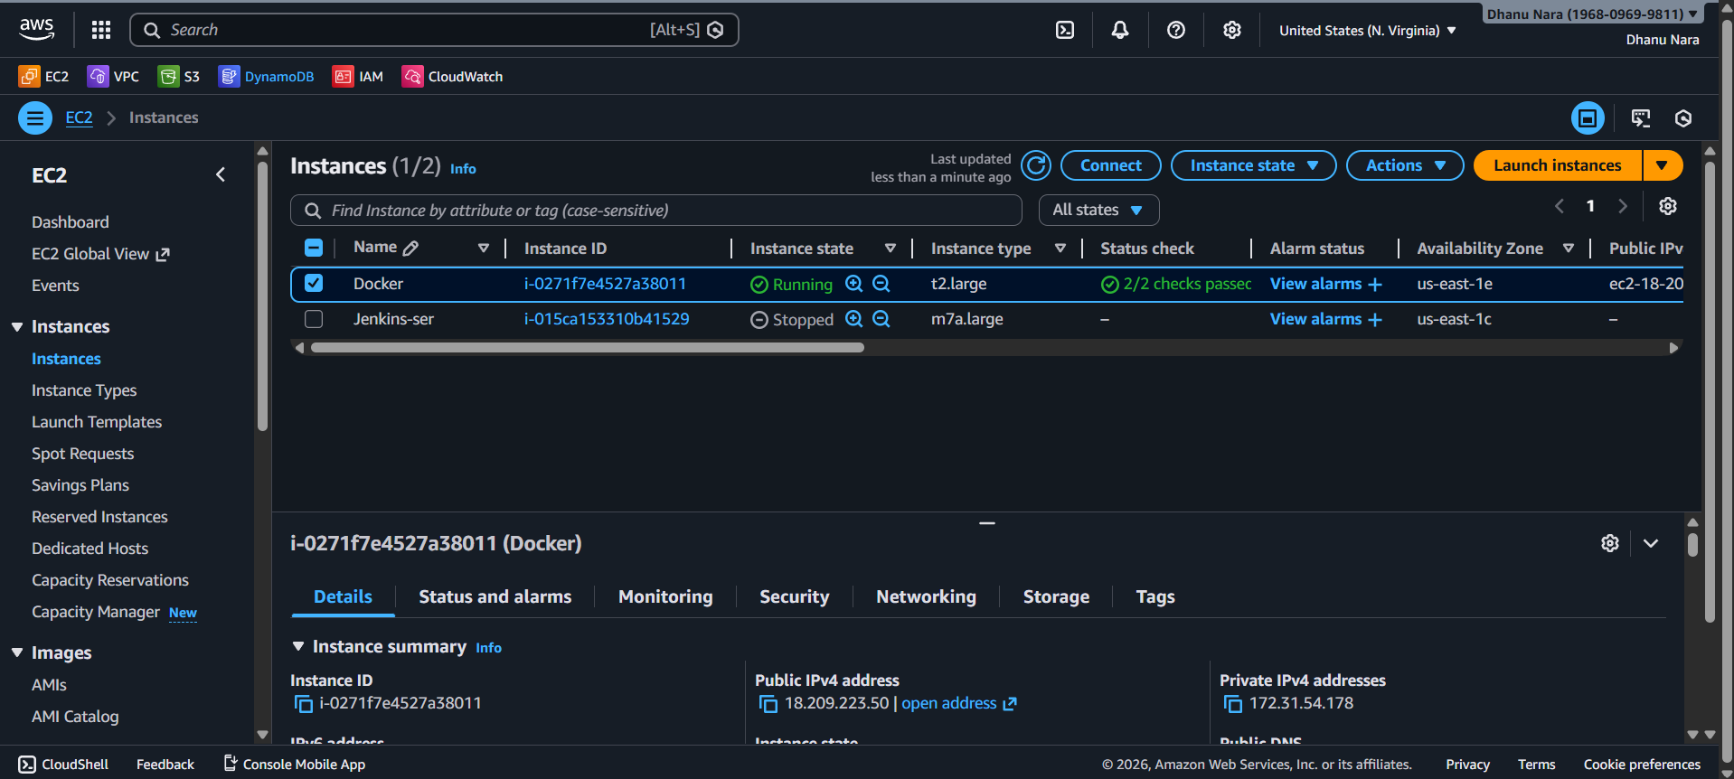
yum update -y
yum install docker -y
systemctl start docker
systemctl status docker
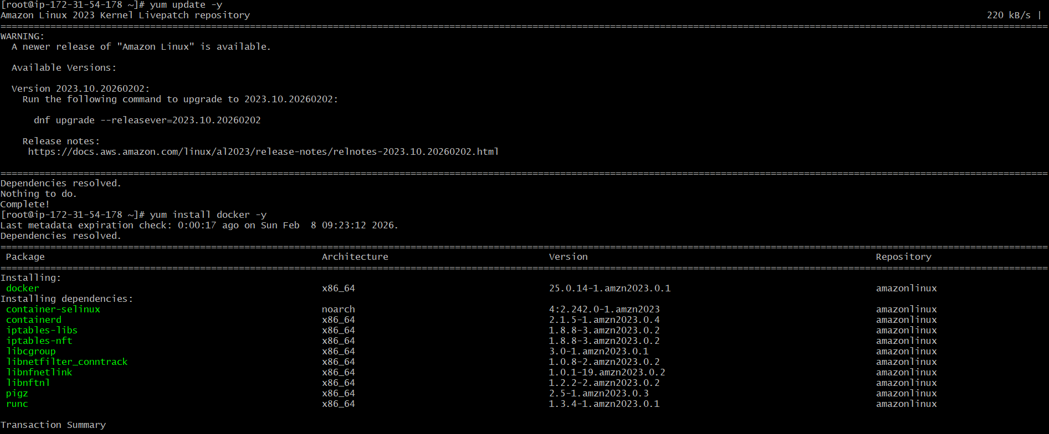
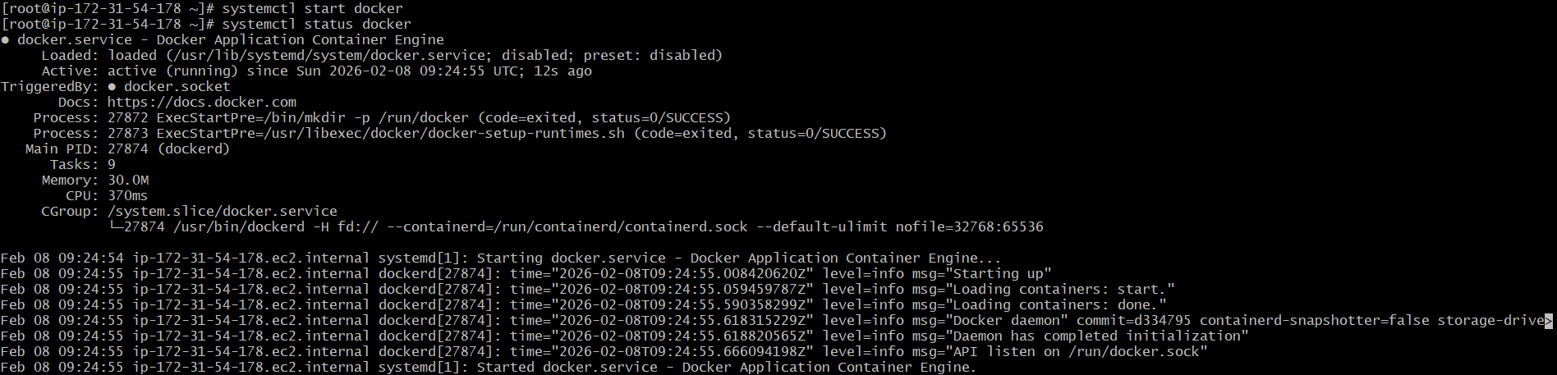

3) Pull 5 docker images.(nginx,apache tomcat,ubuntu,jenkins,sonarqube)

✅ What is docker pull?
docker pull is a Docker command used to download an image from Docker Hub (or any Docker registry) into your local system.
Example:
docker pull nginx
This downloads the nginx image from Docker Hub.

✅ Why do we pull images?
We pull images because Docker containers cannot run without an image.
So before running a container, Docker needs the image file (template).

Main reasons:

1️⃣ To download required application image
Example:
- nginx image → to run nginx server
- jenkins image → to run Jenkins
- sonarqube image → to run SonarQube

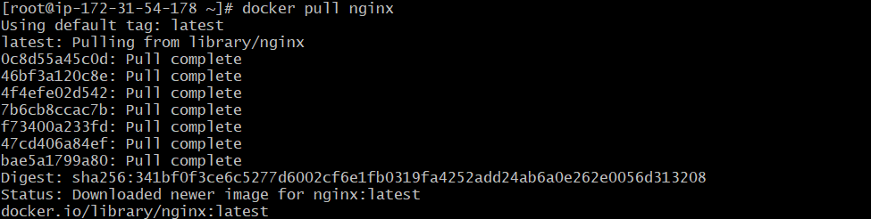
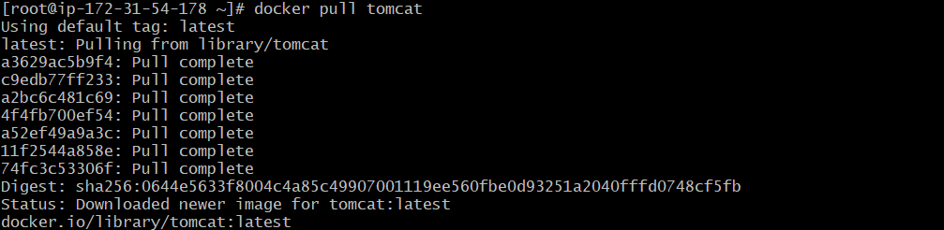
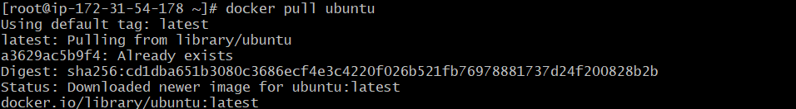
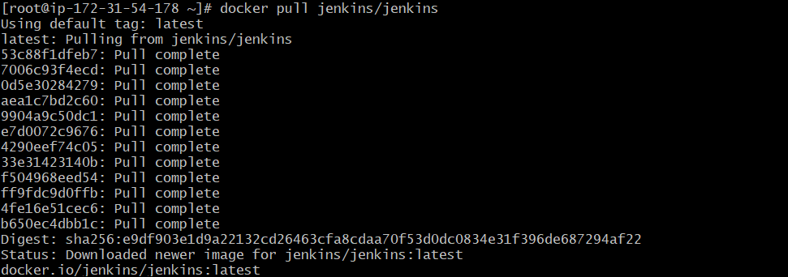
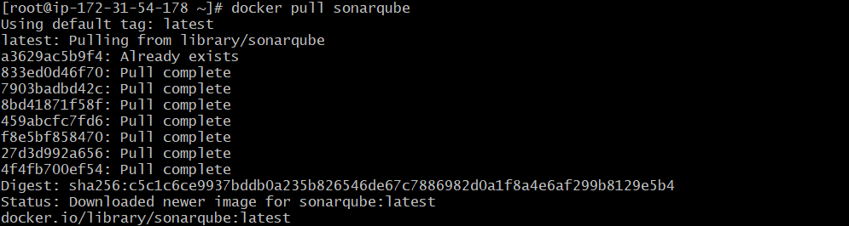
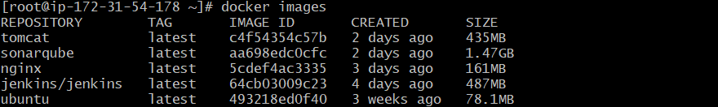

4)Run nginx container and expose on port number 81.

Step 1: Check nginx Image
docker images
Confirm you see:
nginx:latest

Step 2: Run nginx Container on Port 81
Run:
docker run -d --name nginx-server -p 81:80 nginx:latest

Meaning:
- -d → run in background
- --name nginx-server → container name
- -p 81:80 → host port 81 mapped to container port 80
- nginx:latest → nginx image

Step 3: Verify Container is Running
docker ps
You should see nginx running.

Step 4: Test from Server (CLI)
Run:
curl http://localhost:81
You should get nginx welcome HTML output.

Step 5 : open in browser
Go to browser and open:
http://<server-public-ip>:81
Example:
http://100.53.180.115:81
You should see Welcome to nginx!

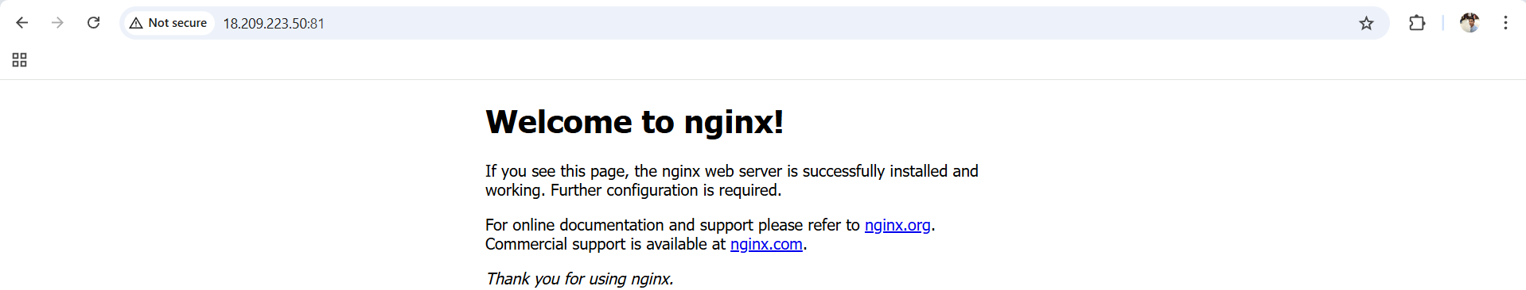

5) Delete the apache tomcat image from local.

✅ Step 1: Check Tomcat Image Name
Run:
docker images
If you see:
tomcat latest <image-id>

✅ Step 2: Remove Tomcat Image
Run:
docker rmi tomcat:latest

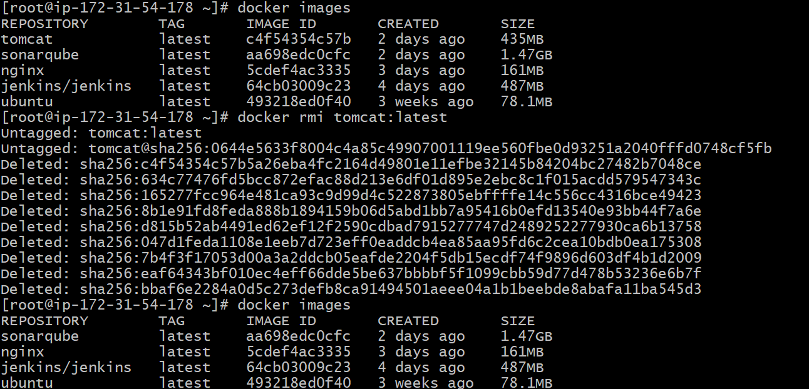

6) Inspect the jenkins image,sonarqube image.

✅ What is meant by Inspect in Docker?
In Docker, inspect means:
👉 To view complete detailed information about a Docker object (image/container/network/volume).
So when you run inspect on an image, Docker shows:
- Image ID
- Created date
- Size
- OS & Architecture
- Environment variables
- Exposed ports
- Entrypoint / CMD
- Volumes
- Layers and metadata
It gives output in JSON format.

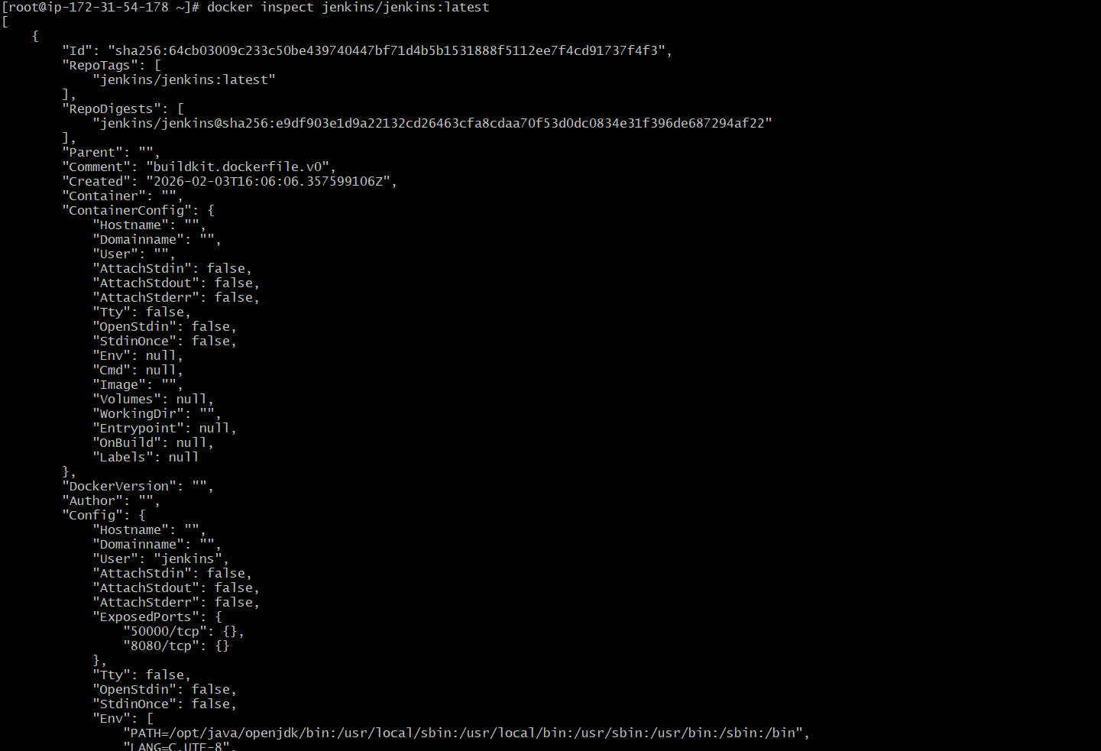

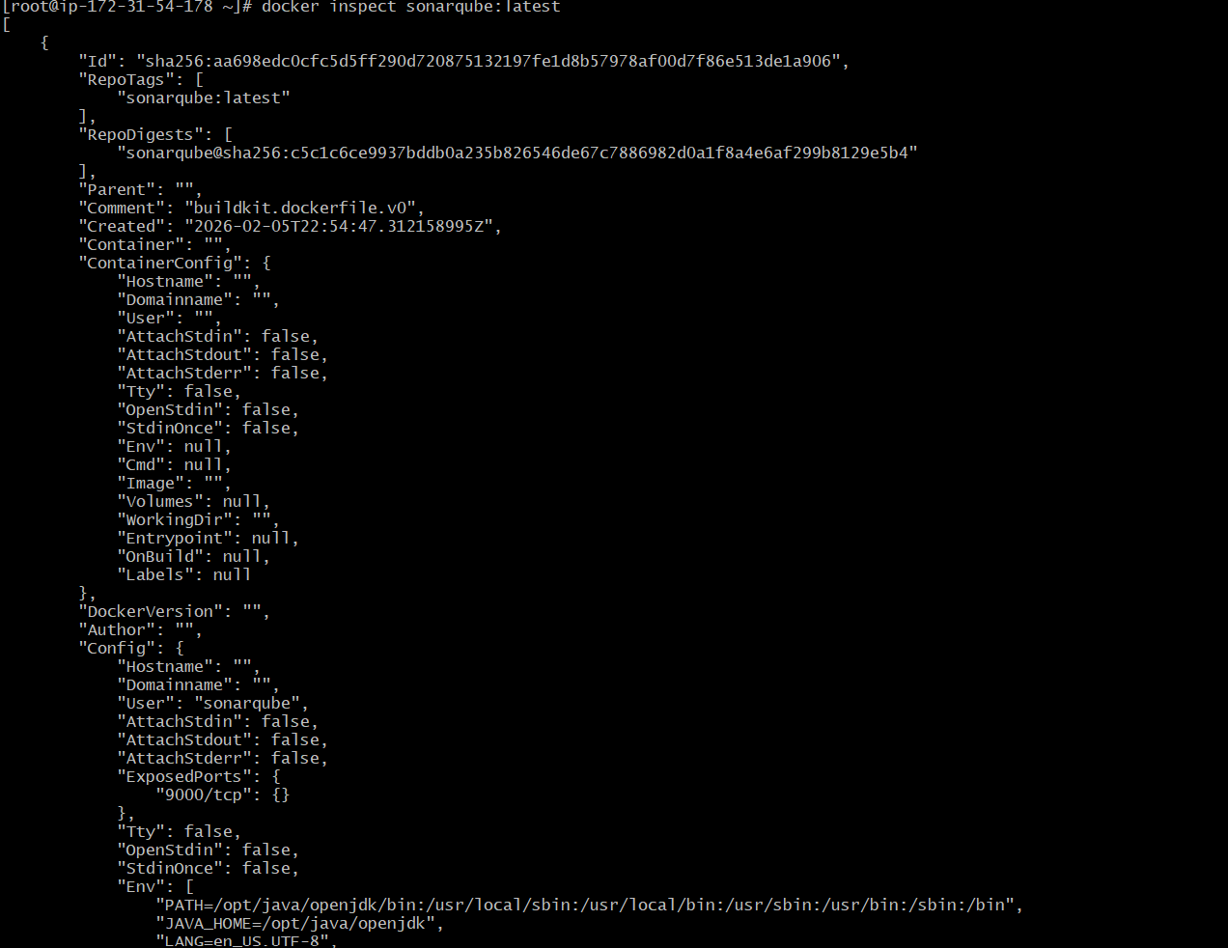

7) Run Jenkins container and run one sample job.

Step 1: Check Jenkins Image
Run:
docker images
You already have:
jenkins/jenkins:latest

Step 2: Run Jenkins Container
Run this command:
docker run -d \
--name jenkins \
-p 8080:8080 \
-p 50000:50000 \
-v jenkins_home:/var/jenkins_home \
jenkins/jenkins:latest

Step 3: Verify Jenkins Container Running
docker ps
jenkins container status as Up

Step 4: Check Jenkins Initial Password
Run:
docker exec -it jenkins cat /var/jenkins_home/secrets/initialAdminPassword
Copy the password.

Step 5: Open Jenkins UI
Open browser and type:
http://<jenkins-server-public-ip>:8080

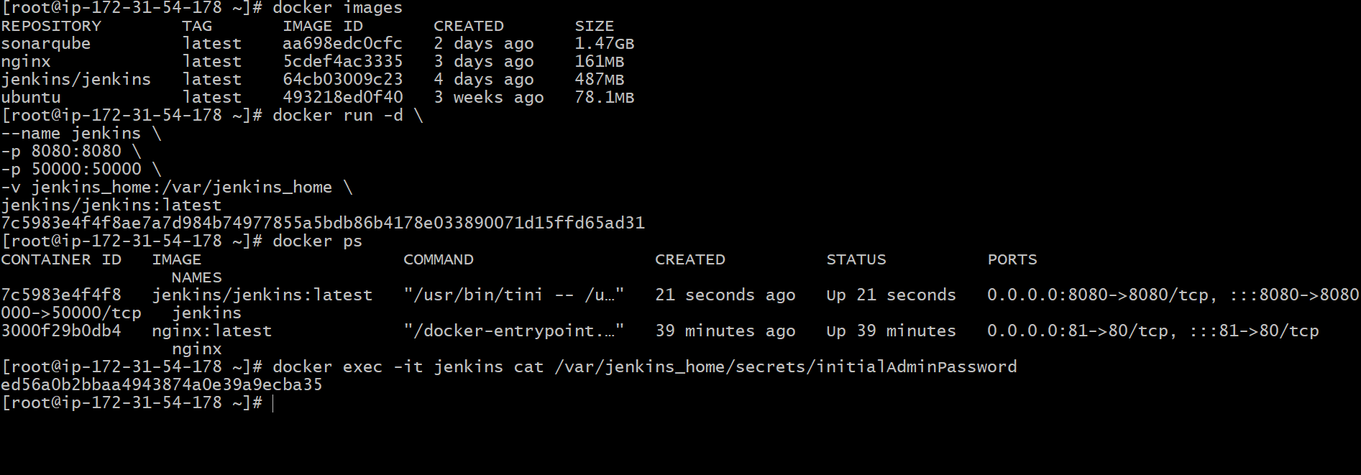

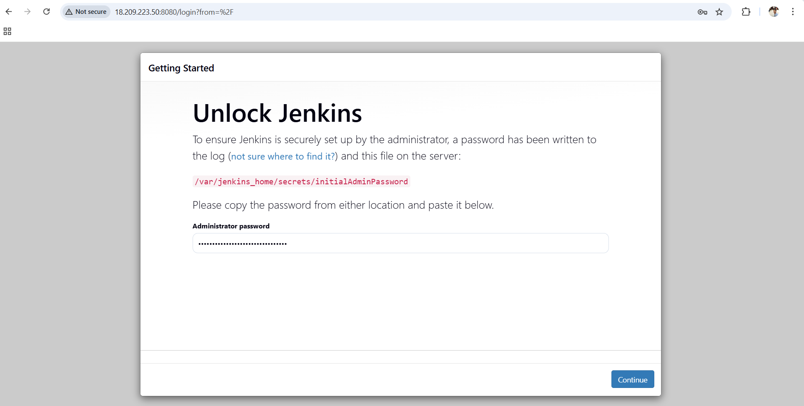

Step 6: Create Sample Job
Go to Jenkins Dashboard → click:
✅ New Item

Step 7: Select Freestyle Project
- Enter job name: sample-job
- Select: Freestyle project
- Click: OK

Step 8: Configure Build Step
Scroll down → Build Steps → click:
✅ Add build step → Execute Shell
Paste this:
echo "Jenkins job running successfully"
date
hostname
whoami
uptime

Step 9: Save Job
Click:
✅ Save

Step 10: Run Job
Click:
✅ Build Now

Step 11: Check Console Output
Click build number (#1) → click:
✅ Console Output
Jenkins job running successfully
Sun Feb ...
hostname...
jenkins
Finished: SUCCESS

