Docker-02

1.Create a tomcat container on 8080 and deploy sample application in tomcat.

Step1: pull tomcat image
On your EC2 / Linux server:
docker pull tomcat:latest

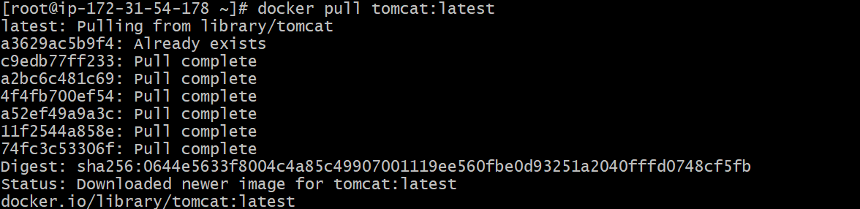

Step 2: Run Tomcat Container on Port 8080
Run container with port mapping host 8080 → container 8080:
docker run -d --name tomcat-server -p 8080:8080 tomcat:latest
Check container running:
docker ps
You should see output like:
- container name: tomcat-server
- port: 0.0.0.0:8080->8080/tcp
Step 3: Access Tomcat in Browser
Open browser:
http://<EC2-PUBLIC-IP>:8080

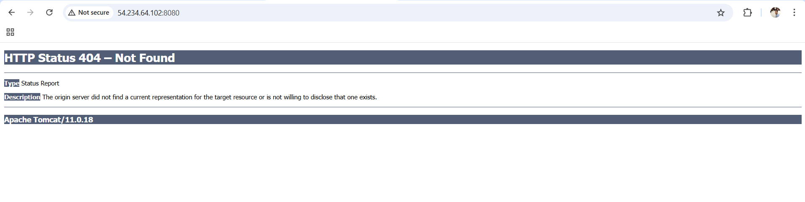
Step 4: Enter into Tomcat Container
Now login into container:
docker exec -it tomcat-server /bin/bash

Step 5: Go to webapps folder
Inside container run:
cd /usr/local/tomcat
ls
Then go to:
cd webapps
ls

Step 6: Download Sample WAR file
Inside webapps directory download sample application war file:
wget https://tomcat.apache.org/tomcat-5.5-doc/appdev/sample/sample.war

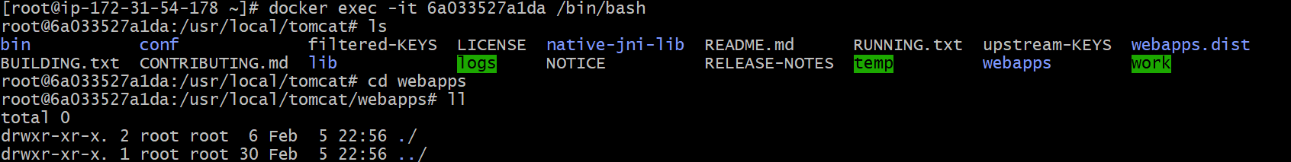
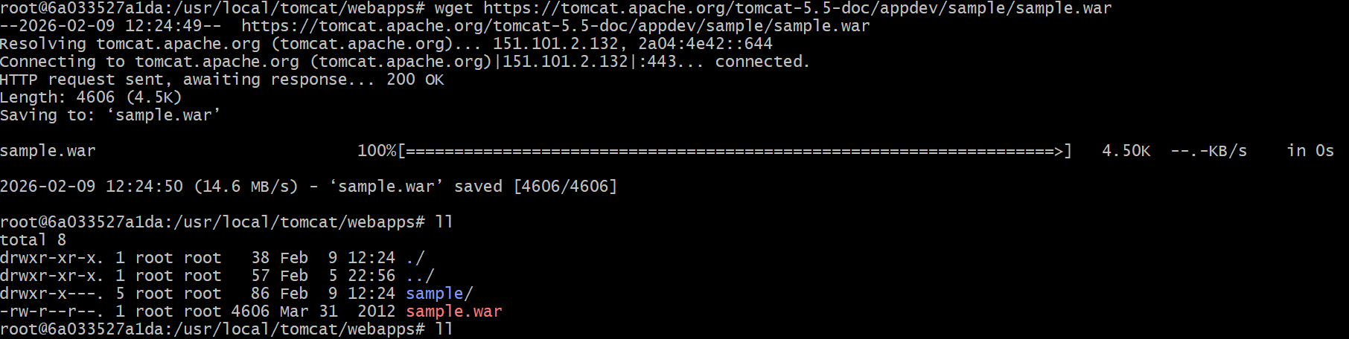
Step 7: Tomcat Auto Extracts WAR File
Tomcat automatically extracts the .war file into a folder.
Wait 5–10 seconds, then check:
ls -l
Now you will see:
- sample.war
- sample/ (extracted application)
Step 8: Exit Container
exit

Step 9: Access Sample Application from Browser
Now open browser:
http://<EC2-PUBLIC-IP>:8080/sample/

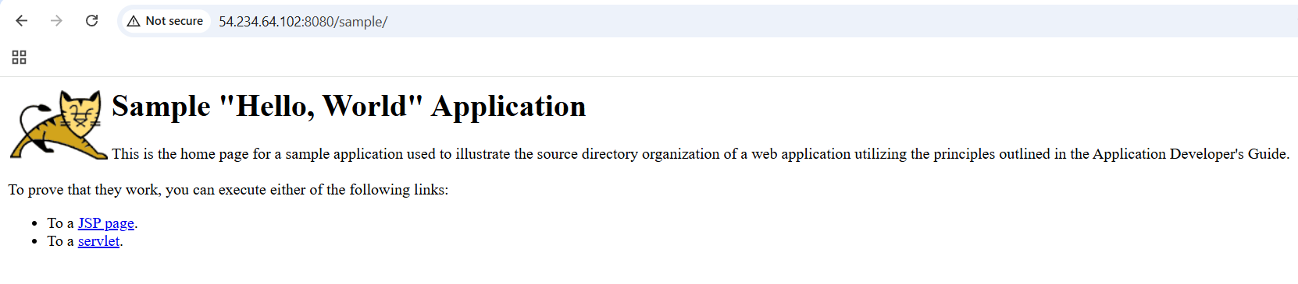

2.Create volume and deploy tomcat container on port 8081.
Docker volumes means:
✅ a way to store container data permanently (outside the container).
Because containers are temporary. If you delete a container, normally the data inside it is also deleted.
But if you use a volume, the data stays safe.

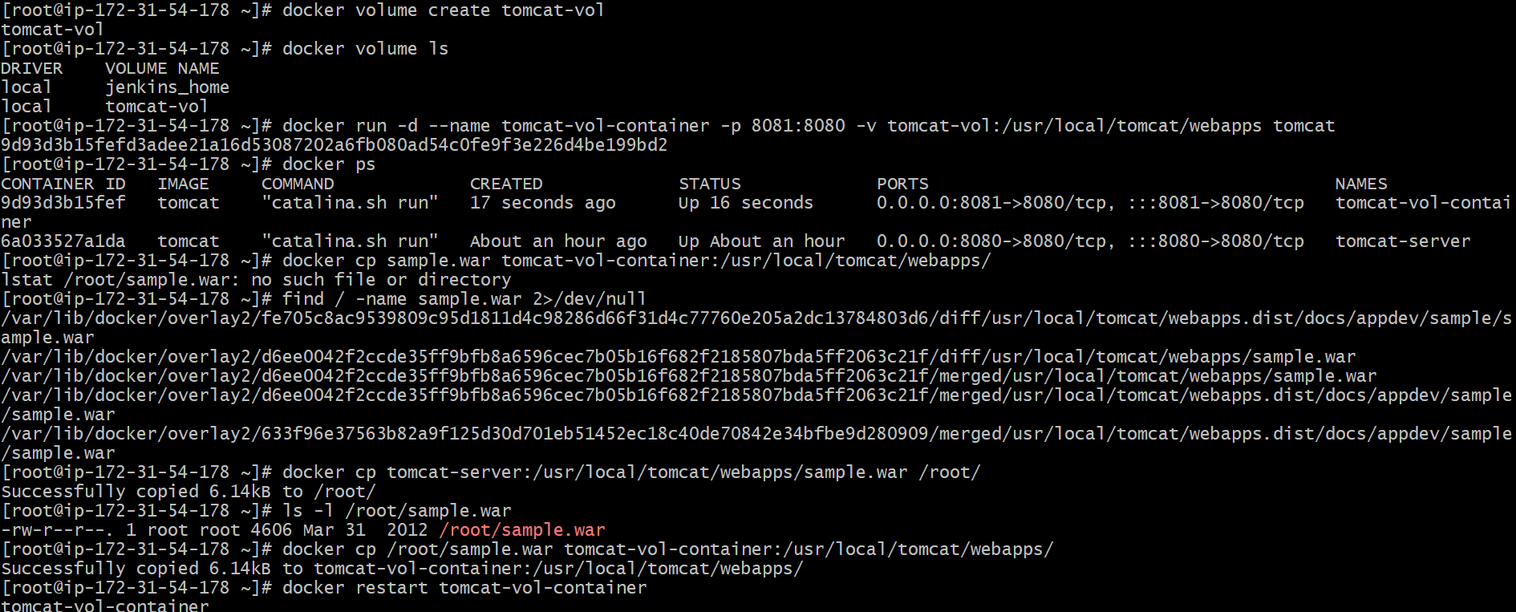

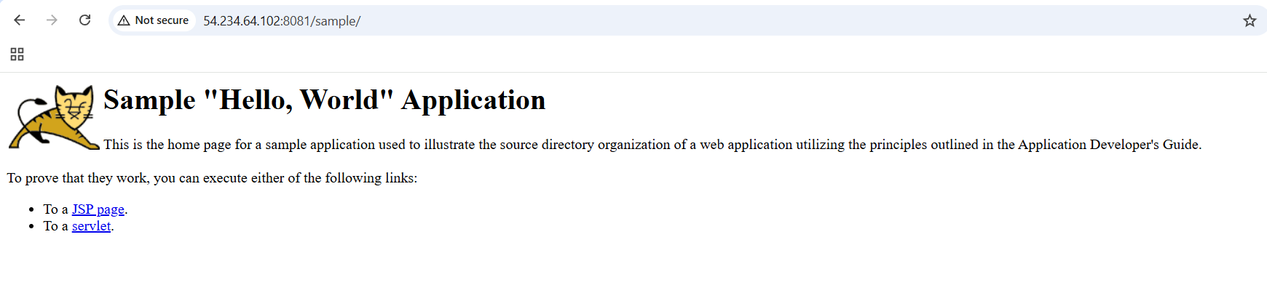

3.Limit the nginx container to 500 MB.

To limit an nginx container to 500MB RAM:
docker run -d --name nginx500 -p 82:80 --memory="500m" nginx

✅ Check live usage
docker stats nginx500

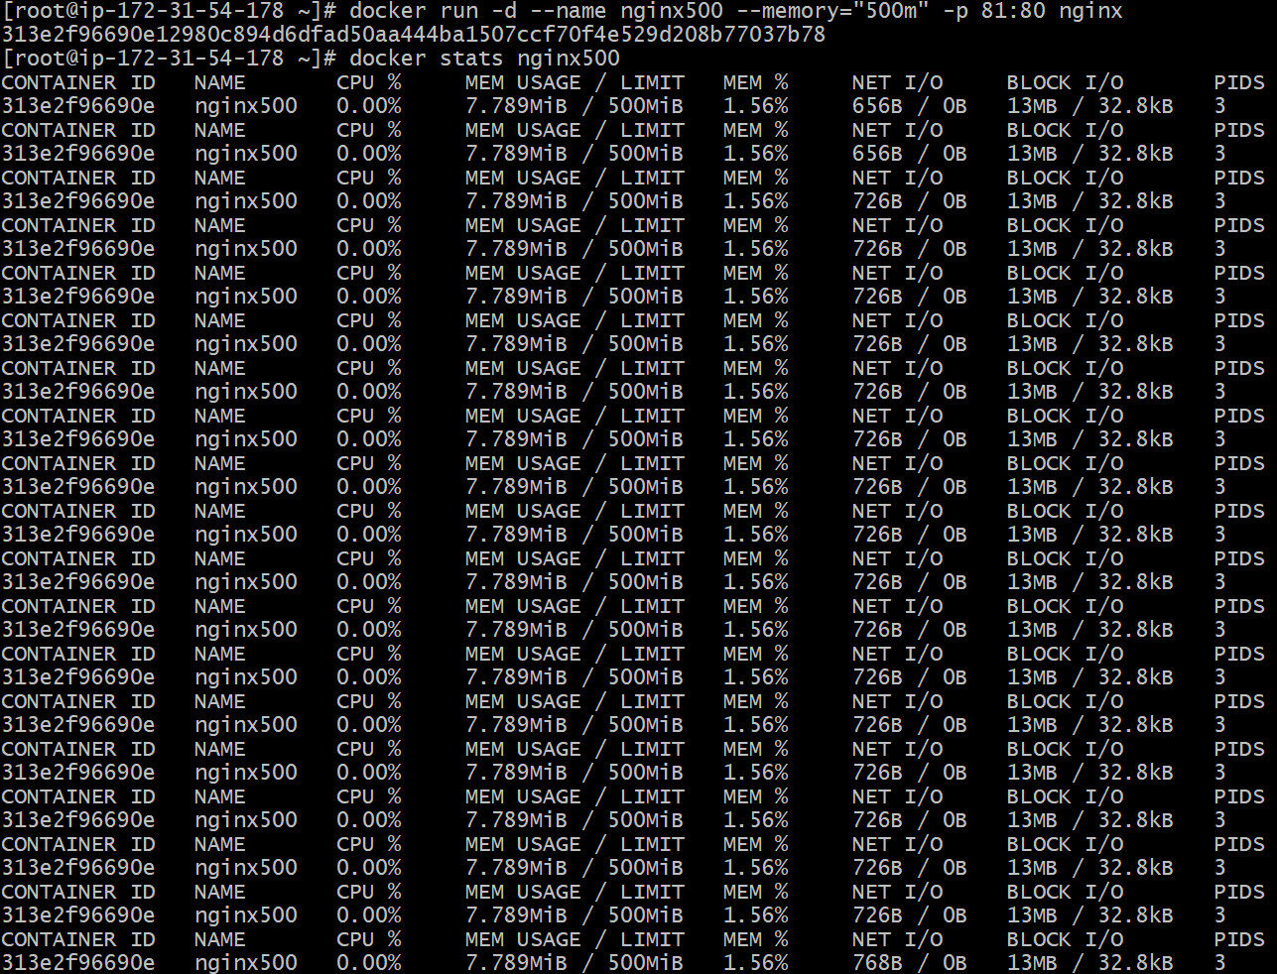

4.Create a sample docker file using below instructions.
Base module as amazonlinux:latest
Maintainer you name
Install nginx
COPY one index.html file to image
Expose on port 80
Command to start the nginx container

Step 1: Create a Folder
mkdir nginx-docker
cd nginx-docker

Step 2: Create Dockerfile
vi Dockerfile
Paste this inside:
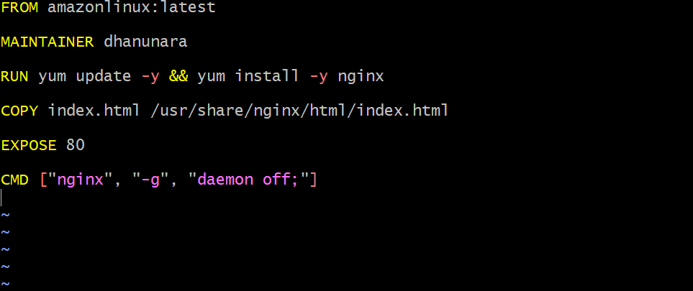

Step 3: Create index.html file
vi index.html
Paste this:
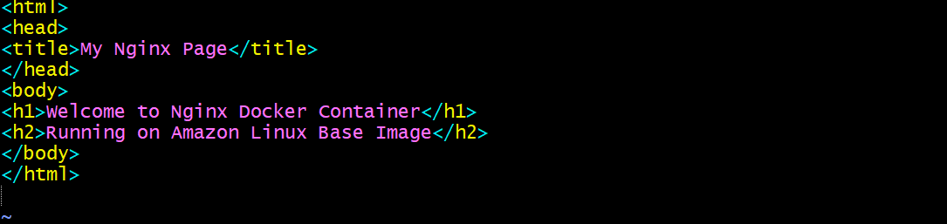
Step 4: Build Docker Image
Run:
docker build -t amazon-nginx .
Check image:
docker images

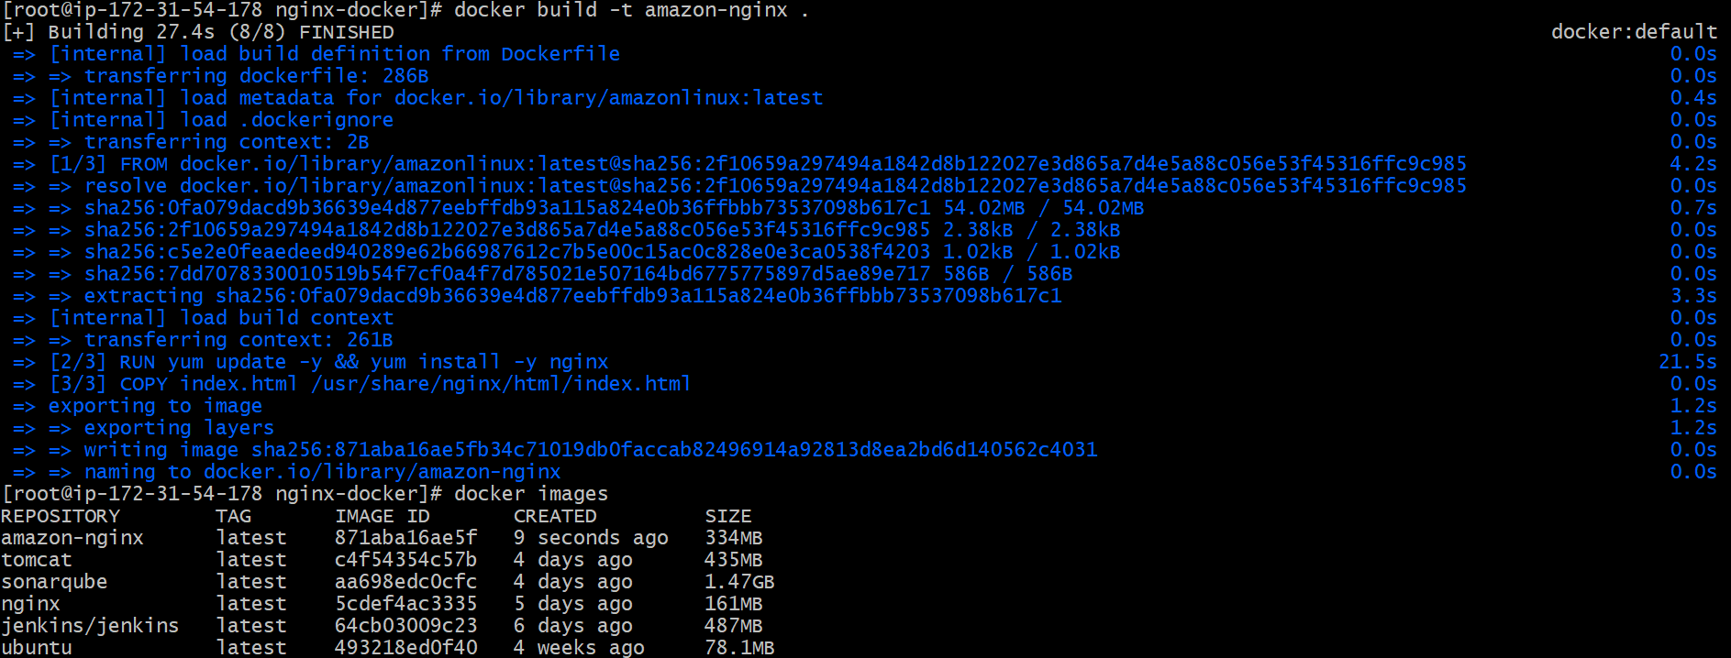
Step 5: Run Container

docker run -d --name nginx-container -p 82:80 amazon-nginx
Check container:
docker ps

Open inbound rule in Security Group:
Custom TCP → Port 82 → Source 0.0.0.0/0

Step 6: Test in Browser
Open:
http://<server-ip>

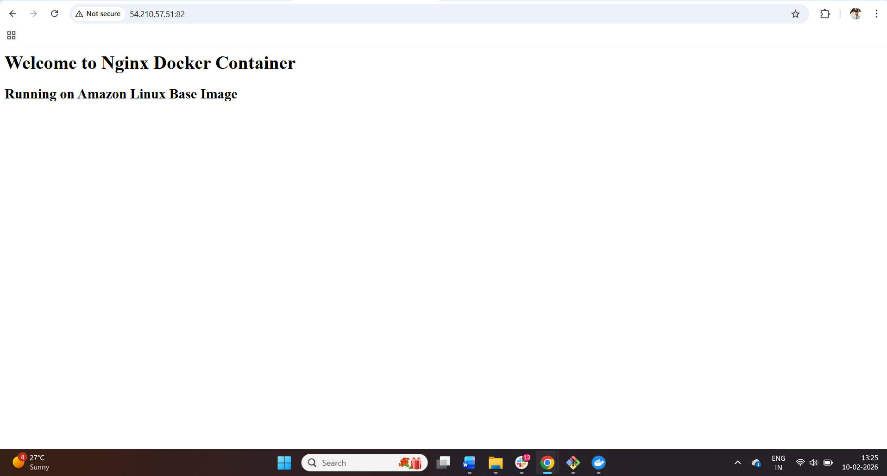

5.Push image to Docker hub.

Step 1: Login to Docker Hub

docker login
Enter your:
- Docker Hub username
- password
Step 2: Check Your Image Name
docker images
You will see something like:
amazon-nginx latest <image_id>

Step 3: Tag the Image
Docker hub format:
dockerhubusername/reponame:tag
Example:
If your DockerHub username is dhanunara
Run:
docker tag amazon-nginx dhanunara/amazon-nginx:latest

Step 4: Push Image to Docker Hub
docker push dhanunara/amazon-nginx:latest

Step 5: Verify in Docker Hub
Go to Docker Hub website → Repositories
You will see:
✅ amazon-nginx

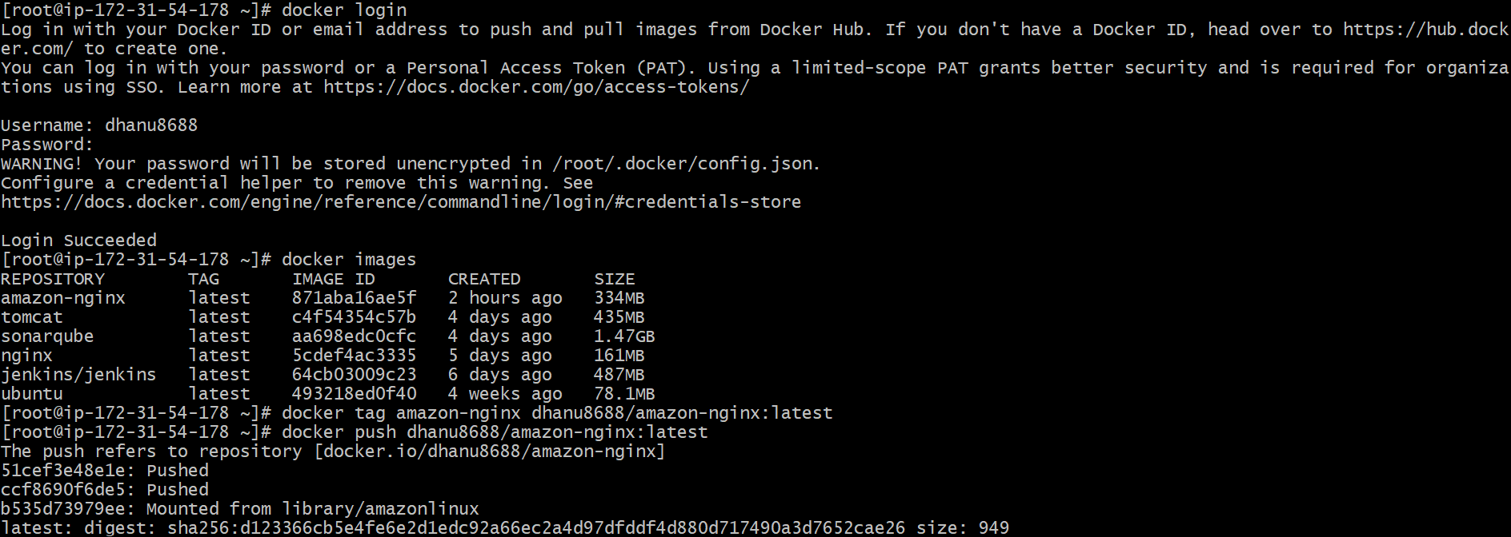
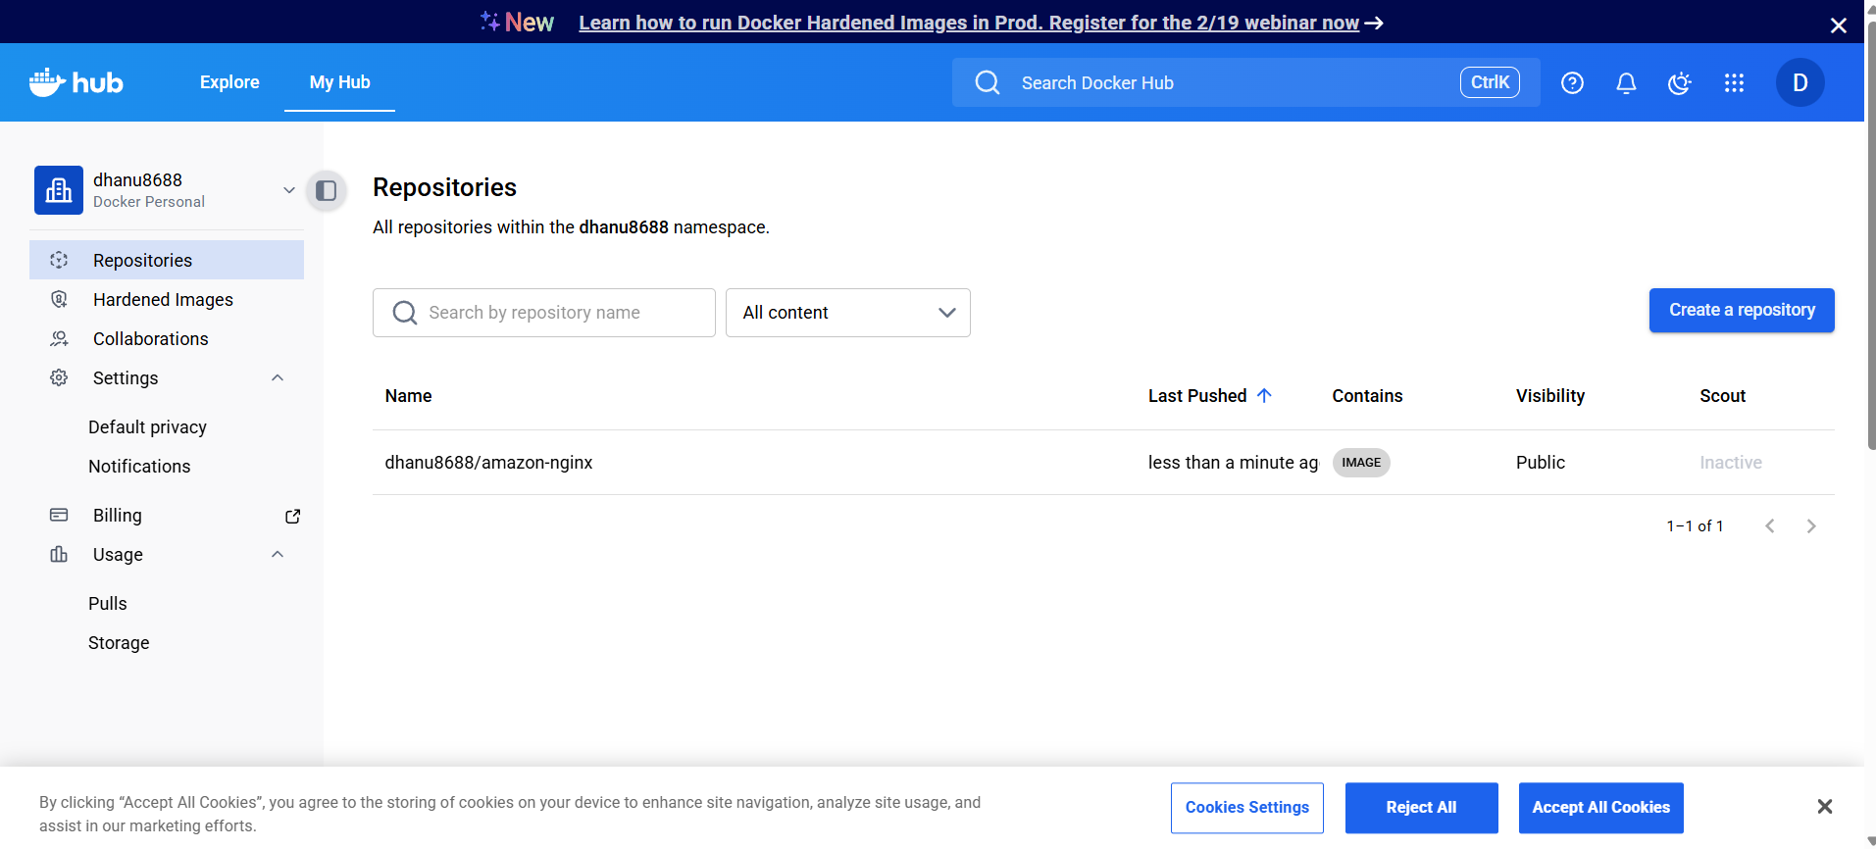

6.Push image to AWS ECR.

Step 1: Install AWS CLI (if not installed)
Check:
aws --version
If not installed (Amazon Linux):
yum install -y awscli

Step 2: Configure AWS CLI
aws configure
Enter:
- AWS Access Key
- AWS Secret Key
- Region (example: us-east-1)
- Output format: json
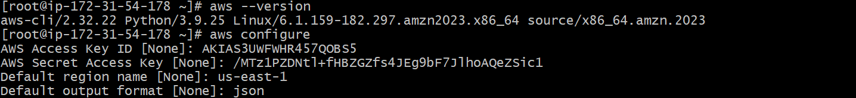

Step 3: Create ECR Repository
Example repo name: amazon-nginx
aws ecr create-repository --repository-name amazon-nginx

Step 4: Login to ECR
First get account id:
aws sts get-caller-identity

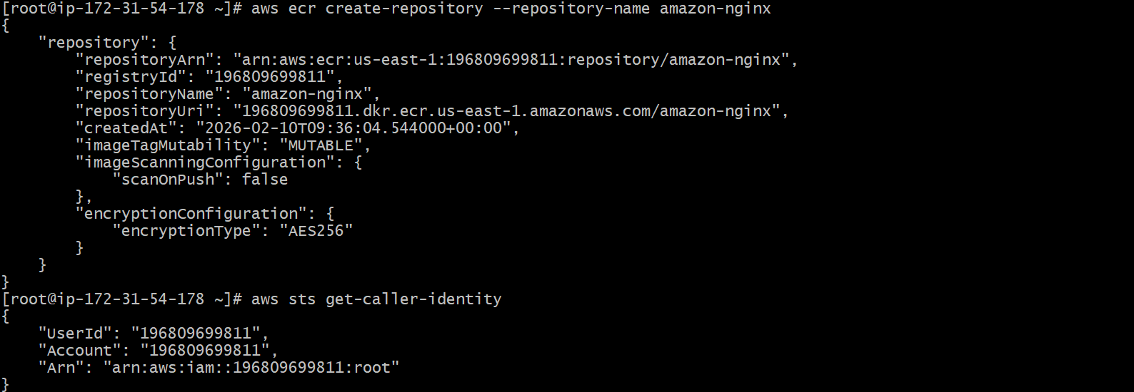
Step 5: Tag Your Docker Image
Format:
docker tag <image-name> <account-id>.dkr.ecr.<region>.amazonaws.com/<repo-name>:latest

Step 6: Push Image to ECR
docker push 123456789012.dkr.ecr.us-east-1.amazonaws.com/amazon-nginx:latest

